UNITED STATES
SECURITIES AND EXCHANGE COMMISSION
Washington, D.C. 20549

FORM 6-K

REPORT OF FOREIGN PRIVATE ISSUER
PURSUANT TO RULE 13a-16 OR 15d-16 OF
THE SECURITIES EXCHANGE ACT OF 1934

For the month of September, 2026

Commission File Number: 001-42128

Telix Pharmaceuticals Limited
(Translation of registrant’s name into English)

55 Flemington Road
North Melbourne, Victoria 3051, Australia
(Address of principal executive offices)

Indicate by check mark whether the registrant files or will file annual reports under cover of Form 20-F or
Form 40-F.

Form 20-F ☒ Form 40-F ☐

INFORMATION CONTAINED IN THIS FORM 6-K REPORT

On September 2, 2026 (Melbourne, Australia), Telix Pharmaceuticals Limited filed an announcement with
the Australian Securities Exchange titled “Telix Completes Enrollment in Phase 3 BiPASS Study, Aligns
with FDA on NDA Pathway” a copy of which is attached to this Form 6-K as Exhibit 99.1.
The information contained in this Form 6-K, except for (i) the commentary in Exhibit 99.1 appearing in the
fifth, sixth and seventh paragraphs of the announcement and (ii) information accessible by hyperlinks
included therein, is incorporated by reference into our Registration Statement on Form F-3ASR (File No.
333-293611) and Registration Statement on Form S-8 (File No. 333-283917).

99.1
Press release – September 2, 2026
SIGNATURES

Pursuant to the requirements of the Securities Exchange Act of 1934, the registrant has duly caused this
report to be signed on its behalf by the undersigned, thereunto duly authorized.

Date
:

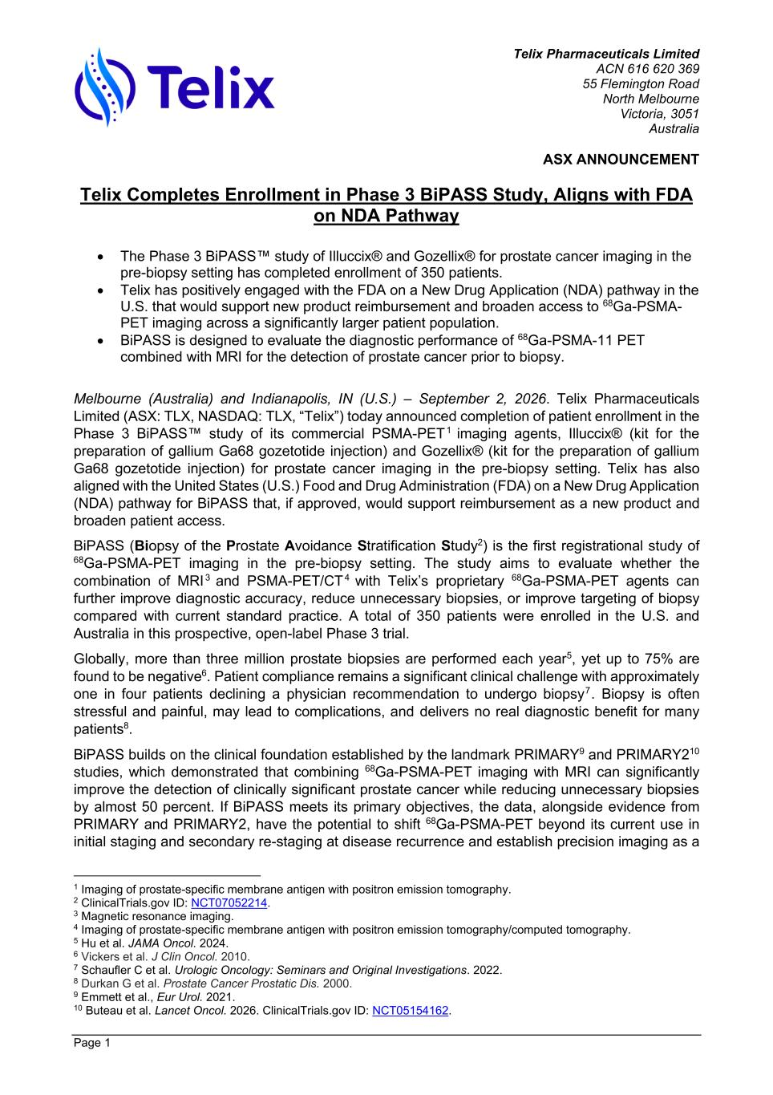
Telix Pharmaceuticals Limited ACN 616 620 369 55 Flemington Road North Melbourne Victoria, 3051 Australia ASX ANNOUNCEMENT Page 1 Telix Completes Enrollment in Phase 3 BiPASS Study, Aligns with FDA on NDA Pathway • The Phase 3 BiPASS™ study of Illuccix® and Gozellix® for prostate cancer imaging in the pre-biopsy setting has completed enrollment of 350 patients. • Telix has positively engaged with the FDA on a New Drug Application (NDA) pathway in the U.S. that would support new product reimbursement and broaden access to 68Ga-PSMA- PET imaging across a significantly larger patient population. • BiPASS is designed to evaluate the diagnostic performance of 68Ga-PSMA-11 PET combined with MRI for the detection of prostate cancer prior to biopsy. Melbourne (Australia) and Indianapolis, IN (U.S.) – September 2, 2026. Telix Pharmaceuticals Limited (ASX: TLX, NASDAQ: TLX, “Telix”) today announced completion of patient enrollment in the Phase 3 BiPASS™ study of its commercial PSMA-PET1 imaging agents, Illuccix® (kit for the preparation of gallium Ga68 gozetotide injection) and Gozellix® (kit for the preparation of gallium Ga68 gozetotide injection) for prostate cancer imaging in the pre-biopsy setting. Telix has also aligned with the United States (U.S.) Food and Drug Administration (FDA) on a New Drug Application (NDA) pathway for BiPASS that, if approved, would support reimbursement as a new product and broaden patient access. BiPASS (Biopsy of the Prostate Avoidance Stratification Study2) is the first registrational study of 68Ga-PSMA-PET imaging in the pre-biopsy setting. The study aims to evaluate whether the combination of MRI 3 and PSMA-PET/CT 4 with Telix’s proprietary 68Ga-PSMA-PET agents can further improve diagnostic accuracy, reduce unnecessary biopsies, or improve targeting of biopsy compared with current standard practice. A total of 350 patients were enrolled in the U.S. and Australia in this prospective, open-label Phase 3 trial. Globally, more than three million prostate biopsies are performed each year5, yet up to 75% are found to be negative6. Patient compliance remains a significant clinical challenge with approximately one in four patients declining a physician recommendation to undergo biopsy7. Biopsy is often stressful and painful, may lead to complications, and delivers no real diagnostic benefit for many patients8. BiPASS builds on the clinical foundation established by the landmark PRIMARY9 and PRIMARY210 studies, which demonstrated that combining 68Ga-PSMA-PET imaging with MRI can significantly improve the detection of clinically significant prostate cancer while reducing unnecessary biopsies by almost 50 percent. If BiPASS meets its primary objectives, the data, alongside evidence from PRIMARY and PRIMARY2, have the potential to shift 68Ga-PSMA-PET beyond its current use in initial staging and secondary re-staging at disease recurrence and establish precision imaging as a 1 Imaging of prostate-specific membrane antigen with positron emission tomography. 2 ClinicalTrials.gov ID: NCT07052214. 3 Magnetic resonance imaging. 4 Imaging of prostate-specific membrane antigen with positron emission tomography/computed tomography. 5 Hu et al. JAMA Oncol. 2024. 6 Vickers et al. J Clin Oncol. 2010. 7 Schaufler C et al. Urologic Oncology: Seminars and Original Investigations. 2022. 8 Durkan G et al. Prostate Cancer Prostatic Dis. 2000. 9 Emmett et al., Eur Urol. 2021. 10 Buteau et al. Lancet Oncol. 2026. ClinicalTrials.gov ID: NCT05154162.

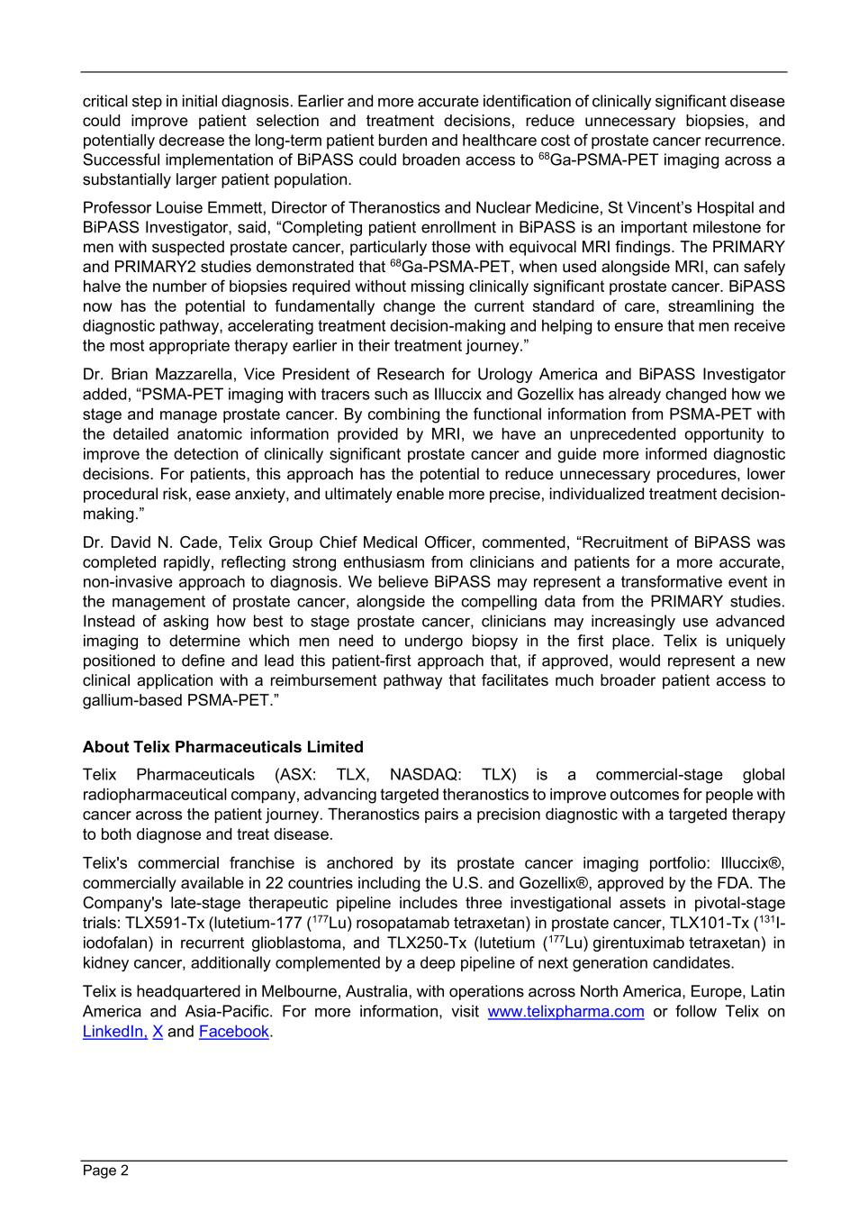
Page 2 critical step in initial diagnosis. Earlier and more accurate identification of clinically significant disease could improve patient selection and treatment decisions, reduce unnecessary biopsies, and potentially decrease the long-term patient burden and healthcare cost of prostate cancer recurrence. Successful implementation of BiPASS could broaden access to 68Ga-PSMA-PET imaging across a substantially larger patient population. Professor Louise Emmett, Director of Theranostics and Nuclear Medicine, St Vincent’s Hospital and BiPASS Investigator, said, “Completing patient enrollment in BiPASS is an important milestone for men with suspected prostate cancer, particularly those with equivocal MRI findings. The PRIMARY and PRIMARY2 studies demonstrated that 68Ga-PSMA-PET, when used alongside MRI, can safely halve the number of biopsies required without missing clinically significant prostate cancer. BiPASS now has the potential to fundamentally change the current standard of care, streamlining the diagnostic pathway, accelerating treatment decision-making and helping to ensure that men receive the most appropriate therapy earlier in their treatment journey.” Dr. Brian Mazzarella, Vice President of Research for Urology America and BiPASS Investigator added, “PSMA-PET imaging with tracers such as Illuccix and Gozellix has already changed how we stage and manage prostate cancer. By combining the functional information from PSMA-PET with the detailed anatomic information provided by MRI, we have an unprecedented opportunity to improve the detection of clinically significant prostate cancer and guide more informed diagnostic decisions. For patients, this approach has the potential to reduce unnecessary procedures, lower procedural risk, ease anxiety, and ultimately enable more precise, individualized treatment decision- making.” Dr. David N. Cade, Telix Group Chief Medical Officer, commented, “Recruitment of BiPASS was completed rapidly, reflecting strong enthusiasm from clinicians and patients for a more accurate, non-invasive approach to diagnosis. We believe BiPASS may represent a transformative event in the management of prostate cancer, alongside the compelling data from the PRIMARY studies. Instead of asking how best to stage prostate cancer, clinicians may increasingly use advanced imaging to determine which men need to undergo biopsy in the first place. Telix is uniquely positioned to define and lead this patient-first approach that, if approved, would represent a new clinical application with a reimbursement pathway that facilitates much broader patient access to gallium-based PSMA-PET.” About Telix Pharmaceuticals Limited Telix Pharmaceuticals (ASX: TLX, NASDAQ: TLX) is a commercial-stage global radiopharmaceutical company, advancing targeted theranostics to improve outcomes for people with cancer across the patient journey. Theranostics pairs a precision diagnostic with a targeted therapy to both diagnose and treat disease. Telix's commercial franchise is anchored by its prostate cancer imaging portfolio: Illuccix®, commercially available in 22 countries including the U.S. and Gozellix®, approved by the FDA. The Company's late-stage therapeutic pipeline includes three investigational assets in pivotal-stage trials: TLX591-Tx (lutetium-177 (177Lu) rosopatamab tetraxetan) in prostate cancer, TLX101-Tx (131I- iodofalan) in recurrent glioblastoma, and TLX250-Tx (lutetium (177Lu) girentuximab tetraxetan) in kidney cancer, additionally complemented by a deep pipeline of next generation candidates. Telix is headquartered in Melbourne, Australia, with operations across North America, Europe, Latin America and Asia-Pacific. For more information, visit www.telixpharma.com or follow Telix on LinkedIn, X and Facebook.

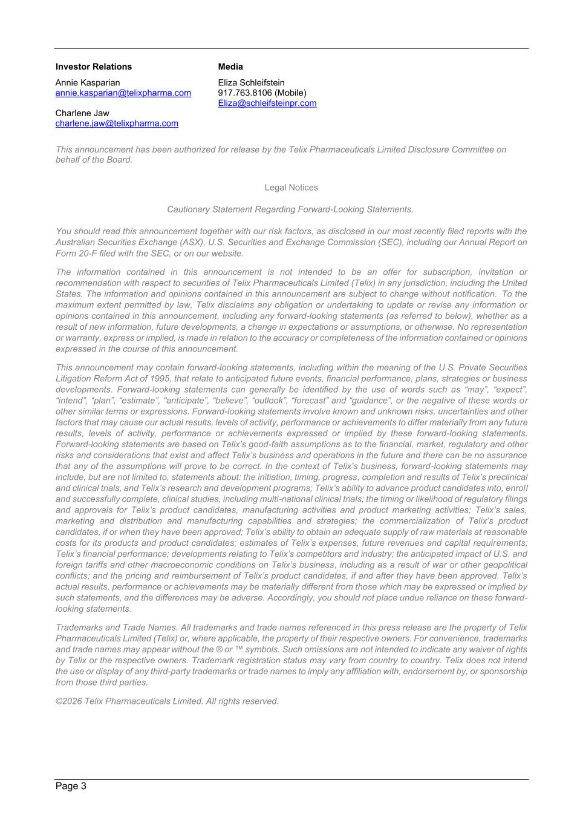
Page 3 Investor Relations Annie Kasparian annie.kasparian@telixpharma.com Charlene Jaw charlene.jaw@telixpharma.com Media Eliza Schleifstein 917.763.8106 (Mobile) Eliza@schleifsteinpr.com This announcement has been authorized for release by the Telix Pharmaceuticals Limited Disclosure Committee on behalf of the Board. Legal Notices Cautionary Statement Regarding Forward-Looking Statements. You should read this announcement together with our risk factors, as disclosed in our most recently filed reports with the Australian Securities Exchange (ASX), U.S. Securities and Exchange Commission (SEC), including our Annual Report on Form 20-F filed with the SEC, or on our website. The information contained in this announcement is not intended to be an offer for subscription, invitation or recommendation with respect to securities of Telix Pharmaceuticals Limited (Telix) in any jurisdiction, including the United States. The information and opinions contained in this announcement are subject to change without notification. To the maximum extent permitted by law, Telix disclaims any obligation or undertaking to update or revise any information or opinions contained in this announcement, including any forward-looking statements (as referred to below), whether as a result of new information, future developments, a change in expectations or assumptions, or otherwise. No representation or warranty, express or implied, is made in relation to the accuracy or completeness of the information contained or opinions expressed in the course of this announcement. This announcement may contain forward-looking statements, including within the meaning of the U.S. Private Securities Litigation Reform Act of 1995, that relate to anticipated future events, financial performance, plans, strategies or business developments. Forward-looking statements can generally be identified by the use of words such as “may”, “expect”, “intend”, “plan”, “estimate”, “anticipate”, “believe”, “outlook”, “forecast” and “guidance”, or the negative of these words or other similar terms or expressions. Forward-looking statements involve known and unknown risks, uncertainties and other factors that may cause our actual results, levels of activity, performance or achievements to differ materially from any future results, levels of activity, performance or achievements expressed or implied by these forward-looking statements. Forward-looking statements are based on Telix’s good-faith assumptions as to the financial, market, regulatory and other risks and considerations that exist and affect Telix’s business and operations in the future and there can be no assurance that any of the assumptions will prove to be correct. In the context of Telix’s business, forward-looking statements may include, but are not limited to, statements about: the initiation, timing, progress, completion and results of Telix’s preclinical and clinical trials, and Telix’s research and development programs; Telix’s ability to advance product candidates into, enroll and successfully complete, clinical studies, including multi-national clinical trials; the timing or likelihood of regulatory filings and approvals for Telix’s product candidates, manufacturing activities and product marketing activities; Telix’s sales, marketing and distribution and manufacturing capabilities and strategies; the commercialization of Telix’s product candidates, if or when they have been approved; Telix’s ability to obtain an adequate supply of raw materials at reasonable costs for its products and product candidates; estimates of Telix’s expenses, future revenues and capital requirements; Telix’s financial performance; developments relating to Telix’s competitors and industry; the anticipated impact of U.S. and foreign tariffs and other macroeconomic conditions on Telix’s business, including as a result of war or other geopolitical conflicts; and the pricing and reimbursement of Telix’s product candidates, if and after they have been approved. Telix’s actual results, performance or achievements may be materially different from those which may be expressed or implied by such statements, and the differences may be adverse. Accordingly, you should not place undue reliance on these forward- looking statements. Trademarks and Trade Names. All trademarks and trade names referenced in this press release are the property of Telix Pharmaceuticals Limited (Telix) or, where applicable, the property of their respective owners. For convenience, trademarks and trade names may appear without the ® or ™ symbols. Such omissions are not intended to indicate any waiver of rights by Telix or the respective owners. Trademark registration status may vary from country to country. Telix does not intend the use or display of any third-party trademarks or trade names to imply any affiliation with, endorsement by, or sponsorship from those third parties. ©2026 Telix Pharmaceuticals Limited. All rights reserved.

