UNITED STATES
SECURITIES AND EXCHANGE COMMISSION
Washington, D.C. 20549

FORM 6-K

REPORT OF FOREIGN PRIVATE ISSUER
PURSUANT TO RULE 13a-16 OR 15d-16 OF
THE SECURITIES EXCHANGE ACT OF 1934

For the month of August, 2026

Commission File Number: 001-42128

Telix Pharmaceuticals Limited
(Translation of registrant’s name into English)

55 Flemington Road
North Melbourne, Victoria 3051, Australia
(Address of principal executive offices)

Indicate by check mark whether the registrant files or will file annual reports under cover of Form 20-F or Form 40-
F.

Form 20-F ☒ Form 40-F ☐

INFORMATION CONTAINED IN THIS FORM 6-K REPORT

On August 20, 2026 (Melbourne, Australia), Telix Pharmaceuticals Limited ( “Telix”) filed the following
announcements with the Australian Securities Exchange titled: (i) “Telix H1 2026 Results Presentation,” (ii) “Telix
H1 2026 Appendix 4D and Interim Report,” and (iii) “Telix H1 2026 Results Announcement,” copies of which are
attached to this Form 6-K as Exhibit 99.1, Exhibit 99.2, and Exhibit 99.3, respectively.
Also attached as Exhibit 99.4 to this Form 6-K, are copies of Telix’s unaudited interim consolidated financial
statements for the half-year ended June 30, 2026, and the related Operating and Financial Review discussion for the
half-year ended June 30, 2026, formatted in Extensible Business Reporting Language (“XBRL”).
Exhibits 99.2 and 99.4 are incorporated by reference into Telix’s Registration Statement on Form F-3ASR (File No.
333-293611) and Registration Statement on Form S-8 (File No. 333-283917).
99.1 | Telix H1 2026 Results Presentation
99.2 | Telix H1 2026 Appendix 4D and Interim Report
99.3 | Telix H1 2026 Results Announcement
99.4 | Telix Half-Year 2026 Operating and Financial Review and Unaudited Interim  Consolidated Financial Statements
101.INS | Inline XBRL Instance Document
101.SCH | Inline XBRL Taxonomy Extension Scheme Linkbase Document
101.CAL | Inline XBRL Taxonomy Extension Calculation Linkbase Document
101.DEF | Inline XBRL Taxonomy Extension Definition Linkbase Document
101.LAB | Inline XBRL Taxonomy Extension Label Linkbase Document
101.PRE | Inline XBRL Taxonomy Extension Presentation Linkbase Document
104 | Cover Page Interactive Data File (formatted as Inline XBRL and contained in Exhibit 101)

SIGNATURES

Pursuant to the requirements of the Securities Exchange Act of 1934, the registrant has duly caused this report to be
signed on its behalf by the undersigned, thereunto duly authorized.

 |  | Telix Pharmaceuticals Limited
Date: | August 20, 2026 | By: | /s/ Christian Krautkramer
 |  |  | Name: Christian Krautkramer
 |  |  | Title: Group General Counsel

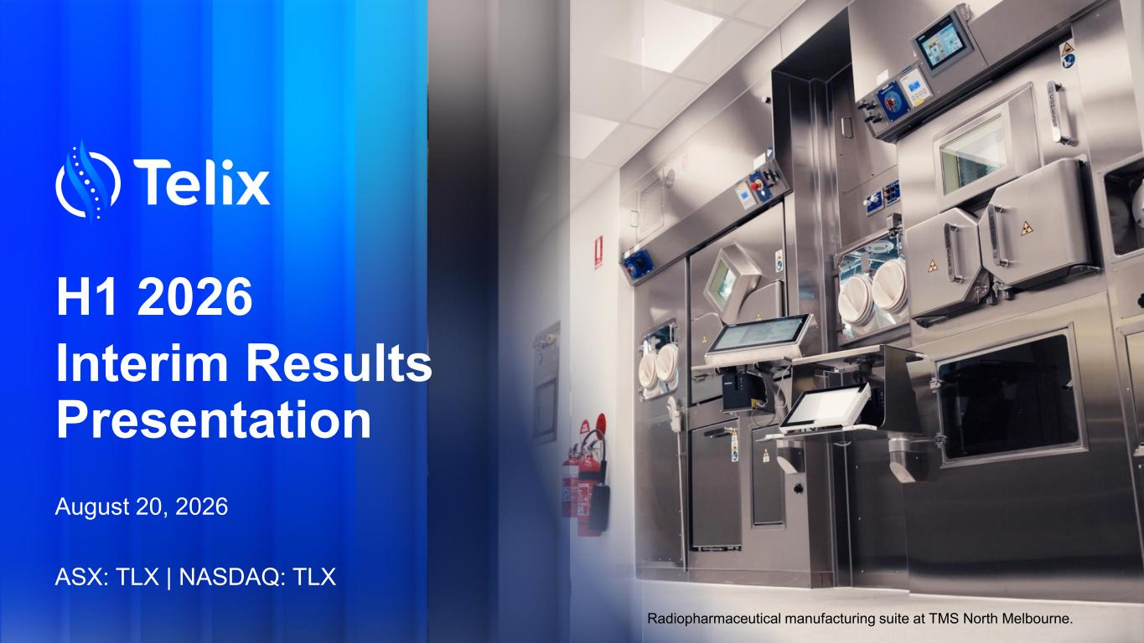
H1 2026 Interim Results Presentation August 20, 2026 ASX: TLX | NASDAQ: TLX Radiopharmaceutical manufacturing suite at TMS North Melbourne.

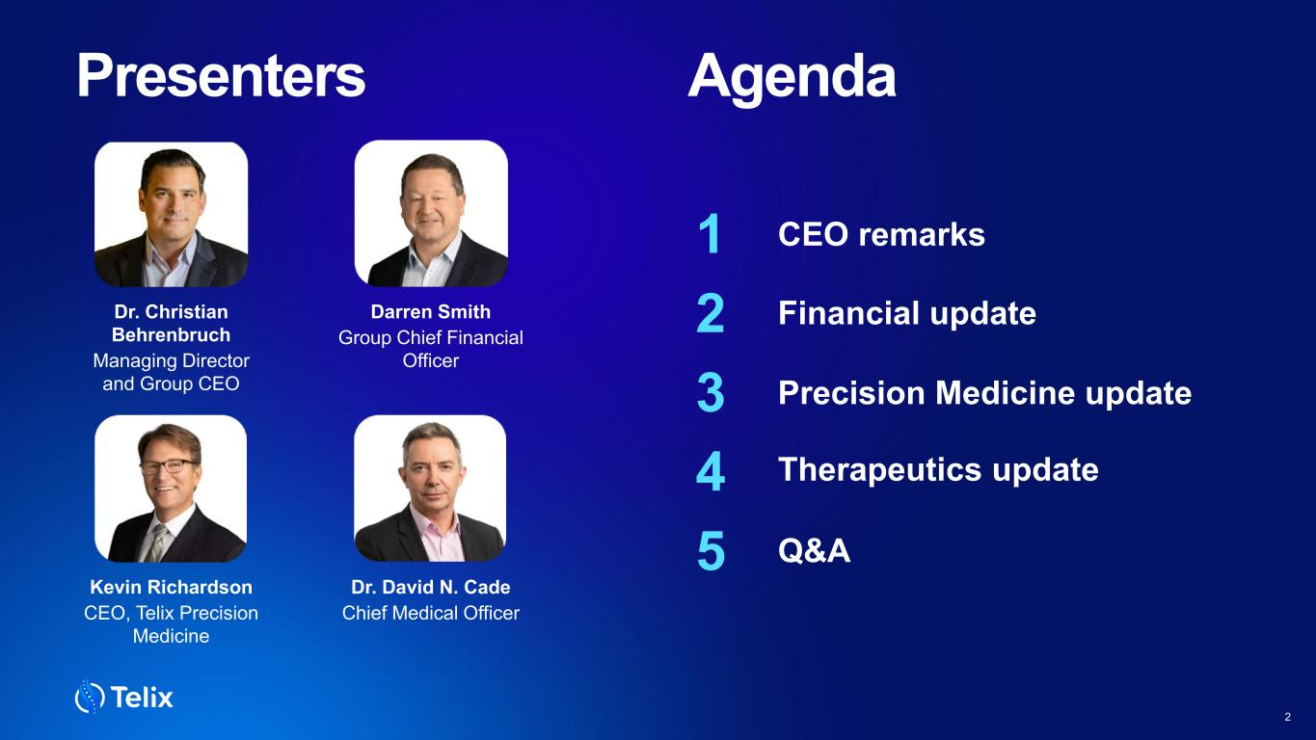
Presenters Agenda CEO remarks1 Therapeutics update 2 Financial update 3 Precision Medicine update 4 Q&A 2 5 Dr. Christian Behrenbruch Managing Director and Group CEO Darren Smith Group Chief Financial Officer Kevin Richardson CEO, Telix Precision Medicine Dr. David N. Cade Chief Medical Officer

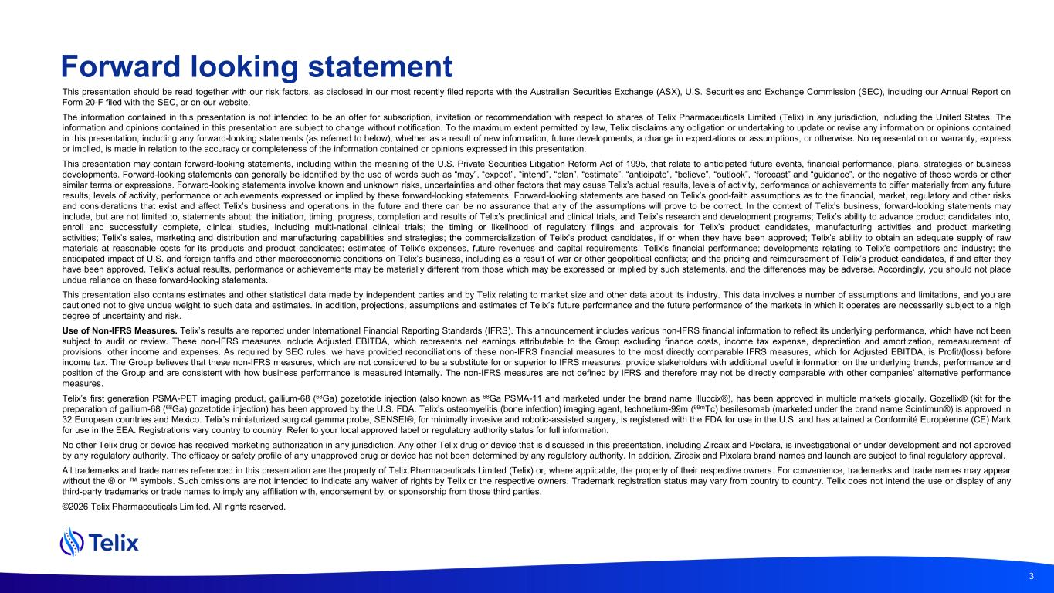
This presentation should be read together with our risk factors, as disclosed in our most recently filed reports with the Australian Securities Exchange (ASX), U.S. Securities and Exchange Commission (SEC), including our Annual Report on Form 20-F filed with the SEC, or on our website. The information contained in this presentation is not intended to be an offer for subscription, invitation or recommendation with respect to shares of Telix Pharmaceuticals Limited (Telix) in any jurisdiction, including the United States. The information and opinions contained in this presentation are subject to change without notification. To the maximum extent permitted by law, Telix disclaims any obligation or undertaking to update or revise any information or opinions contained in this presentation, including any forward-looking statements (as referred to below), whether as a result of new information, future developments, a change in expectations or assumptions, or otherwise. No representation or warranty, express or implied, is made in relation to the accuracy or completeness of the information contained or opinions expressed in this presentation. This presentation may contain forward-looking statements, including within the meaning of the U.S. Private Securities Litigation Reform Act of 1995, that relate to anticipated future events, financial performance, plans, strategies or business developments. Forward-looking statements can generally be identified by the use of words such as “may”, “expect”, “intend”, “plan”, “estimate”, “anticipate”, “believe”, “outlook”, “forecast” and “guidance”, or the negative of these words or other similar terms or expressions. Forward-looking statements involve known and unknown risks, uncertainties and other factors that may cause Telix’s actual results, levels of activity, performance or achievements to differ materially from any future results, levels of activity, performance or achievements expressed or implied by these forward-looking statements. Forward-looking statements are based on Telix’s good-faith assumptions as to the financial, market, regulatory and other risks and considerations that exist and affect Telix’s business and operations in the future and there can be no assurance that any of the assumptions will prove to be correct. In the context of Telix’s business, forward-looking statements may include, but are not limited to, statements about: the initiation, timing, progress, completion and results of Telix’s preclinical and clinical trials, and Telix’s research and development programs; Telix’s ability to advance product candidates into, enroll and successfully complete, clinical studies, including multi-national clinical trials; the timing or likelihood of regulatory filings and approvals for Telix’s product candidates, manufacturing activities and product marketing activities; Telix’s sales, marketing and distribution and manufacturing capabilities and strategies; the commercialization of Telix’s product candidates, if or when they have been approved; Telix’s ability to obtain an adequate supply of raw materials at reasonable costs for its products and product candidates; estimates of Telix’s expenses, future revenues and capital requirements; Telix’s financial performance; developments relating to Telix’s competitors and industry; the anticipated impact of U.S. and foreign tariffs and other macroeconomic conditions on Telix’s business, including as a result of war or other geopolitical conflicts; and the pricing and reimbursement of Telix’s product candidates, if and after they have been approved. Telix’s actual results, performance or achievements may be materially different from those which may be expressed or implied by such statements, and the differences may be adverse. Accordingly, you should not place undue reliance on these forward-looking statements. This presentation also contains estimates and other statistical data made by independent parties and by Telix relating to market size and other data about its industry. This data involves a number of assumptions and limitations, and you are cautioned not to give undue weight to such data and estimates. In addition, projections, assumptions and estimates of Telix’s future performance and the future performance of the markets in which it operates are necessarily subject to a high degree of uncertainty and risk. Use of Non-IFRS Measures. Telix’s results are reported under International Financial Reporting Standards (IFRS). This announcement includes various non-IFRS financial information to reflect its underlying performance, which have not been subject to audit or review. These non-IFRS measures include Adjusted EBITDA, which represents net earnings attributable to the Group excluding finance costs, income tax expense, depreciation and amortization, remeasurement of provisions, other income and expenses. As required by SEC rules, we have provided reconciliations of these non-IFRS financial measures to the most directly comparable IFRS measures, which for Adjusted EBITDA, is Profit/(loss) before income tax. The Group believes that these non-IFRS measures, which are not considered to be a substitute for or superior to IFRS measures, provide stakeholders with additional useful information on the underlying trends, performance and position of the Group and are consistent with how business performance is measured internally. The non-IFRS measures are not defined by IFRS and therefore may not be directly comparable with other companies’ alternative performance measures. Telix’s first generation PSMA-PET imaging product, gallium-68 (68Ga) gozetotide injection (also known as 68Ga PSMA-11 and marketed under the brand name Illuccix®), has been approved in multiple markets globally. Gozellix® (kit for the preparation of gallium-68 (68Ga) gozetotide injection) has been approved by the U.S. FDA. Telix’s osteomyelitis (bone infection) imaging agent, technetium-99m (99mTc) besilesomab (marketed under the brand name Scintimun®) is approved in 32 European countries and Mexico. Telix’s miniaturized surgical gamma probe, SENSEI®, for minimally invasive and robotic-assisted surgery, is registered with the FDA for use in the U.S. and has attained a Conformité Européenne (CE) Mark for use in the EEA. Registrations vary country to country. Refer to your local approved label or regulatory authority status for full information. No other Telix drug or device has received marketing authorization in any jurisdiction. Any other Telix drug or device that is discussed in this presentation, including Zircaix and Pixclara, is investigational or under development and not approved by any regulatory authority. The efficacy or safety profile of any unapproved drug or device has not been determined by any regulatory authority. In addition, Zircaix and Pixclara brand names and launch are subject to final regulatory approval. All trademarks and trade names referenced in this presentation are the property of Telix Pharmaceuticals Limited (Telix) or, where applicable, the property of their respective owners. For convenience, trademarks and trade names may appear without the ® or symbols. Such omissions are not intended to indicate any waiver of rights by Telix or the respective owners. Trademark registration status may vary from country to country. Telix does not intend the use or display of any third-party trademarks or trade names to imply any affiliation with, endorsement by, or sponsorship from those third parties. ©2026 Telix Pharmaceuticals Limited. All rights reserved. 3 Forward looking statement

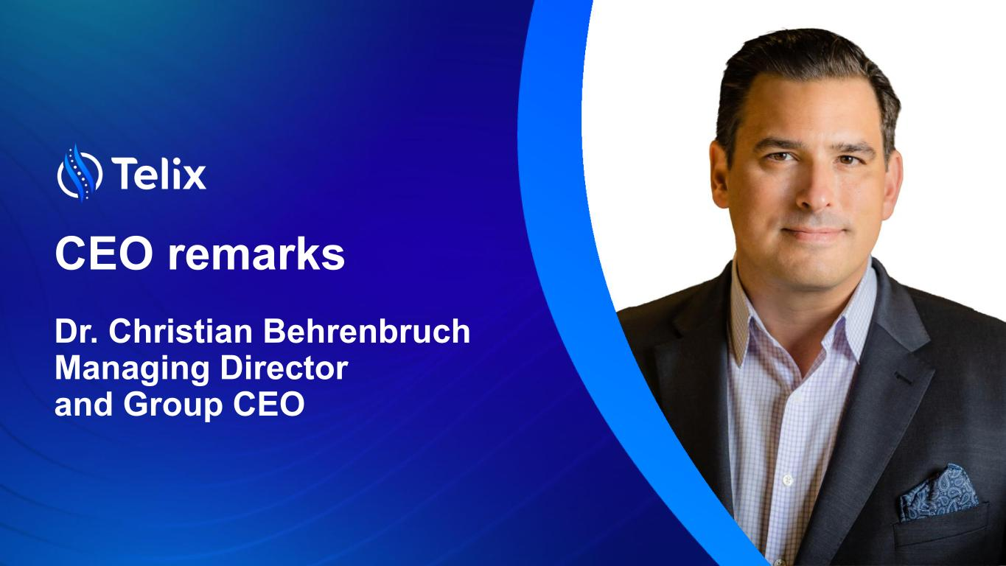
CEO remarks Dr. Christian Behrenbruch Managing Director and Group CEO

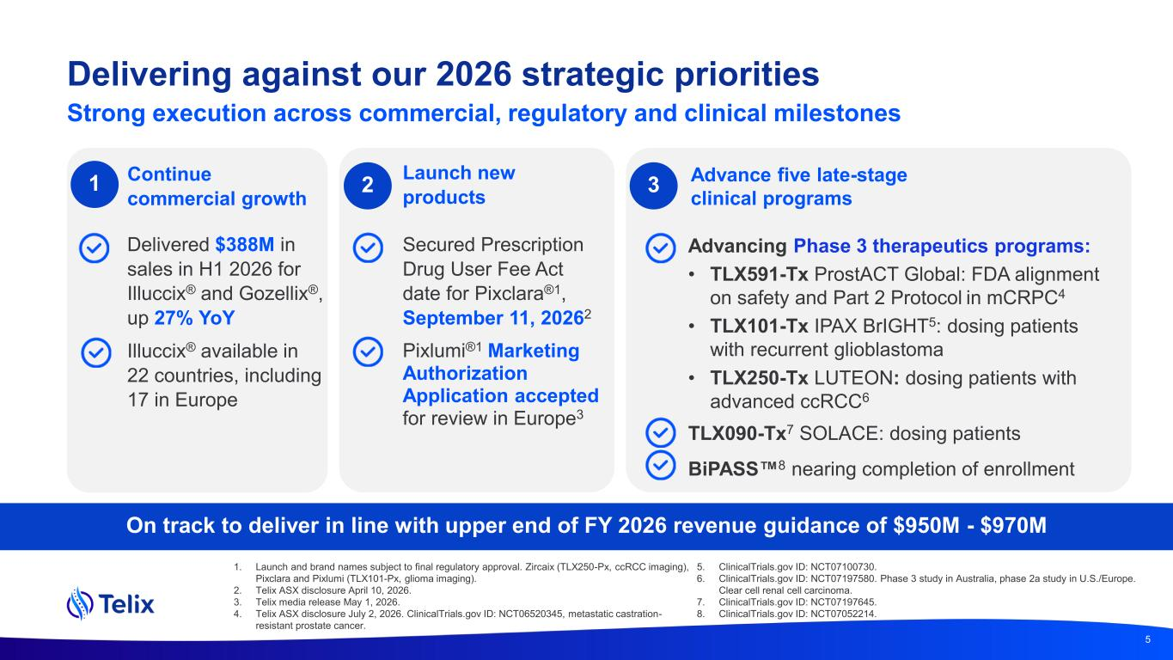
Delivering against our 2026 strategic priorities 5 Continue commercial growth Secured Prescription Drug User Fee Act date for Pixclara®1, September 11, 20262 Pixlumi®1 Marketing Authorization Application accepted for review in Europe3 Advancing Phase 3 therapeutics programs: • TLX591-Tx ProstACT Global: FDA alignment on safety and Part 2 Protocol in mCRPC4 • TLX101-Tx IPAX BrIGHT5: dosing patients with recurrent glioblastoma • TLX250-Tx LUTEON: dosing patients with advanced ccRCC6 TLX090-Tx7 SOLACE: dosing patients BiPASS 8 nearing completion of enrollment 2 3 On track to deliver in line with upper end of FY 2026 revenue guidance of $950M - $970M 1 Delivered $388M in sales in H1 2026 for Illuccix® and Gozellix®, up 27% YoY Illuccix® available in 22 countries, including 17 in Europe Launch new products Advance five late-stage clinical programs Strong execution across commercial, regulatory and clinical milestones 1. Launch and brand names subject to final regulatory approval. Zircaix (TLX250-Px, ccRCC imaging), Pixclara and Pixlumi (TLX101-Px, glioma imaging). 2. Telix ASX disclosure April 10, 2026. 3. Telix media release May 1, 2026. 4. Telix ASX disclosure July 2, 2026. ClinicalTrials.gov ID: NCT06520345, metastatic castration- resistant prostate cancer. 5. ClinicalTrials.gov ID: NCT07100730. 6. ClinicalTrials.gov ID: NCT07197580. Phase 3 study in Australia, phase 2a study in U.S./Europe. Clear cell renal cell carcinoma. 7. ClinicalTrials.gov ID: NCT07197645. 8. ClinicalTrials.gov ID: NCT07052214.

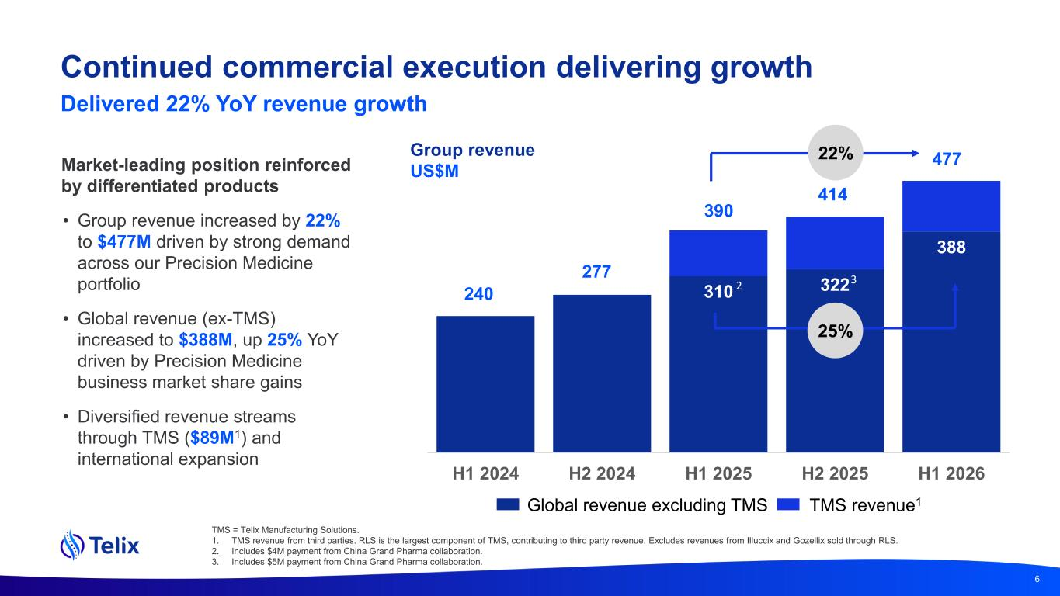
Continued commercial execution delivering growth Delivered 22% YoY revenue growth Group revenue US$M 56% 6 Market-leading position reinforced by differentiated products • Group revenue increased by 22% to $477M driven by strong demand across our Precision Medicine portfolio • Global revenue (ex-TMS) increased to $388M, up 25% YoY driven by Precision Medicine business market share gains • Diversified revenue streams through TMS ($89M1) and international expansion TMS = Telix Manufacturing Solutions. 1. TMS revenue from third parties. RLS is the largest component of TMS, contributing to third party revenue. Excludes revenues from Illuccix and Gozellix sold through RLS. 2. Includes $4M payment from China Grand Pharma collaboration. 3. Includes $5M payment from China Grand Pharma collaboration. 310 322 388 H1 2024 H2 2024 H1 2025 H2 2025 H1 2026 240 277 390 414 477 Global revenue excluding TMS TMS revenue1 22% 25% 2 3

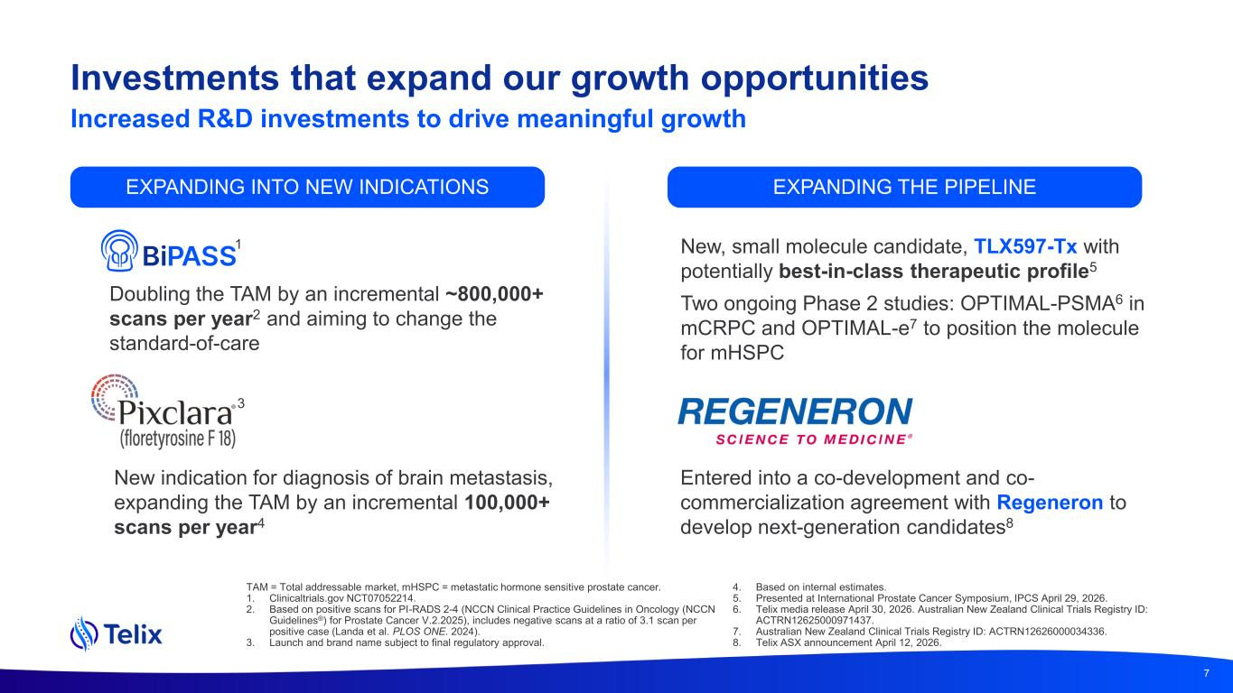
Investments that expand our growth opportunities Doubling the TAM by an incremental ~800,000+ scans per year2 and aiming to change the standard-of-care New indication for diagnosis of brain metastasis, expanding the TAM by an incremental 100,000+ scans per year4 New, small molecule candidate, TLX597-Tx with potentially best-in-class therapeutic profile5 Two ongoing Phase 2 studies: OPTIMAL-PSMA6 in mCRPC and OPTIMAL-e7 to position the molecule for mHSPC Entered into a co-development and co- commercialization agreement with Regeneron to develop next-generation candidates8 TAM = Total addressable market, mHSPC = metastatic hormone sensitive prostate cancer. 1. Clinicaltrials.gov NCT07052214. 2. Based on positive scans for PI-RADS 2-4 (NCCN Clinical Practice Guidelines in Oncology (NCCN Guidelines®) for Prostate Cancer V.2.2025), includes negative scans at a ratio of 3.1 scan per positive case (Landa et al. PLOS ONE. 2024). 3. Launch and brand name subject to final regulatory approval. 4. Based on internal estimates. 5. Presented at International Prostate Cancer Symposium, IPCS April 29, 2026. 6. Telix media release April 30, 2026. Australian New Zealand Clinical Trials Registry ID: ACTRN12625000971437. 7. Australian New Zealand Clinical Trials Registry ID: ACTRN12626000034336. 8. Telix ASX announcement April 12, 2026. Increased R&D investments to drive meaningful growth EXPANDING INTO NEW INDICATIONS EXPANDING THE PIPELINE 7 3 1

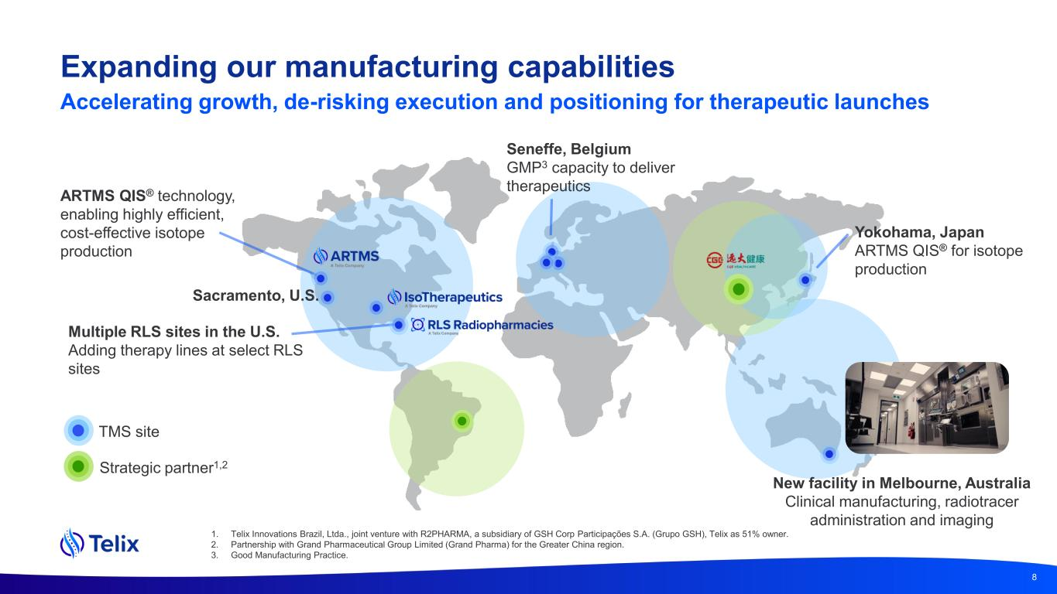
Expanding our manufacturing capabilities 8 1. Telix Innovations Brazil, Ltda., joint venture with R2PHARMA, a subsidiary of GSH Corp Participações S.A. (Grupo GSH), Telix as 51% owner. 2. Partnership with Grand Pharmaceutical Group Limited (Grand Pharma) for the Greater China region. 3. Good Manufacturing Practice. Multiple RLS sites in the U.S. Adding therapy lines at select RLS sites Strategic partner1,2 TMS site Yokohama, Japan ARTMS QIS® for isotope production ARTMS QIS® technology, enabling highly efficient, cost-effective isotope production Sacramento, U.S. New facility in Melbourne, Australia Clinical manufacturing, radiotracer administration and imaging Seneffe, Belgium GMP3 capacity to deliver therapeutics Accelerating growth, de-risking execution and positioning for therapeutic launches

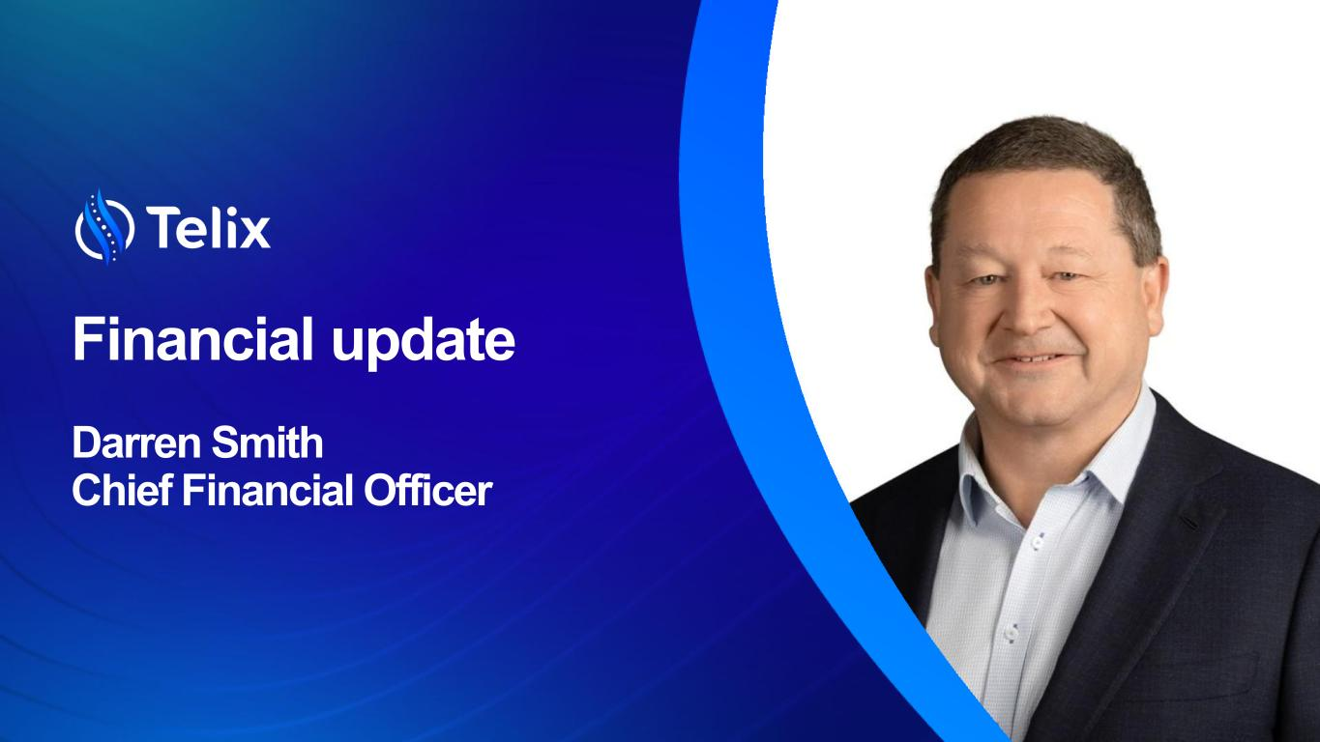
Financial update Darren Smith Chief Financial Officer

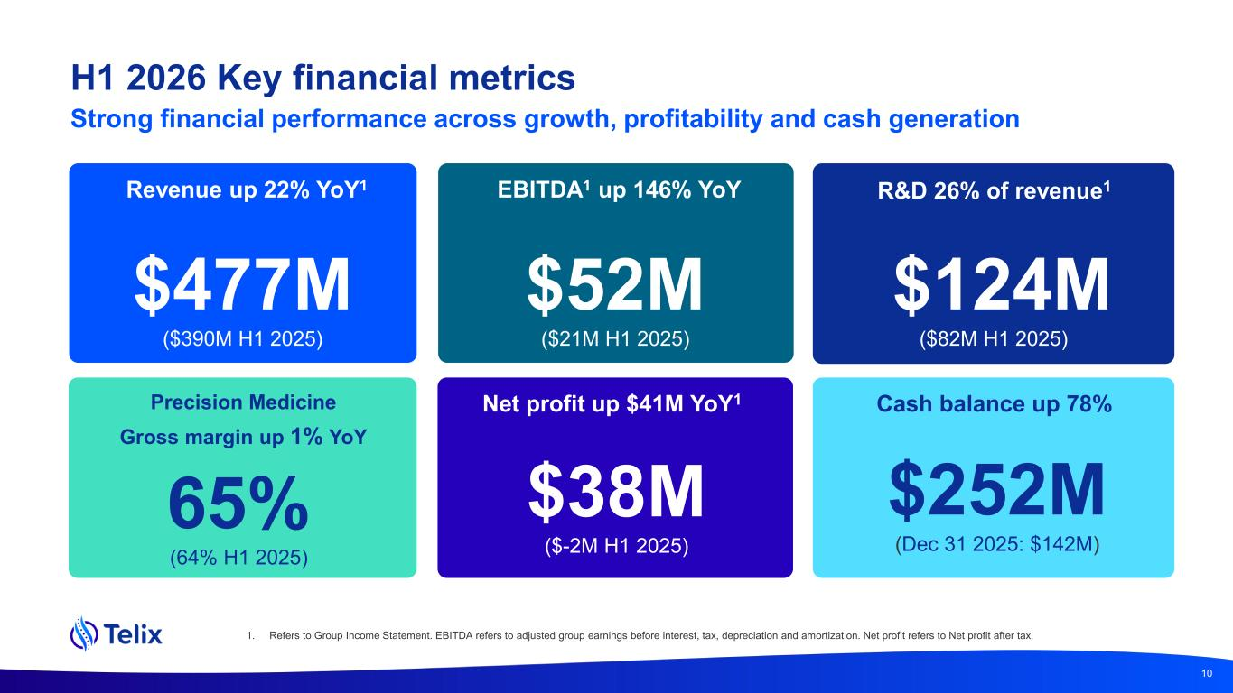
H1 2026 Key financial metrics Strong financial performance across growth, profitability and cash generation Revenue up 22% YoY1 $477M ($390M H1 2025) R&D 26% of revenue1 Net profit up $41M YoY1 $38M ($-2M H1 2025) Cash balance up 78% $252M (Dec 31 2025: $142M) $124M ($82M H1 2025) EBITDA1 up 146% YoY $52M ($21M H1 2025) Precision Medicine Gross margin up 1% YoY 65% (64% H1 2025) 10 1. Refers to Group Income Statement. EBITDA refers to adjusted group earnings before interest, tax, depreciation and amortization. Net profit refers to Net profit after tax.

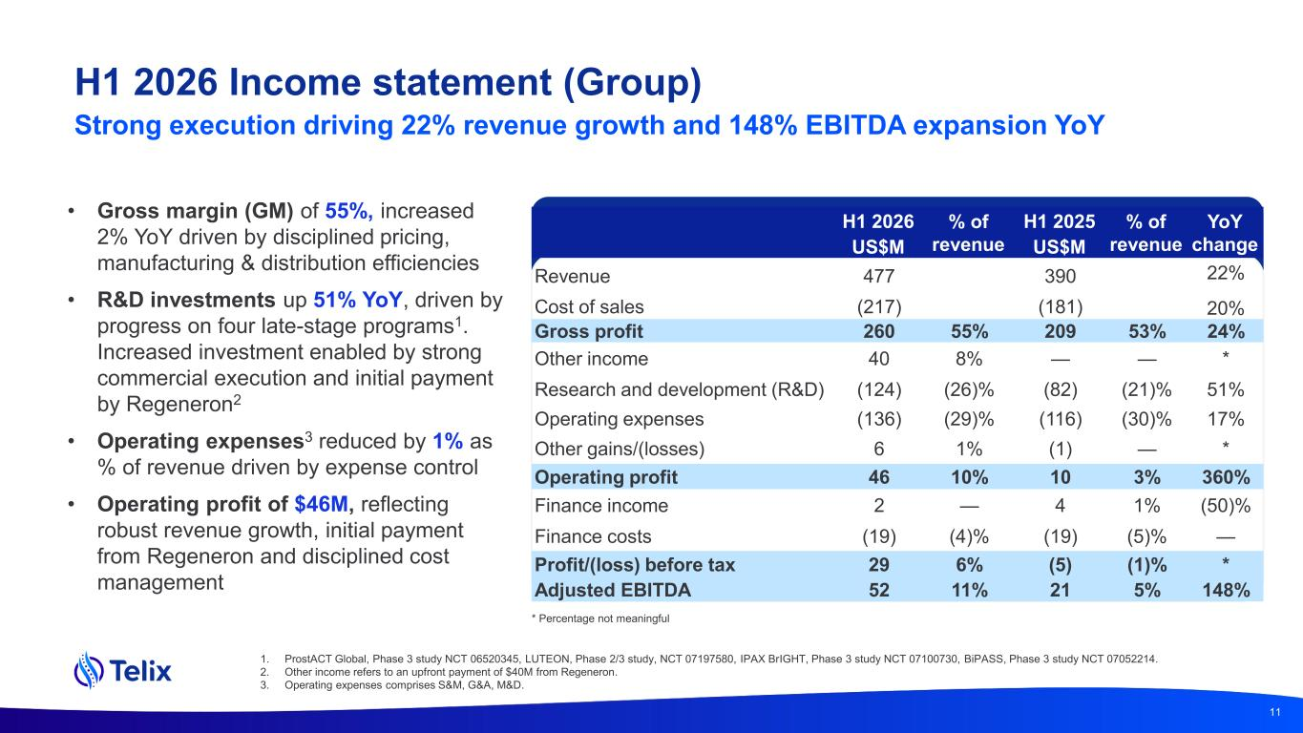
• Gross margin (GM) of 55%, increased 2% YoY driven by disciplined pricing, manufacturing & distribution efficiencies • R&D investments up 51% YoY, driven by progress on four late-stage programs1. Increased investment enabled by strong commercial execution and initial payment by Regeneron2 • Operating expenses3 reduced by 1% as % of revenue driven by expense control • Operating profit of $46M, reflecting robust revenue growth, initial payment from Regeneron and disciplined cost management H1 2026 Income statement (Group) Strong execution driving 22% revenue growth and 148% EBITDA expansion YoY 1. ProstACT Global, Phase 3 study NCT 06520345, LUTEON, Phase 2/3 study, NCT 07197580, IPAX BrIGHT, Phase 3 study NCT 07100730, BiPASS, Phase 3 study NCT 07052214. 2. Other income refers to an upfront payment of $40M from Regeneron. 3. Operating expenses comprises S&M, G&A, M&D. 11 H1 2026 % of revenue H1 2025 % of revenue YoY changeUS$M US$M Revenue 477 390 22% Cost of sales (217) (181) 20% Gross profit 260 55% 209 53% 24% Other income 40 8% — — * Research and development (R&D) (124) (26)% (82) (21)% 51% Operating expenses (136) (29)% (116) (30)% 17% Other gains/(losses) 6 1% (1) — * Operating profit 46 10% 10 3% 360% Finance income 2 — 4 1% (50)% Finance costs (19) (4)% (19) (5)% — Profit/(loss) before tax 29 6% (5) (1)% * Adjusted EBITDA 52 11% 21 5% 148% * Percentage not meaningful

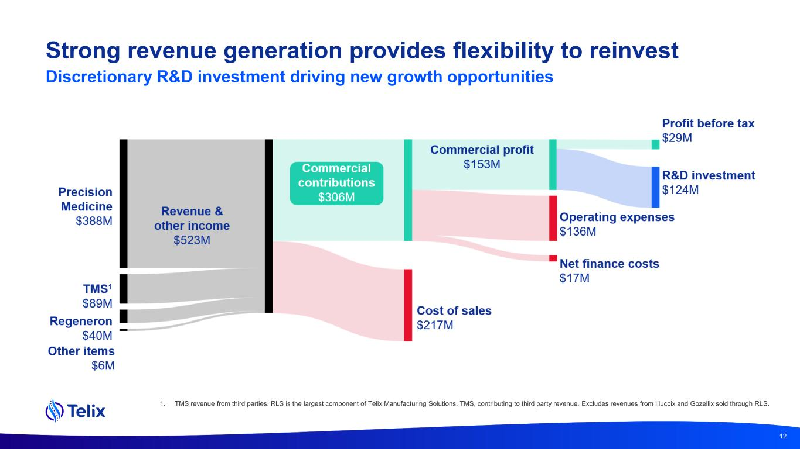
Strong revenue generation provides flexibility to reinvest Discretionary R&D investment driving new growth opportunities 1. TMS revenue from third parties. RLS is the largest component of Telix Manufacturing Solutions, TMS, contributing to third party revenue. Excludes revenues from Illuccix and Gozellix sold through RLS. 12

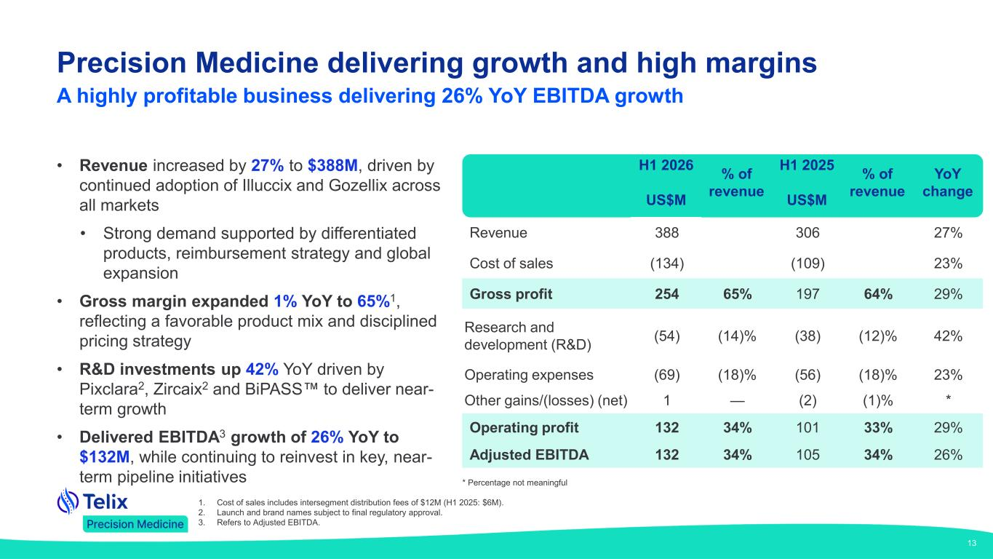
Precision Medicine delivering growth and high margins A highly profitable business delivering 26% YoY EBITDA growth 1. Cost of sales includes intersegment distribution fees of $12M (H1 2025: $6M). 2. Launch and brand names subject to final regulatory approval. 3. Refers to Adjusted EBITDA. 13 • Revenue increased by 27% to $388M, driven by continued adoption of Illuccix and Gozellix across all markets • Strong demand supported by differentiated products, reimbursement strategy and global expansion • Gross margin expanded 1% YoY to 65%1, reflecting a favorable product mix and disciplined pricing strategy • R&D investments up 42% YoY driven by Pixclara2, Zircaix2 and BiPASS to deliver near- term growth • Delivered EBITDA3 growth of 26% YoY to $132M, while continuing to reinvest in key, near- term pipeline initiatives H1 2026 % of revenue H1 2025 % of revenue YoY change US$M US$M Revenue 388 306 27% Cost of sales (134) (109) 23% Gross profit 254 65% 197 64% 29% Research and development (R&D) (54) (14)% (38) (12)% 42% Operating expenses (69) (18)% (56) (18)% 23% Other gains/(losses) (net) 1 — (2) (1)% * Operating profit 132 34% 101 33% 29% Adjusted EBITDA 132 34% 105 34% 26% * Percentage not meaningful

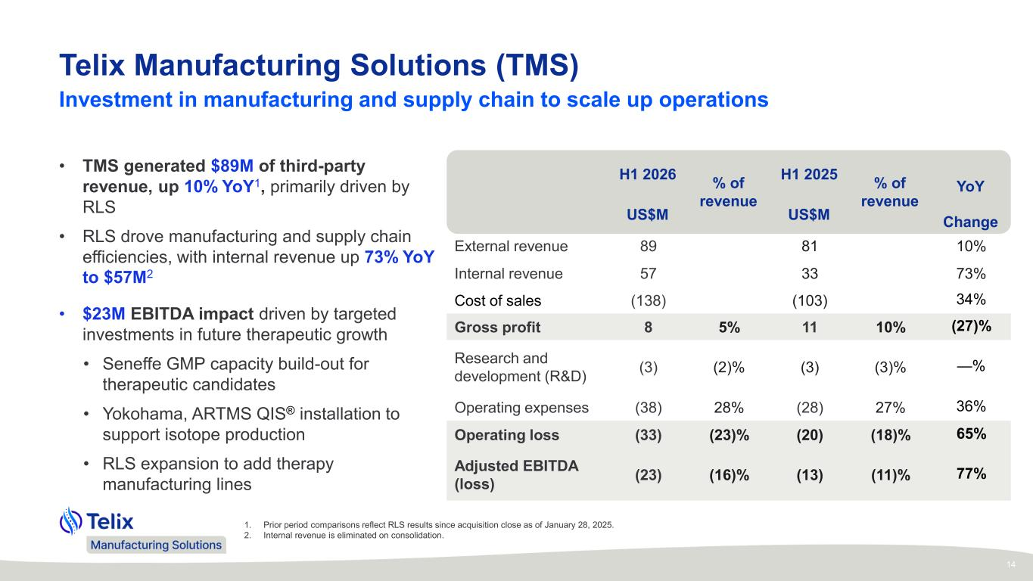
Telix Manufacturing Solutions (TMS) 1. Prior period comparisons reflect RLS results since acquisition close as of January 28, 2025. 2. Internal revenue is eliminated on consolidation. Investment in manufacturing and supply chain to scale up operations 14 • TMS generated $89M of third-party revenue, up 10% YoY1, primarily driven by RLS • RLS drove manufacturing and supply chain efficiencies, with internal revenue up 73% YoY to $57M2 • $23M EBITDA impact driven by targeted investments in future therapeutic growth • Seneffe GMP capacity build-out for therapeutic candidates • Yokohama, ARTMS QIS® installation to support isotope production • RLS expansion to add therapy manufacturing lines H1 2026 % of revenue H1 2025 % of revenue YoY US$M US$M Change External revenue 89 81 10% Internal revenue 57 33 73% Cost of sales (138) (103) 34% Gross profit 8 5% 11 10% (27)% Research and development (R&D) (3) (2)% (3) (3)% —% Operating expenses (38) 28% (28) 27% 36% Operating loss (33) (23)% (20) (18)% 65% Adjusted EBITDA (loss) (23) (16)% (13) (11)% 77%

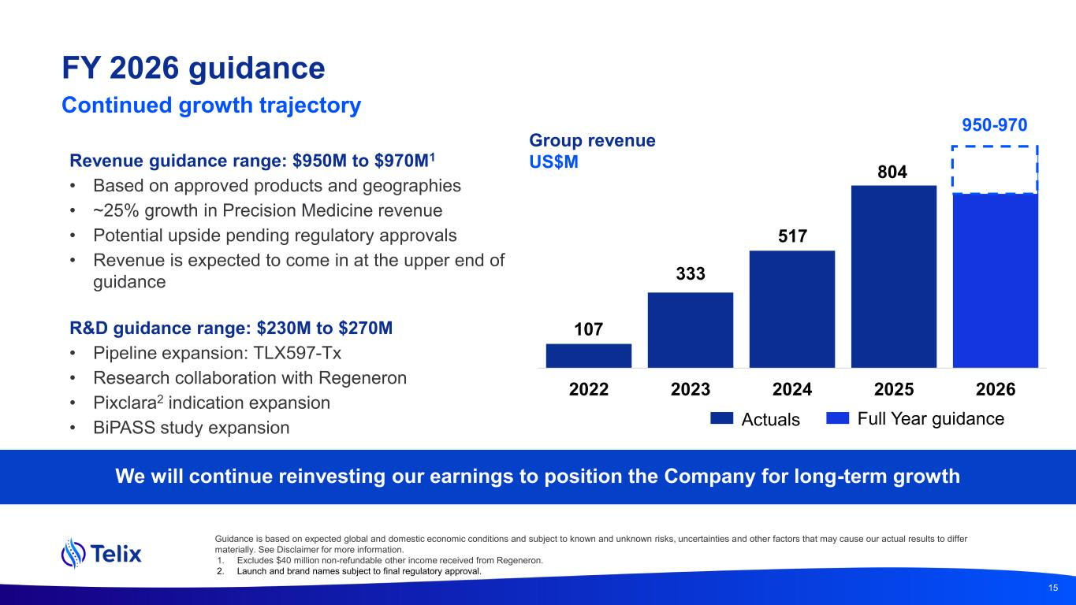
Group revenue US$MRevenue guidance range: $950M to $970M1 • Based on approved products and geographies • ~25% growth in Precision Medicine revenue • Potential upside pending regulatory approvals • Revenue is expected to come in at the upper end of guidance R&D guidance range: $230M to $270M • Pipeline expansion: TLX597-Tx • Research collaboration with Regeneron • Pixclara2 indication expansion • BiPASS study expansion We will continue reinvesting our earnings to position the Company for long-term growth 15 2022 2023 2024 2025 2026 107 333 517 804 950-970 Actuals Full Year guidance Guidance is based on expected global and domestic economic conditions and subject to known and unknown risks, uncertainties and other factors that may cause our actual results to differ materially. See Disclaimer for more information. 1. Excludes $40 million non-refundable other income received from Regeneron. 2. Launch and brand names subject to final regulatory approval. FY 2026 guidance Continued growth trajectory

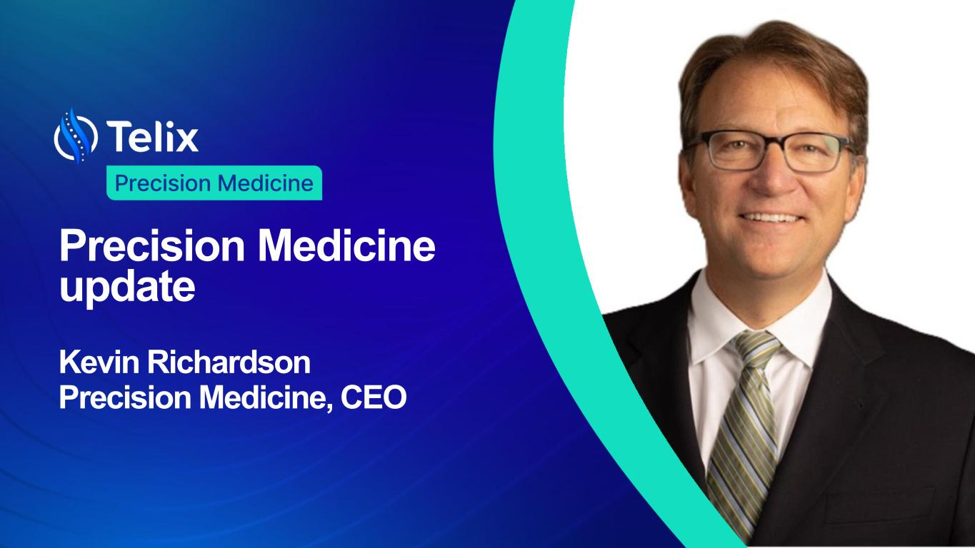
Precision Medicine update Kevin Richardson Precision Medicine, CEO

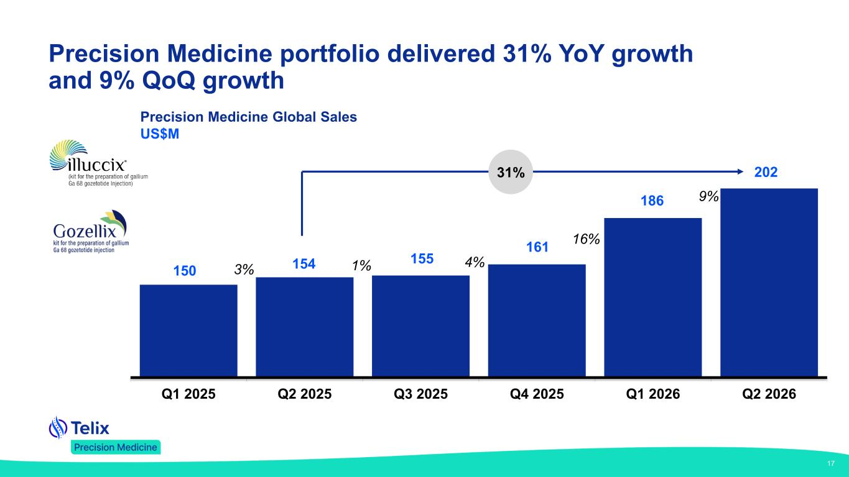
17 Q1 2025 Q2 2025 Q3 2025 Q4 2025 Q1 2026 Q2 2026 150 154 155 186 1% 161 202 3% 4% 16% 9% 31% Precision Medicine Global Sales US$M Precision Medicine portfolio delivered 31% YoY growth and 9% QoQ growth

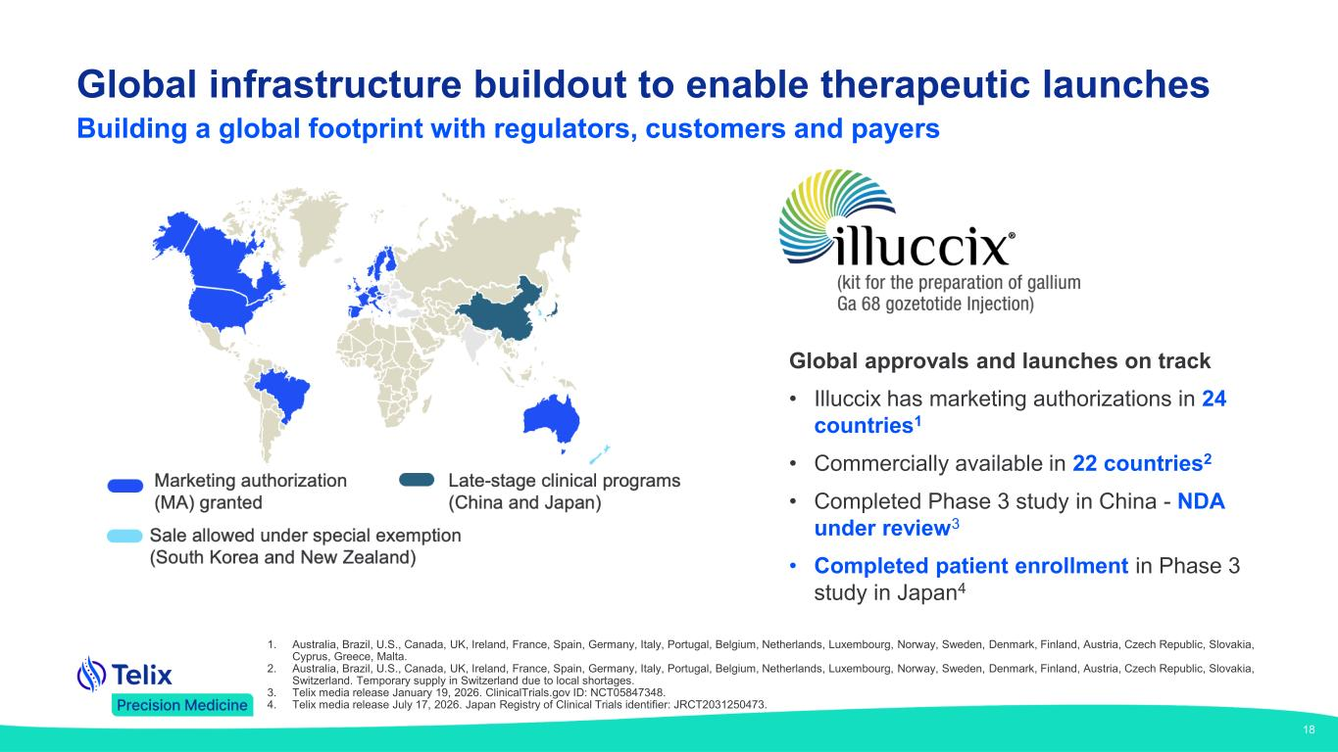
Global infrastructure buildout to enable therapeutic launches 18 1. Australia, Brazil, U.S., Canada, UK, Ireland, France, Spain, Germany, Italy, Portugal, Belgium, Netherlands, Luxembourg, Norway, Sweden, Denmark, Finland, Austria, Czech Republic, Slovakia, Cyprus, Greece, Malta. 2. Australia, Brazil, U.S., Canada, UK, Ireland, France, Spain, Germany, Italy, Portugal, Belgium, Netherlands, Luxembourg, Norway, Sweden, Denmark, Finland, Austria, Czech Republic, Slovakia, Switzerland. Temporary supply in Switzerland due to local shortages. 3. Telix media release January 19, 2026. ClinicalTrials.gov ID: NCT05847348. 4. Telix media release July 17, 2026. Japan Registry of Clinical Trials identifier: JRCT2031250473. Global approvals and launches on track • Illuccix has marketing authorizations in 24 countries1 • Commercially available in 22 countries2 • Completed Phase 3 study in China - NDA under review3 • Completed patient enrollment in Phase 3 study in Japan4 Building a global footprint with regulators, customers and payers

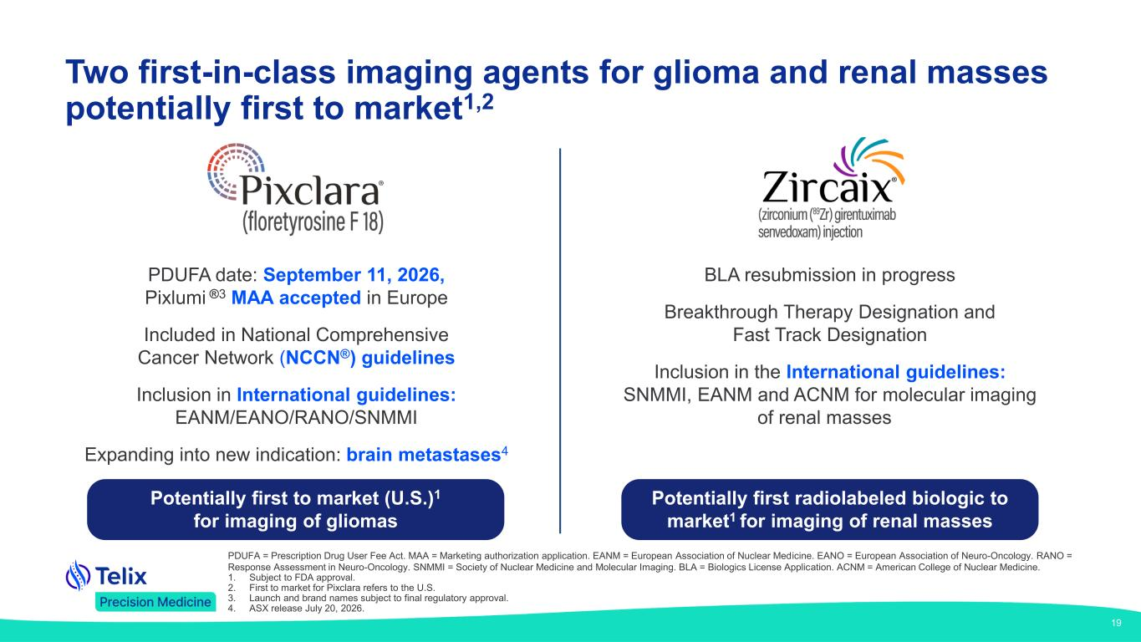
Two first-in-class imaging agents for glioma and renal masses potentially first to market1,2 PDUFA date: September 11, 2026, Pixlumi ®3 MAA accepted in Europe Included in National Comprehensive Cancer Network (NCCN®) guidelines Inclusion in International guidelines: EANM/EANO/RANO/SNMMI Expanding into new indication: brain metastases4 Potentially first to market (U.S.)1 for imaging of gliomas BLA resubmission in progress Breakthrough Therapy Designation and Fast Track Designation Inclusion in the International guidelines: SNMMI, EANM and ACNM for molecular imaging of renal masses Potentially first radiolabeled biologic to market1 for imaging of renal masses PDUFA = Prescription Drug User Fee Act. MAA = Marketing authorization application. EANM = European Association of Nuclear Medicine. EANO = European Association of Neuro-Oncology. RANO = Response Assessment in Neuro-Oncology. SNMMI = Society of Nuclear Medicine and Molecular Imaging. BLA = Biologics License Application. ACNM = American College of Nuclear Medicine. 1. Subject to FDA approval. 2. First to market for Pixclara refers to the U.S. 3. Launch and brand names subject to final regulatory approval. 4. ASX release July 20, 2026. 19

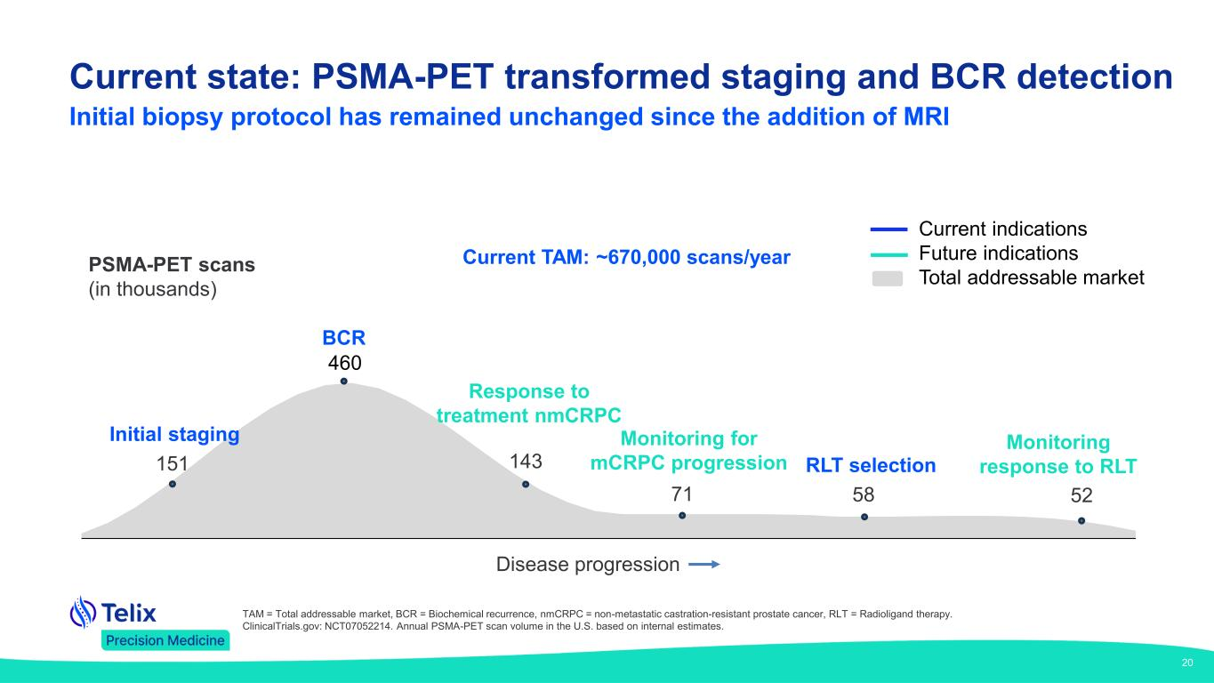
PSMA-PET scans (in thousands) Initial staging 151 BCR 460 143 RLT selection 58 Monitoring for mCRPC progression Monitoring response to RLT 71 52 Response to treatment nmCRPC Disease progression Current indications Future indications Total addressable market Current TAM: ~670,000 scans/year 20 TAM = Total addressable market, BCR = Biochemical recurrence, nmCRPC = non-metastatic castration-resistant prostate cancer, RLT = Radioligand therapy. ClinicalTrials.gov: NCT07052214. Annual PSMA-PET scan volume in the U.S. based on internal estimates. Current state: PSMA-PET transformed staging and BCR detection Initial biopsy protocol has remained unchanged since the addition of MRI

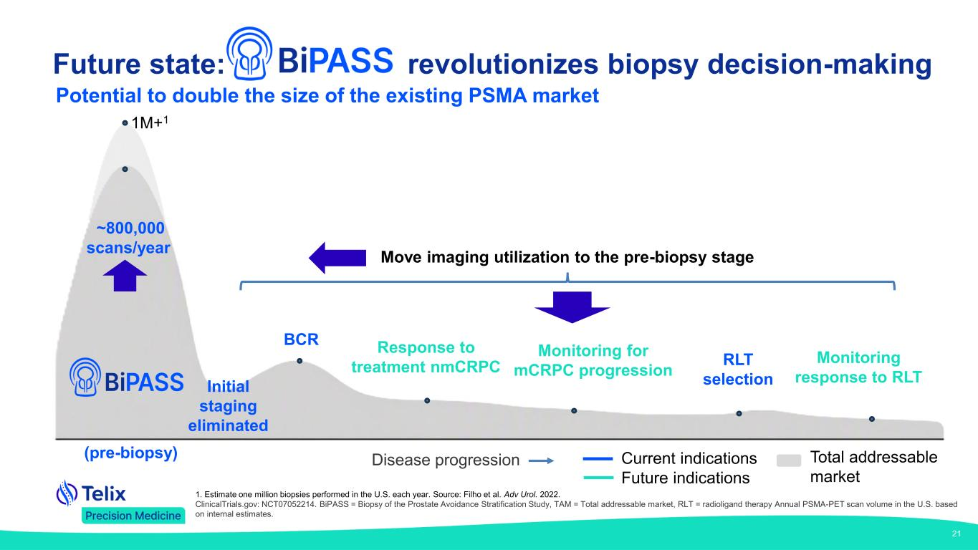
BCR RLT selection Monitoring for mCRPC progression Monitoring response to RLT Response to treatment nmCRPC (pre-biopsy) Move imaging utilization to the pre-biopsy stage Disease progression Current indications Future indications Total addressable market Initial staging eliminated 1M+1 ~800,000 scans/year 21 1. Estimate one million biopsies performed in the U.S. each year. Source: Filho et al. Adv Urol. 2022. ClinicalTrials.gov: NCT07052214. BiPASS = Biopsy of the Prostate Avoidance Stratification Study, TAM = Total addressable market, RLT = radioligand therapy Annual PSMA-PET scan volume in the U.S. based on internal estimates. Future state: revolutionizes biopsy decision-making Potential to double the size of the existing PSMA market

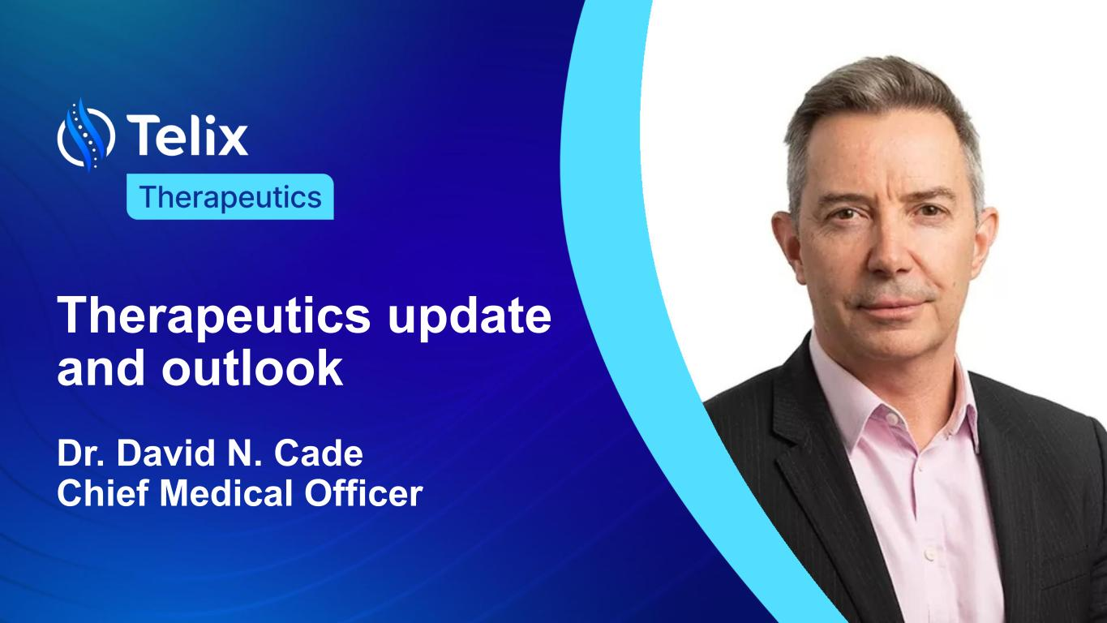
Therapeutics update and outlook Dr. David N. Cade Chief Medical Officer

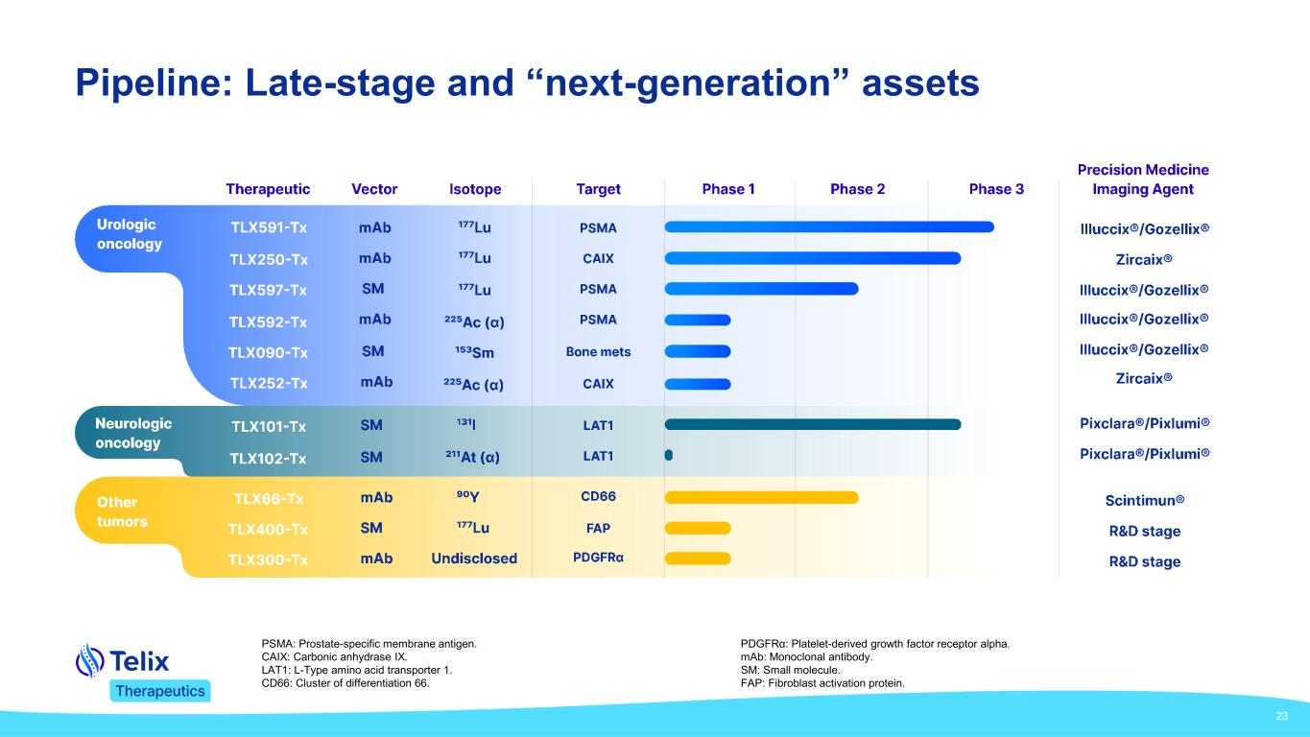
23 Pipeline: Late-stage and “next-generation” assets PSMA: Prostate-specific membrane antigen. CAIX: Carbonic anhydrase IX. LAT1: L-Type amino acid transporter 1. CD66: Cluster of differentiation 66. PDGFRα: Platelet-derived growth factor receptor alpha. mAb: Monoclonal antibody. SM: Small molecule. FAP: Fibroblast activation protein.

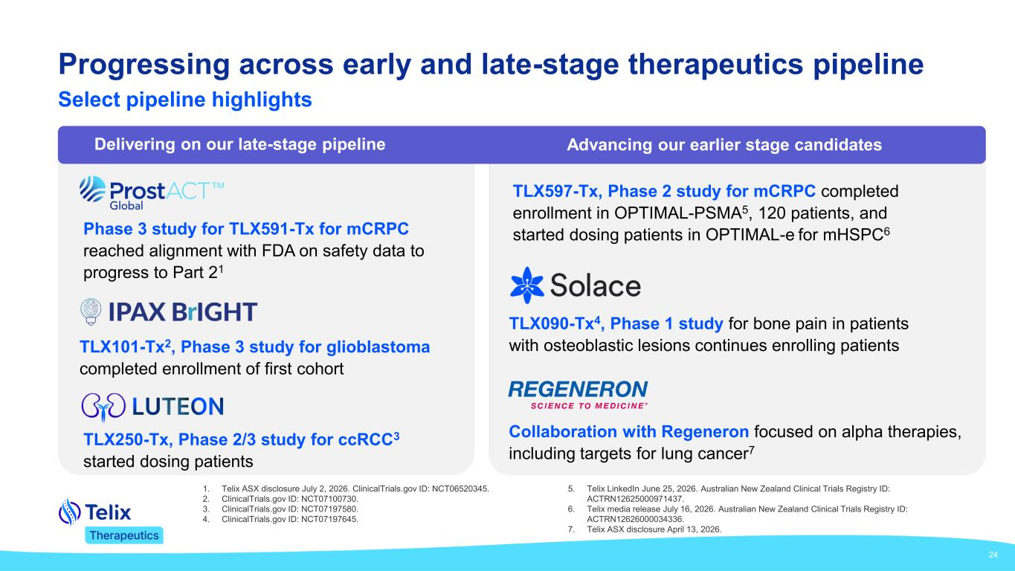
24 Progressing across early and late-stage therapeutics pipeline Select pipeline highlights Phase 3 study for TLX591-Tx for mCRPC reached alignment with FDA on safety data to progress to Part 21 TLX597-Tx, Phase 2 study for mCRPC completed enrollment in OPTIMAL-PSMA5, 120 patients, and started dosing patients in OPTIMAL-e for mHSPC6 TLX101-Tx2, Phase 3 study for glioblastoma completed enrollment of first cohort TLX250-Tx, Phase 2/3 study for ccRCC3 started dosing patients TLX090-Tx4, Phase 1 study for bone pain in patients with osteoblastic lesions continues enrolling patients Collaboration with Regeneron focused on alpha therapies, including targets for lung cancer7 Delivering on our late-stage pipeline Advancing our earlier stage candidates 1. Telix ASX disclosure July 2, 2026. ClinicalTrials.gov ID: NCT06520345. 2. ClinicalTrials.gov ID: NCT07100730. 3. ClinicalTrials.gov ID: NCT07197580. 4. ClinicalTrials.gov ID: NCT07197645. 5. Telix LinkedIn June 25, 2026. Australian New Zealand Clinical Trials Registry ID: ACTRN12625000971437. 6. Telix media release July 16, 2026. Australian New Zealand Clinical Trials Registry ID: ACTRN12626000034336. 7. Telix ASX disclosure April 13, 2026.

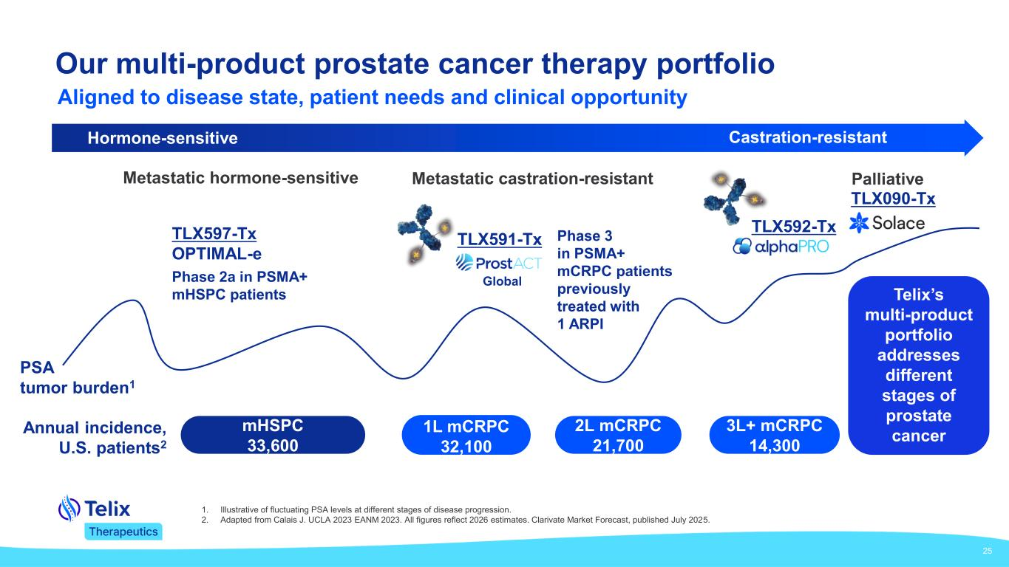
25 Our multi-product prostate cancer therapy portfolio Hormone-sensitive Castration-resistant PSA tumor burden1 mHSPC 33,600 Metastatic castration-resistant 3L+ mCRPC 14,300 2L mCRPC 21,700 1L mCRPC 32,100 Global TLX591-Tx Phase 2a in PSMA+ mHSPC patients TLX597-Tx OPTIMAL-e Annual incidence, U.S. patients2 TLX592-Tx TLX090-Tx PalliativeMetastatic hormone-sensitive Phase 3 in PSMA+ mCRPC patients previously treated with 1 ARPI Telix’s multi-product portfolio addresses different stages of prostate cancer 1. Illustrative of fluctuating PSA levels at different stages of disease progression. 2. Adapted from Calais J. UCLA 2023 EANM 2023. All figures reflect 2026 estimates. Clarivate Market Forecast, published July 2025. Aligned to disease state, patient needs and clinical opportunity

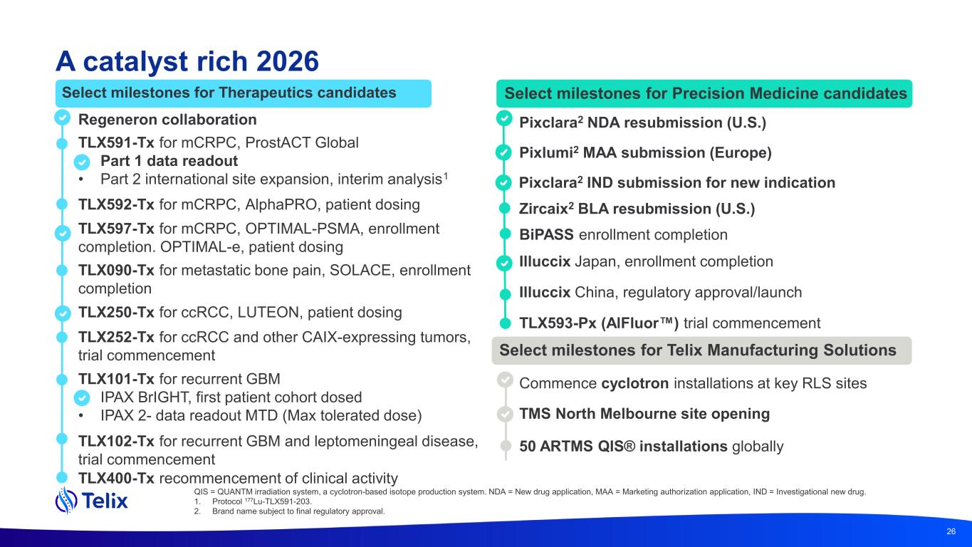
26 Select milestones for Therapeutics candidates Select milestones for Precision Medicine candidates Select milestones for Telix Manufacturing Solutions TLX591-Tx for mCRPC, ProstACT Global • Part 1 data readout • Part 2 international site expansion, interim analysis1 TLX250-Tx for ccRCC, LUTEON, patient dosing TLX090-Tx for metastatic bone pain, SOLACE, enrollment completion TLX592-Tx for mCRPC, AlphaPRO, patient dosing TLX102-Tx for recurrent GBM and leptomeningeal disease, trial commencement TLX252-Tx for ccRCC and other CAIX-expressing tumors, trial commencement TLX400-Tx recommencement of clinical activity Pixclara2 NDA resubmission (U.S.) Zircaix2 BLA resubmission (U.S.) BiPASS enrollment completion Illuccix Japan, enrollment completion Illuccix China, regulatory approval/launch TLX593-Px (AlFluor ) trial commencement Commence cyclotron installations at key RLS sites 50 ARTMS QIS® installations globally TLX101-Tx for recurrent GBM • IPAX BrIGHT, first patient cohort dosed • IPAX 2- data readout MTD (Max tolerated dose) Regeneron collaboration Pixlumi2 MAA submission (Europe) TLX597-Tx for mCRPC, OPTIMAL-PSMA, enrollment completion. OPTIMAL-e, patient dosing A catalyst rich 2026 Pixclara2 IND submission for new indication TMS North Melbourne site opening QIS = QUANTM irradiation system, a cyclotron-based isotope production system. NDA = New drug application, MAA = Marketing authorization application, IND = Investigational new drug. 1. Protocol 177Lu-TLX591-203. 2. Brand name subject to final regulatory approval.


Q&A

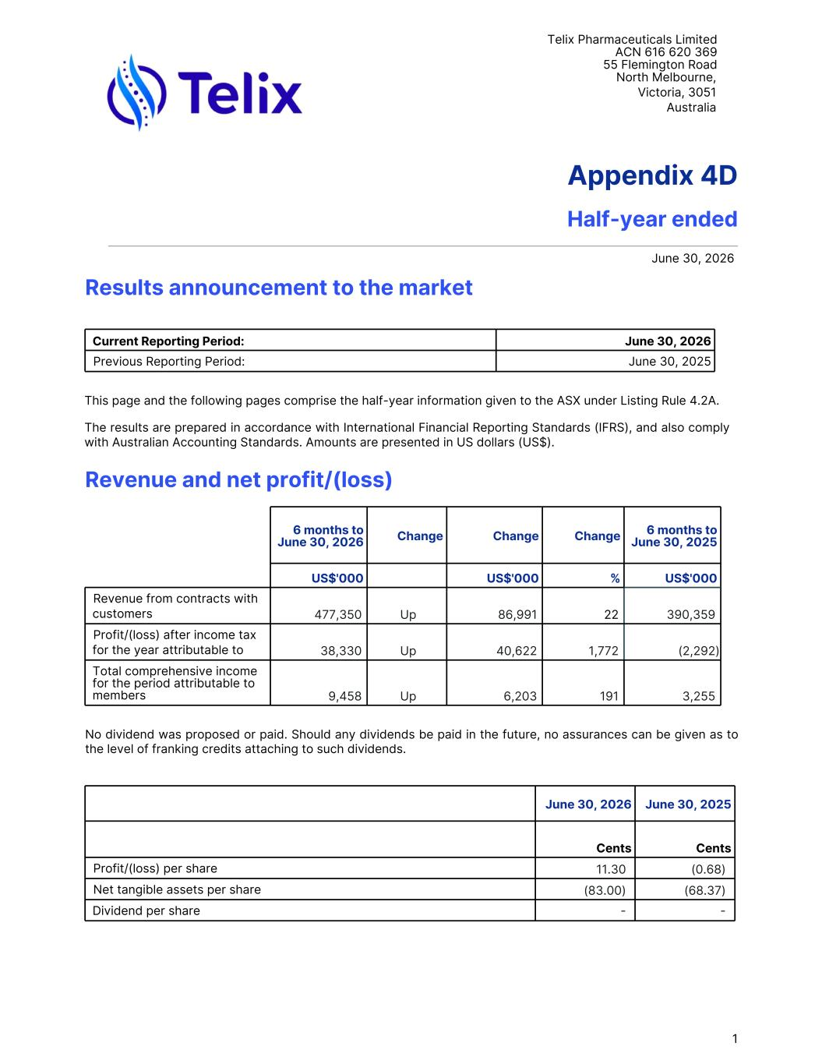
Telix Pharmaceuticals Limited ACN 616 620 369 55 Flemington Road North Melbourne, Victoria, 3051 Australia Appendix 4D Half-year ended June 30, 2026 Results announcement to the market Current Reporting Period: June 30, 2026 Previous Reporting Period: June 30, 2025 This page and the following pages comprise the half-year information given to the ASX under Listing Rule 4.2A. The results are prepared in accordance with International Financial Reporting Standards (IFRS), and also comply with Australian Accounting Standards. Amounts are presented in US dollars (US$). Revenue and net profit/(loss) 6 months to June 30, 2026 Change Change Change 6 months to June 30, 2025 US$'000 US$'000 % US$'000 Revenue from contracts with customers 477,350 Up 86,991 22 390,359 Profit/(loss) after income tax for the year attributable to members 38,330 Up 40,622 1,772 (2,292) Total comprehensive income for the period attributable to members 9,458 Up 6,203 191 3,255 No dividend was proposed or paid. Should any dividends be paid in the future, no assurances can be given as to the level of franking credits attaching to such dividends. June 30, 2026 June 30, 2025 Cents Cents Profit/(loss) per share 11.30 (0.68) Net tangible assets per share (83.00) (68.37) Dividend per share - - 1

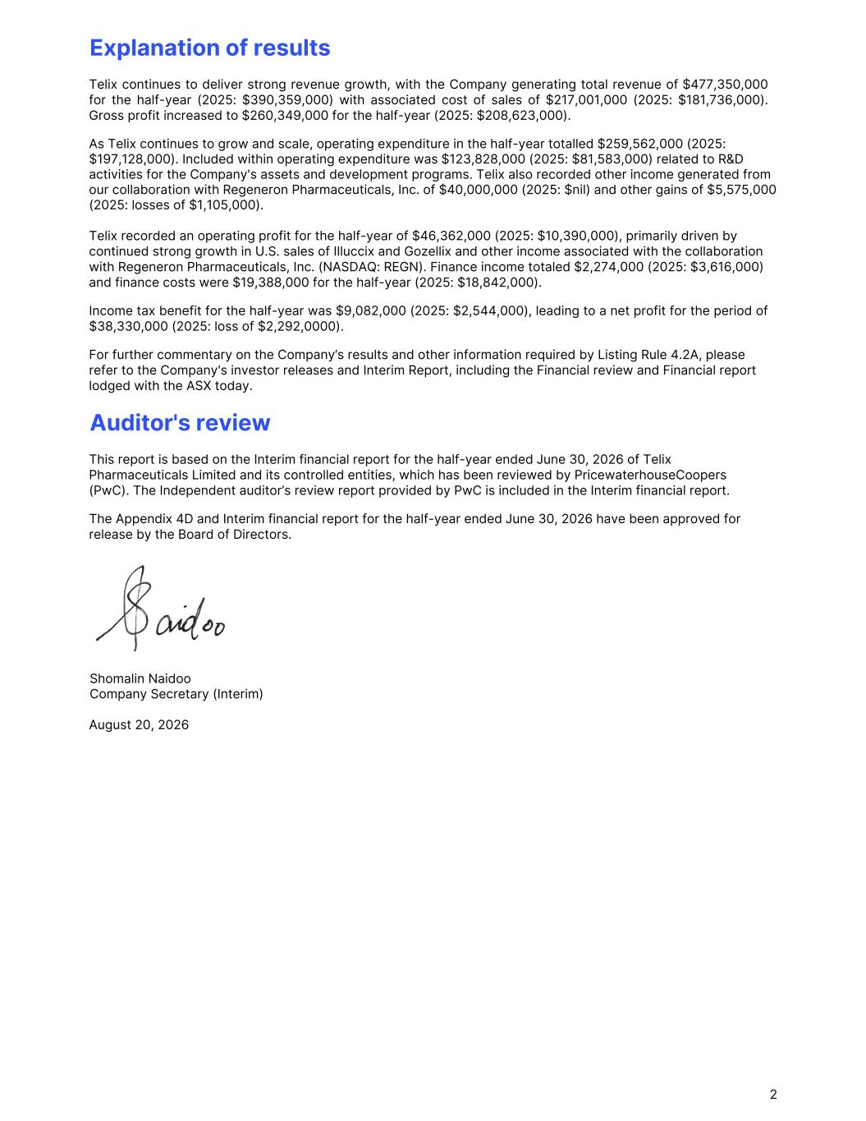
Explanation of results Telix continues to deliver strong revenue growth, with the Company generating total revenue of $477,350,000 for the half-year (2025: $390,359,000) with associated cost of sales of $217,001,000 (2025: $181,736,000). Gross profit increased to $260,349,000 for the half-year (2025: $208,623,000). As Telix continues to grow and scale, operating expenditure in the half-year totalled $259,562,000 (2025: $197,128,000). Included within operating expenditure was $123,828,000 (2025: $81,583,000) related to R&D activities for the Company's assets and development programs. Telix also recorded other income generated from our collaboration with Regeneron Pharmaceuticals, Inc. of $40,000,000 (2025: $nil) and other gains of $5,575,000 (2025: losses of $1,105,000). Telix recorded an operating profit for the half-year of $46,362,000 (2025: $10,390,000), primarily driven by continued strong growth in U.S. sales of Illuccix and Gozellix and other income associated with the collaboration with Regeneron Pharmaceuticals, Inc. (NASDAQ: REGN). Finance income totaled $2,274,000 (2025: $3,616,000) and finance costs were $19,388,000 for the half-year (2025: $18,842,000). Income tax benefit for the half-year was $9,082,000 (2025: $2,544,000), leading to a net profit for the period of $38,330,000 (2025: loss of $2,292,0000). For further commentary on the Company’s results and other information required by Listing Rule 4.2A, please refer to the Company's investor releases and Interim Report, including the Financial review and Financial report lodged with the ASX today. Auditor's review This report is based on the Interim financial report for the half-year ended June 30, 2026 of Telix Pharmaceuticals Limited and its controlled entities, which has been reviewed by PricewaterhouseCoopers (PwC). The Independent auditor’s review report provided by PwC is included in the Interim financial report. The Appendix 4D and Interim financial report for the half-year ended June 30, 2026 have been approved for release by the Board of Directors. Shomalin Naidoo Company Secretary (Interim) August 20, 2026 2

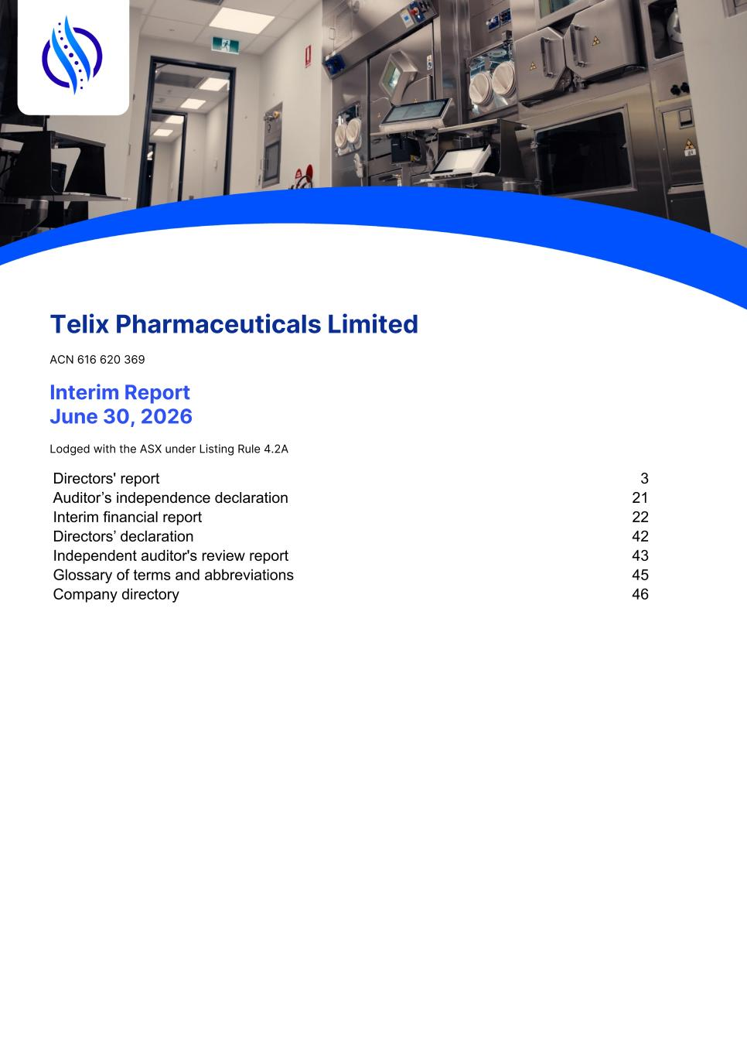
Telix Pharmaceuticals Limited ACN 616 620 369 Interim Report June 30, 2026 Lodged with the ASX under Listing Rule 4.2A Directors' report 3 Auditor’s independence declaration 21 Interim financial report 22 Directors’ declaration 42 Independent auditor's review report 43 Glossary of terms and abbreviations 45 Company directory 46 1

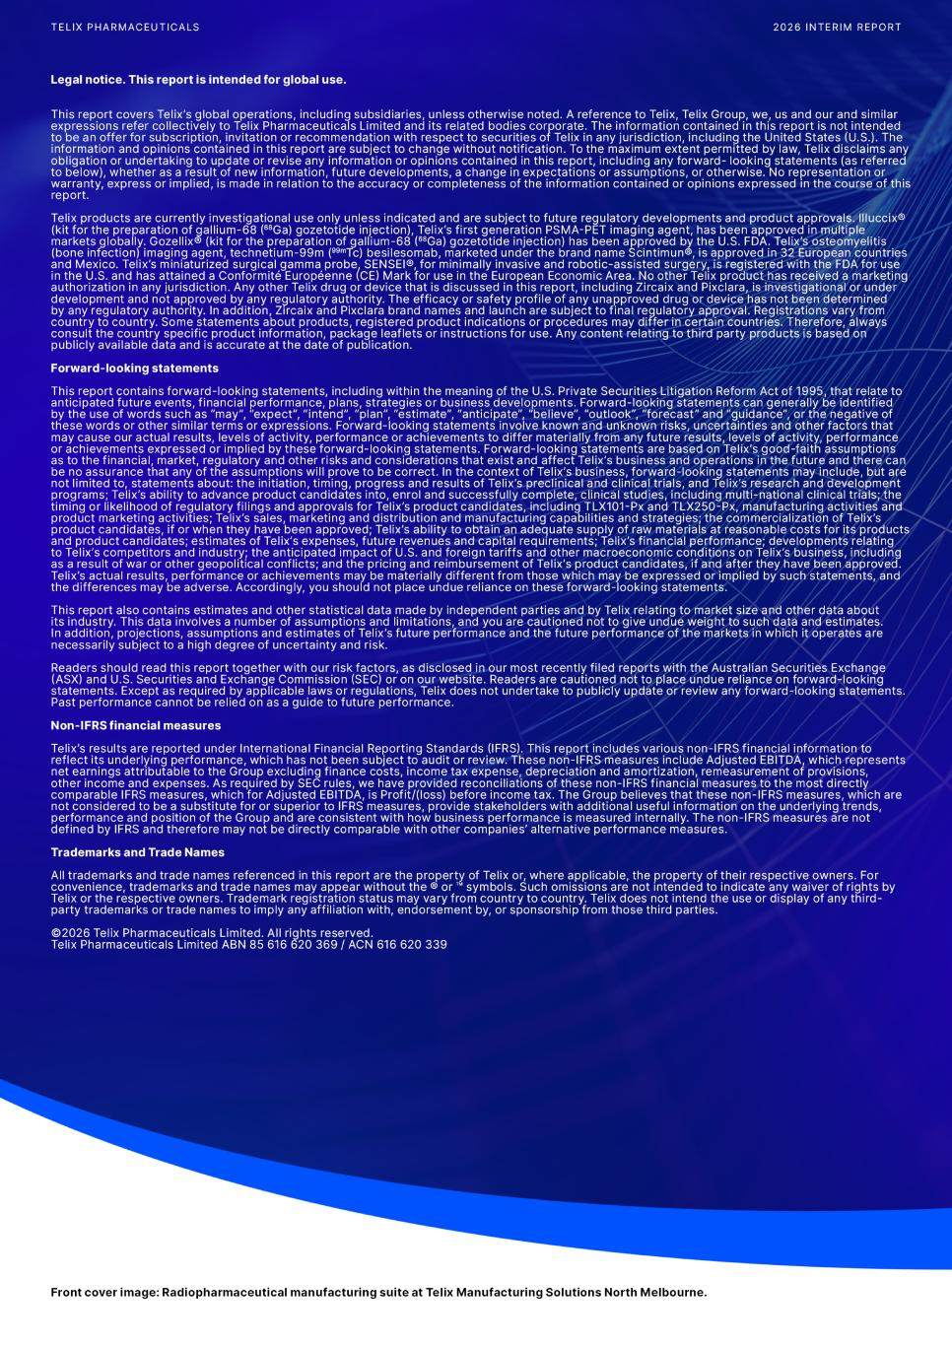
2

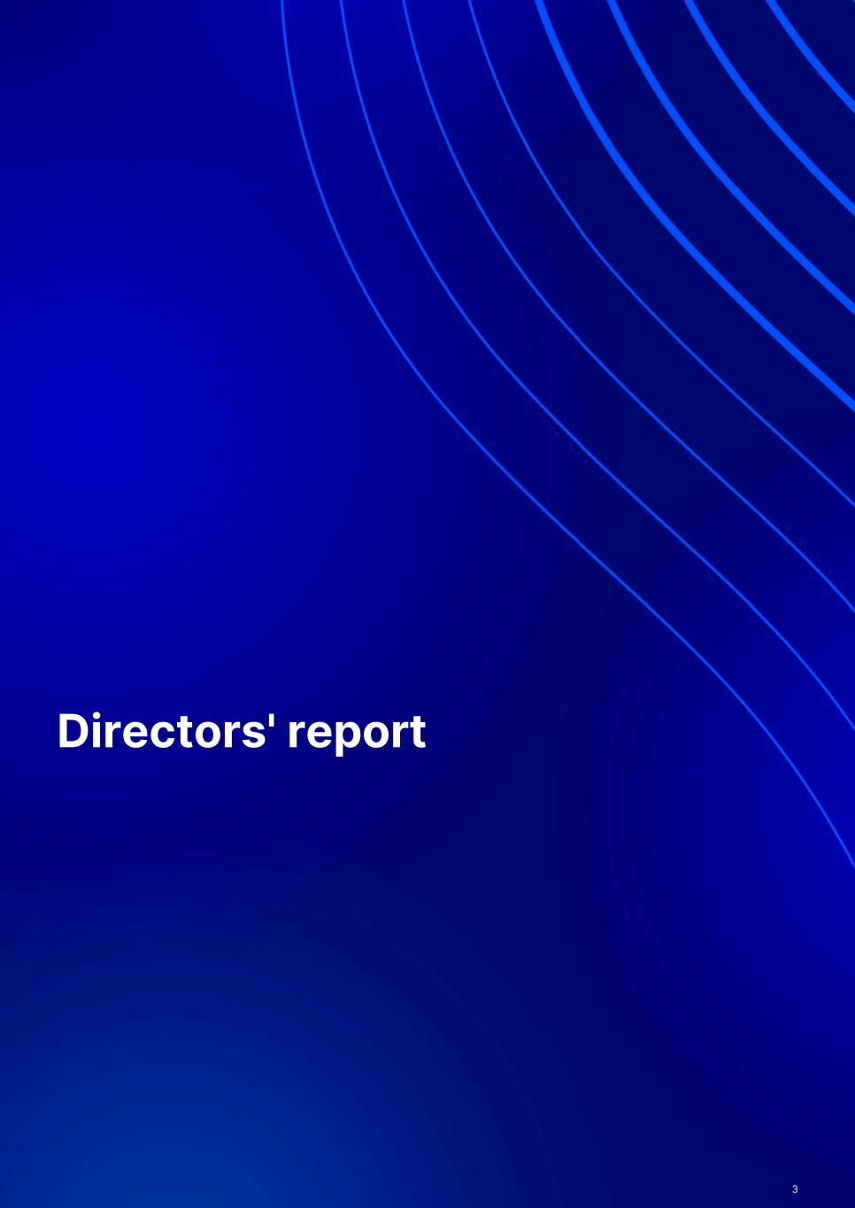
Directors' report 3

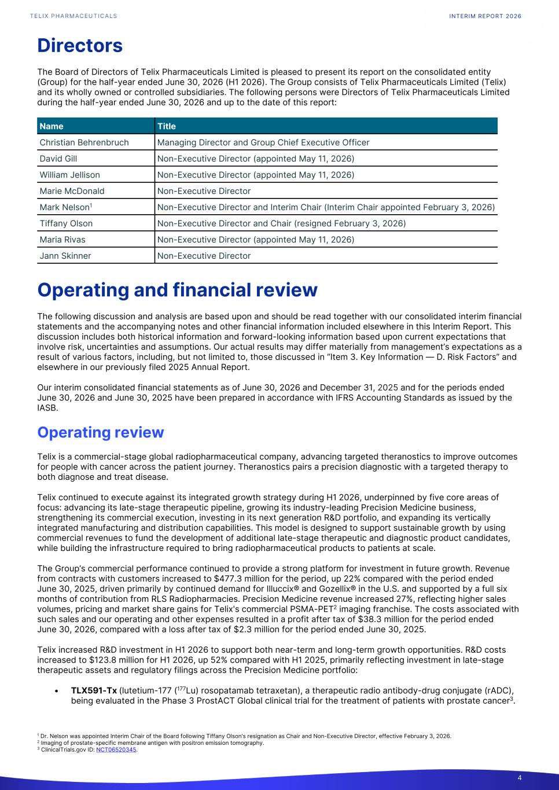
Directors The Board of Directors of Telix Pharmaceuticals Limited is pleased to present its report on the consolidated entity (Group) for the half-year ended June 30, 2026 (H1 2026). The Group consists of Telix Pharmaceuticals Limited (Telix) and its wholly owned or controlled subsidiaries. The following persons were Directors of Telix Pharmaceuticals Limited during the half-year ended June 30, 2026 and up to the date of this report: Name Title Christian Behrenbruch Managing Director and Group Chief Executive Officer David Gill Non-Executive Director (appointed May 11, 2026) William Jellison Non-Executive Director (appointed May 11, 2026) Marie McDonald Non-Executive Director Mark Nelson1 Non-Executive Director and Interim Chair (Interim Chair appointed February 3, 2026) Tiffany Olson Non-Executive Director and Chair (resigned February 3, 2026) Maria Rivas Non-Executive Director (appointed May 11, 2026) Jann Skinner Non-Executive Director Operating and financial review The following discussion and analysis are based upon and should be read together with our consolidated interim financial statements and the accompanying notes and other financial information included elsewhere in this Interim Report. This discussion includes both historical information and forward-looking information based upon current expectations that involve risk, uncertainties and assumptions. Our actual results may differ materially from management’s expectations as a result of various factors, including, but not limited to, those discussed in “Item 3. Key Information — D. Risk Factors” and elsewhere in our previously filed 2025 Annual Report. Our interim consolidated financial statements as of June 30, 2026 and December 31, 2025 and for the periods ended June 30, 2026 and June 30, 2025 have been prepared in accordance with IFRS Accounting Standards as issued by the IASB. Operating review Telix is a commercial-stage global radiopharmaceutical company, advancing targeted theranostics to improve outcomes for people with cancer across the patient journey. Theranostics pairs a precision diagnostic with a targeted therapy to both diagnose and treat disease. Telix continued to execute against its integrated growth strategy during H1 2026, underpinned by five core areas of focus: advancing its late-stage therapeutic pipeline, growing its industry-leading Precision Medicine business, strengthening its commercial execution, investing in its next generation R&D portfolio, and expanding its vertically integrated manufacturing and distribution capabilities. This model is designed to support sustainable growth by using commercial revenues to fund the development of additional late-stage therapeutic and diagnostic product candidates, while building the infrastructure required to bring radiopharmaceutical products to patients at scale. The Group’s commercial performance continued to provide a strong platform for investment in future growth. Revenue from contracts with customers increased to $477.3 million for the period, up 22% compared with the period ended June 30, 2025, driven primarily by continued demand for Illuccix® and Gozellix® in the U.S. and supported by a full six months of contribution from RLS Radiopharmacies. Precision Medicine revenue increased 27%, reflecting higher sales volumes, pricing and market share gains for Telix's commercial PSMA-PET2 imaging franchise. The costs associated with such sales and our operating and other expenses resulted in a profit after tax of $38.3 million for the period ended June 30, 2026, compared with a loss after tax of $2.3 million for the period ended June 30, 2025. Telix increased R&D investment in H1 2026 to support both near-term and long-term growth opportunities. R&D costs increased to $123.8 million for H1 2026, up 52% compared with H1 2025, primarily reflecting investment in late-stage therapeutic assets and regulatory filings across the Precision Medicine portfolio: • TLX591-Tx (lutetium-177 (177Lu) rosopatamab tetraxetan), a therapeutic radio antibody-drug conjugate (rADC), being evaluated in the Phase 3 ProstACT Global clinical trial for the treatment of patients with prostate cancer3. INTERIM REPORT 2026 4 1 Dr. Nelson was appointed Interim Chair of the Board following Tiffany Olson's resignation as Chair and Non-Executive Director, effective February 3, 2026. 2 Imaging of prostate-specific membrane antigen with positron emission tomography. 3 ClinicalTrials.gov ID: NCT06520345.

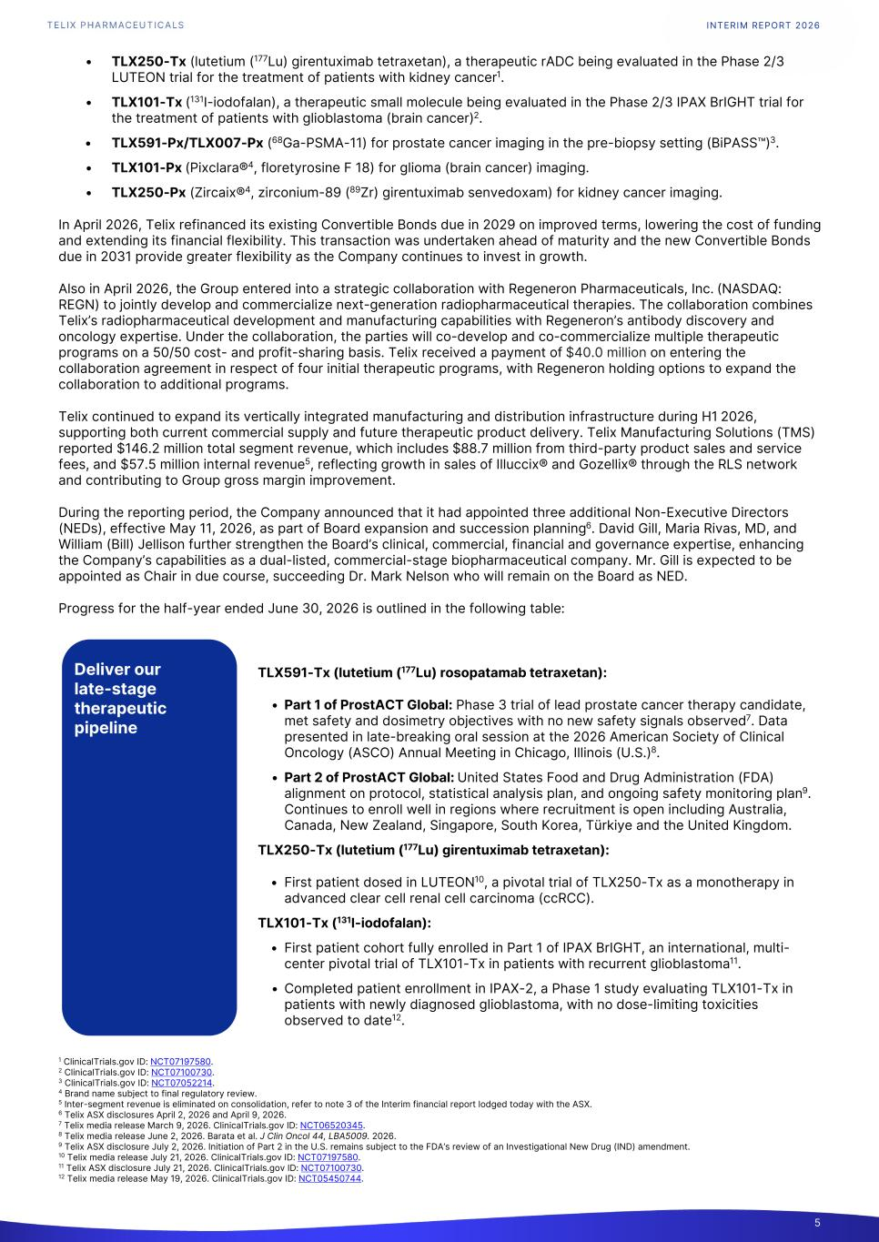
• TLX250-Tx (lutetium (177Lu) girentuximab tetraxetan), a therapeutic rADC being evaluated in the Phase 2/3 LUTEON trial for the treatment of patients with kidney cancer1. • TLX101-Tx (131I-iodofalan), a therapeutic small molecule being evaluated in the Phase 2/3 IPAX BrIGHT trial for the treatment of patients with glioblastoma (brain cancer)2. • TLX591-Px/TLX007-Px (68Ga-PSMA-11) for prostate cancer imaging in the pre-biopsy setting (BiPASS™)3. • TLX101-Px (Pixclara®4, floretyrosine F 18) for glioma (brain cancer) imaging. • TLX250-Px (Zircaix®4, zirconium-89 (89Zr) girentuximab senvedoxam) for kidney cancer imaging. In April 2026, Telix refinanced its existing Convertible Bonds due in 2029 on improved terms, lowering the cost of funding and extending its financial flexibility. This transaction was undertaken ahead of maturity and the new Convertible Bonds due in 2031 provide greater flexibility as the Company continues to invest in growth. Also in April 2026, the Group entered into a strategic collaboration with Regeneron Pharmaceuticals, Inc. (NASDAQ: REGN) to jointly develop and commercialize next-generation radiopharmaceutical therapies. The collaboration combines Telix’s radiopharmaceutical development and manufacturing capabilities with Regeneron’s antibody discovery and oncology expertise. Under the collaboration, the parties will co-develop and co-commercialize multiple therapeutic programs on a 50/50 cost- and profit-sharing basis. Telix received a payment of $40.0 million on entering the collaboration agreement in respect of four initial therapeutic programs, with Regeneron holding options to expand the collaboration to additional programs. Telix continued to expand its vertically integrated manufacturing and distribution infrastructure during H1 2026, supporting both current commercial supply and future therapeutic product delivery. Telix Manufacturing Solutions (TMS) reported $146.2 million total segment revenue, which includes $88.7 million from third-party product sales and service fees, and $57.5 million internal revenue5, reflecting growth in sales of Illuccix® and Gozellix® through the RLS network and contributing to Group gross margin improvement. During the reporting period, the Company announced that it had appointed three additional Non-Executive Directors (NEDs), effective May 11, 2026, as part of Board expansion and succession planning6. David Gill, Maria Rivas, MD, and William (Bill) Jellison further strengthen the Board’s clinical, commercial, financial and governance expertise, enhancing the Company’s capabilities as a dual-listed, commercial-stage biopharmaceutical company. Mr. Gill is expected to be appointed as Chair in due course, succeeding Dr. Mark Nelson who will remain on the Board as NED. Progress for the half-year ended June 30, 2026 is outlined in the following table: TLX591-Tx (lutetium (177Lu) rosopatamab tetraxetan): • Part 1 of ProstACT Global: Phase 3 trial of lead prostate cancer therapy candidate, met safety and dosimetry objectives with no new safety signals observed7. Data presented in late-breaking oral session at the 2026 American Society of Clinical Oncology (ASCO) Annual Meeting in Chicago, Illinois (U.S.)8. • Part 2 of ProstACT Global: United States Food and Drug Administration (FDA) alignment on protocol, statistical analysis plan, and ongoing safety monitoring plan9. Continues to enroll well in regions where recruitment is open including Australia, Canada, New Zealand, Singapore, South Korea, Türkiye and the United Kingdom. TLX250-Tx (lutetium (177Lu) girentuximab tetraxetan): • First patient dosed in LUTEON10, a pivotal trial of TLX250-Tx as a monotherapy in advanced clear cell renal cell carcinoma (ccRCC). TLX101-Tx (131I-iodofalan): • First patient cohort fully enrolled in Part 1 of IPAX BrIGHT, an international, multi- center pivotal trial of TLX101-Tx in patients with recurrent glioblastoma11. • Completed patient enrollment in IPAX-2, a Phase 1 study evaluating TLX101-Tx in patients with newly diagnosed glioblastoma, with no dose-limiting toxicities observed to date12. INTERIM REPORT 2026 5 1 ClinicalTrials.gov ID: NCT07197580. 2 ClinicalTrials.gov ID: NCT07100730. 3 ClinicalTrials.gov ID: NCT07052214. 4 Brand name subject to final regulatory review. 5 Inter-segment revenue is eliminated on consolidation, refer to note 3 of the Interim financial report lodged today with the ASX. 6 Telix ASX disclosures April 2, 2026 and April 9, 2026. 7 Telix media release March 9, 2026. ClinicalTrials.gov ID: NCT06520345. 8 Telix media release June 2, 2026. Barata et al. J Clin Oncol 44, LBA5009. 2026. 9 Telix ASX disclosure July 2, 2026. Initiation of Part 2 in the U.S. remains subject to the FDA’s review of an Investigational New Drug (IND) amendment. 10 Telix media release July 21, 2026. ClinicalTrials.gov ID: NCT07197580. 11 Telix ASX disclosure July 21, 2026. ClinicalTrials.gov ID: NCT07100730. 12 Telix media release May 19, 2026. ClinicalTrials.gov ID: NCT05450744. Deliver our late-stage therapeutic pipeline

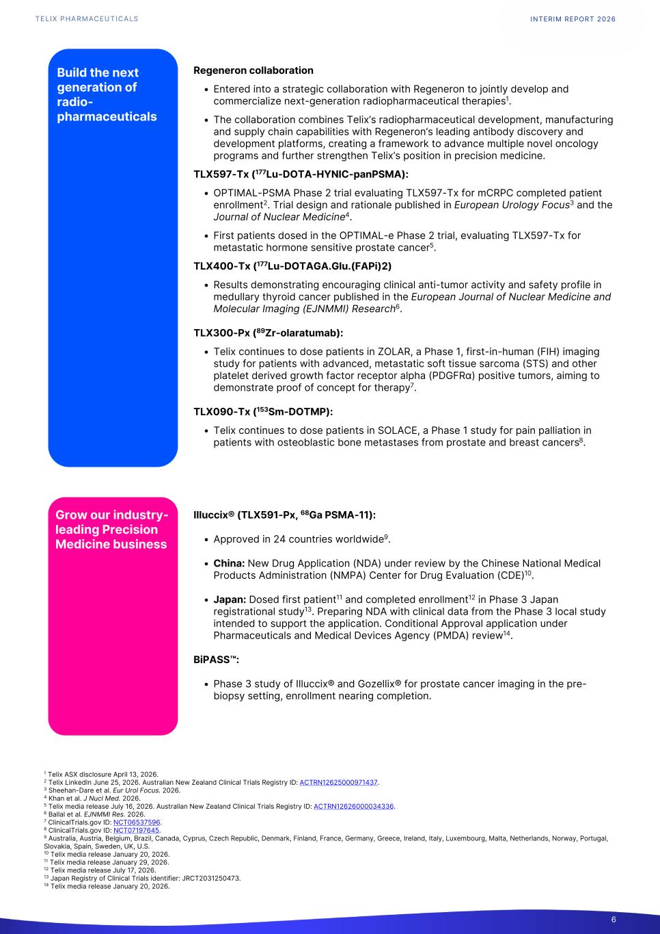
Regeneron collaboration • Entered into a strategic collaboration with Regeneron to jointly develop and commercialize next-generation radiopharmaceutical therapies1. • The collaboration combines Telix’s radiopharmaceutical development, manufacturing and supply chain capabilities with Regeneron’s leading antibody discovery and development platforms, creating a framework to advance multiple novel oncology programs and further strengthen Telix’s position in precision medicine. TLX597-Tx (177Lu-DOTA-HYNIC-panPSMA): • OPTIMAL-PSMA Phase 2 trial evaluating TLX597-Tx for mCRPC completed patient enrollment2. Trial design and rationale published in European Urology Focus3 and the Journal of Nuclear Medicine4. • First patients dosed in the OPTIMAL-e Phase 2 trial, evaluating TLX597-Tx for metastatic hormone sensitive prostate cancer5. TLX400-Tx (177Lu-DOTAGA.Glu.(FAPi)2) • Results demonstrating encouraging clinical anti-tumor activity and safety profile in medullary thyroid cancer published in the European Journal of Nuclear Medicine and Molecular Imaging (EJNMMI) Research6. TLX300-Px (89Zr-olaratumab): • Telix continues to dose patients in ZOLAR, a Phase 1, first-in-human (FIH) imaging study for patients with advanced, metastatic soft tissue sarcoma (STS) and other platelet derived growth factor receptor alpha (PDGFRα) positive tumors, aiming to demonstrate proof of concept for therapy7. TLX090-Tx (153Sm-DOTMP): • Telix continues to dose patients in SOLACE, a Phase 1 study for pain palliation in patients with osteoblastic bone metastases from prostate and breast cancers8. Illuccix® (TLX591-Px, 68Ga PSMA-11): • Approved in 24 countries worldwide9. • China: New Drug Application (NDA) under review by the Chinese National Medical Products Administration (NMPA) Center for Drug Evaluation (CDE)10. • Japan: Dosed first patient11 and completed enrollment12 in Phase 3 Japan registrational study13. Preparing NDA with clinical data from the Phase 3 local study intended to support the application. Conditional Approval application under Pharmaceuticals and Medical Devices Agency (PMDA) review14. BiPASS™: • Phase 3 study of Illuccix® and Gozellix® for prostate cancer imaging in the pre- biopsy setting, enrollment nearing completion. INTERIM REPORT 2026 6 1 Telix ASX disclosure April 13, 2026. 2 Telix LinkedIn June 25, 2026. Australian New Zealand Clinical Trials Registry ID: ACTRN12625000971437. 3 Sheehan-Dare et al. Eur Urol Focus. 2026. 4 Khan et al. J Nucl Med. 2026. 5 Telix media release July 16, 2026. Australian New Zealand Clinical Trials Registry ID: ACTRN12626000034336. 6 Ballal et al. EJNMMI Res. 2026. 7 ClinicalTrials.gov ID: NCT06537596. 8 ClinicalTrials.gov ID: NCT07197645. 9 Australia, Austria, Belgium, Brazil, Canada, Cyprus, Czech Republic, Denmark, Finland, France, Germany, Greece, Ireland, Italy, Luxembourg, Malta, Netherlands, Norway, Portugal, Slovakia, Spain, Sweden, UK, U.S. 10 Telix media release January 20, 2026. 11 Telix media release January 29, 2026. 12 Telix media release July 17, 2026. 13 Japan Registry of Clinical Trials identifier: JRCT2031250473. 14 Telix media release January 20, 2026. Build the next generation of radio- pharmaceuticals Grow our industry- leading Precision Medicine business

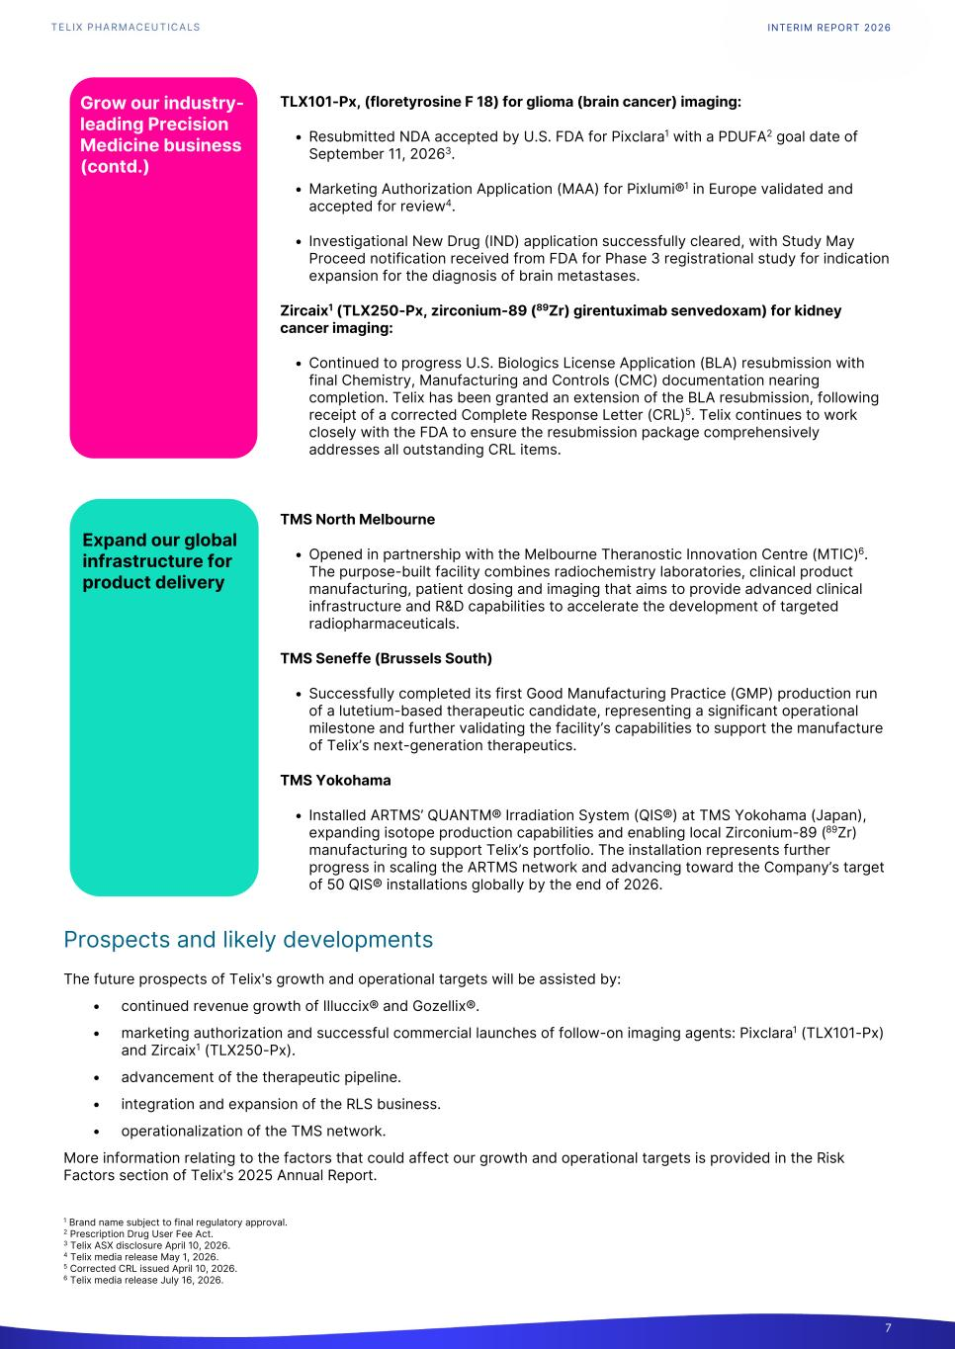
TLX101-Px, (floretyrosine F 18) for glioma (brain cancer) imaging: • Resubmitted NDA accepted by U.S. FDA for Pixclara1 with a PDUFA2 goal date of September 11, 20263. • Marketing Authorization Application (MAA) for Pixlumi®1 in Europe validated and accepted for review4. • Investigational New Drug (IND) application successfully cleared, with Study May Proceed notification received from FDA for Phase 3 registrational study for indication expansion for the diagnosis of brain metastases. Zircaix1 (TLX250-Px, zirconium-89 (89Zr) girentuximab senvedoxam) for kidney cancer imaging: • Continued to progress U.S. Biologics License Application (BLA) resubmission with final Chemistry, Manufacturing and Controls (CMC) documentation nearing completion. Telix has been granted an extension of the BLA resubmission, following receipt of a corrected Complete Response Letter (CRL)5. Telix continues to work closely with the FDA to ensure the resubmission package comprehensively addresses all outstanding CRL items. TMS North Melbourne • Opened in partnership with the Melbourne Theranostic Innovation Centre (MTIC)6. The purpose-built facility combines radiochemistry laboratories, clinical product manufacturing, patient dosing and imaging that aims to provide advanced clinical infrastructure and R&D capabilities to accelerate the development of targeted radiopharmaceuticals. TMS Seneffe (Brussels South) • Successfully completed its first Good Manufacturing Practice (GMP) production run of a lutetium-based therapeutic candidate, representing a significant operational milestone and further validating the facility’s capabilities to support the manufacture of Telix’s next-generation therapeutics. TMS Yokohama • Installed ARTMS’ QUANTM® Irradiation System (QIS®) at TMS Yokohama (Japan), expanding isotope production capabilities and enabling local Zirconium-89 (89Zr) manufacturing to support Telix’s portfolio. The installation represents further progress in scaling the ARTMS network and advancing toward the Company’s target of 50 QIS® installations globally by the end of 2026. Prospects and likely developments The future prospects of Telix's growth and operational targets will be assisted by: • continued revenue growth of Illuccix® and Gozellix®. • marketing authorization and successful commercial launches of follow-on imaging agents: Pixclara1 (TLX101-Px) and Zircaix1 (TLX250-Px). • advancement of the therapeutic pipeline. • integration and expansion of the RLS business. • operationalization of the TMS network. More information relating to the factors that could affect our growth and operational targets is provided in the Risk Factors section of Telix's 2025 Annual Report. INTERIM REPORT 2026 7 1 Brand name subject to final regulatory approval. 2 Prescription Drug User Fee Act. 3 Telix ASX disclosure April 10, 2026. 4 Telix media release May 1, 2026. 5 Corrected CRL issued April 10, 2026. 6 Telix media release July 16, 2026. Grow our industry- leading Precision Medicine business (contd.) Expand our global infrastructure for product delivery

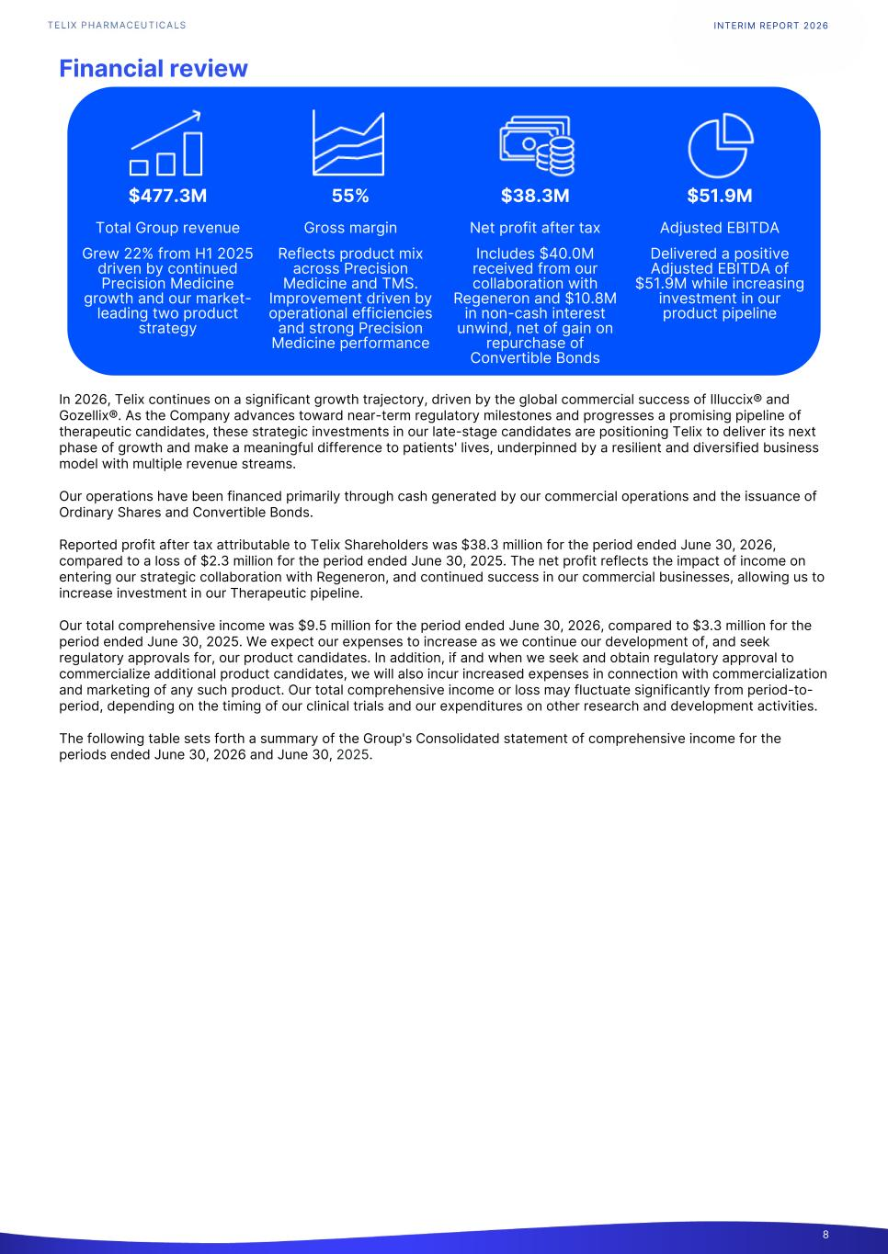
Financial review In 2026, Telix continues on a significant growth trajectory, driven by the global commercial success of Illuccix® and Gozellix®. As the Company advances toward near-term regulatory milestones and progresses a promising pipeline of therapeutic candidates, these strategic investments in our late-stage candidates are positioning Telix to deliver its next phase of growth and make a meaningful difference to patients' lives, underpinned by a resilient and diversified business model with multiple revenue streams. Our operations have been financed primarily through cash generated by our commercial operations and the issuance of Ordinary Shares and Convertible Bonds. Reported profit after tax attributable to Telix Shareholders was $38.3 million for the period ended June 30, 2026, compared to a loss of $2.3 million for the period ended June 30, 2025. The net profit reflects the impact of income on entering our strategic collaboration with Regeneron, and continued success in our commercial businesses, allowing us to increase investment in our Therapeutic pipeline. Our total comprehensive income was $9.5 million for the period ended June 30, 2026, compared to $3.3 million for the period ended June 30, 2025. We expect our expenses to increase as we continue our development of, and seek regulatory approvals for, our product candidates. In addition, if and when we seek and obtain regulatory approval to commercialize additional product candidates, we will also incur increased expenses in connection with commercialization and marketing of any such product. Our total comprehensive income or loss may fluctuate significantly from period-to- period, depending on the timing of our clinical trials and our expenditures on other research and development activities. The following table sets forth a summary of the Group's Consolidated statement of comprehensive income for the periods ended June 30, 2026 and June 30, 2025. INTERIM REPORT 2026 8 $477.3M 55% $38.3M $51.9M Total Group revenue Gross margin Net profit after tax Adjusted EBITDA Grew 22% from H1 2025 driven by continued Precision Medicine growth and our market- leading two product strategy Reflects product mix across Precision Medicine and TMS. Improvement driven by operational efficiencies and strong Precision Medicine performance Includes $40.0M received from our collaboration with Regeneron and $10.8M in non-cash interest unwind, net of gain on repurchase of Convertible Bonds Delivered a positive Adjusted EBITDA of $51.9M while increasing investment in our product pipeline

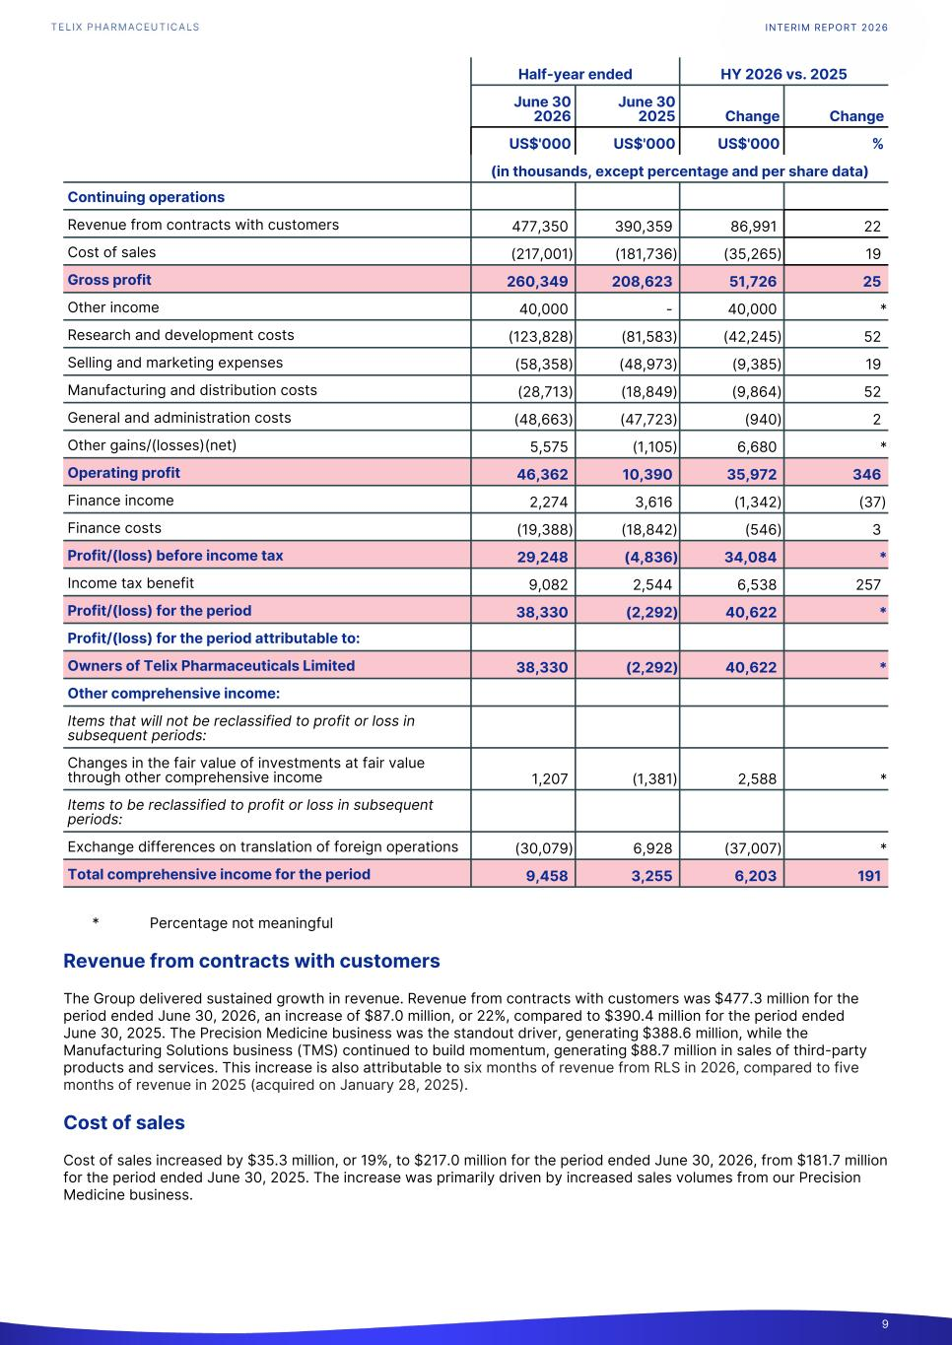
Half-year ended HY 2026 vs. 2025 June 30 2026 June 30 2025 Change Change US$'000 US$'000 US$'000 % (in thousands, except percentage and per share data) Continuing operations Revenue from contracts with customers 477,350 390,359 86,991 22 Cost of sales (217,001) (181,736) (35,265) 19 Gross profit 260,349 208,623 51,726 25 Other income 40,000 - 40,000 * Research and development costs (123,828) (81,583) (42,245) 52 Selling and marketing expenses (58,358) (48,973) (9,385) 19 Manufacturing and distribution costs (28,713) (18,849) (9,864) 52 General and administration costs (48,663) (47,723) (940) 2 Other gains/(losses)(net) 5,575 (1,105) 6,680 * Operating profit 46,362 10,390 35,972 346 Finance income 2,274 3,616 (1,342) (37) Finance costs (19,388) (18,842) (546) 3 Profit/(loss) before income tax 29,248 (4,836) 34,084 * Income tax benefit 9,082 2,544 6,538 257 Profit/(loss) for the period 38,330 (2,292) 40,622 * Profit/(loss) for the period attributable to: Owners of Telix Pharmaceuticals Limited 38,330 (2,292) 40,622 * Other comprehensive income: Items that will not be reclassified to profit or loss in subsequent periods: Changes in the fair value of investments at fair value through other comprehensive income 1,207 (1,381) 2,588 * Items to be reclassified to profit or loss in subsequent periods: Exchange differences on translation of foreign operations (30,079) 6,928 (37,007) * Total comprehensive income for the period 9,458 3,255 6,203 191 * Percentage not meaningful Revenue from contracts with customers The Group delivered sustained growth in revenue. Revenue from contracts with customers was $477.3 million for the period ended June 30, 2026, an increase of $87.0 million, or 22%, compared to $390.4 million for the period ended June 30, 2025. The Precision Medicine business was the standout driver, generating $388.6 million, while the Manufacturing Solutions business (TMS) continued to build momentum, generating $88.7 million in sales of third-party products and services. This increase is also attributable to six months of revenue from RLS in 2026, compared to five months of revenue in 2025 (acquired on January 28, 2025). Cost of sales Cost of sales increased by $35.3 million, or 19%, to $217.0 million for the period ended June 30, 2026, from $181.7 million for the period ended June 30, 2025. The increase was primarily driven by increased sales volumes from our Precision Medicine business. INTERIM REPORT 2026 9

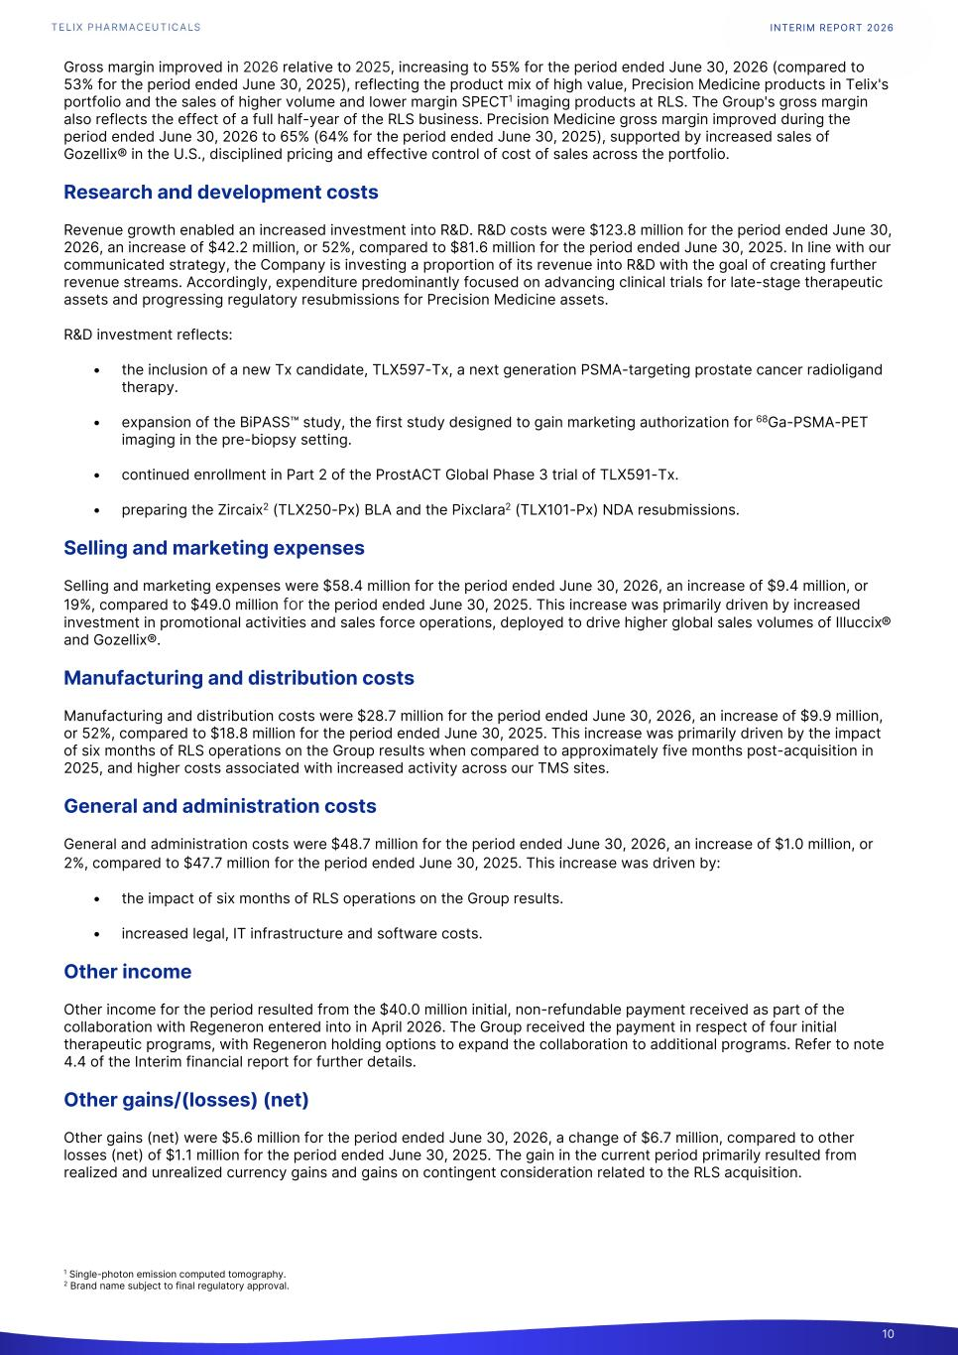
Gross margin improved in 2026 relative to 2025, increasing to 55% for the period ended June 30, 2026 (compared to 53% for the period ended June 30, 2025), reflecting the product mix of high value, Precision Medicine products in Telix's portfolio and the sales of higher volume and lower margin SPECT1 imaging products at RLS. The Group's gross margin also reflects the effect of a full half-year of the RLS business. Precision Medicine gross margin improved during the period ended June 30, 2026 to 65% (64% for the period ended June 30, 2025), supported by increased sales of Gozellix® in the U.S., disciplined pricing and effective control of cost of sales across the portfolio. Research and development costs Revenue growth enabled an increased investment into R&D. R&D costs were $123.8 million for the period ended June 30, 2026, an increase of $42.2 million, or 52%, compared to $81.6 million for the period ended June 30, 2025. In line with our communicated strategy, the Company is investing a proportion of its revenue into R&D with the goal of creating further revenue streams. Accordingly, expenditure predominantly focused on advancing clinical trials for late-stage therapeutic assets and progressing regulatory resubmissions for Precision Medicine assets. R&D investment reflects: • the inclusion of a new Tx candidate, TLX597-Tx, a next generation PSMA-targeting prostate cancer radioligand therapy. • expansion of the BiPASS™ study, the first study designed to gain marketing authorization for 68Ga-PSMA-PET imaging in the pre-biopsy setting. • continued enrollment in Part 2 of the ProstACT Global Phase 3 trial of TLX591-Tx. • preparing the Zircaix2 (TLX250-Px) BLA and the Pixclara2 (TLX101-Px) NDA resubmissions. Selling and marketing expenses Selling and marketing expenses were $58.4 million for the period ended June 30, 2026, an increase of $9.4 million, or 19%, compared to $49.0 million for the period ended June 30, 2025. This increase was primarily driven by increased investment in promotional activities and sales force operations, deployed to drive higher global sales volumes of Illuccix® and Gozellix®. Manufacturing and distribution costs Manufacturing and distribution costs were $28.7 million for the period ended June 30, 2026, an increase of $9.9 million, or 52%, compared to $18.8 million for the period ended June 30, 2025. This increase was primarily driven by the impact of six months of RLS operations on the Group results when compared to approximately five months post-acquisition in 2025, and higher costs associated with increased activity across our TMS sites. General and administration costs General and administration costs were $48.7 million for the period ended June 30, 2026, an increase of $1.0 million, or 2%, compared to $47.7 million for the period ended June 30, 2025. This increase was driven by: • the impact of six months of RLS operations on the Group results. • increased legal, IT infrastructure and software costs. Other income Other income for the period resulted from the $40.0 million initial, non-refundable payment received as part of the collaboration with Regeneron entered into in April 2026. The Group received the payment in respect of four initial therapeutic programs, with Regeneron holding options to expand the collaboration to additional programs. Refer to note 4.4 of the Interim financial report for further details. Other gains/(losses) (net) Other gains (net) were $5.6 million for the period ended June 30, 2026, a change of $6.7 million, compared to other losses (net) of $1.1 million for the period ended June 30, 2025. The gain in the current period primarily resulted from realized and unrealized currency gains and gains on contingent consideration related to the RLS acquisition. INTERIM REPORT 2026 10 1 Single-photon emission computed tomography. 2 Brand name subject to final regulatory approval.

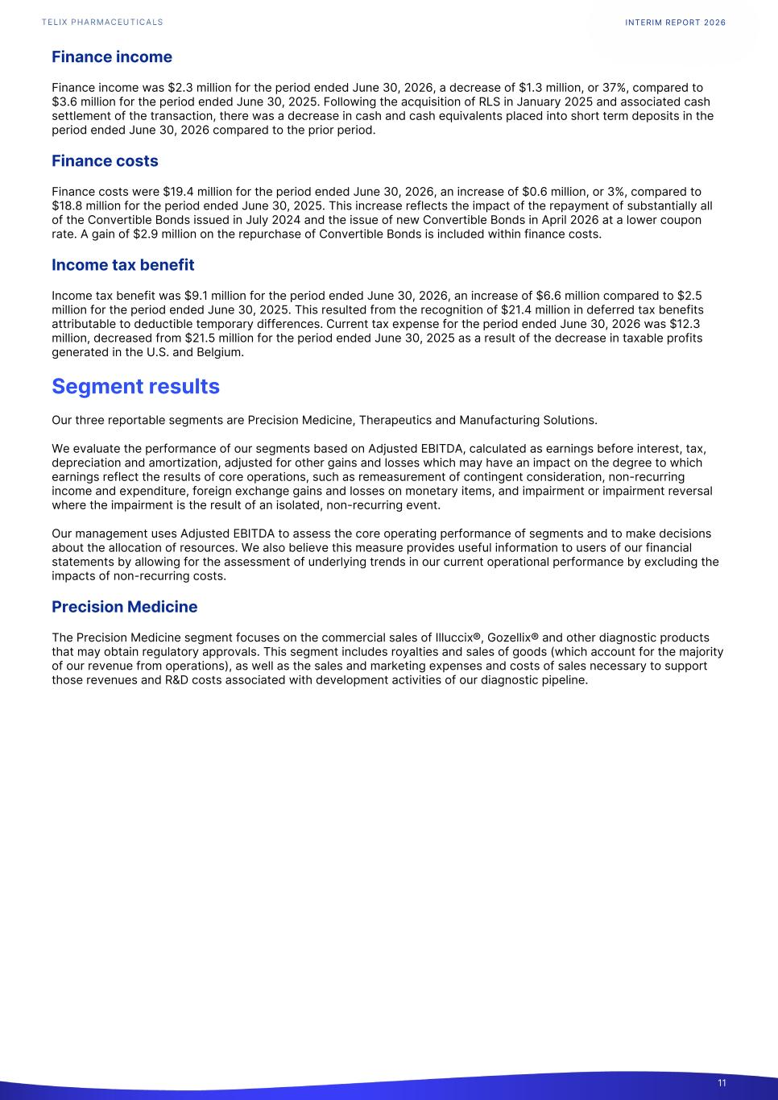
Finance income Finance income was $2.3 million for the period ended June 30, 2026, a decrease of $1.3 million, or 37%, compared to $3.6 million for the period ended June 30, 2025. Following the acquisition of RLS in January 2025 and associated cash settlement of the transaction, there was a decrease in cash and cash equivalents placed into short term deposits in the period ended June 30, 2026 compared to the prior period. Finance costs Finance costs were $19.4 million for the period ended June 30, 2026, an increase of $0.6 million, or 3%, compared to $18.8 million for the period ended June 30, 2025. This increase reflects the impact of the repayment of substantially all of the Convertible Bonds issued in July 2024 and the issue of new Convertible Bonds in April 2026 at a lower coupon rate. A gain of $2.9 million on the repurchase of Convertible Bonds is included within finance costs. Income tax benefit Income tax benefit was $9.1 million for the period ended June 30, 2026, an increase of $6.6 million compared to $2.5 million for the period ended June 30, 2025. This resulted from the recognition of $21.4 million in deferred tax benefits attributable to deductible temporary differences. Current tax expense for the period ended June 30, 2026 was $12.3 million, decreased from $21.5 million for the period ended June 30, 2025 as a result of the decrease in taxable profits generated in the U.S. and Belgium. Segment results Our three reportable segments are Precision Medicine, Therapeutics and Manufacturing Solutions. We evaluate the performance of our segments based on Adjusted EBITDA, calculated as earnings before interest, tax, depreciation and amortization, adjusted for other gains and losses which may have an impact on the degree to which earnings reflect the results of core operations, such as remeasurement of contingent consideration, non-recurring income and expenditure, foreign exchange gains and losses on monetary items, and impairment or impairment reversal where the impairment is the result of an isolated, non-recurring event. Our management uses Adjusted EBITDA to assess the core operating performance of segments and to make decisions about the allocation of resources. We also believe this measure provides useful information to users of our financial statements by allowing for the assessment of underlying trends in our current operational performance by excluding the impacts of non-recurring costs. Precision Medicine The Precision Medicine segment focuses on the commercial sales of Illuccix®, Gozellix® and other diagnostic products that may obtain regulatory approvals. This segment includes royalties and sales of goods (which account for the majority of our revenue from operations), as well as the sales and marketing expenses and costs of sales necessary to support those revenues and R&D costs associated with development activities of our diagnostic pipeline. INTERIM REPORT 2026 11

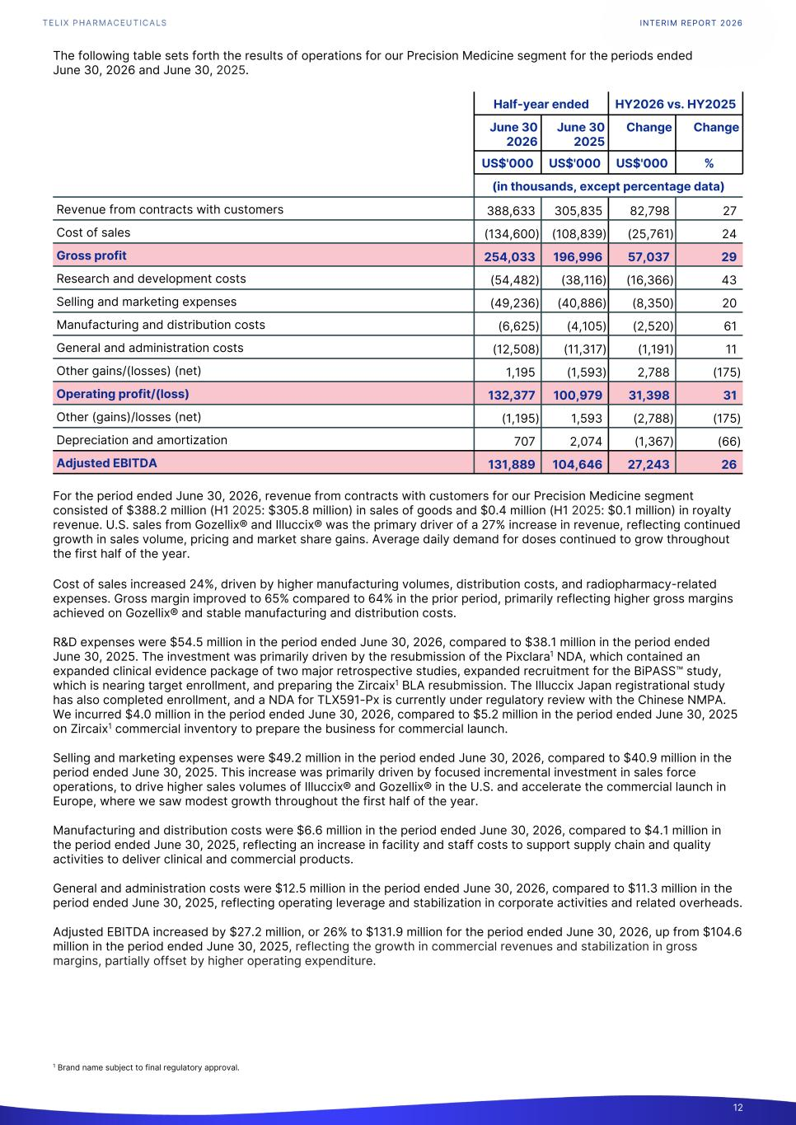
The following table sets forth the results of operations for our Precision Medicine segment for the periods ended June 30, 2026 and June 30, 2025. Half-year ended HY2026 vs. HY2025 June 30 2026 June 30 2025 Change Change US$'000 US$'000 US$'000 % (in thousands, except percentage data) Revenue from contracts with customers 388,633 305,835 82,798 27 Cost of sales (134,600) (108,839) (25,761) 24 Gross profit 254,033 196,996 57,037 29 Research and development costs (54,482) (38,116) (16,366) 43 Selling and marketing expenses (49,236) (40,886) (8,350) 20 Manufacturing and distribution costs (6,625) (4,105) (2,520) 61 General and administration costs (12,508) (11,317) (1,191) 11 Other gains/(losses) (net) 1,195 (1,593) 2,788 (175) Operating profit/(loss) 132,377 100,979 31,398 31 Other (gains)/losses (net) (1,195) 1,593 (2,788) (175) Depreciation and amortization 707 2,074 (1,367) (66) Adjusted EBITDA 131,889 104,646 27,243 26 For the period ended June 30, 2026, revenue from contracts with customers for our Precision Medicine segment consisted of $388.2 million (H1 2025: $305.8 million) in sales of goods and $0.4 million (H1 2025: $0.1 million) in royalty revenue. U.S. sales from Gozellix® and Illuccix® was the primary driver of a 27% increase in revenue, reflecting continued growth in sales volume, pricing and market share gains. Average daily demand for doses continued to grow throughout the first half of the year. Cost of sales increased 24%, driven by higher manufacturing volumes, distribution costs, and radiopharmacy-related expenses. Gross margin improved to 65% compared to 64% in the prior period, primarily reflecting higher gross margins achieved on Gozellix® and stable manufacturing and distribution costs. R&D expenses were $54.5 million in the period ended June 30, 2026, compared to $38.1 million in the period ended June 30, 2025. The investment was primarily driven by the resubmission of the Pixclara1 NDA, which contained an expanded clinical evidence package of two major retrospective studies, expanded recruitment for the BiPASS™ study, which is nearing target enrollment, and preparing the Zircaix1 BLA resubmission. The Illuccix Japan registrational study has also completed enrollment, and a NDA for TLX591-Px is currently under regulatory review with the Chinese NMPA. We incurred $4.0 million in the period ended June 30, 2026, compared to $5.2 million in the period ended June 30, 2025 on Zircaix1 commercial inventory to prepare the business for commercial launch. Selling and marketing expenses were $49.2 million in the period ended June 30, 2026, compared to $40.9 million in the period ended June 30, 2025. This increase was primarily driven by focused incremental investment in sales force operations, to drive higher sales volumes of Illuccix® and Gozellix® in the U.S. and accelerate the commercial launch in Europe, where we saw modest growth throughout the first half of the year. Manufacturing and distribution costs were $6.6 million in the period ended June 30, 2026, compared to $4.1 million in the period ended June 30, 2025, reflecting an increase in facility and staff costs to support supply chain and quality activities to deliver clinical and commercial products. General and administration costs were $12.5 million in the period ended June 30, 2026, compared to $11.3 million in the period ended June 30, 2025, reflecting operating leverage and stabilization in corporate activities and related overheads. Adjusted EBITDA increased by $27.2 million, or 26% to $131.9 million for the period ended June 30, 2026, up from $104.6 million in the period ended June 30, 2025, reflecting the growth in commercial revenues and stabilization in gross margins, partially offset by higher operating expenditure. INTERIM REPORT 2026 12 1 Brand name subject to final regulatory approval.

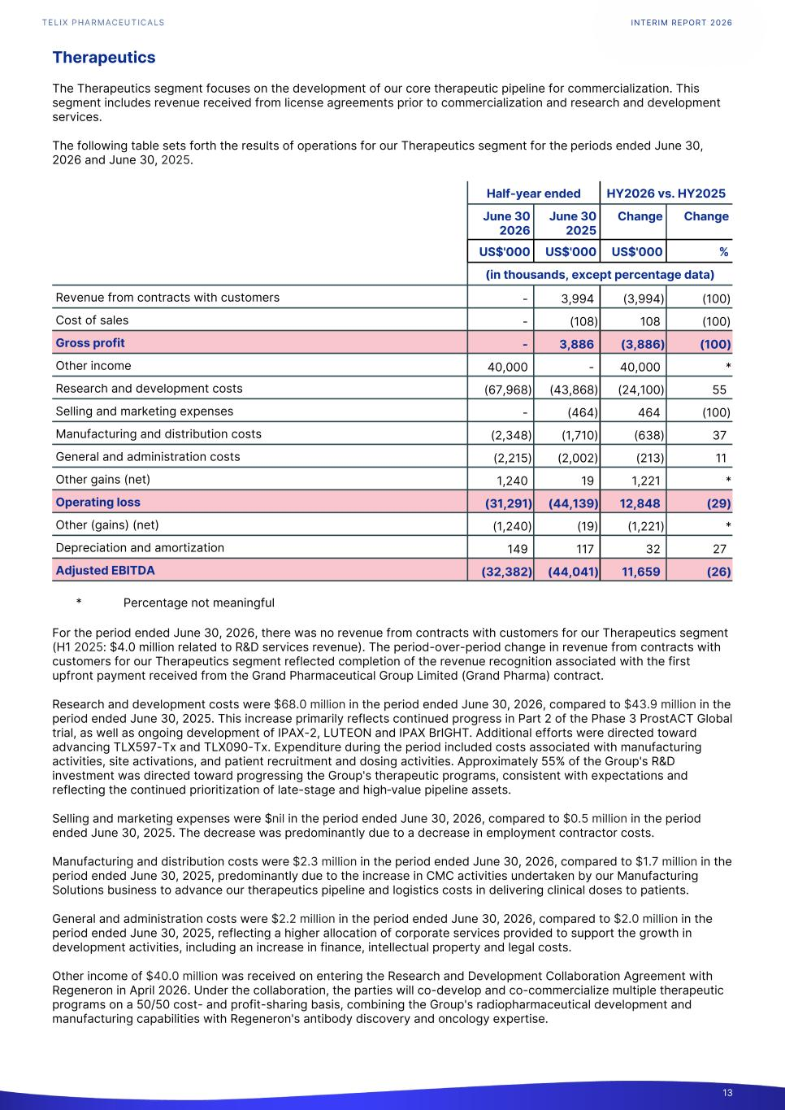
Therapeutics The Therapeutics segment focuses on the development of our core therapeutic pipeline for commercialization. This segment includes revenue received from license agreements prior to commercialization and research and development services. The following table sets forth the results of operations for our Therapeutics segment for the periods ended June 30, 2026 and June 30, 2025. Half-year ended HY2026 vs. HY2025 June 30 2026 June 30 2025 Change Change US$'000 US$'000 US$'000 % (in thousands, except percentage data) Revenue from contracts with customers - 3,994 (3,994) (100) Cost of sales - (108) 108 (100) Gross profit - 3,886 (3,886) (100) Other income 40,000 - 40,000 * Research and development costs (67,968) (43,868) (24,100) 55 Selling and marketing expenses - (464) 464 (100) Manufacturing and distribution costs (2,348) (1,710) (638) 37 General and administration costs (2,215) (2,002) (213) 11 Other gains (net) 1,240 19 1,221 * Operating loss (31,291) (44,139) 12,848 (29) Other (gains) (net) (1,240) (19) (1,221) * Depreciation and amortization 149 117 32 27 Adjusted EBITDA (32,382) (44,041) 11,659 (26) * Percentage not meaningful For the period ended June 30, 2026, there was no revenue from contracts with customers for our Therapeutics segment (H1 2025: $4.0 million related to R&D services revenue). The period-over-period change in revenue from contracts with customers for our Therapeutics segment reflected completion of the revenue recognition associated with the first upfront payment received from the Grand Pharmaceutical Group Limited (Grand Pharma) contract. Research and development costs were $68.0 million in the period ended June 30, 2026, compared to $43.9 million in the period ended June 30, 2025. This increase primarily reflects continued progress in Part 2 of the Phase 3 ProstACT Global trial, as well as ongoing development of IPAX-2, LUTEON and IPAX BrIGHT. Additional efforts were directed toward advancing TLX597-Tx and TLX090-Tx. Expenditure during the period included costs associated with manufacturing activities, site activations, and patient recruitment and dosing activities. Approximately 55% of the Group's R&D investment was directed toward progressing the Group's therapeutic programs, consistent with expectations and reflecting the continued prioritization of late-stage and high-value pipeline assets. Selling and marketing expenses were $nil in the period ended June 30, 2026, compared to $0.5 million in the period ended June 30, 2025. The decrease was predominantly due to a decrease in employment contractor costs. Manufacturing and distribution costs were $2.3 million in the period ended June 30, 2026, compared to $1.7 million in the period ended June 30, 2025, predominantly due to the increase in CMC activities undertaken by our Manufacturing Solutions business to advance our therapeutics pipeline and logistics costs in delivering clinical doses to patients. General and administration costs were $2.2 million in the period ended June 30, 2026, compared to $2.0 million in the period ended June 30, 2025, reflecting a higher allocation of corporate services provided to support the growth in development activities, including an increase in finance, intellectual property and legal costs. Other income of $40.0 million was received on entering the Research and Development Collaboration Agreement with Regeneron in April 2026. Under the collaboration, the parties will co-develop and co-commercialize multiple therapeutic programs on a 50/50 cost- and profit-sharing basis, combining the Group's radiopharmaceutical development and manufacturing capabilities with Regeneron's antibody discovery and oncology expertise. INTERIM REPORT 2026 13

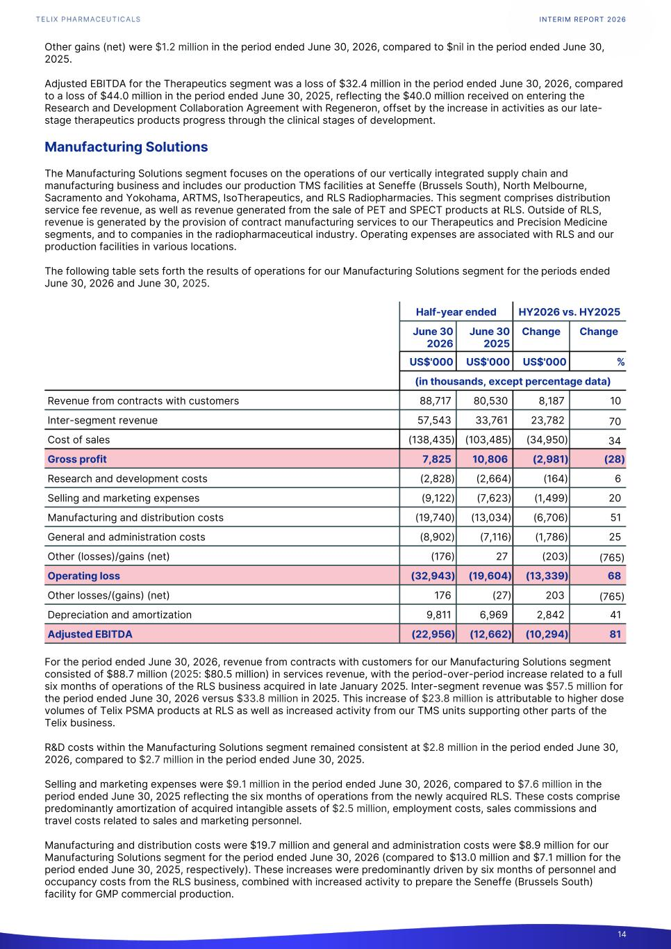
Other gains (net) were $1.2 million in the period ended June 30, 2026, compared to $nil in the period ended June 30, 2025. Adjusted EBITDA for the Therapeutics segment was a loss of $32.4 million in the period ended June 30, 2026, compared to a loss of $44.0 million in the period ended June 30, 2025, reflecting the $40.0 million received on entering the Research and Development Collaboration Agreement with Regeneron, offset by the increase in activities as our late- stage therapeutics products progress through the clinical stages of development. Manufacturing Solutions The Manufacturing Solutions segment focuses on the operations of our vertically integrated supply chain and manufacturing business and includes our production TMS facilities at Seneffe (Brussels South), North Melbourne, Sacramento and Yokohama, ARTMS, IsoTherapeutics, and RLS Radiopharmacies. This segment comprises distribution service fee revenue, as well as revenue generated from the sale of PET and SPECT products at RLS. Outside of RLS, revenue is generated by the provision of contract manufacturing services to our Therapeutics and Precision Medicine segments, and to companies in the radiopharmaceutical industry. Operating expenses are associated with RLS and our production facilities in various locations. The following table sets forth the results of operations for our Manufacturing Solutions segment for the periods ended June 30, 2026 and June 30, 2025. Half-year ended HY2026 vs. HY2025 June 30 2026 June 30 2025 Change Change US$'000 US$'000 US$'000 % (in thousands, except percentage data) Revenue from contracts with customers 88,717 80,530 8,187 10 Inter-segment revenue 57,543 33,761 23,782 70 Cost of sales (138,435) (103,485) (34,950) 34 Gross profit 7,825 10,806 (2,981) (28) Research and development costs (2,828) (2,664) (164) 6 Selling and marketing expenses (9,122) (7,623) (1,499) 20 Manufacturing and distribution costs (19,740) (13,034) (6,706) 51 General and administration costs (8,902) (7,116) (1,786) 25 Other (losses)/gains (net) (176) 27 (203) (765) Operating loss (32,943) (19,604) (13,339) 68 Other losses/(gains) (net) 176 (27) 203 (765) Depreciation and amortization 9,811 6,969 2,842 41 Adjusted EBITDA (22,956) (12,662) (10,294) 81 For the period ended June 30, 2026, revenue from contracts with customers for our Manufacturing Solutions segment consisted of $88.7 million (2025: $80.5 million) in services revenue, with the period-over-period increase related to a full six months of operations of the RLS business acquired in late January 2025. Inter-segment revenue was $57.5 million for the period ended June 30, 2026 versus $33.8 million in 2025. This increase of $23.8 million is attributable to higher dose volumes of Telix PSMA products at RLS as well as increased activity from our TMS units supporting other parts of the Telix business. R&D costs within the Manufacturing Solutions segment remained consistent at $2.8 million in the period ended June 30, 2026, compared to $2.7 million in the period ended June 30, 2025. Selling and marketing expenses were $9.1 million in the period ended June 30, 2026, compared to $7.6 million in the period ended June 30, 2025 reflecting the six months of operations from the newly acquired RLS. These costs comprise predominantly amortization of acquired intangible assets of $2.5 million, employment costs, sales commissions and travel costs related to sales and marketing personnel. Manufacturing and distribution costs were $19.7 million and general and administration costs were $8.9 million for our Manufacturing Solutions segment for the period ended June 30, 2026 (compared to $13.0 million and $7.1 million for the period ended June 30, 2025, respectively). These increases were predominantly driven by six months of personnel and occupancy costs from the RLS business, combined with increased activity to prepare the Seneffe (Brussels South) facility for GMP commercial production. INTERIM REPORT 2026 14

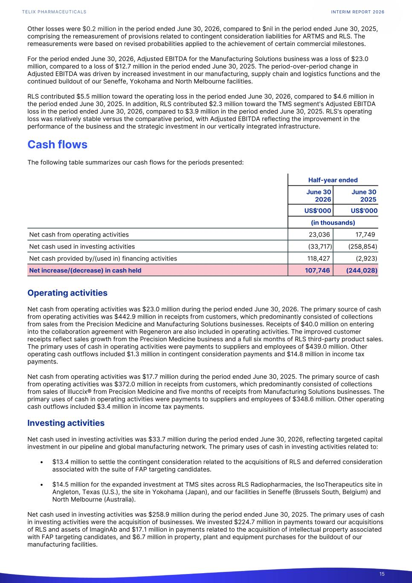
Other losses were $0.2 million in the period ended June 30, 2026, compared to $nil in the period ended June 30, 2025, comprising the remeasurement of provisions related to contingent consideration liabilities for ARTMS and RLS. The remeasurements were based on revised probabilities applied to the achievement of certain commercial milestones. For the period ended June 30, 2026, Adjusted EBITDA for the Manufacturing Solutions business was a loss of $23.0 million, compared to a loss of $12.7 million in the period ended June 30, 2025. The period-over-period change in Adjusted EBITDA was driven by increased investment in our manufacturing, supply chain and logistics functions and the continued buildout of our Seneffe, Yokohama and North Melbourne facilities. RLS contributed $5.5 million toward the operating loss in the period ended June 30, 2026, compared to $4.6 million in the period ended June 30, 2025. In addition, RLS contributed $2.3 million toward the TMS segment's Adjusted EBITDA loss in the period ended June 30, 2026, compared to $3.9 million in the period ended June 30, 2025. RLS's operating loss was relatively stable versus the comparative period, with Adjusted EBITDA reflecting the improvement in the performance of the business and the strategic investment in our vertically integrated infrastructure. Cash flows The following table summarizes our cash flows for the periods presented: Half-year ended June 30 2026 June 30 2025 US$'000 US$'000 (in thousands) Net cash from operating activities 23,036 17,749 Net cash used in investing activities (33,717) (258,854) Net cash provided by/(used in) financing activities 118,427 (2,923) Net increase/(decrease) in cash held 107,746 (244,028) Operating activities Net cash from operating activities was $23.0 million during the period ended June 30, 2026. The primary source of cash from operating activities was $442.9 million in receipts from customers, which predominantly consisted of collections from sales from the Precision Medicine and Manufacturing Solutions businesses. Receipts of $40.0 million on entering into the collaboration agreement with Regeneron are also included in operating activities. The improved customer receipts reflect sales growth from the Precision Medicine business and a full six months of RLS third-party product sales. The primary uses of cash in operating activities were payments to suppliers and employees of $439.0 million. Other operating cash outflows included $1.3 million in contingent consideration payments and $14.8 million in income tax payments. Net cash from operating activities was $17.7 million during the period ended June 30, 2025. The primary source of cash from operating activities was $372.0 million in receipts from customers, which predominantly consisted of collections from sales of Illuccix® from Precision Medicine and five months of receipts from Manufacturing Solutions businesses. The primary uses of cash in operating activities were payments to suppliers and employees of $348.6 million. Other operating cash outflows included $3.4 million in income tax payments. Investing activities Net cash used in investing activities was $33.7 million during the period ended June 30, 2026, reflecting targeted capital investment in our pipeline and global manufacturing network. The primary uses of cash in investing activities related to: • $13.4 million to settle the contingent consideration related to the acquisitions of RLS and deferred consideration associated with the suite of FAP targeting candidates. • $14.5 million for the expanded investment at TMS sites across RLS Radiopharmacies, the IsoTherapeutics site in Angleton, Texas (U.S.), the site in Yokohama (Japan), and our facilities in Seneffe (Brussels South, Belgium) and North Melbourne (Australia). Net cash used in investing activities was $258.9 million during the period ended June 30, 2025. The primary uses of cash in investing activities were the acquisition of businesses. We invested $224.7 million in payments toward our acquisitions of RLS and assets of ImaginAb and $17.1 million in payments related to the acquisition of intellectual property associated with FAP targeting candidates, and $6.7 million in property, plant and equipment purchases for the buildout of our manufacturing facilities. INTERIM REPORT 2026 15

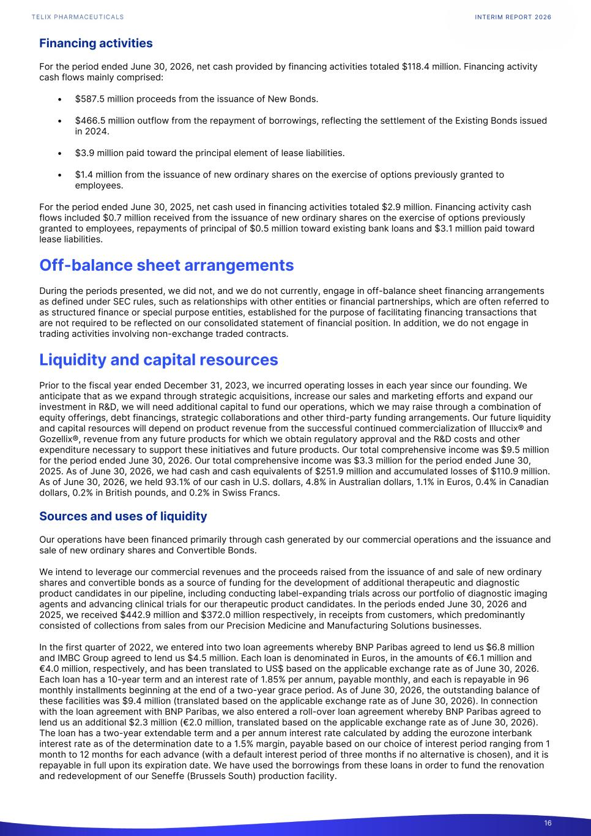
Financing activities For the period ended June 30, 2026, net cash provided by financing activities totaled $118.4 million. Financing activity cash flows mainly comprised: • $587.5 million proceeds from the issuance of New Bonds. • $466.5 million outflow from the repayment of borrowings, reflecting the settlement of the Existing Bonds issued in 2024. • $3.9 million paid toward the principal element of lease liabilities. • $1.4 million from the issuance of new ordinary shares on the exercise of options previously granted to employees. For the period ended June 30, 2025, net cash used in financing activities totaled $2.9 million. Financing activity cash flows included $0.7 million received from the issuance of new ordinary shares on the exercise of options previously granted to employees, repayments of principal of $0.5 million toward existing bank loans and $3.1 million paid toward lease liabilities. Off-balance sheet arrangements During the periods presented, we did not, and we do not currently, engage in off-balance sheet financing arrangements as defined under SEC rules, such as relationships with other entities or financial partnerships, which are often referred to as structured finance or special purpose entities, established for the purpose of facilitating financing transactions that are not required to be reflected on our consolidated statement of financial position. In addition, we do not engage in trading activities involving non-exchange traded contracts. Liquidity and capital resources Prior to the fiscal year ended December 31, 2023, we incurred operating losses in each year since our founding. We anticipate that as we expand through strategic acquisitions, increase our sales and marketing efforts and expand our investment in R&D, we will need additional capital to fund our operations, which we may raise through a combination of equity offerings, debt financings, strategic collaborations and other third-party funding arrangements. Our future liquidity and capital resources will depend on product revenue from the successful continued commercialization of Illuccix® and Gozellix®, revenue from any future products for which we obtain regulatory approval and the R&D costs and other expenditure necessary to support these initiatives and future products. Our total comprehensive income was $9.5 million for the period ended June 30, 2026. Our total comprehensive income was $3.3 million for the period ended June 30, 2025. As of June 30, 2026, we had cash and cash equivalents of $251.9 million and accumulated losses of $110.9 million. As of June 30, 2026, we held 93.1% of our cash in U.S. dollars, 4.8% in Australian dollars, 1.1% in Euros, 0.4% in Canadian dollars, 0.2% in British pounds, and 0.2% in Swiss Francs. Sources and uses of liquidity Our operations have been financed primarily through cash generated by our commercial operations and the issuance and sale of new ordinary shares and Convertible Bonds. We intend to leverage our commercial revenues and the proceeds raised from the issuance of and sale of new ordinary shares and convertible bonds as a source of funding for the development of additional therapeutic and diagnostic product candidates in our pipeline, including conducting label-expanding trials across our portfolio of diagnostic imaging agents and advancing clinical trials for our therapeutic product candidates. In the periods ended June 30, 2026 and 2025, we received $442.9 million and $372.0 million respectively, in receipts from customers, which predominantly consisted of collections from sales from our Precision Medicine and Manufacturing Solutions businesses. In the first quarter of 2022, we entered into two loan agreements whereby BNP Paribas agreed to lend us $6.8 million and IMBC Group agreed to lend us $4.5 million. Each loan is denominated in Euros, in the amounts of €6.1 million and €4.0 million, respectively, and has been translated to US$ based on the applicable exchange rate as of June 30, 2026. Each loan has a 10-year term and an interest rate of 1.85% per annum, payable monthly, and each is repayable in 96 monthly installments beginning at the end of a two-year grace period. As of June 30, 2026, the outstanding balance of these facilities was $9.4 million (translated based on the applicable exchange rate as of June 30, 2026). In connection with the loan agreement with BNP Paribas, we also entered a roll-over loan agreement whereby BNP Paribas agreed to lend us an additional $2.3 million (€2.0 million, translated based on the applicable exchange rate as of June 30, 2026). The loan has a two-year extendable term and a per annum interest rate calculated by adding the eurozone interbank interest rate as of the determination date to a 1.5% margin, payable based on our choice of interest period ranging from 1 month to 12 months for each advance (with a default interest period of three months if no alternative is chosen), and it is repayable in full upon its expiration date. We have used the borrowings from these loans in order to fund the renovation and redevelopment of our Seneffe (Brussels South) production facility. INTERIM REPORT 2026 16

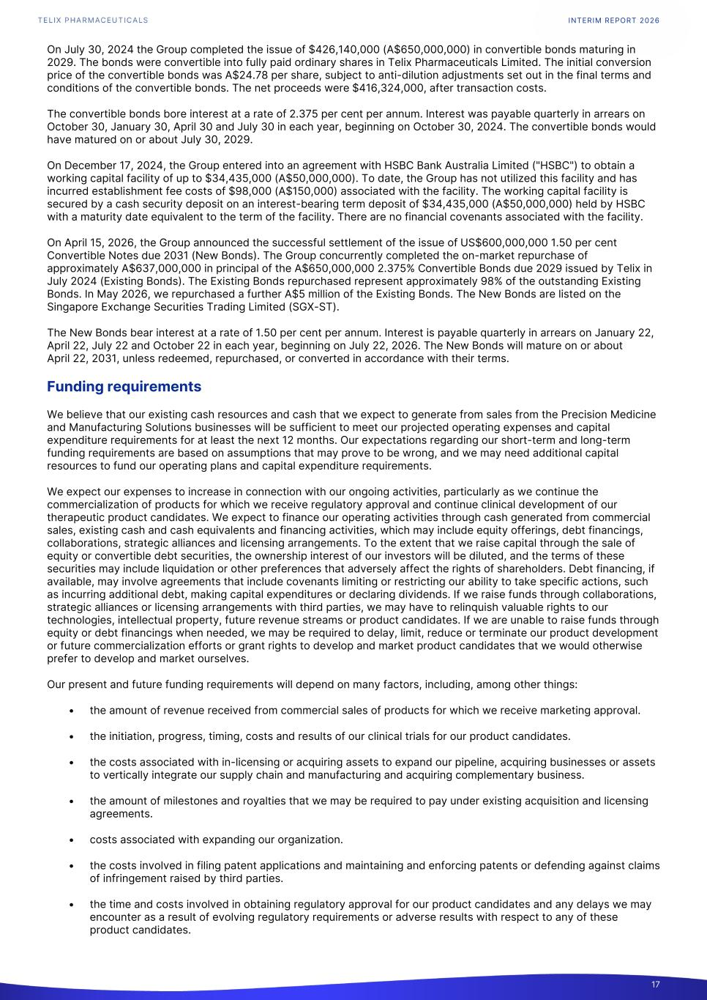
On July 30, 2024 the Group completed the issue of $426,140,000 (A$650,000,000) in convertible bonds maturing in 2029. The bonds were convertible into fully paid ordinary shares in Telix Pharmaceuticals Limited. The initial conversion price of the convertible bonds was A$24.78 per share, subject to anti-dilution adjustments set out in the final terms and conditions of the convertible bonds. The net proceeds were $416,324,000, after transaction costs. The convertible bonds bore interest at a rate of 2.375 per cent per annum. Interest was payable quarterly in arrears on October 30, January 30, April 30 and July 30 in each year, beginning on October 30, 2024. The convertible bonds would have matured on or about July 30, 2029. On December 17, 2024, the Group entered into an agreement with HSBC Bank Australia Limited ("HSBC") to obtain a working capital facility of up to $34,435,000 (A$50,000,000). To date, the Group has not utilized this facility and has incurred establishment fee costs of $98,000 (A$150,000) associated with the facility. The working capital facility is secured by a cash security deposit on an interest-bearing term deposit of $34,435,000 (A$50,000,000) held by HSBC with a maturity date equivalent to the term of the facility. There are no financial covenants associated with the facility. On April 15, 2026, the Group announced the successful settlement of the issue of US$600,000,000 1.50 per cent Convertible Notes due 2031 (New Bonds). The Group concurrently completed the on-market repurchase of approximately A$637,000,000 in principal of the A$650,000,000 2.375% Convertible Bonds due 2029 issued by Telix in July 2024 (Existing Bonds). The Existing Bonds repurchased represent approximately 98% of the outstanding Existing Bonds. In May 2026, we repurchased a further A$5 million of the Existing Bonds. The New Bonds are listed on the Singapore Exchange Securities Trading Limited (SGX-ST). The New Bonds bear interest at a rate of 1.50 per cent per annum. Interest is payable quarterly in arrears on January 22, April 22, July 22 and October 22 in each year, beginning on July 22, 2026. The New Bonds will mature on or about April 22, 2031, unless redeemed, repurchased, or converted in accordance with their terms. Funding requirements We believe that our existing cash resources and cash that we expect to generate from sales from the Precision Medicine and Manufacturing Solutions businesses will be sufficient to meet our projected operating expenses and capital expenditure requirements for at least the next 12 months. Our expectations regarding our short-term and long-term funding requirements are based on assumptions that may prove to be wrong, and we may need additional capital resources to fund our operating plans and capital expenditure requirements. We expect our expenses to increase in connection with our ongoing activities, particularly as we continue the commercialization of products for which we receive regulatory approval and continue clinical development of our therapeutic product candidates. We expect to finance our operating activities through cash generated from commercial sales, existing cash and cash equivalents and financing activities, which may include equity offerings, debt financings, collaborations, strategic alliances and licensing arrangements. To the extent that we raise capital through the sale of equity or convertible debt securities, the ownership interest of our investors will be diluted, and the terms of these securities may include liquidation or other preferences that adversely affect the rights of shareholders. Debt financing, if available, may involve agreements that include covenants limiting or restricting our ability to take specific actions, such as incurring additional debt, making capital expenditures or declaring dividends. If we raise funds through collaborations, strategic alliances or licensing arrangements with third parties, we may have to relinquish valuable rights to our technologies, intellectual property, future revenue streams or product candidates. If we are unable to raise funds through equity or debt financings when needed, we may be required to delay, limit, reduce or terminate our product development or future commercialization efforts or grant rights to develop and market product candidates that we would otherwise prefer to develop and market ourselves. Our present and future funding requirements will depend on many factors, including, among other things: • the amount of revenue received from commercial sales of products for which we receive marketing approval. • the initiation, progress, timing, costs and results of our clinical trials for our product candidates. • the costs associated with in-licensing or acquiring assets to expand our pipeline, acquiring businesses or assets to vertically integrate our supply chain and manufacturing and acquiring complementary business. • the amount of milestones and royalties that we may be required to pay under existing acquisition and licensing agreements. • costs associated with expanding our organization. • the costs involved in filing patent applications and maintaining and enforcing patents or defending against claims of infringement raised by third parties. • the time and costs involved in obtaining regulatory approval for our product candidates and any delays we may encounter as a result of evolving regulatory requirements or adverse results with respect to any of these product candidates. INTERIM REPORT 2026 17

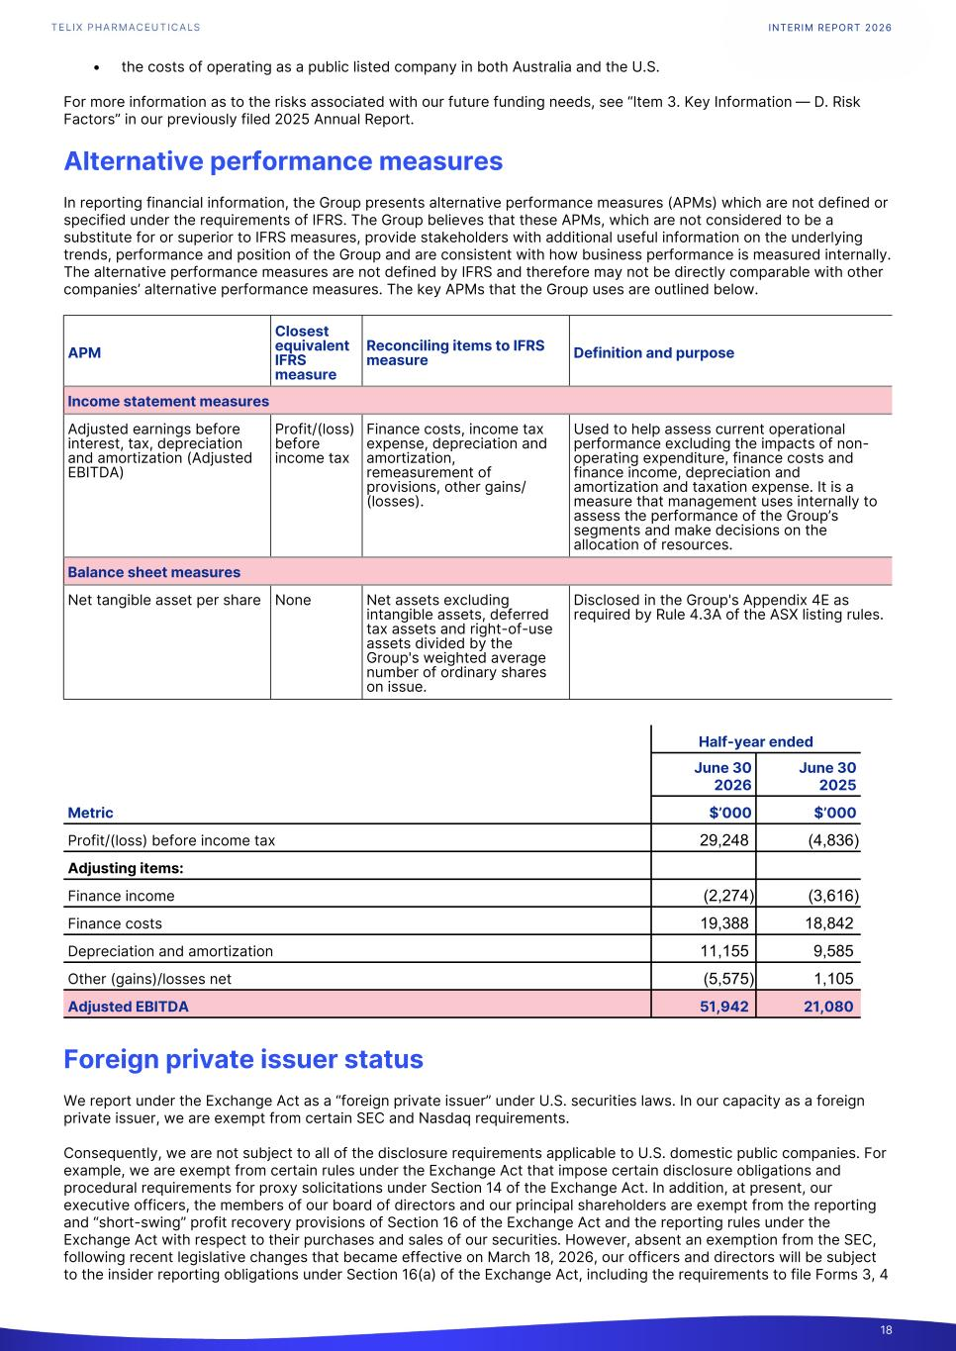
• the costs of operating as a public listed company in both Australia and the U.S. For more information as to the risks associated with our future funding needs, see “Item 3. Key Information — D. Risk Factors” in our previously filed 2025 Annual Report. Alternative performance measures In reporting financial information, the Group presents alternative performance measures (APMs) which are not defined or specified under the requirements of IFRS. The Group believes that these APMs, which are not considered to be a substitute for or superior to IFRS measures, provide stakeholders with additional useful information on the underlying trends, performance and position of the Group and are consistent with how business performance is measured internally. The alternative performance measures are not defined by IFRS and therefore may not be directly comparable with other companies’ alternative performance measures. The key APMs that the Group uses are outlined below. APM Closest equivalent IFRS measure Reconciling items to IFRS measure Definition and purpose Income statement measures Adjusted earnings before interest, tax, depreciation and amortization (Adjusted EBITDA) Profit/(loss) before income tax Finance costs, income tax expense, depreciation and amortization, remeasurement of provisions, other gains/ (losses). Used to help assess current operational performance excluding the impacts of non- operating expenditure, finance costs and finance income, depreciation and amortization and taxation expense. It is a measure that management uses internally to assess the performance of the Group’s segments and make decisions on the allocation of resources. Balance sheet measures Net tangible asset per share None Net assets excluding intangible assets, deferred tax assets and right-of-use assets divided by the Group's weighted average number of ordinary shares on issue. Disclosed in the Group's Appendix 4E as required by Rule 4.3A of the ASX listing rules. Half-year ended June 30 2026 June 30 2025 Metric $’000 $’000 Profit/(loss) before income tax 29,248 (4,836) Adjusting items: Finance income (2,274) (3,616) Finance costs 19,388 18,842 Depreciation and amortization 11,155 9,585 Other (gains)/losses net (5,575) 1,105 Adjusted EBITDA 51,942 21,080 Foreign private issuer status We report under the Exchange Act as a “foreign private issuer” under U.S. securities laws. In our capacity as a foreign private issuer, we are exempt from certain SEC and Nasdaq requirements. Consequently, we are not subject to all of the disclosure requirements applicable to U.S. domestic public companies. For example, we are exempt from certain rules under the Exchange Act that impose certain disclosure obligations and procedural requirements for proxy solicitations under Section 14 of the Exchange Act. In addition, at present, our executive officers, the members of our board of directors and our principal shareholders are exempt from the reporting and “short-swing” profit recovery provisions of Section 16 of the Exchange Act and the reporting rules under the Exchange Act with respect to their purchases and sales of our securities. However, absent an exemption from the SEC, following recent legislative changes that became effective on March 18, 2026, our officers and directors will be subject to the insider reporting obligations under Section 16(a) of the Exchange Act, including the requirements to file Forms 3, 4 INTERIM REPORT 2026 18

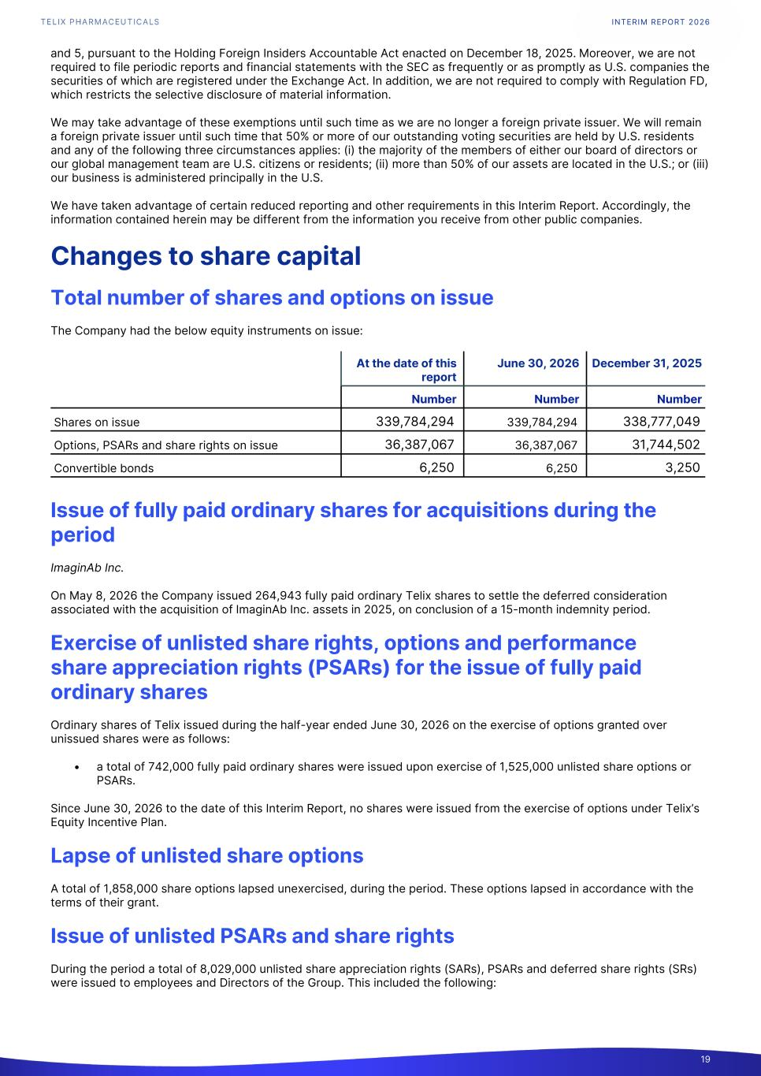
and 5, pursuant to the Holding Foreign Insiders Accountable Act enacted on December 18, 2025. Moreover, we are not required to file periodic reports and financial statements with the SEC as frequently or as promptly as U.S. companies the securities of which are registered under the Exchange Act. In addition, we are not required to comply with Regulation FD, which restricts the selective disclosure of material information. We may take advantage of these exemptions until such time as we are no longer a foreign private issuer. We will remain a foreign private issuer until such time that 50% or more of our outstanding voting securities are held by U.S. residents and any of the following three circumstances applies: (i) the majority of the members of either our board of directors or our global management team are U.S. citizens or residents; (ii) more than 50% of our assets are located in the U.S.; or (iii) our business is administered principally in the U.S. We have taken advantage of certain reduced reporting and other requirements in this Interim Report. Accordingly, the information contained herein may be different from the information you receive from other public companies. Changes to share capital Total number of shares and options on issue The Company had the below equity instruments on issue: At the date of this report June 30, 2026 December 31, 2025 Number Number Number Shares on issue 339,784,294 339,784,294 338,777,049 Options, PSARs and share rights on issue 36,387,067 36,387,067 31,744,502 Convertible bonds 6,250 6,250 3,250 Issue of fully paid ordinary shares for acquisitions during the period ImaginAb Inc. On May 8, 2026 the Company issued 264,943 fully paid ordinary Telix shares to settle the deferred consideration associated with the acquisition of ImaginAb Inc. assets in 2025, on conclusion of a 15-month indemnity period. Exercise of unlisted share rights, options and performance share appreciation rights (PSARs) for the issue of fully paid ordinary shares Ordinary shares of Telix issued during the half-year ended June 30, 2026 on the exercise of options granted over unissued shares were as follows: • a total of 742,000 fully paid ordinary shares were issued upon exercise of 1,525,000 unlisted share options or PSARs. Since June 30, 2026 to the date of this Interim Report, no shares were issued from the exercise of options under Telix’s Equity Incentive Plan. Lapse of unlisted share options A total of 1,858,000 share options lapsed unexercised, during the period. These options lapsed in accordance with the terms of their grant. Issue of unlisted PSARs and share rights During the period a total of 8,029,000 unlisted share appreciation rights (SARs), PSARs and deferred share rights (SRs) were issued to employees and Directors of the Group. This included the following: INTERIM REPORT 2026 19

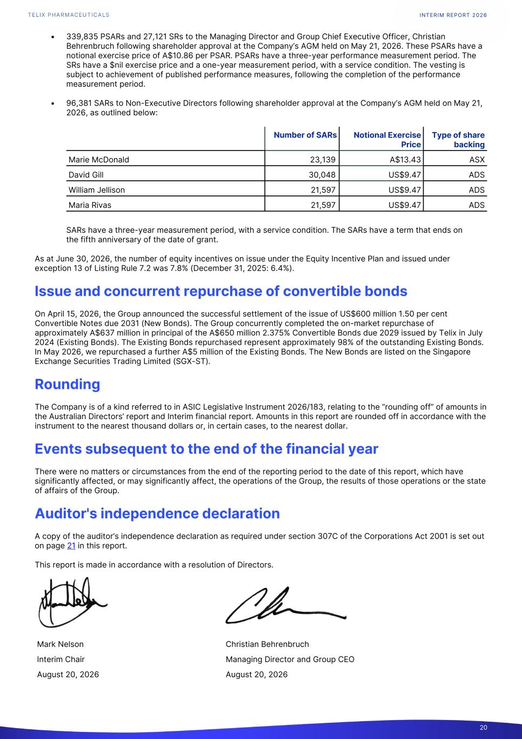
• 339,835 PSARs and 27,121 SRs to the Managing Director and Group Chief Executive Officer, Christian Behrenbruch following shareholder approval at the Company’s AGM held on May 21, 2026. These PSARs have a notional exercise price of A$10.86 per PSAR. PSARs have a three-year performance measurement period. The SRs have a $nil exercise price and a one-year measurement period, with a service condition. The vesting is subject to achievement of published performance measures, following the completion of the performance measurement period. • 96,381 SARs to Non-Executive Directors following shareholder approval at the Company’s AGM held on May 21, 2026, as outlined below: Marie McDonald 23,139 A$13.43 ASX David Gill 30,048 US$9.47 ADS William Jellison 21,597 US$9.47 ADS Maria Rivas 21,597 US$9.47 ADS Number of SARs Notional Exercise Price Type of share backing SARs have a three-year measurement period, with a service condition. The SARs have a term that ends on the fifth anniversary of the date of grant. As at June 30, 2026, the number of equity incentives on issue under the Equity Incentive Plan and issued under exception 13 of Listing Rule 7.2 was 7.8% (December 31, 2025: 6.4%). Issue and concurrent repurchase of convertible bonds On April 15, 2026, the Group announced the successful settlement of the issue of US$600 million 1.50 per cent Convertible Notes due 2031 (New Bonds). The Group concurrently completed the on-market repurchase of approximately A$637 million in principal of the A$650 million 2.375% Convertible Bonds due 2029 issued by Telix in July 2024 (Existing Bonds). The Existing Bonds repurchased represent approximately 98% of the outstanding Existing Bonds. In May 2026, we repurchased a further A$5 million of the Existing Bonds. The New Bonds are listed on the Singapore Exchange Securities Trading Limited (SGX-ST). Rounding The Company is of a kind referred to in ASIC Legislative Instrument 2026/183, relating to the “rounding off” of amounts in the Australian Directors’ report and Interim financial report. Amounts in this report are rounded off in accordance with the instrument to the nearest thousand dollars or, in certain cases, to the nearest dollar. Events subsequent to the end of the financial year There were no matters or circumstances from the end of the reporting period to the date of this report, which have significantly affected, or may significantly affect, the operations of the Group, the results of those operations or the state of affairs of the Group. Auditor's independence declaration A copy of the auditor’s independence declaration as required under section 307C of the Corporations Act 2001 is set out on page 21 in this report. This report is made in accordance with a resolution of Directors. Mark Nelson Christian Behrenbruch Interim Chair Managing Director and Group CEO August 20, 2026 August 20, 2026 INTERIM REPORT 2026 20

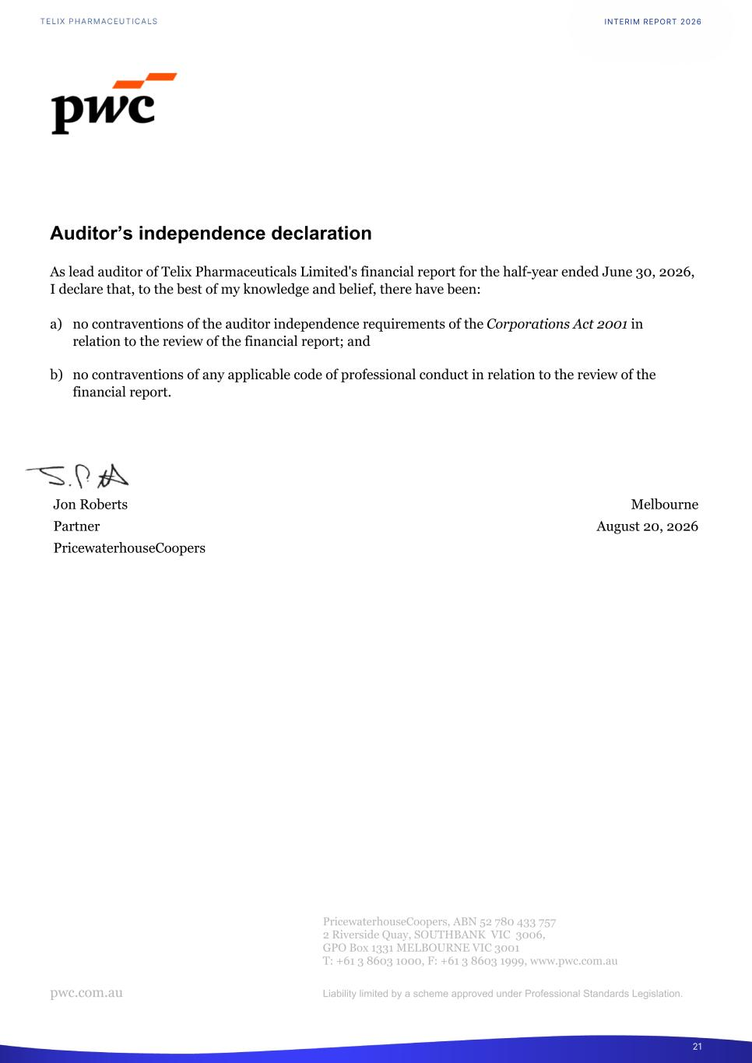
Auditor’s independence declaration As lead auditor of Telix Pharmaceuticals Limited's financial report for the half-year ended June 30, 2026, I declare that, to the best of my knowledge and belief, there have been: a) no contraventions of the auditor independence requirements of the Corporations Act 2001 in relation to the review of the financial report; and b) no contraventions of any applicable code of professional conduct in relation to the review of the financial report. Jon Roberts Melbourne Partner August 20, 2026 PricewaterhouseCoopers PricewaterhouseCoopers, ABN 52 780 433 757 2 Riverside Quay, SOUTHBANK VIC 3006, GPO Box 1331 MELBOURNE VIC 3001 T: +61 3 8603 1000, F: +61 3 8603 1999, www.pwc.com.au pwc.com.au Liability limited by a scheme approved under Professional Standards Legislation. INTERIM REPORT 2026 21

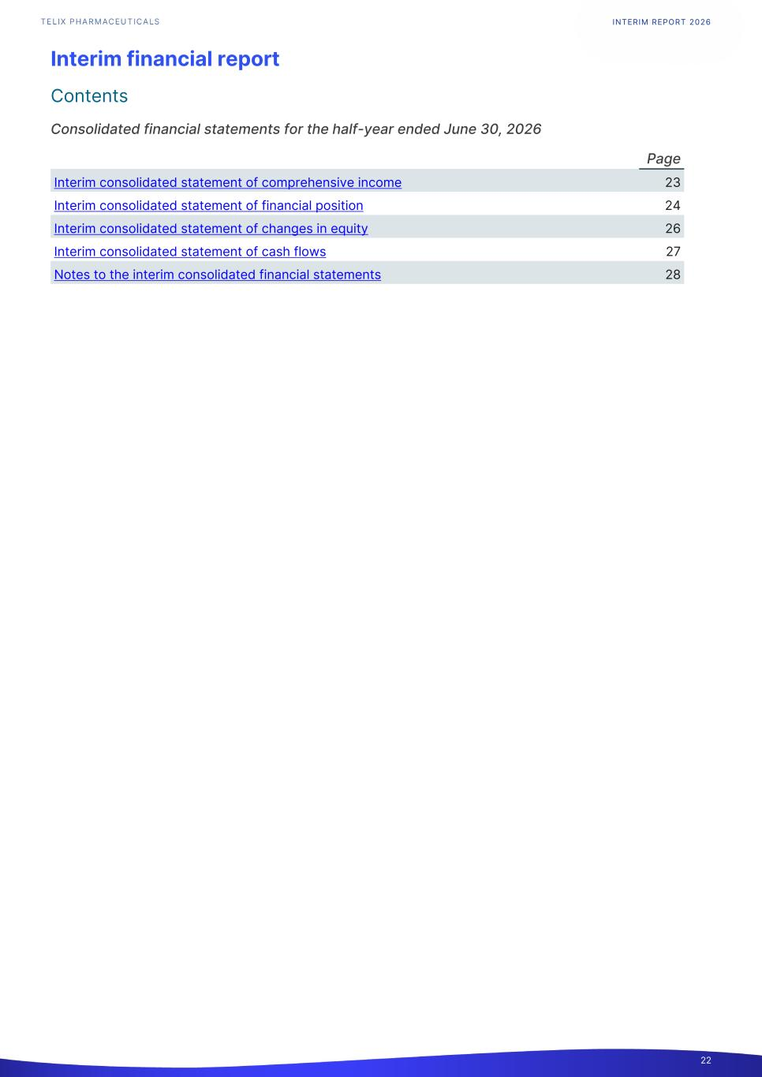
Interim financial report Contents Consolidated financial statements for the half-year ended June 30, 2026 Page Interim consolidated statement of comprehensive income 23 Interim consolidated statement of financial position 24 Interim consolidated statement of changes in equity 26 Interim consolidated statement of cash flows 27 Notes to the interim consolidated financial statements 28 INTERIM REPORT 2026 22

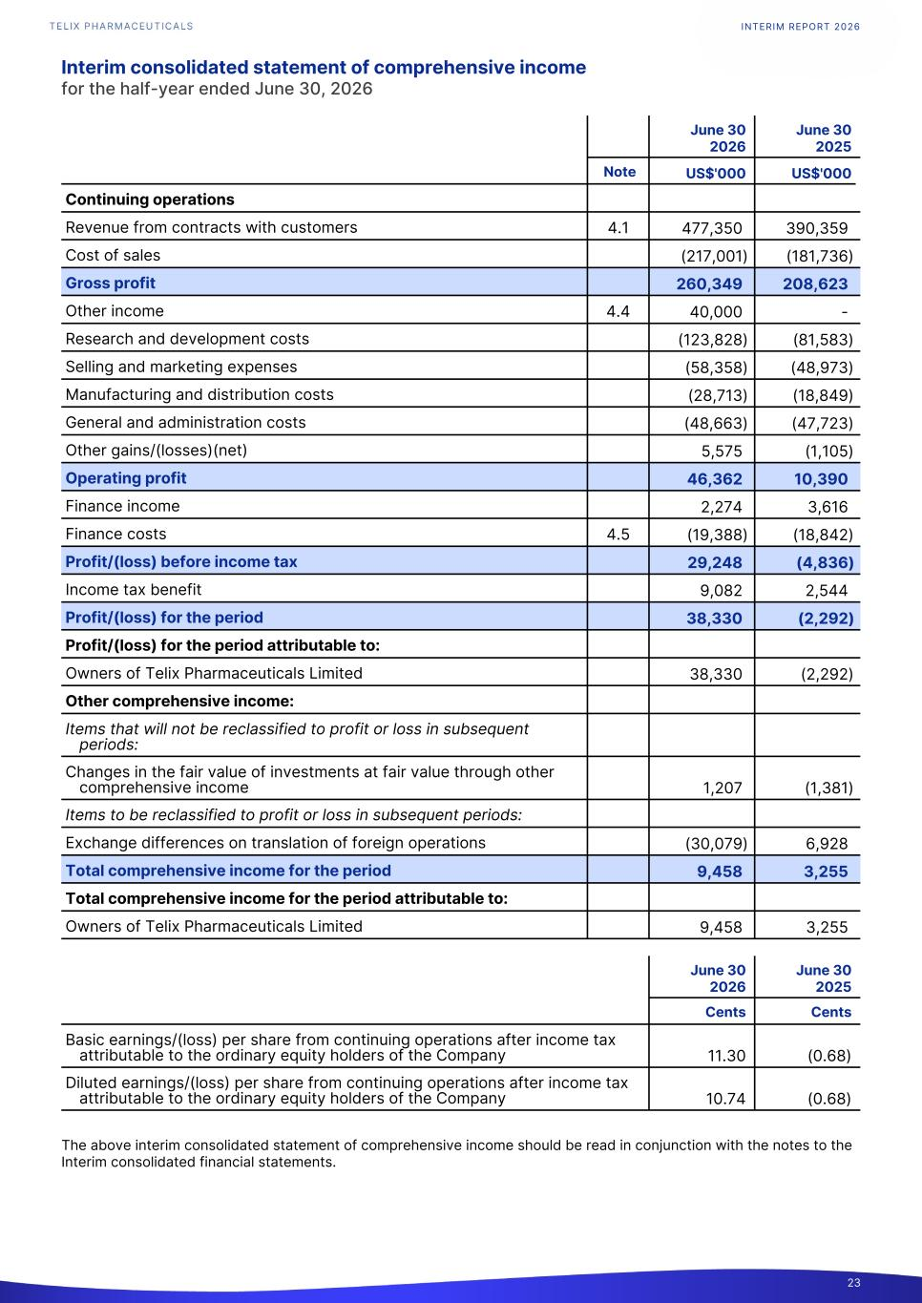
Interim consolidated statement of comprehensive income for the half-year ended June 30, 2026 June 30 2026 June 30 2025 Note US$'000 US$'000 Continuing operations Revenue from contracts with customers 4.1 477,350 390,359 Cost of sales (217,001) (181,736) Gross profit 260,349 208,623 Other income 4.4 40,000 - Research and development costs (123,828) (81,583) Selling and marketing expenses (58,358) (48,973) Manufacturing and distribution costs (28,713) (18,849) General and administration costs (48,663) (47,723) Other gains/(losses)(net) 5,575 (1,105) Operating profit 46,362 10,390 Finance income 2,274 3,616 Finance costs 4.5 (19,388) (18,842) Profit/(loss) before income tax 29,248 (4,836) Income tax benefit 9,082 2,544 Profit/(loss) for the period 38,330 (2,292) Profit/(loss) for the period attributable to: Owners of Telix Pharmaceuticals Limited 38,330 (2,292) Other comprehensive income: Items that will not be reclassified to profit or loss in subsequent periods: Changes in the fair value of investments at fair value through other comprehensive income 1,207 (1,381) Items to be reclassified to profit or loss in subsequent periods: Exchange differences on translation of foreign operations (30,079) 6,928 Total comprehensive income for the period 9,458 3,255 Total comprehensive income for the period attributable to: Owners of Telix Pharmaceuticals Limited 9,458 3,255 June 30 2026 June 30 2025 Cents Cents Basic earnings/(loss) per share from continuing operations after income tax attributable to the ordinary equity holders of the Company 11.30 (0.68) Diluted earnings/(loss) per share from continuing operations after income tax attributable to the ordinary equity holders of the Company 10.74 (0.68) The above interim consolidated statement of comprehensive income should be read in conjunction with the notes to the Interim consolidated financial statements. INTERIM REPORT 2026 23

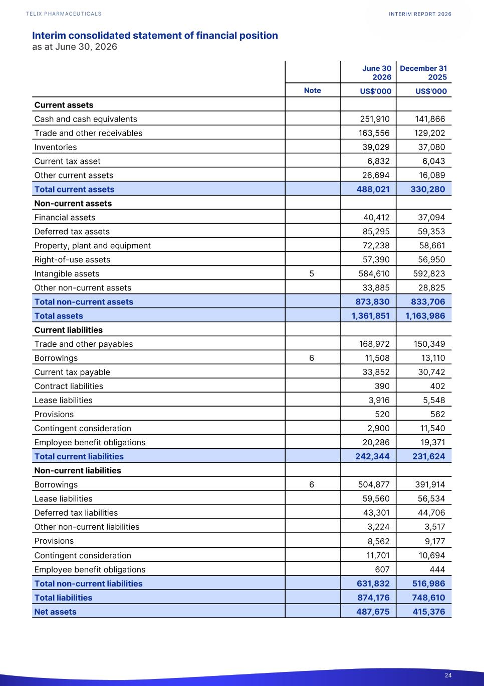
Interim consolidated statement of financial position as at June 30, 2026 Current assets Cash and cash equivalents 251,910 141,866 Trade and other receivables 163,556 129,202 Inventories 39,029 37,080 Current tax asset 6,832 6,043 Other current assets 26,694 16,089 Total current assets 488,021 330,280 Non-current assets Financial assets 40,412 37,094 Deferred tax assets 85,295 59,353 Property, plant and equipment 72,238 58,661 Right-of-use assets 57,390 56,950 Intangible assets 5 584,610 592,823 Other non-current assets 33,885 28,825 Total non-current assets 873,830 833,706 Total assets 1,361,851 1,163,986 Current liabilities Trade and other payables 168,972 150,349 Borrowings 6 11,508 13,110 Current tax payable 33,852 30,742 Contract liabilities 390 402 Lease liabilities 3,916 5,548 Provisions 520 562 Contingent consideration 2,900 11,540 Employee benefit obligations 20,286 19,371 Total current liabilities 242,344 231,624 Non-current liabilities Borrowings 6 504,877 391,914 Lease liabilities 59,560 56,534 Deferred tax liabilities 43,301 44,706 Other non-current liabilities 3,224 3,517 Provisions 8,562 9,177 Contingent consideration 11,701 10,694 Employee benefit obligations 607 444 Total non-current liabilities 631,832 516,986 Total liabilities 874,176 748,610 Net assets 487,675 415,376 June 30 2026 December 31 2025 Note US$'000 US$'000 INTERIM REPORT 2026 24

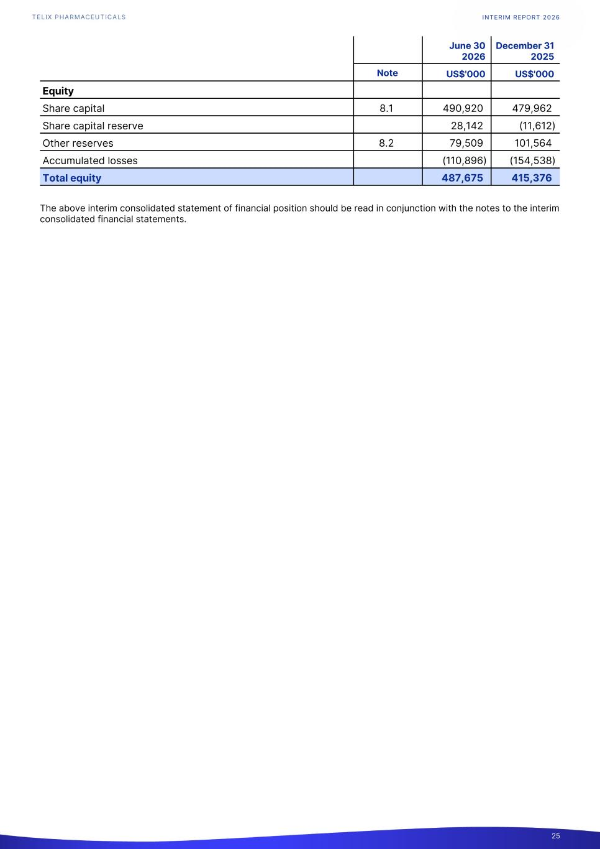
Equity Share capital 8.1 490,920 479,962 Share capital reserve 28,142 (11,612) Other reserves 8.2 79,509 101,564 Accumulated losses (110,896) (154,538) Total equity 487,675 415,376 June 30 2026 December 31 2025 Note US$'000 US$'000 The above interim consolidated statement of financial position should be read in conjunction with the notes to the interim consolidated financial statements. INTERIM REPORT 2026 25

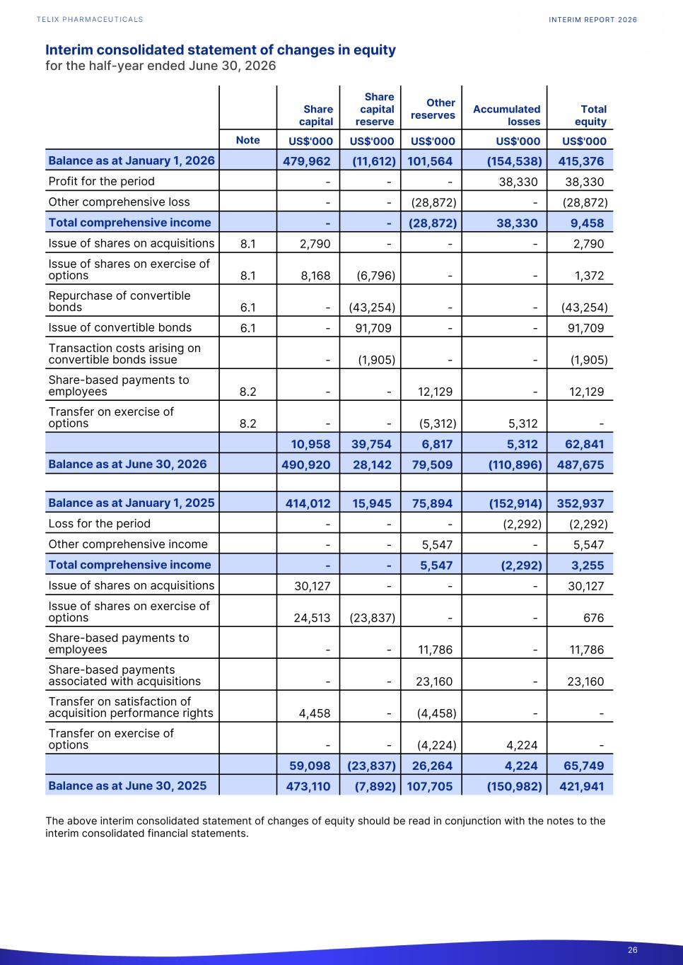
Interim consolidated statement of changes in equity for the half-year ended June 30, 2026 Balance as at January 1, 2026 479,962 (11,612) 101,564 (154,538) 415,376 Profit for the period - - - 38,330 38,330 Other comprehensive loss - - (28,872) - (28,872) Total comprehensive income - - (28,872) 38,330 9,458 Issue of shares on acquisitions 8.1 2,790 - - - 2,790 Issue of shares on exercise of options 8.1 8,168 (6,796) - - 1,372 Repurchase of convertible bonds 6.1 - (43,254) - - (43,254) Issue of convertible bonds 6.1 - 91,709 - - 91,709 Transaction costs arising on convertible bonds issue - (1,905) - - (1,905) Share-based payments to employees 8.2 - - 12,129 - 12,129 Transfer on exercise of options 8.2 - - (5,312) 5,312 - 10,958 39,754 6,817 5,312 62,841 Balance as at June 30, 2026 490,920 28,142 79,509 (110,896) 487,675 Balance as at January 1, 2025 414,012 15,945 75,894 (152,914) 352,937 Loss for the period - - - (2,292) (2,292) Other comprehensive income - - 5,547 - 5,547 Total comprehensive income - - 5,547 (2,292) 3,255 Issue of shares on acquisitions 30,127 - - - 30,127 Issue of shares on exercise of options 24,513 (23,837) - - 676 Share-based payments to employees - - 11,786 - 11,786 Share-based payments associated with acquisitions - - 23,160 - 23,160 Transfer on satisfaction of acquisition performance rights 4,458 - (4,458) - - Transfer on exercise of options - - (4,224) 4,224 - 59,098 (23,837) 26,264 4,224 65,749 Balance as at June 30, 2025 473,110 (7,892) 107,705 (150,982) 421,941 Share capital Share capital reserve Other reserves Accumulated losses Total equity Note US$'000 US$'000 US$'000 US$'000 US$'000 The above interim consolidated statement of changes of equity should be read in conjunction with the notes to the interim consolidated financial statements. INTERIM REPORT 2026 26

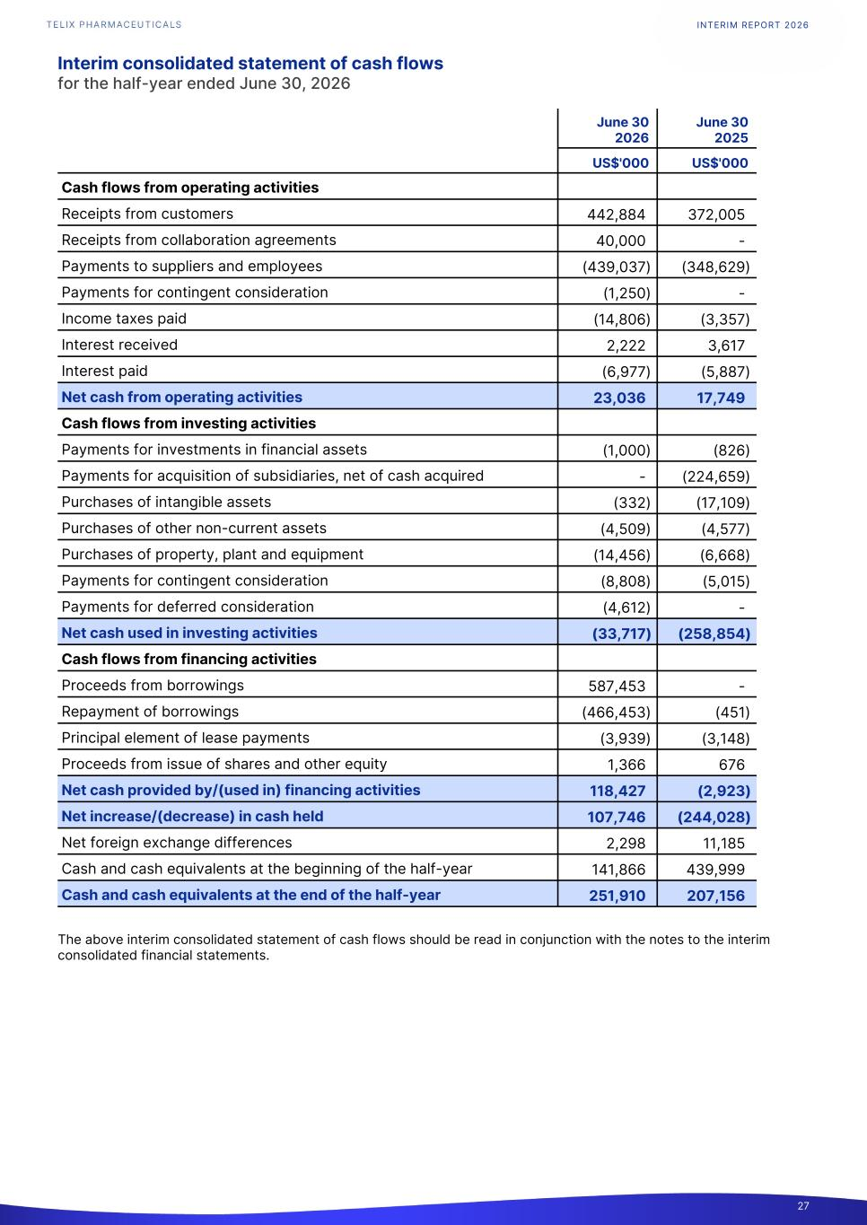
Interim consolidated statement of cash flows for the half-year ended June 30, 2026 June 30 2026 June 30 2025 US$'000 US$'000 Cash flows from operating activities Receipts from customers 442,884 372,005 Receipts from collaboration agreements 40,000 - Payments to suppliers and employees (439,037) (348,629) Payments for contingent consideration (1,250) - Income taxes paid (14,806) (3,357) Interest received 2,222 3,617 Interest paid (6,977) (5,887) Net cash from operating activities 23,036 17,749 Cash flows from investing activities Payments for investments in financial assets (1,000) (826) Payments for acquisition of subsidiaries, net of cash acquired - (224,659) Purchases of intangible assets (332) (17,109) Purchases of other non-current assets (4,509) (4,577) Purchases of property, plant and equipment (14,456) (6,668) Payments for contingent consideration (8,808) (5,015) Payments for deferred consideration (4,612) - Net cash used in investing activities (33,717) (258,854) Cash flows from financing activities Proceeds from borrowings 587,453 - Repayment of borrowings (466,453) (451) Principal element of lease payments (3,939) (3,148) Proceeds from issue of shares and other equity 1,366 676 Net cash provided by/(used in) financing activities 118,427 (2,923) Net increase/(decrease) in cash held 107,746 (244,028) Net foreign exchange differences 2,298 11,185 Cash and cash equivalents at the beginning of the half-year 141,866 439,999 Cash and cash equivalents at the end of the half-year 251,910 207,156 The above interim consolidated statement of cash flows should be read in conjunction with the notes to the interim consolidated financial statements. INTERIM REPORT 2026 27

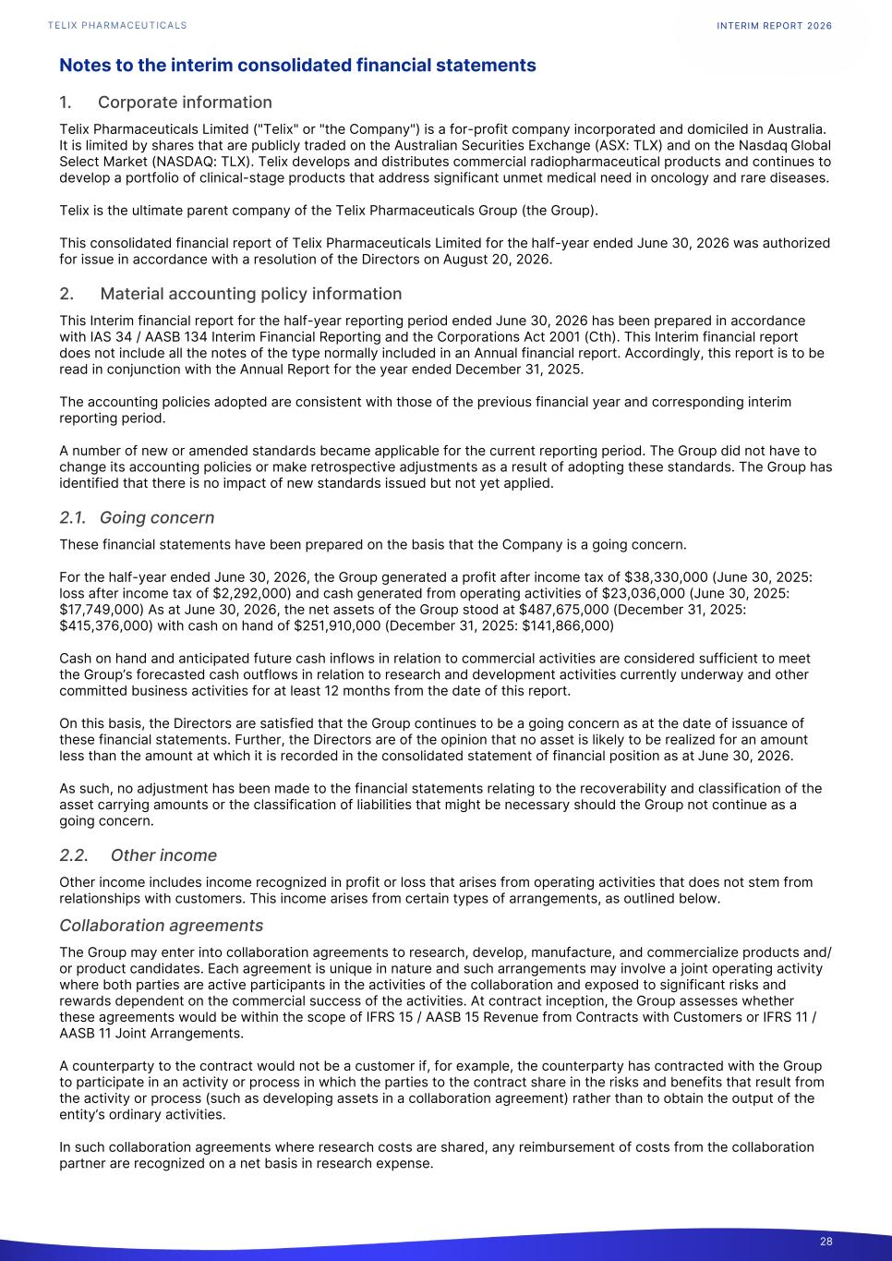
Notes to the interim consolidated financial statements 1. Corporate information Telix Pharmaceuticals Limited ("Telix" or "the Company") is a for-profit company incorporated and domiciled in Australia. It is limited by shares that are publicly traded on the Australian Securities Exchange (ASX: TLX) and on the Nasdaq Global Select Market (NASDAQ: TLX). Telix develops and distributes commercial radiopharmaceutical products and continues to develop a portfolio of clinical-stage products that address significant unmet medical need in oncology and rare diseases. Telix is the ultimate parent company of the Telix Pharmaceuticals Group (the Group). This consolidated financial report of Telix Pharmaceuticals Limited for the half-year ended June 30, 2026 was authorized for issue in accordance with a resolution of the Directors on August 20, 2026. 2. Material accounting policy information This Interim financial report for the half-year reporting period ended June 30, 2026 has been prepared in accordance with IAS 34 / AASB 134 Interim Financial Reporting and the Corporations Act 2001 (Cth). This Interim financial report does not include all the notes of the type normally included in an Annual financial report. Accordingly, this report is to be read in conjunction with the Annual Report for the year ended December 31, 2025. The accounting policies adopted are consistent with those of the previous financial year and corresponding interim reporting period. A number of new or amended standards became applicable for the current reporting period. The Group did not have to change its accounting policies or make retrospective adjustments as a result of adopting these standards. The Group has identified that there is no impact of new standards issued but not yet applied. 2.1. Going concern These financial statements have been prepared on the basis that the Company is a going concern. For the half-year ended June 30, 2026, the Group generated a profit after income tax of $38,330,000 (June 30, 2025: loss after income tax of $2,292,000) and cash generated from operating activities of $23,036,000 (June 30, 2025: $17,749,000) As at June 30, 2026, the net assets of the Group stood at $487,675,000 (December 31, 2025: $415,376,000) with cash on hand of $251,910,000 (December 31, 2025: $141,866,000) Cash on hand and anticipated future cash inflows in relation to commercial activities are considered sufficient to meet the Group’s forecasted cash outflows in relation to research and development activities currently underway and other committed business activities for at least 12 months from the date of this report. On this basis, the Directors are satisfied that the Group continues to be a going concern as at the date of issuance of these financial statements. Further, the Directors are of the opinion that no asset is likely to be realized for an amount less than the amount at which it is recorded in the consolidated statement of financial position as at June 30, 2026. As such, no adjustment has been made to the financial statements relating to the recoverability and classification of the asset carrying amounts or the classification of liabilities that might be necessary should the Group not continue as a going concern. 2.2. Other income Other income includes income recognized in profit or loss that arises from operating activities that does not stem from relationships with customers. This income arises from certain types of arrangements, as outlined below. Collaboration agreements The Group may enter into collaboration agreements to research, develop, manufacture, and commercialize products and/ or product candidates. Each agreement is unique in nature and such arrangements may involve a joint operating activity where both parties are active participants in the activities of the collaboration and exposed to significant risks and rewards dependent on the commercial success of the activities. At contract inception, the Group assesses whether these agreements would be within the scope of IFRS 15 / AASB 15 Revenue from Contracts with Customers or IFRS 11 / AASB 11 Joint Arrangements. A counterparty to the contract would not be a customer if, for example, the counterparty has contracted with the Group to participate in an activity or process in which the parties to the contract share in the risks and benefits that result from the activity or process (such as developing assets in a collaboration agreement) rather than to obtain the output of the entity’s ordinary activities. In such collaboration agreements where research costs are shared, any reimbursement of costs from the collaboration partner are recognized on a net basis in research expense. INTERIM REPORT 2026 28

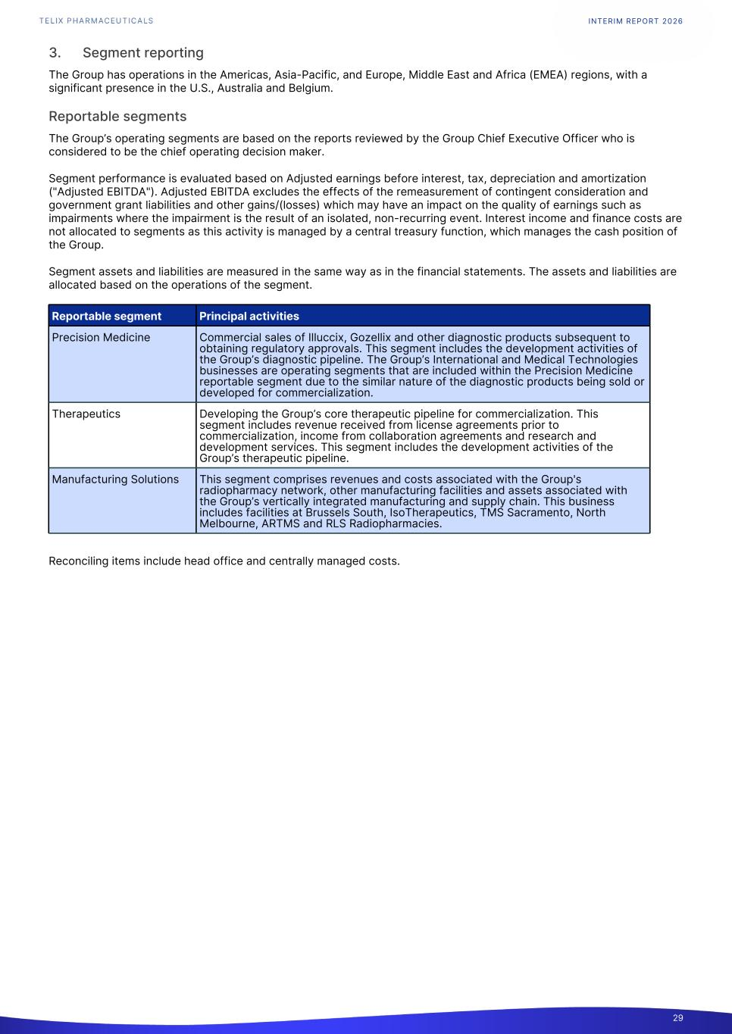
3. Segment reporting The Group has operations in the Americas, Asia-Pacific, and Europe, Middle East and Africa (EMEA) regions, with a significant presence in the U.S., Australia and Belgium. Reportable segments The Group’s operating segments are based on the reports reviewed by the Group Chief Executive Officer who is considered to be the chief operating decision maker. Segment performance is evaluated based on Adjusted earnings before interest, tax, depreciation and amortization ("Adjusted EBITDA"). Adjusted EBITDA excludes the effects of the remeasurement of contingent consideration and government grant liabilities and other gains/(losses) which may have an impact on the quality of earnings such as impairments where the impairment is the result of an isolated, non-recurring event. Interest income and finance costs are not allocated to segments as this activity is managed by a central treasury function, which manages the cash position of the Group. Segment assets and liabilities are measured in the same way as in the financial statements. The assets and liabilities are allocated based on the operations of the segment. Reportable segment Principal activities Precision Medicine Commercial sales of Illuccix, Gozellix and other diagnostic products subsequent to obtaining regulatory approvals. This segment includes the development activities of the Group’s diagnostic pipeline. The Group’s International and Medical Technologies businesses are operating segments that are included within the Precision Medicine reportable segment due to the similar nature of the diagnostic products being sold or developed for commercialization. Therapeutics Developing the Group’s core therapeutic pipeline for commercialization. This segment includes revenue received from license agreements prior to commercialization, income from collaboration agreements and research and development services. This segment includes the development activities of the Group’s therapeutic pipeline. Manufacturing Solutions This segment comprises revenues and costs associated with the Group's radiopharmacy network, other manufacturing facilities and assets associated with the Group’s vertically integrated manufacturing and supply chain. This business includes facilities at Brussels South, IsoTherapeutics, TMS Sacramento, North Melbourne, ARTMS and RLS Radiopharmacies. Reconciling items include head office and centrally managed costs. INTERIM REPORT 2026 29

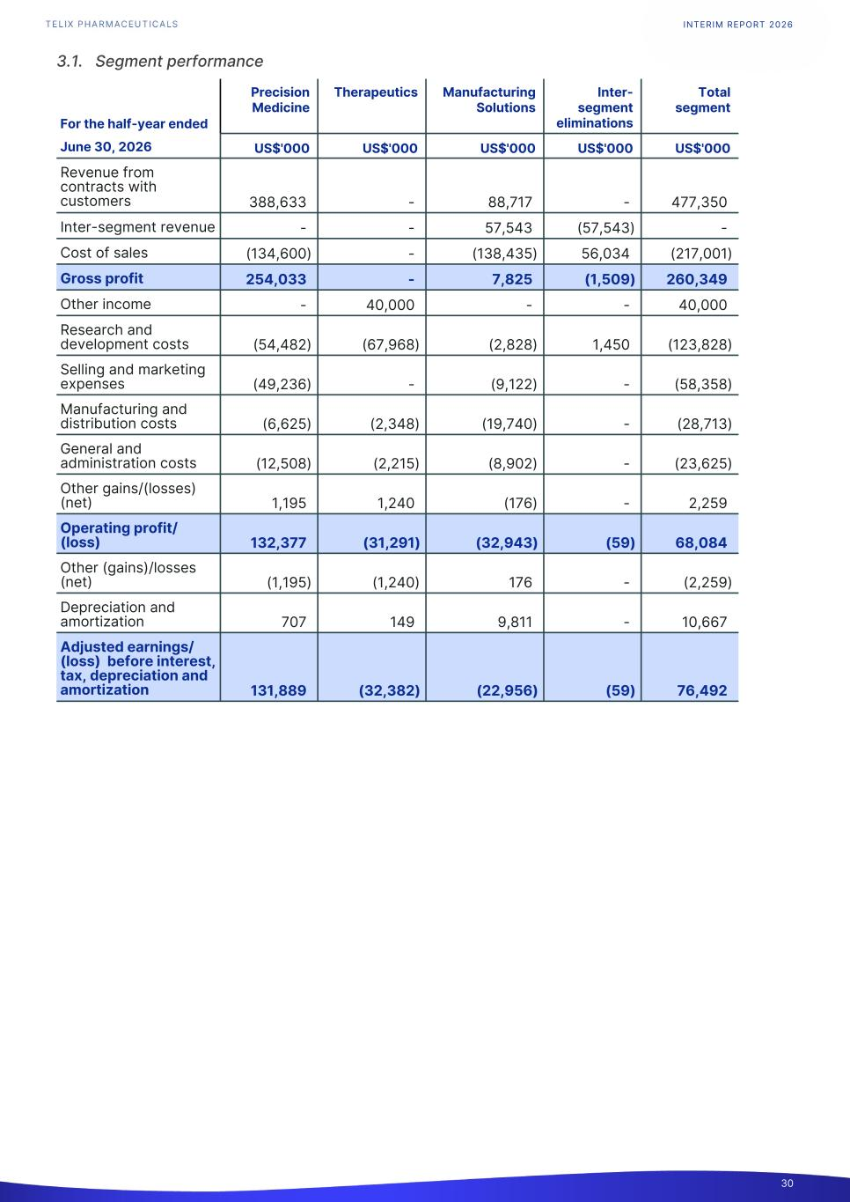
3.1. Segment performance For the half-year ended Precision Medicine Therapeutics Manufacturing Solutions Inter- segment eliminations Total segment1. June 30, 2026 US$'000 US$'000 US$'000 US$'000 US$'000 Revenue from contracts with customers 388,633 - 88,717 - 477,350 Inter-segment revenue - - 57,543 (57,543) - Cost of sales (134,600) - (138,435) 56,034 (217,001) Gross profit 254,033 - 7,825 (1,509) 260,349 Other income - 40,000 - - 40,000 Research and development costs (54,482) (67,968) (2,828) 1,450 (123,828) Selling and marketing expenses (49,236) - (9,122) - (58,358) Manufacturing and distribution costs (6,625) (2,348) (19,740) - (28,713) General and administration costs (12,508) (2,215) (8,902) - (23,625) Other gains/(losses) (net) 1,195 1,240 (176) - 2,259 Operating profit/ (loss) 132,377 (31,291) (32,943) (59) 68,084 Other (gains)/losses (net) (1,195) (1,240) 176 - (2,259) Depreciation and amortization 707 149 9,811 - 10,667 Adjusted earnings/ (loss) before interest, tax, depreciation and amortization 131,889 (32,382) (22,956) (59) 76,492 INTERIM REPORT 2026 30

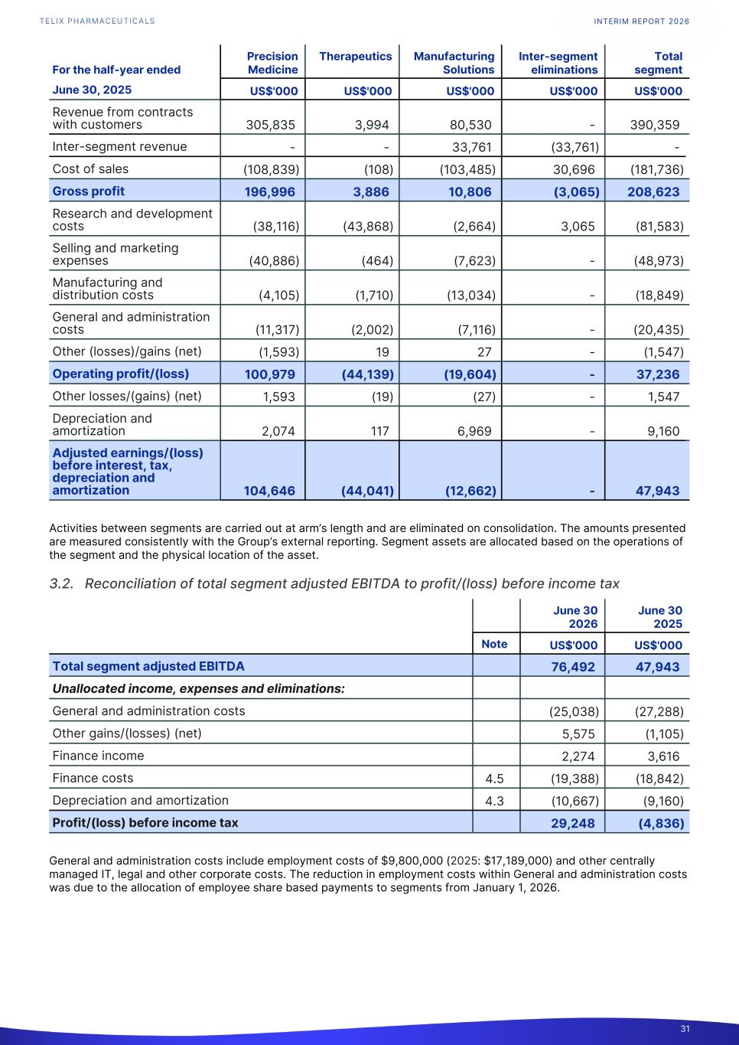
For the half-year ended Precision Medicine Therapeutics Manufacturing Solutions Inter-segment eliminations Total segment1. June 30, 2025 US$'000 US$'000 US$'000 US$'000 US$'000 Revenue from contracts with customers 305,835 3,994 80,530 - 390,359 Inter-segment revenue - - 33,761 (33,761) - Cost of sales (108,839) (108) (103,485) 30,696 (181,736) Gross profit 196,996 3,886 10,806 (3,065) 208,623 Research and development costs (38,116) (43,868) (2,664) 3,065 (81,583) Selling and marketing expenses (40,886) (464) (7,623) - (48,973) Manufacturing and distribution costs (4,105) (1,710) (13,034) - (18,849) General and administration costs (11,317) (2,002) (7,116) - (20,435) Other (losses)/gains (net) (1,593) 19 27 - (1,547) Operating profit/(loss) 100,979 (44,139) (19,604) - 37,236 Other losses/(gains) (net) 1,593 (19) (27) - 1,547 Depreciation and amortization 2,074 117 6,969 - 9,160 Adjusted earnings/(loss) before interest, tax, depreciation and amortization 104,646 (44,041) (12,662) - 47,943 Activities between segments are carried out at arm’s length and are eliminated on consolidation. The amounts presented are measured consistently with the Group’s external reporting. Segment assets are allocated based on the operations of the segment and the physical location of the asset. 3.2. Reconciliation of total segment adjusted EBITDA to profit/(loss) before income tax June 30 2026 June 30 2025 Note US$'000 US$'000 Total segment adjusted EBITDA 76,492 47,943 Unallocated income, expenses and eliminations: General and administration costs (25,038) (27,288) Other gains/(losses) (net) 5,575 (1,105) Finance income 2,274 3,616 Finance costs 4.5 (19,388) (18,842) Depreciation and amortization 4.3 (10,667) (9,160) Profit/(loss) before income tax 29,248 (4,836) General and administration costs include employment costs of $9,800,000 (2025: $17,189,000) and other centrally managed IT, legal and other corporate costs. The reduction in employment costs within General and administration costs was due to the allocation of employee share based payments to segments from January 1, 2026. INTERIM REPORT 2026 31

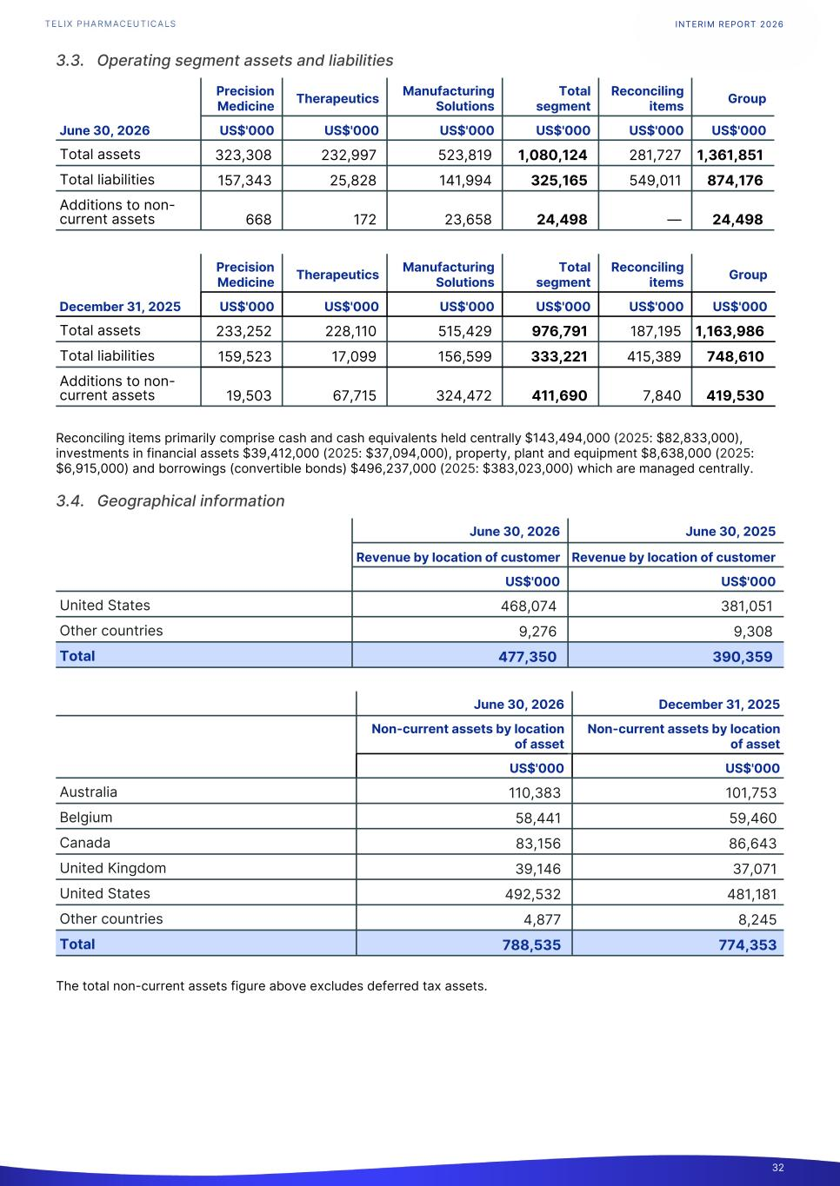
3.3. Operating segment assets and liabilities Precision Medicine Therapeutics Manufacturing Solutions Total segment Reconciling items Group1. June 30, 2026 US$'000 US$'000 US$'000 US$'000 US$'000 US$'000 Total assets 323,308 232,997 523,819 1,080,124 281,727 1,361,851 Total liabilities 157,343 25,828 141,994 325,165 549,011 874,176 Additions to non- current assets 668 172 23,658 24,498 — 24,498 Precision Medicine Therapeutics Manufacturing Solutions Total segment Reconciling items Group December 31, 2025 US$'000 US$'000 US$'000 US$'000 US$'000 US$'000 Total assets 233,252 228,110 515,429 976,791 187,195 1,163,986 Total liabilities 159,523 17,099 156,599 333,221 415,389 748,610 Additions to non- current assets 19,503 67,715 324,472 411,690 7,840 419,530 Reconciling items primarily comprise cash and cash equivalents held centrally $143,494,000 (2025: $82,833,000), investments in financial assets $39,412,000 (2025: $37,094,000), property, plant and equipment $8,638,000 (2025: $6,915,000) and borrowings (convertible bonds) $496,237,000 (2025: $383,023,000) which are managed centrally. 3.4. Geographical information June 30, 2026 June 30, 2025 Revenue by location of customer Revenue by location of customer US$'000 US$'000 United States 468,074 381,051 Other countries 9,276 9,308 Total 477,350 390,359 June 30, 2026 December 31, 2025 Non-current assets by location of asset Non-current assets by location of asset US$'000 US$'000 Australia 110,383 101,753 Belgium 58,441 59,460 Canada 83,156 86,643 United Kingdom 39,146 37,071 United States 492,532 481,181 Other countries 4,877 8,245 Total 788,535 774,353 The total non-current assets figure above excludes deferred tax assets. INTERIM REPORT 2026 32

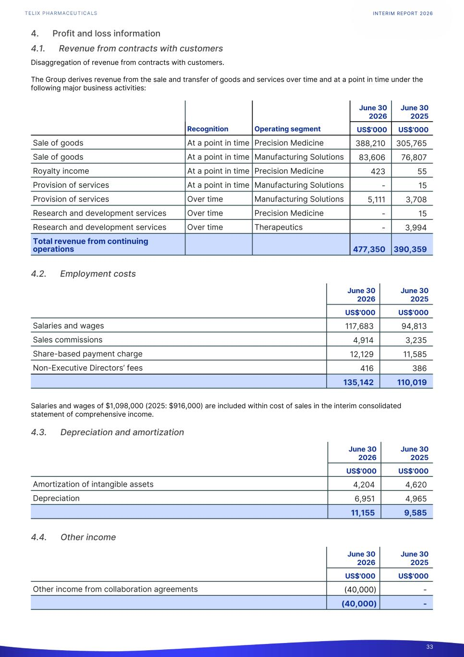
4. Profit and loss information 4.1. Revenue from contracts with customers Disaggregation of revenue from contracts with customers. The Group derives revenue from the sale and transfer of goods and services over time and at a point in time under the following major business activities: June 30 2026 June 30 2025 Recognition Operating segment US$'000 US$'000 Sale of goods At a point in time Precision Medicine 388,210 305,765 Sale of goods At a point in time Manufacturing Solutions 83,606 76,807 Royalty income At a point in time Precision Medicine 423 55 Provision of services At a point in time Manufacturing Solutions - 15 Provision of services Over time Manufacturing Solutions 5,111 3,708 Research and development services Over time Precision Medicine - 15 Research and development services Over time Therapeutics - 3,994 Total revenue from continuing operations 477,350 390,359 4.2. Employment costs June 30 2026 June 30 2025 US$'000 US$'000 Salaries and wages 117,683 94,813 Sales commissions 4,914 3,235 Share-based payment charge 12,129 11,585 Non-Executive Directors’ fees 416 386 135,142 110,019 Salaries and wages of $1,098,000 (2025: $916,000) are included within cost of sales in the interim consolidated statement of comprehensive income. 4.3. Depreciation and amortization June 30 2026 June 30 2025 US$'000 US$'000 Amortization of intangible assets 4,204 4,620 Depreciation 6,951 4,965 11,155 9,585 4.4. Other income June 30 2026 June 30 2025 US$'000 US$'000 Other income from collaboration agreements (40,000) - (40,000) - INTERIM REPORT 2026 33

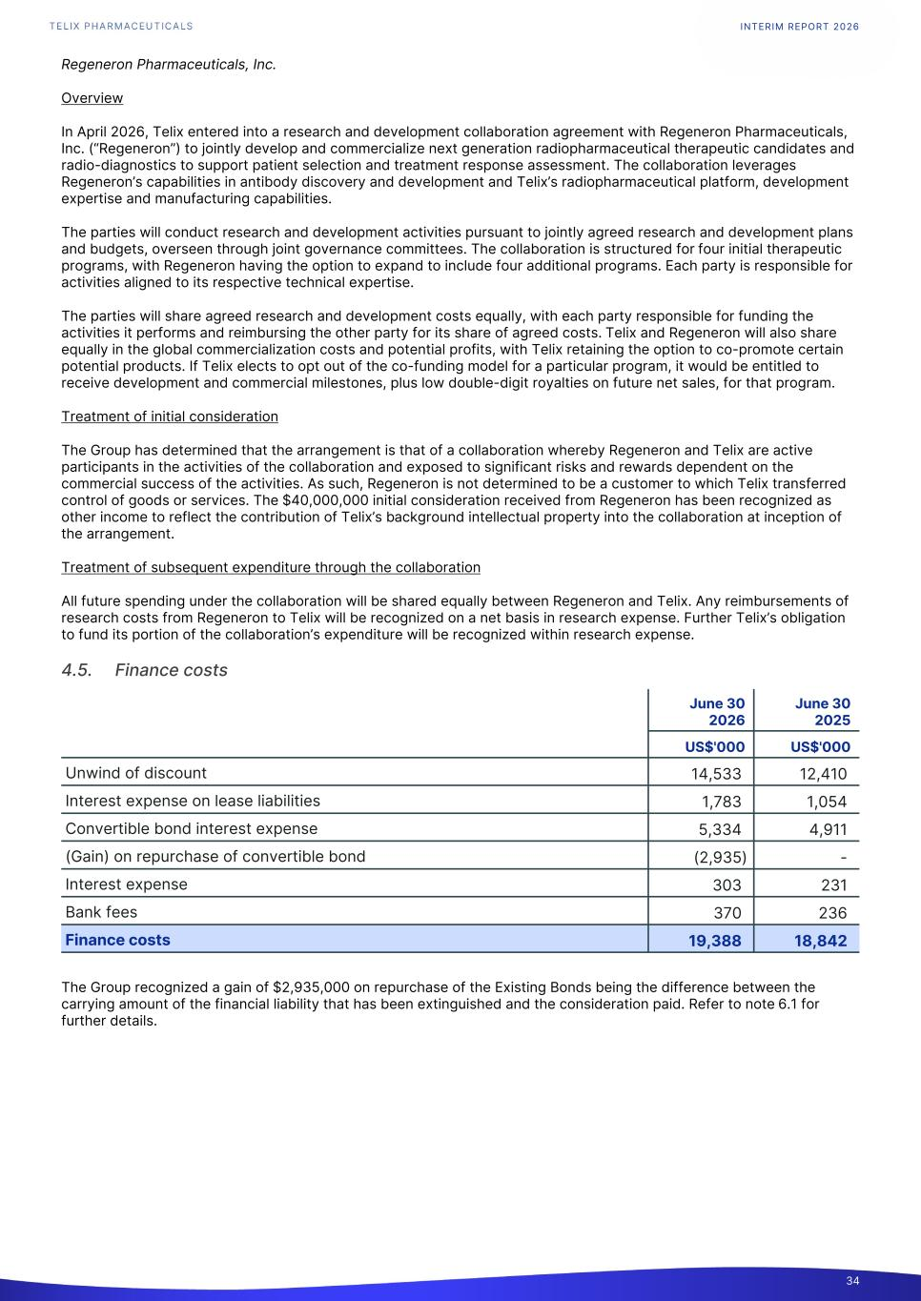
Regeneron Pharmaceuticals, Inc. Overview In April 2026, Telix entered into a research and development collaboration agreement with Regeneron Pharmaceuticals, Inc. (“Regeneron”) to jointly develop and commercialize next generation radiopharmaceutical therapeutic candidates and radio-diagnostics to support patient selection and treatment response assessment. The collaboration leverages Regeneron’s capabilities in antibody discovery and development and Telix’s radiopharmaceutical platform, development expertise and manufacturing capabilities. The parties will conduct research and development activities pursuant to jointly agreed research and development plans and budgets, overseen through joint governance committees. The collaboration is structured for four initial therapeutic programs, with Regeneron having the option to expand to include four additional programs. Each party is responsible for activities aligned to its respective technical expertise. The parties will share agreed research and development costs equally, with each party responsible for funding the activities it performs and reimbursing the other party for its share of agreed costs. Telix and Regeneron will also share equally in the global commercialization costs and potential profits, with Telix retaining the option to co-promote certain potential products. If Telix elects to opt out of the co-funding model for a particular program, it would be entitled to receive development and commercial milestones, plus low double-digit royalties on future net sales, for that program. Treatment of initial consideration The Group has determined that the arrangement is that of a collaboration whereby Regeneron and Telix are active participants in the activities of the collaboration and exposed to significant risks and rewards dependent on the commercial success of the activities. As such, Regeneron is not determined to be a customer to which Telix transferred control of goods or services. The $40,000,000 initial consideration received from Regeneron has been recognized as other income to reflect the contribution of Telix’s background intellectual property into the collaboration at inception of the arrangement. Treatment of subsequent expenditure through the collaboration All future spending under the collaboration will be shared equally between Regeneron and Telix. Any reimbursements of research costs from Regeneron to Telix will be recognized on a net basis in research expense. Further Telix’s obligation to fund its portion of the collaboration’s expenditure will be recognized within research expense. 4.5. Finance costs June 30 2026 June 30 2025 US$'000 US$'000 Unwind of discount 14,533 12,410 Interest expense on lease liabilities 1,783 1,054 Convertible bond interest expense 5,334 4,911 (Gain) on repurchase of convertible bond (2,935) - Interest expense 303 231 Bank fees 370 236 Finance costs 19,388 18,842 The Group recognized a gain of $2,935,000 on repurchase of the Existing Bonds being the difference between the carrying amount of the financial liability that has been extinguished and the consideration paid. Refer to note 6.1 for further details. INTERIM REPORT 2026 34

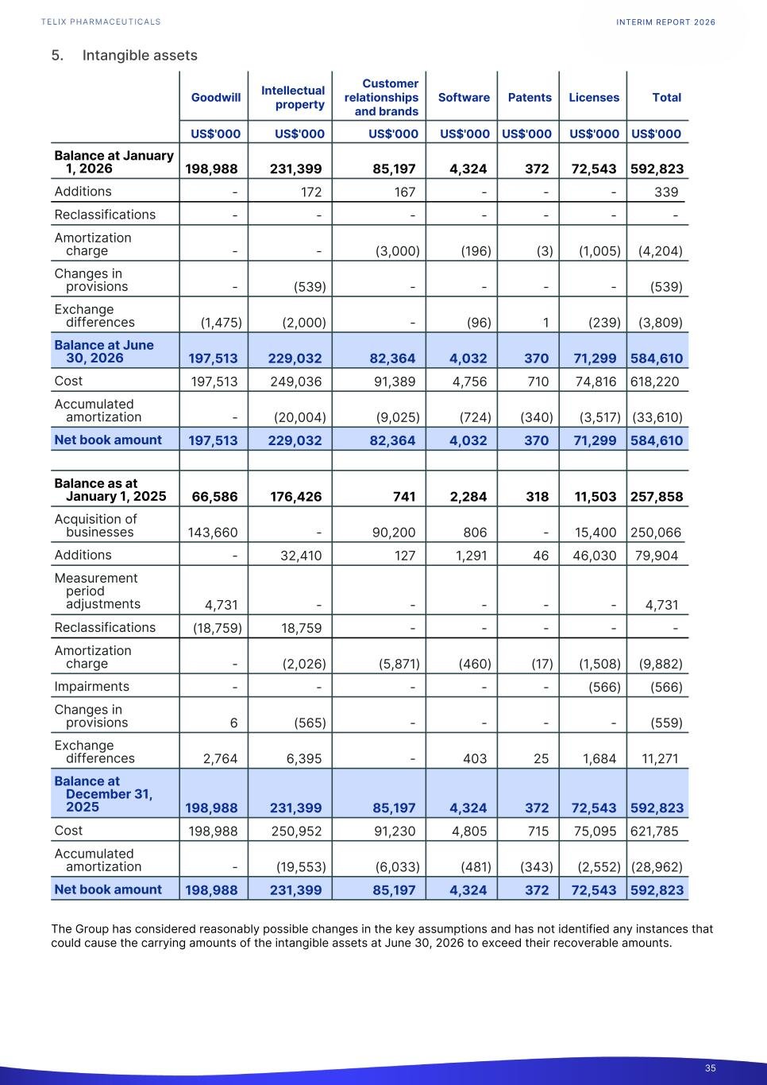
5. Intangible assets Goodwill Intellectual property Customer relationships and brands Software Patents Licenses Total1. US$'000 US$'000 US$'000 US$'000 US$'000 US$'000 US$'0001. Balance at January 1, 2026 198,988 231,399 85,197 4,324 372 72,543 592,823 Additions - 172 167 - - - 339 Reclassifications - - - - - - - Amortization charge - - (3,000) (196) (3) (1,005) (4,204) Changes in provisions - (539) - - - - (539) Exchange differences (1,475) (2,000) - (96) 1 (239) (3,809) Balance at June 30, 2026 197,513 229,032 82,364 4,032 370 71,299 584,610 Cost 197,513 249,036 91,389 4,756 710 74,816 618,220 Accumulated amortization - (20,004) (9,025) (724) (340) (3,517) (33,610) Net book amount 197,513 229,032 82,364 4,032 370 71,299 584,610 Balance as at January 1, 2025 66,586 176,426 741 2,284 318 11,503 257,858 Acquisition of businesses 143,660 - 90,200 806 - 15,400 250,066 Additions - 32,410 127 1,291 46 46,030 79,904 Measurement period adjustments 4,731 - - - - - 4,731 Reclassifications (18,759) 18,759 - - - - - Amortization charge - (2,026) (5,871) (460) (17) (1,508) (9,882) Impairments - - - - - (566) (566) Changes in provisions 6 (565) - - - - (559) Exchange differences 2,764 6,395 - 403 25 1,684 11,271 Balance at December 31, 2025 198,988 231,399 85,197 4,324 372 72,543 592,823 Cost 198,988 250,952 91,230 4,805 715 75,095 621,785 Accumulated amortization - (19,553) (6,033) (481) (343) (2,552) (28,962) Net book amount 198,988 231,399 85,197 4,324 372 72,543 592,823 The Group has considered reasonably possible changes in the key assumptions and has not identified any instances that could cause the carrying amounts of the intangible assets at June 30, 2026 to exceed their recoverable amounts. INTERIM REPORT 2026 35

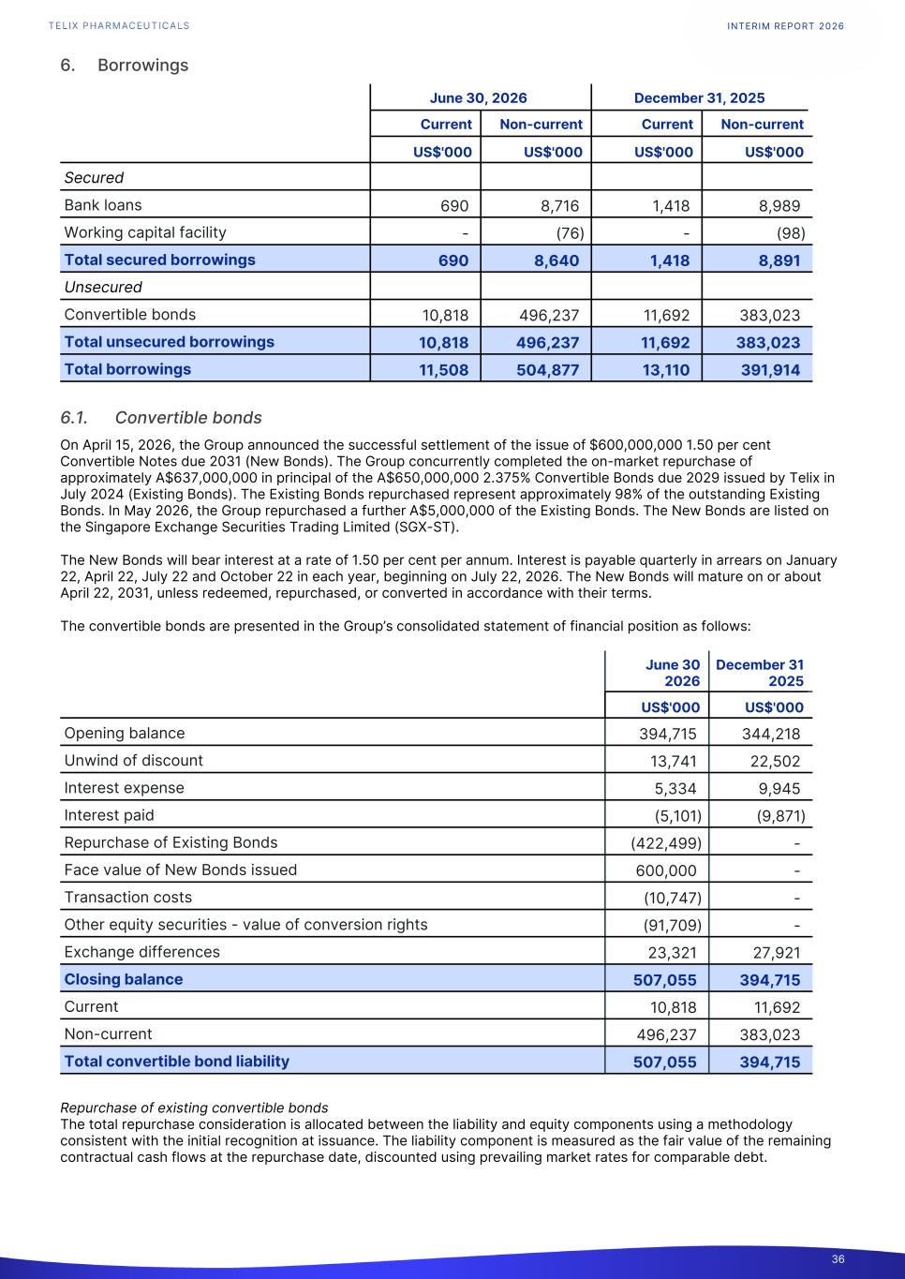
6. Borrowings June 30, 2026 December 31, 2025 Current Non-current Current Non-current1. US$'000 US$'000 US$'000 US$'000 Secured Bank loans 690 8,716 1,418 8,989 Working capital facility - (76) - (98) Total secured borrowings 690 8,640 1,418 8,891 Unsecured Convertible bonds 10,818 496,237 11,692 383,023 Total unsecured borrowings 10,818 496,237 11,692 383,023 Total borrowings 11,508 504,877 13,110 391,914 6.1. Convertible bonds On April 15, 2026, the Group announced the successful settlement of the issue of $600,000,000 1.50 per cent Convertible Notes due 2031 (New Bonds). The Group concurrently completed the on-market repurchase of approximately A$637,000,000 in principal of the A$650,000,000 2.375% Convertible Bonds due 2029 issued by Telix in July 2024 (Existing Bonds). The Existing Bonds repurchased represent approximately 98% of the outstanding Existing Bonds. In May 2026, the Group repurchased a further A$5,000,000 of the Existing Bonds. The New Bonds are listed on the Singapore Exchange Securities Trading Limited (SGX-ST). The New Bonds will bear interest at a rate of 1.50 per cent per annum. Interest is payable quarterly in arrears on January 22, April 22, July 22 and October 22 in each year, beginning on July 22, 2026. The New Bonds will mature on or about April 22, 2031, unless redeemed, repurchased, or converted in accordance with their terms. The convertible bonds are presented in the Group’s consolidated statement of financial position as follows: June 30 2026 December 31 20251. US$'000 US$'0001. Opening balance 394,715 344,218 Unwind of discount 13,741 22,502 Interest expense 5,334 9,945 Interest paid (5,101) (9,871) Repurchase of Existing Bonds (422,499) - Face value of New Bonds issued 600,000 - Transaction costs (10,747) - Other equity securities - value of conversion rights (91,709) - Exchange differences 23,321 27,921 Closing balance 507,055 394,715 Current 10,818 11,692 Non-current 496,237 383,023 Total convertible bond liability 507,055 394,715 Repurchase of existing convertible bonds The total repurchase consideration is allocated between the liability and equity components using a methodology consistent with the initial recognition at issuance. The liability component is measured as the fair value of the remaining contractual cash flows at the repurchase date, discounted using prevailing market rates for comparable debt. INTERIM REPORT 2026 36

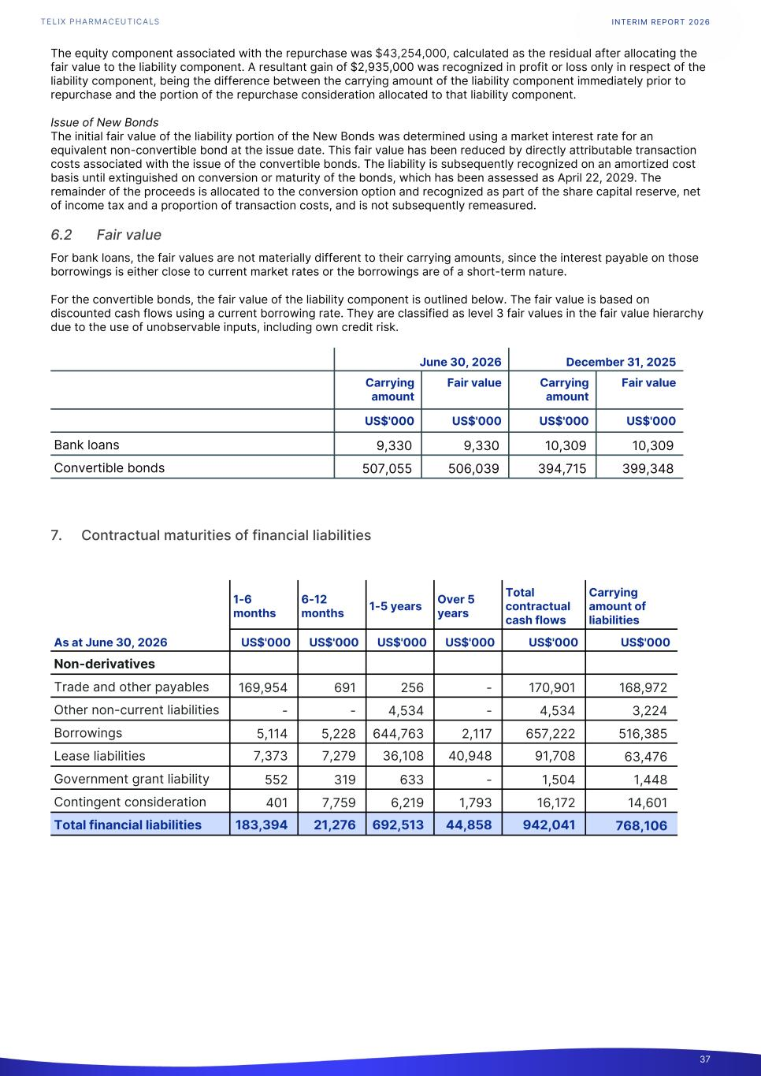
The equity component associated with the repurchase was $43,254,000, calculated as the residual after allocating the fair value to the liability component. A resultant gain of $2,935,000 was recognized in profit or loss only in respect of the liability component, being the difference between the carrying amount of the liability component immediately prior to repurchase and the portion of the repurchase consideration allocated to that liability component. Issue of New Bonds The initial fair value of the liability portion of the New Bonds was determined using a market interest rate for an equivalent non-convertible bond at the issue date. This fair value has been reduced by directly attributable transaction costs associated with the issue of the convertible bonds. The liability is subsequently recognized on an amortized cost basis until extinguished on conversion or maturity of the bonds, which has been assessed as April 22, 2029. The remainder of the proceeds is allocated to the conversion option and recognized as part of the share capital reserve, net of income tax and a proportion of transaction costs, and is not subsequently remeasured. 6.2 Fair value For bank loans, the fair values are not materially different to their carrying amounts, since the interest payable on those borrowings is either close to current market rates or the borrowings are of a short-term nature. For the convertible bonds, the fair value of the liability component is outlined below. The fair value is based on discounted cash flows using a current borrowing rate. They are classified as level 3 fair values in the fair value hierarchy due to the use of unobservable inputs, including own credit risk. June 30, 2026 December 31, 2025 1. Carrying amount Fair value Carrying amount Fair value1. US$'000 US$'000 US$'000 US$'0001. Bank loans 9,330 9,330 10,309 10,309 Convertible bonds 507,055 506,039 394,715 399,348 7. Contractual maturities of financial liabilities 1-6 months 6-12 months 1-5 years Over 5 years Total contractual cash flows Carrying amount of liabilities As at June 30, 2026 US$'000 US$'000 US$'000 US$'000 US$'000 US$'000 Non-derivatives Trade and other payables 169,954 691 256 - 170,901 168,972 Other non-current liabilities - - 4,534 - 4,534 3,224 Borrowings 5,114 5,228 644,763 2,117 657,222 516,385 Lease liabilities 7,373 7,279 36,108 40,948 91,708 63,476 Government grant liability 552 319 633 - 1,504 1,448 Contingent consideration 401 7,759 6,219 1,793 16,172 14,601 Total financial liabilities 183,394 21,276 692,513 44,858 942,041 768,106 INTERIM REPORT 2026 37

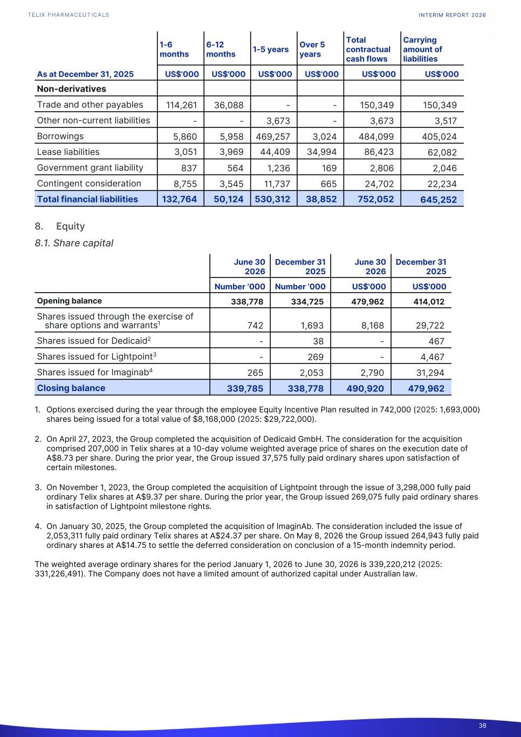
1-6 months 6-12 months 1-5 years Over 5 years Total contractual cash flows Carrying amount of liabilities As at December 31, 2025 US$'000 US$'000 US$'000 US$'000 US$'000 US$'000 Non-derivatives Trade and other payables 114,261 36,088 - - 150,349 150,349 Other non-current liabilities - - 3,673 - 3,673 3,517 Borrowings 5,860 5,958 469,257 3,024 484,099 405,024 Lease liabilities 3,051 3,969 44,409 34,994 86,423 62,082 Government grant liability 837 564 1,236 169 2,806 2,046 Contingent consideration 8,755 3,545 11,737 665 24,702 22,234 Total financial liabilities 132,764 50,124 530,312 38,852 752,052 645,252 8. Equity 8.1. Share capital June 30 2026 December 31 2025 June 30 2026 December 31 2025 Number ‘000 Number ‘000 US$'000 US$'000 Opening balance 338,778 334,725 479,962 414,012 Shares issued through the exercise of share options and warrants1 742 1,693 8,168 29,722 Shares issued for Dedicaid2 - 38 - 467 Shares issued for Lightpoint3 - 269 - 4,467 Shares issued for Imaginab4 265 2,053 2,790 31,294 Closing balance 339,785 338,778 490,920 479,962 1. Options exercised during the year through the employee Equity Incentive Plan resulted in 742,000 (2025: 1,693,000) shares being issued for a total value of $8,168,000 (2025: $29,722,000). 2. On April 27, 2023, the Group completed the acquisition of Dedicaid GmbH. The consideration for the acquisition comprised 207,000 in Telix shares at a 10-day volume weighted average price of shares on the execution date of A$8.73 per share. During the prior year, the Group issued 37,575 fully paid ordinary shares upon satisfaction of certain milestones. 3. On November 1, 2023, the Group completed the acquisition of Lightpoint through the issue of 3,298,000 fully paid ordinary Telix shares at A$9.37 per share. During the prior year, the Group issued 269,075 fully paid ordinary shares in satisfaction of Lightpoint milestone rights. 4. On January 30, 2025, the Group completed the acquisition of ImaginAb. The consideration included the issue of 2,053,311 fully paid ordinary Telix shares at A$24.37 per share. On May 8, 2026 the Group issued 264,943 fully paid ordinary shares at A$14.75 to settle the deferred consideration on conclusion of a 15-month indemnity period. The weighted average ordinary shares for the period January 1, 2026 to June 30, 2026 is 339,220,212 (2025: 331,226,491). The Company does not have a limited amount of authorized capital under Australian law. INTERIM REPORT 2026 38

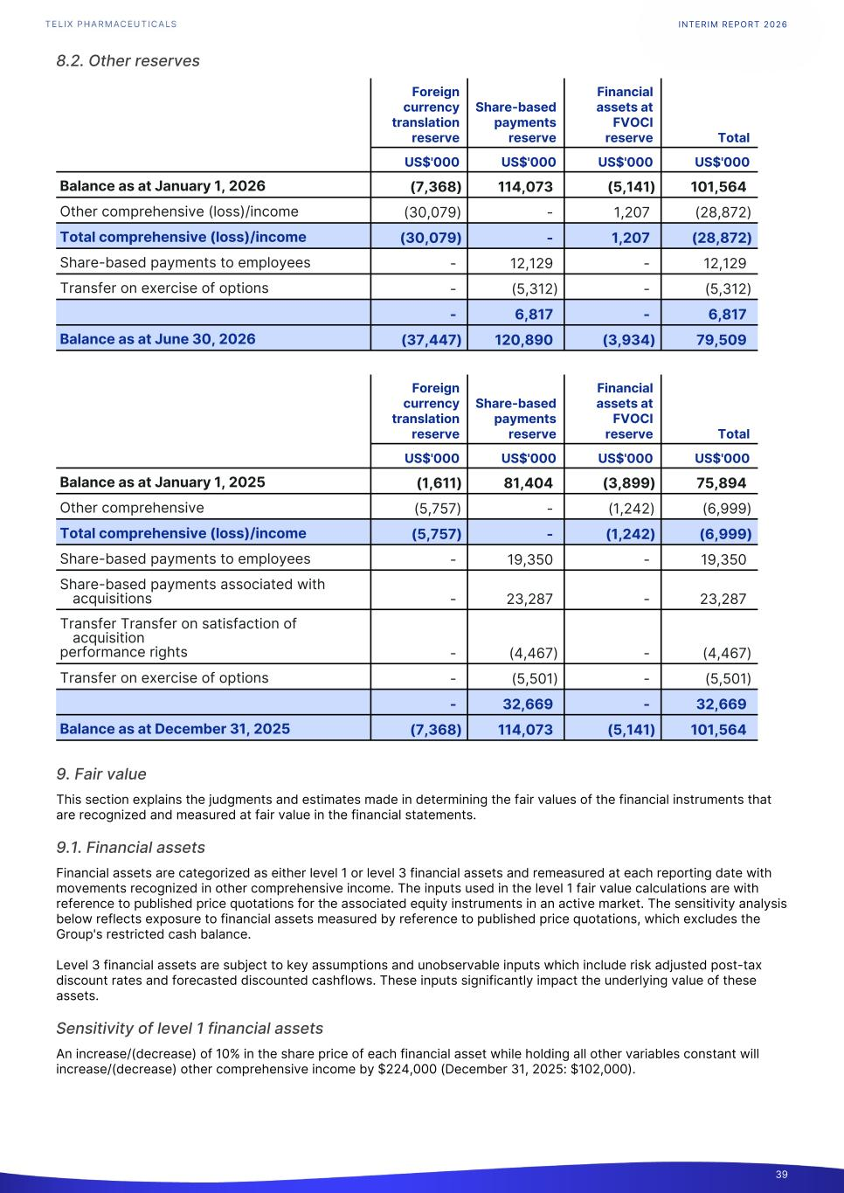
8.2. Other reserves Foreign currency translation reserve Share-based payments reserve Financial assets at FVOCI reserve Total1. US$'000 US$'000 US$'000 US$'000 Balance as at January 1, 2026 (7,368) 114,073 (5,141) 101,564 Other comprehensive (loss)/income (30,079) - 1,207 (28,872) Total comprehensive (loss)/income (30,079) - 1,207 (28,872) Share-based payments to employees - 12,129 - 12,129 Transfer on exercise of options - (5,312) - (5,312) - 6,817 - 6,817 Balance as at June 30, 2026 (37,447) 120,890 (3,934) 79,509 Foreign currency translation reserve Share-based payments reserve Financial assets at FVOCI reserve Total1. US$'000 US$'000 US$'000 US$'000 Balance as at January 1, 2025 (1,611) 81,404 (3,899) 75,894 Other comprehensive (5,757) - (1,242) (6,999) Total comprehensive (loss)/income (5,757) - (1,242) (6,999) Share-based payments to employees - 19,350 - 19,350 Share-based payments associated with acquisitions - 23,287 - 23,287 Transfer Transfer on satisfaction of acquisition performance rights - (4,467) - (4,467) Transfer on exercise of options - (5,501) - (5,501) - 32,669 - 32,669 Balance as at December 31, 2025 (7,368) 114,073 (5,141) 101,564 9. Fair value This section explains the judgments and estimates made in determining the fair values of the financial instruments that are recognized and measured at fair value in the financial statements. 9.1. Financial assets Financial assets are categorized as either level 1 or level 3 financial assets and remeasured at each reporting date with movements recognized in other comprehensive income. The inputs used in the level 1 fair value calculations are with reference to published price quotations for the associated equity instruments in an active market. The sensitivity analysis below reflects exposure to financial assets measured by reference to published price quotations, which excludes the Group's restricted cash balance. Level 3 financial assets are subject to key assumptions and unobservable inputs which include risk adjusted post-tax discount rates and forecasted discounted cashflows. These inputs significantly impact the underlying value of these assets. Sensitivity of level 1 financial assets An increase/(decrease) of 10% in the share price of each financial asset while holding all other variables constant will increase/(decrease) other comprehensive income by $224,000 (December 31, 2025: $102,000). INTERIM REPORT 2026 39

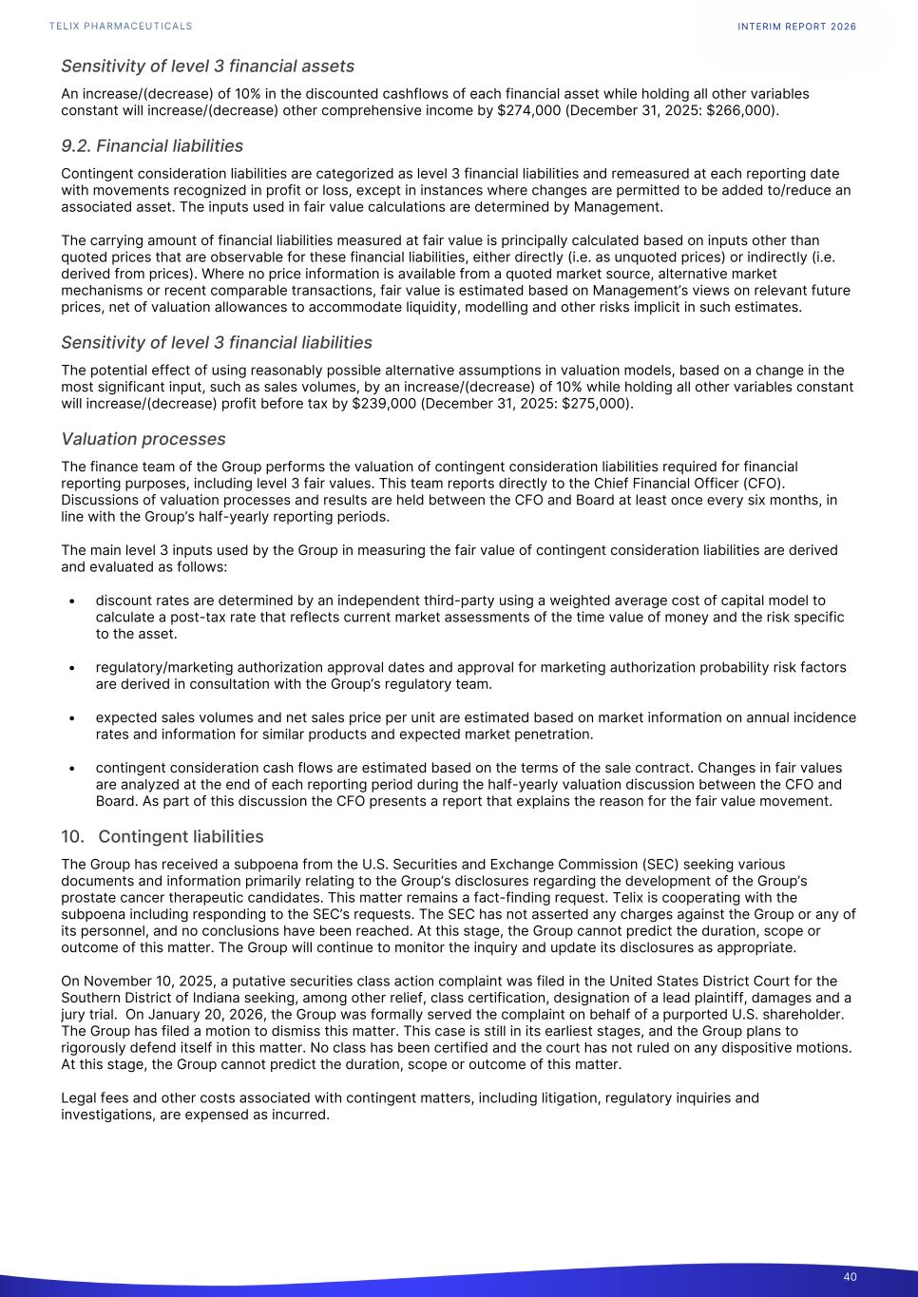
Sensitivity of level 3 financial assets An increase/(decrease) of 10% in the discounted cashflows of each financial asset while holding all other variables constant will increase/(decrease) other comprehensive income by $274,000 (December 31, 2025: $266,000). 9.2. Financial liabilities Contingent consideration liabilities are categorized as level 3 financial liabilities and remeasured at each reporting date with movements recognized in profit or loss, except in instances where changes are permitted to be added to/reduce an associated asset. The inputs used in fair value calculations are determined by Management. The carrying amount of financial liabilities measured at fair value is principally calculated based on inputs other than quoted prices that are observable for these financial liabilities, either directly (i.e. as unquoted prices) or indirectly (i.e. derived from prices). Where no price information is available from a quoted market source, alternative market mechanisms or recent comparable transactions, fair value is estimated based on Management’s views on relevant future prices, net of valuation allowances to accommodate liquidity, modelling and other risks implicit in such estimates. Sensitivity of level 3 financial liabilities The potential effect of using reasonably possible alternative assumptions in valuation models, based on a change in the most significant input, such as sales volumes, by an increase/(decrease) of 10% while holding all other variables constant will increase/(decrease) profit before tax by $239,000 (December 31, 2025: $275,000). Valuation processes The finance team of the Group performs the valuation of contingent consideration liabilities required for financial reporting purposes, including level 3 fair values. This team reports directly to the Chief Financial Officer (CFO). Discussions of valuation processes and results are held between the CFO and Board at least once every six months, in line with the Group’s half-yearly reporting periods. The main level 3 inputs used by the Group in measuring the fair value of contingent consideration liabilities are derived and evaluated as follows: • discount rates are determined by an independent third-party using a weighted average cost of capital model to calculate a post-tax rate that reflects current market assessments of the time value of money and the risk specific to the asset. • regulatory/marketing authorization approval dates and approval for marketing authorization probability risk factors are derived in consultation with the Group’s regulatory team. • expected sales volumes and net sales price per unit are estimated based on market information on annual incidence rates and information for similar products and expected market penetration. • contingent consideration cash flows are estimated based on the terms of the sale contract. Changes in fair values are analyzed at the end of each reporting period during the half-yearly valuation discussion between the CFO and Board. As part of this discussion the CFO presents a report that explains the reason for the fair value movement. 10. Contingent liabilities The Group has received a subpoena from the U.S. Securities and Exchange Commission (SEC) seeking various documents and information primarily relating to the Group’s disclosures regarding the development of the Group’s prostate cancer therapeutic candidates. This matter remains a fact-finding request. Telix is cooperating with the subpoena including responding to the SEC’s requests. The SEC has not asserted any charges against the Group or any of its personnel, and no conclusions have been reached. At this stage, the Group cannot predict the duration, scope or outcome of this matter. The Group will continue to monitor the inquiry and update its disclosures as appropriate. On November 10, 2025, a putative securities class action complaint was filed in the United States District Court for the Southern District of Indiana seeking, among other relief, class certification, designation of a lead plaintiff, damages and a jury trial. On January 20, 2026, the Group was formally served the complaint on behalf of a purported U.S. shareholder. The Group has filed a motion to dismiss this matter. This case is still in its earliest stages, and the Group plans to rigorously defend itself in this matter. No class has been certified and the court has not ruled on any dispositive motions. At this stage, the Group cannot predict the duration, scope or outcome of this matter. Legal fees and other costs associated with contingent matters, including litigation, regulatory inquiries and investigations, are expensed as incurred. INTERIM REPORT 2026 40

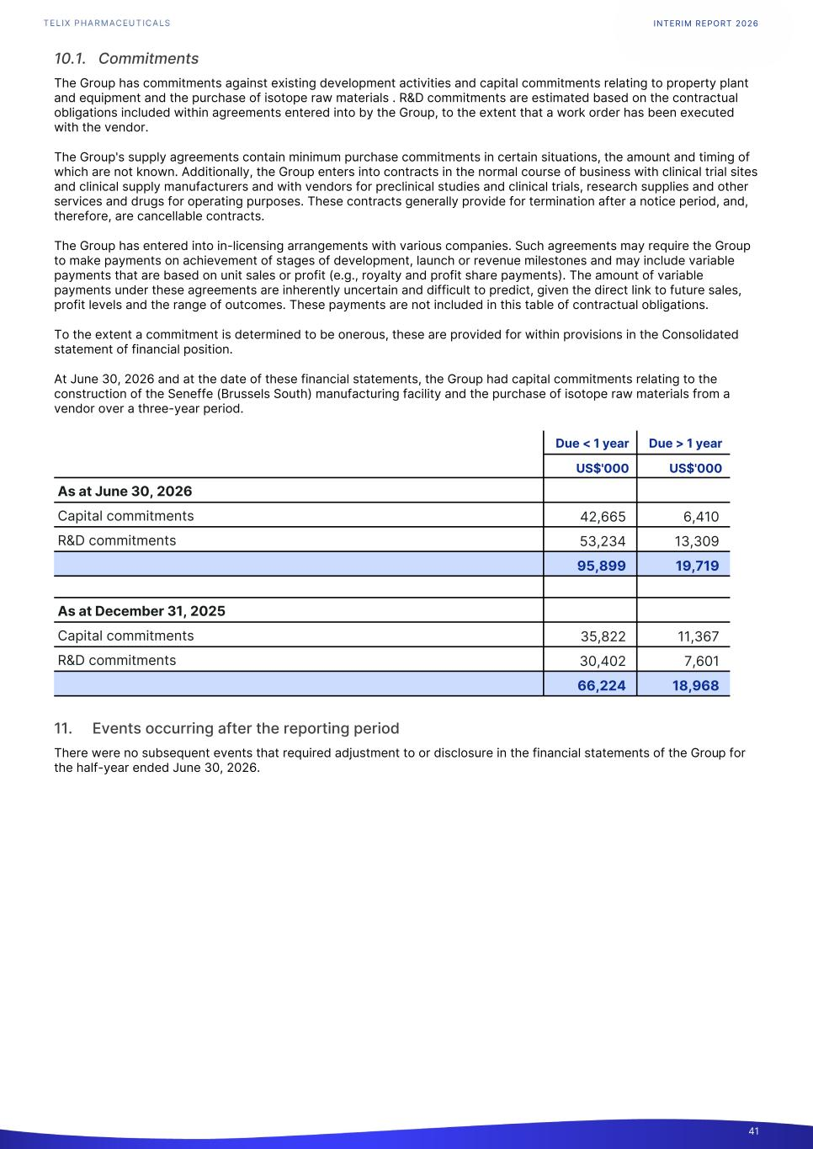
10.1. Commitments The Group has commitments against existing development activities and capital commitments relating to property plant and equipment and the purchase of isotope raw materials . R&D commitments are estimated based on the contractual obligations included within agreements entered into by the Group, to the extent that a work order has been executed with the vendor. The Group's supply agreements contain minimum purchase commitments in certain situations, the amount and timing of which are not known. Additionally, the Group enters into contracts in the normal course of business with clinical trial sites and clinical supply manufacturers and with vendors for preclinical studies and clinical trials, research supplies and other services and drugs for operating purposes. These contracts generally provide for termination after a notice period, and, therefore, are cancellable contracts. The Group has entered into in-licensing arrangements with various companies. Such agreements may require the Group to make payments on achievement of stages of development, launch or revenue milestones and may include variable payments that are based on unit sales or profit (e.g., royalty and profit share payments). The amount of variable payments under these agreements are inherently uncertain and difficult to predict, given the direct link to future sales, profit levels and the range of outcomes. These payments are not included in this table of contractual obligations. To the extent a commitment is determined to be onerous, these are provided for within provisions in the Consolidated statement of financial position. At June 30, 2026 and at the date of these financial statements, the Group had capital commitments relating to the construction of the Seneffe (Brussels South) manufacturing facility and the purchase of isotope raw materials from a vendor over a three-year period. Due < 1 year Due > 1 year1. US$'000 US$'0001. As at June 30, 2026 Capital commitments 42,665 6,410 R&D commitments 53,234 13,309 95,899 19,719 As at December 31, 2025 Capital commitments 35,822 11,367 R&D commitments 30,402 7,601 66,224 18,968 11. Events occurring after the reporting period There were no subsequent events that required adjustment to or disclosure in the financial statements of the Group for the half-year ended June 30, 2026. INTERIM REPORT 2026 41

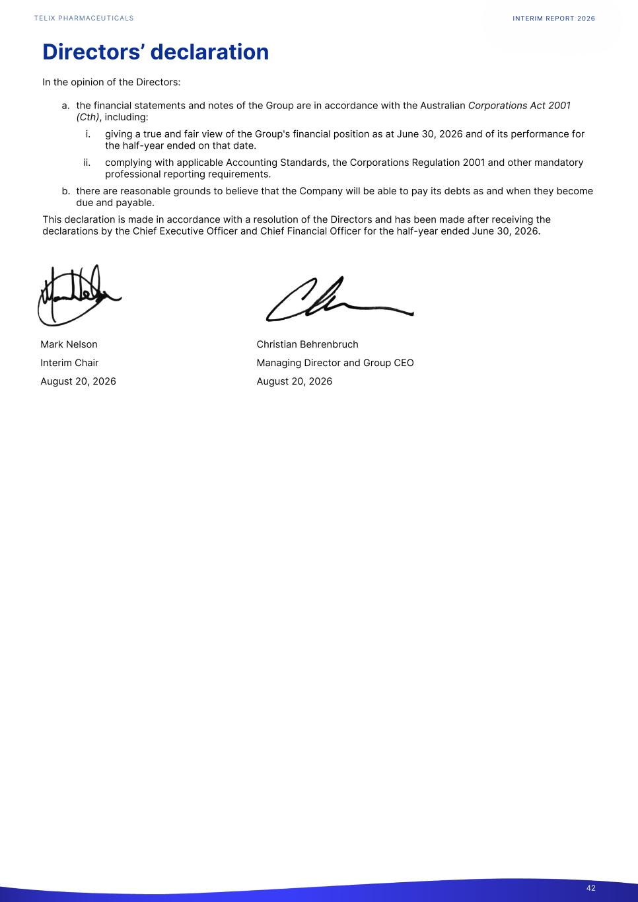
Directors’ declaration In the opinion of the Directors: a. the financial statements and notes of the Group are in accordance with the Australian Corporations Act 2001 (Cth), including: i. giving a true and fair view of the Group's financial position as at June 30, 2026 and of its performance for the half-year ended on that date. ii. complying with applicable Accounting Standards, the Corporations Regulation 2001 and other mandatory professional reporting requirements. b. there are reasonable grounds to believe that the Company will be able to pay its debts as and when they become due and payable. This declaration is made in accordance with a resolution of the Directors and has been made after receiving the declarations by the Chief Executive Officer and Chief Financial Officer for the half-year ended June 30, 2026. Mark Nelson Christian Behrenbruch Interim Chair Managing Director and Group CEO August 20, 2026 August 20, 2026 INTERIM REPORT 2026 42

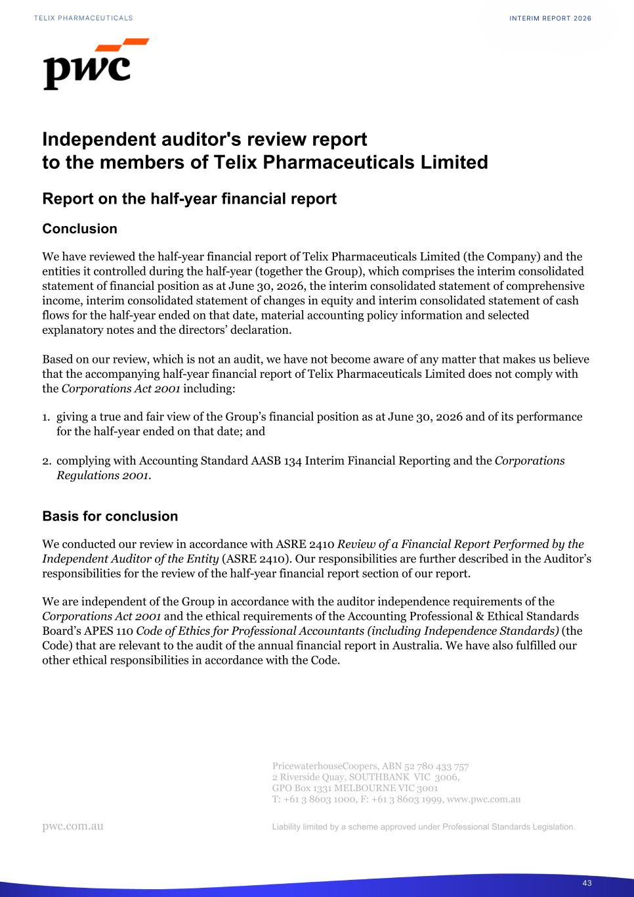
Independent auditor's review report to the members of Telix Pharmaceuticals Limited Report on the half-year financial report Conclusion We have reviewed the half-year financial report of Telix Pharmaceuticals Limited (the Company) and the entities it controlled during the half-year (together the Group), which comprises the interim consolidated statement of financial position as at June 30, 2026, the interim consolidated statement of comprehensive income, interim consolidated statement of changes in equity and interim consolidated statement of cash flows for the half-year ended on that date, material accounting policy information and selected explanatory notes and the directors’ declaration. Based on our review, which is not an audit, we have not become aware of any matter that makes us believe that the accompanying half-year financial report of Telix Pharmaceuticals Limited does not comply with the Corporations Act 2001 including: 1. giving a true and fair view of the Group’s financial position as at June 30, 2026 and of its performance for the half-year ended on that date; and 2. complying with Accounting Standard AASB 134 Interim Financial Reporting and the Corporations Regulations 2001. Basis for conclusion We conducted our review in accordance with ASRE 2410 Review of a Financial Report Performed by the Independent Auditor of the Entity (ASRE 2410). Our responsibilities are further described in the Auditor’s responsibilities for the review of the half-year financial report section of our report. We are independent of the Group in accordance with the auditor independence requirements of the Corporations Act 2001 and the ethical requirements of the Accounting Professional & Ethical Standards Board’s APES 110 Code of Ethics for Professional Accountants (including Independence Standards) (the Code) that are relevant to the audit of the annual financial report in Australia. We have also fulfilled our other ethical responsibilities in accordance with the Code. PricewaterhouseCoopers, ABN 52 780 433 757 2 Riverside Quay, SOUTHBANK VIC 3006, GPO Box 1331 MELBOURNE VIC 3001 T: +61 3 8603 1000, F: +61 3 8603 1999, www.pwc.com.au pwc.com.au Liability limited by a scheme approved under Professional Standards Legislation. INTERIM REPORT 2026 43

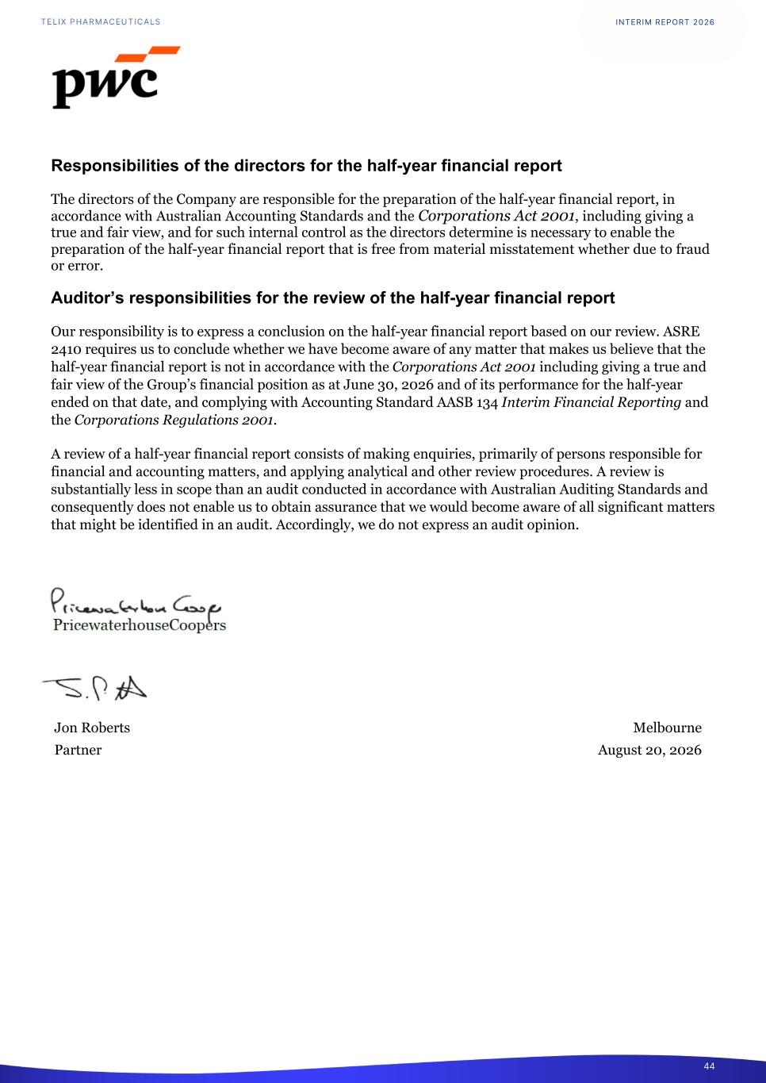
Responsibilities of the directors for the half-year financial report The directors of the Company are responsible for the preparation of the half-year financial report, in accordance with Australian Accounting Standards and the Corporations Act 2001, including giving a true and fair view, and for such internal control as the directors determine is necessary to enable the preparation of the half-year financial report that is free from material misstatement whether due to fraud or error. Auditor’s responsibilities for the review of the half-year financial report Our responsibility is to express a conclusion on the half-year financial report based on our review. ASRE 2410 requires us to conclude whether we have become aware of any matter that makes us believe that the half-year financial report is not in accordance with the Corporations Act 2001 including giving a true and fair view of the Group’s financial position as at June 30, 2026 and of its performance for the half-year ended on that date, and complying with Accounting Standard AASB 134 Interim Financial Reporting and the Corporations Regulations 2001. A review of a half-year financial report consists of making enquiries, primarily of persons responsible for financial and accounting matters, and applying analytical and other review procedures. A review is substantially less in scope than an audit conducted in accordance with Australian Auditing Standards and consequently does not enable us to obtain assurance that we would become aware of all significant matters that might be identified in an audit. Accordingly, we do not express an audit opinion. Jon Roberts Melbourne Partner August 20, 2026 INTERIM REPORT 2026 44

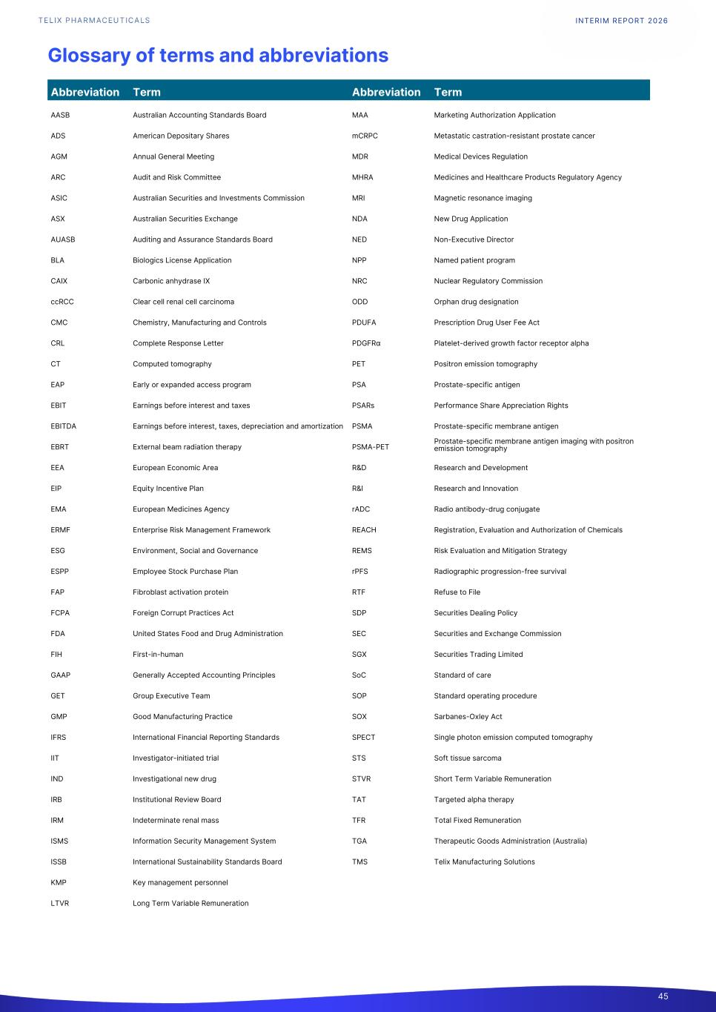
Glossary of terms and abbreviations AASB Australian Accounting Standards Board MAA Marketing Authorization Application ADS American Depositary Shares mCRPC Metastatic castration-resistant prostate cancer AGM Annual General Meeting MDR Medical Devices Regulation ARC Audit and Risk Committee MHRA Medicines and Healthcare Products Regulatory Agency ASIC Australian Securities and Investments Commission MRI Magnetic resonance imaging ASX Australian Securities Exchange NDA New Drug Application AUASB Auditing and Assurance Standards Board NED Non-Executive Director BLA Biologics License Application NPP Named patient program CAIX Carbonic anhydrase IX NRC Nuclear Regulatory Commission ccRCC Clear cell renal cell carcinoma ODD Orphan drug designation CMC Chemistry, Manufacturing and Controls PDUFA Prescription Drug User Fee Act CRL Complete Response Letter PDGFRα Platelet-derived growth factor receptor alpha CT Computed tomography PET Positron emission tomography EAP Early or expanded access program PSA Prostate-specific antigen EBIT Earnings before interest and taxes PSARs Performance Share Appreciation Rights EBITDA Earnings before interest, taxes, depreciation and amortization PSMA Prostate-specific membrane antigen EBRT External beam radiation therapy PSMA-PET Prostate-specific membrane antigen imaging with positron emission tomography EEA European Economic Area R&D Research and Development EIP Equity Incentive Plan R&I Research and Innovation EMA European Medicines Agency rADC Radio antibody-drug conjugate ERMF Enterprise Risk Management Framework REACH Registration, Evaluation and Authorization of Chemicals ESG Environment, Social and Governance REMS Risk Evaluation and Mitigation Strategy ESPP Employee Stock Purchase Plan rPFS Radiographic progression-free survival FAP Fibroblast activation protein RTF Refuse to File FCPA Foreign Corrupt Practices Act SDP Securities Dealing Policy FDA United States Food and Drug Administration SEC Securities and Exchange Commission FIH First-in-human SGX Securities Trading Limited GAAP Generally Accepted Accounting Principles SoC Standard of care GET Group Executive Team SOP Standard operating procedure GMP Good Manufacturing Practice SOX Sarbanes-Oxley Act IFRS International Financial Reporting Standards SPECT Single photon emission computed tomography IIT Investigator-initiated trial STS Soft tissue sarcoma IND Investigational new drug STVR Short Term Variable Remuneration IRB Institutional Review Board TAT Targeted alpha therapy IRM Indeterminate renal mass TFR Total Fixed Remuneration ISMS Information Security Management System TGA Therapeutic Goods Administration (Australia) ISSB International Sustainability Standards Board TMS Telix Manufacturing Solutions KMP Key management personnel LTVR Long Term Variable Remuneration Abbreviation Term Abbreviation Term INTERIM REPORT 2026 45

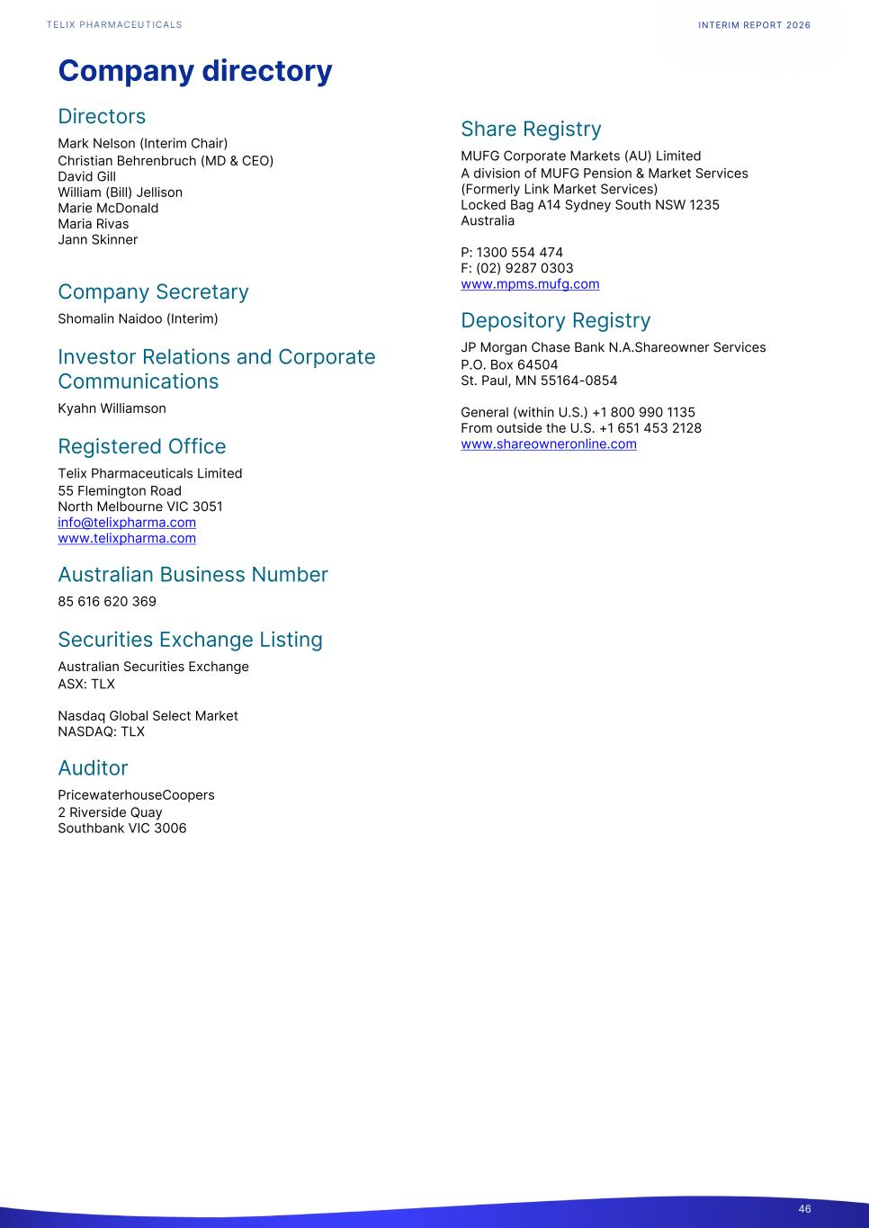
Company directory Directors Mark Nelson (Interim Chair) Christian Behrenbruch (MD & CEO) David Gill William (Bill) Jellison Marie McDonald Maria Rivas Jann Skinner Company Secretary Shomalin Naidoo (Interim) Investor Relations and Corporate Communications Kyahn Williamson Registered Office Telix Pharmaceuticals Limited 55 Flemington Road North Melbourne VIC 3051 info@telixpharma.com www.telixpharma.com Australian Business Number 85 616 620 369 Securities Exchange Listing Australian Securities Exchange ASX: TLX Nasdaq Global Select Market NASDAQ: TLX Auditor PricewaterhouseCoopers 2 Riverside Quay Southbank VIC 3006 Share Registry MUFG Corporate Markets (AU) Limited A division of MUFG Pension & Market Services (Formerly Link Market Services) Locked Bag A14 Sydney South NSW 1235 Australia P: 1300 554 474 F: (02) 9287 0303 www.mpms.mufg.com Depository Registry JP Morgan Chase Bank N.A.Shareowner Services P.O. Box 64504 St. Paul, MN 55164-0854 General (within U.S.) +1 800 990 1135 From outside the U.S. +1 651 453 2128 www.shareowneronline.com INTERIM REPORT 2026 46

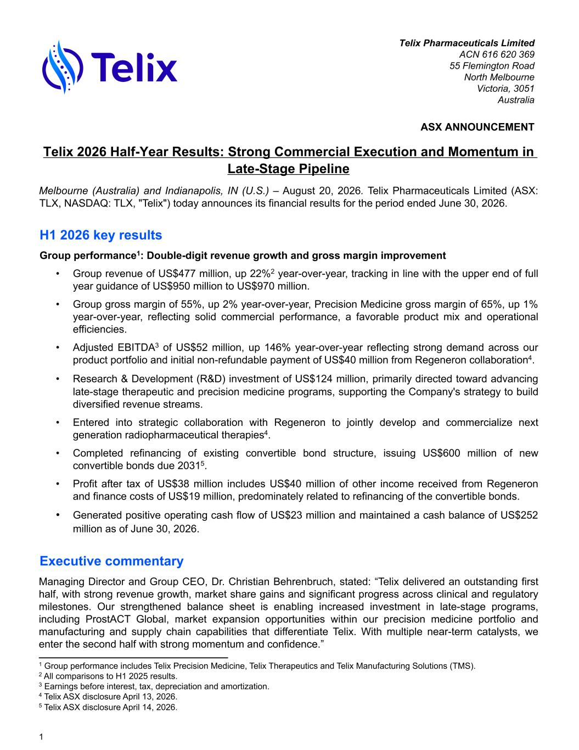
Telix Pharmaceuticals Limited ACN 616 620 369 55 Flemington Road North Melbourne Victoria, 3051 Australia ASX ANNOUNCEMENT Telix 2026 Half-Year Results: Strong Commercial Execution and Momentum in Late-Stage Pipeline Melbourne (Australia) and Indianapolis, IN (U.S.) – August 20, 2026. Telix Pharmaceuticals Limited (ASX: TLX, NASDAQ: TLX, "Telix") today announces its financial results for the period ended June 30, 2026. H1 2026 key results Group performance1: Double-digit revenue growth and gross margin improvement • Group revenue of US$477 million, up 22%2 year-over-year, tracking in line with the upper end of full year guidance of US$950 million to US$970 million. • Group gross margin of 55%, up 2% year-over-year, Precision Medicine gross margin of 65%, up 1% year-over-year, reflecting solid commercial performance, a favorable product mix and operational efficiencies. • Adjusted EBITDA3 of US$52 million, up 146% year-over-year reflecting strong demand across our product portfolio and initial non-refundable payment of US$40 million from Regeneron collaboration4. • Research & Development (R&D) investment of US$124 million, primarily directed toward advancing late-stage therapeutic and precision medicine programs, supporting the Company's strategy to build diversified revenue streams. • Entered into strategic collaboration with Regeneron to jointly develop and commercialize next generation radiopharmaceutical therapies4. • Completed refinancing of existing convertible bond structure, issuing US$600 million of new convertible bonds due 20315. • Profit after tax of US$38 million includes US$40 million of other income received from Regeneron and finance costs of US$19 million, predominately related to refinancing of the convertible bonds. • Generated positive operating cash flow of US$23 million and maintained a cash balance of US$252 million as of June 30, 2026. Executive commentary Managing Director and Group CEO, Dr. Christian Behrenbruch, stated: “Telix delivered an outstanding first half, with strong revenue growth, market share gains and significant progress across clinical and regulatory milestones. Our strengthened balance sheet is enabling increased investment in late-stage programs, including ProstACT Global, market expansion opportunities within our precision medicine portfolio and manufacturing and supply chain capabilities that differentiate Telix. With multiple near-term catalysts, we enter the second half with strong momentum and confidence.” 1 1 Group performance includes Telix Precision Medicine, Telix Therapeutics and Telix Manufacturing Solutions (TMS). 2 All comparisons to H1 2025 results. 3 Earnings before interest, tax, depreciation and amortization. 4 Telix ASX disclosure April 13, 2026. 5 Telix ASX disclosure April 14, 2026.

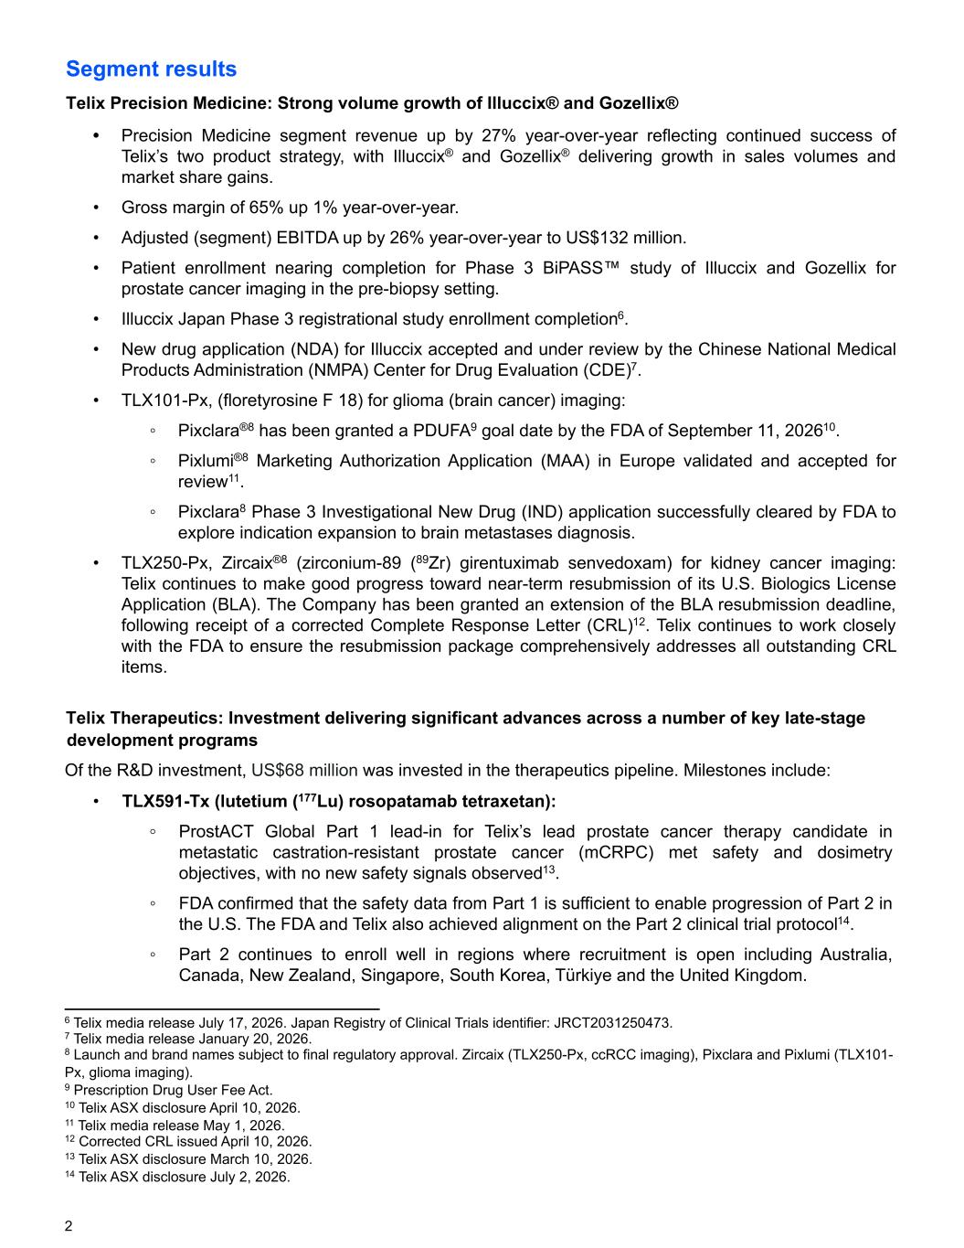
Segment results Telix Precision Medicine: Strong volume growth of Illuccix® and Gozellix® • Precision Medicine segment revenue up by 27% year-over-year reflecting continued success of Telix’s two product strategy, with Illuccix® and Gozellix® delivering growth in sales volumes and market share gains. • Gross margin of 65% up 1% year-over-year. • Adjusted (segment) EBITDA up by 26% year-over-year to US$132 million. • Patient enrollment nearing completion for Phase 3 BiPASS™ study of Illuccix and Gozellix for prostate cancer imaging in the pre-biopsy setting. • Illuccix Japan Phase 3 registrational study enrollment completion6. • New drug application (NDA) for Illuccix accepted and under review by the Chinese National Medical Products Administration (NMPA) Center for Drug Evaluation (CDE)7. • TLX101-Px, (floretyrosine F 18) for glioma (brain cancer) imaging: ◦ Pixclara®8 has been granted a PDUFA9 goal date by the FDA of September 11, 202610. ◦ Pixlumi®8 Marketing Authorization Application (MAA) in Europe validated and accepted for review11. ◦ Pixclara8 Phase 3 Investigational New Drug (IND) application successfully cleared by FDA to explore indication expansion to brain metastases diagnosis. • TLX250-Px, Zircaix®8 (zirconium-89 (89Zr) girentuximab senvedoxam) for kidney cancer imaging: Telix continues to make good progress toward near-term resubmission of its U.S. Biologics License Application (BLA). The Company has been granted an extension of the BLA resubmission deadline, following receipt of a corrected Complete Response Letter (CRL)12. Telix continues to work closely with the FDA to ensure the resubmission package comprehensively addresses all outstanding CRL items. Telix Therapeutics: Investment delivering significant advances across a number of key late-stage development programs Of the R&D investment, US$68 million was invested in the therapeutics pipeline. Milestones include: • TLX591-Tx (lutetium (177Lu) rosopatamab tetraxetan): ◦ ProstACT Global Part 1 lead-in for Telix’s lead prostate cancer therapy candidate in metastatic castration-resistant prostate cancer (mCRPC) met safety and dosimetry objectives, with no new safety signals observed13. ◦ FDA confirmed that the safety data from Part 1 is sufficient to enable progression of Part 2 in the U.S. The FDA and Telix also achieved alignment on the Part 2 clinical trial protocol14. ◦ Part 2 continues to enroll well in regions where recruitment is open including Australia, Canada, New Zealand, Singapore, South Korea, Türkiye and the United Kingdom. 2 6 Telix media release July 17, 2026. Japan Registry of Clinical Trials identifier: JRCT2031250473. 7 Telix media release January 20, 2026. 8 Launch and brand names subject to final regulatory approval. Zircaix (TLX250-Px, ccRCC imaging), Pixclara and Pixlumi (TLX101- Px, glioma imaging). 9 Prescription Drug User Fee Act. 10 Telix ASX disclosure April 10, 2026. 11 Telix media release May 1, 2026. 12 Corrected CRL issued April 10, 2026. 13 Telix ASX disclosure March 10, 2026. 14 Telix ASX disclosure July 2, 2026.

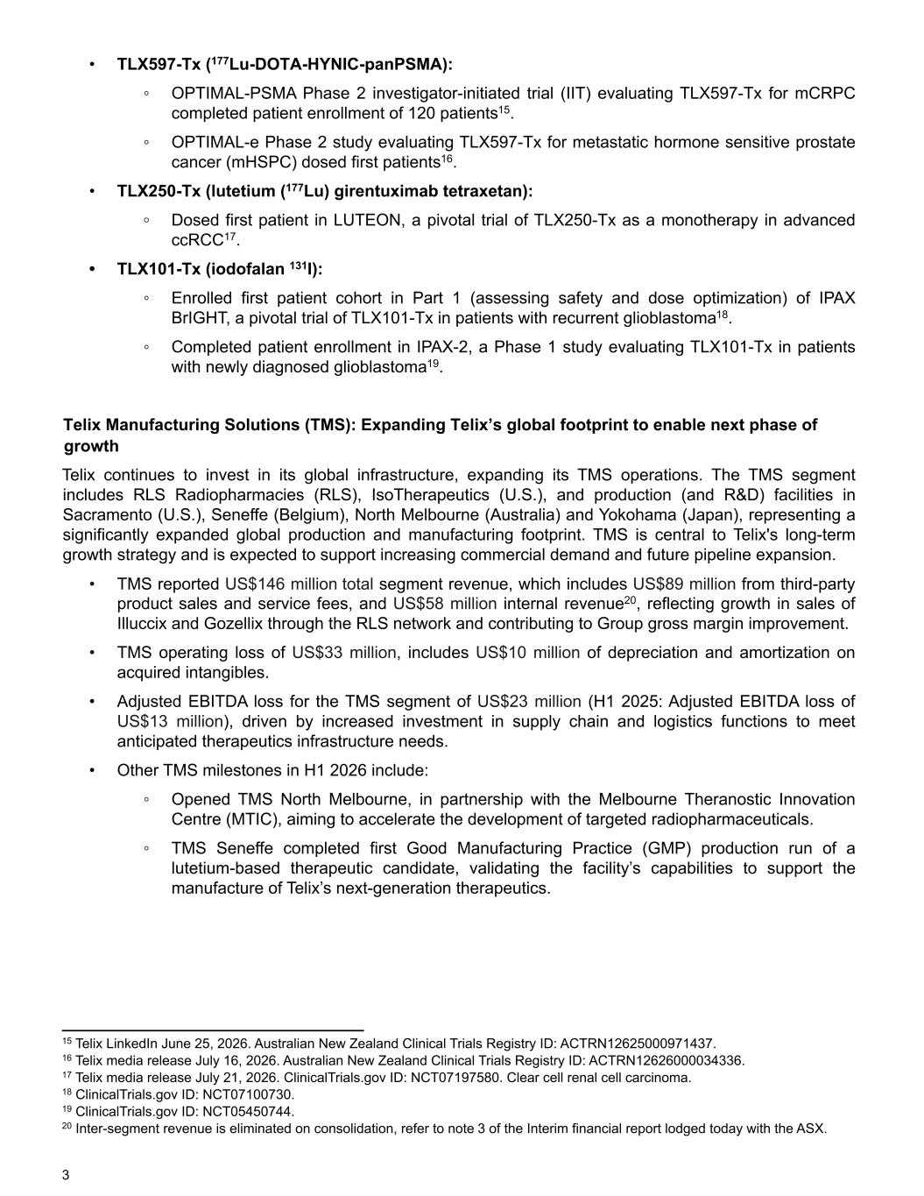
• TLX597-Tx (177Lu-DOTA-HYNIC-panPSMA): ◦ OPTIMAL-PSMA Phase 2 investigator-initiated trial (IIT) evaluating TLX597-Tx for mCRPC completed patient enrollment of 120 patients15. ◦ OPTIMAL-e Phase 2 study evaluating TLX597-Tx for metastatic hormone sensitive prostate cancer (mHSPC) dosed first patients16. • TLX250-Tx (lutetium (177Lu) girentuximab tetraxetan): ◦ Dosed first patient in LUTEON, a pivotal trial of TLX250-Tx as a monotherapy in advanced ccRCC17. • TLX101-Tx (iodofalan 131I): ◦ Enrolled first patient cohort in Part 1 (assessing safety and dose optimization) of IPAX BrIGHT, a pivotal trial of TLX101-Tx in patients with recurrent glioblastoma18. ◦ Completed patient enrollment in IPAX-2, a Phase 1 study evaluating TLX101-Tx in patients with newly diagnosed glioblastoma19. Telix Manufacturing Solutions (TMS): Expanding Telix’s global footprint to enable next phase of growth Telix continues to invest in its global infrastructure, expanding its TMS operations. The TMS segment includes RLS Radiopharmacies (RLS), IsoTherapeutics (U.S.), and production (and R&D) facilities in Sacramento (U.S.), Seneffe (Belgium), North Melbourne (Australia) and Yokohama (Japan), representing a significantly expanded global production and manufacturing footprint. TMS is central to Telix's long-term growth strategy and is expected to support increasing commercial demand and future pipeline expansion. • TMS reported US$146 million total segment revenue, which includes US$89 million from third-party product sales and service fees, and US$58 million internal revenue20, reflecting growth in sales of Illuccix and Gozellix through the RLS network and contributing to Group gross margin improvement. • TMS operating loss of US$33 million, includes US$10 million of depreciation and amortization on acquired intangibles. • Adjusted EBITDA loss for the TMS segment of US$23 million (H1 2025: Adjusted EBITDA loss of US$13 million), driven by increased investment in supply chain and logistics functions to meet anticipated therapeutics infrastructure needs. • Other TMS milestones in H1 2026 include: ◦ Opened TMS North Melbourne, in partnership with the Melbourne Theranostic Innovation Centre (MTIC), aiming to accelerate the development of targeted radiopharmaceuticals. ◦ TMS Seneffe completed first Good Manufacturing Practice (GMP) production run of a lutetium-based therapeutic candidate, validating the facility’s capabilities to support the manufacture of Telix’s next-generation therapeutics. 3 15 Telix LinkedIn June 25, 2026. Australian New Zealand Clinical Trials Registry ID: ACTRN12625000971437. 16 Telix media release July 16, 2026. Australian New Zealand Clinical Trials Registry ID: ACTRN12626000034336. 17 Telix media release July 21, 2026. ClinicalTrials.gov ID: NCT07197580. Clear cell renal cell carcinoma. 18 ClinicalTrials.gov ID: NCT07100730. 19 ClinicalTrials.gov ID: NCT05450744. 20 Inter-segment revenue is eliminated on consolidation, refer to note 3 of the Interim financial report lodged today with the ASX.

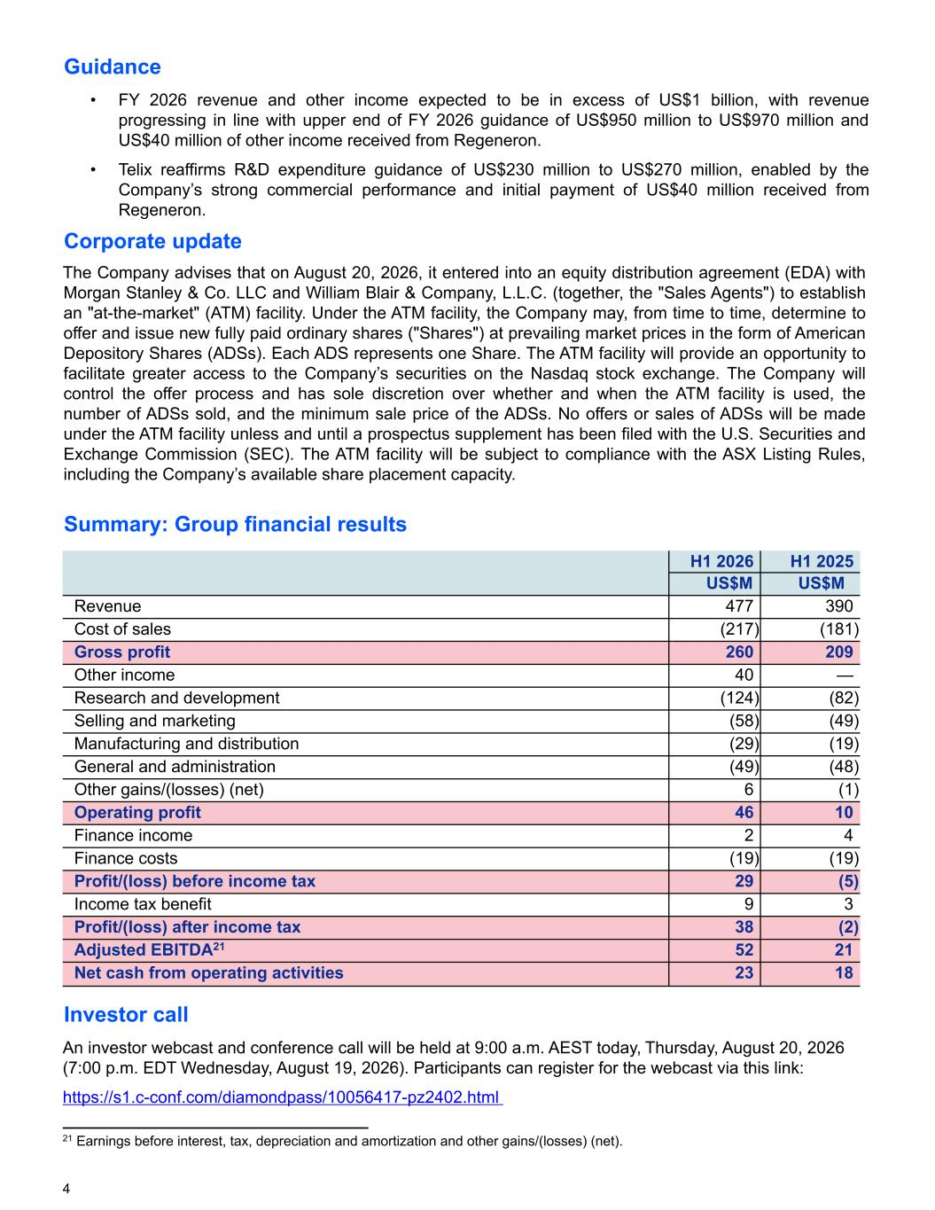
Guidance • FY 2026 revenue and other income expected to be in excess of US$1 billion, with revenue progressing in line with upper end of FY 2026 guidance of US$950 million to US$970 million and US$40 million of other income received from Regeneron. • Telix reaffirms R&D expenditure guidance of US$230 million to US$270 million, enabled by the Company’s strong commercial performance and initial payment of US$40 million received from Regeneron. Corporate update The Company advises that on August 20, 2026, it entered into an equity distribution agreement (EDA) with Morgan Stanley & Co. LLC and William Blair & Company, L.L.C. (together, the "Sales Agents") to establish an "at-the-market" (ATM) facility. Under the ATM facility, the Company may, from time to time, determine to offer and issue new fully paid ordinary shares ("Shares") at prevailing market prices in the form of American Depository Shares (ADSs). Each ADS represents one Share. The ATM facility will provide an opportunity to facilitate greater access to the Company’s securities on the Nasdaq stock exchange. The Company will control the offer process and has sole discretion over whether and when the ATM facility is used, the number of ADSs sold, and the minimum sale price of the ADSs. No offers or sales of ADSs will be made under the ATM facility unless and until a prospectus supplement has been filed with the U.S. Securities and Exchange Commission (SEC). The ATM facility will be subject to compliance with the ASX Listing Rules, including the Company’s available share placement capacity. Summary: Group financial results H1 2026 H1 2025 US$M US$M Revenue 477 390 Cost of sales (217) (181) Gross profit 260 209 Other income 40 — Research and development (124) (82) Selling and marketing (58) (49) Manufacturing and distribution (29) (19) General and administration (49) (48) Other gains/(losses) (net) 6 (1) Operating profit 46 10 Finance income 2 4 Finance costs (19) (19) Profit/(loss) before income tax 29 (5) Income tax benefit 9 3 Profit/(loss) after income tax 38 (2) Adjusted EBITDA21 52 21 Net cash from operating activities 23 18 Investor call An investor webcast and conference call will be held at 9:00 a.m. AEST today, Thursday, August 20, 2026 (7:00 p.m. EDT Wednesday, August 19, 2026). Participants can register for the webcast via this link: https://s1.c-conf.com/diamondpass/10056417-pz2402.html 4 21 Earnings before interest, tax, depreciation and amortization and other gains/(losses) (net).

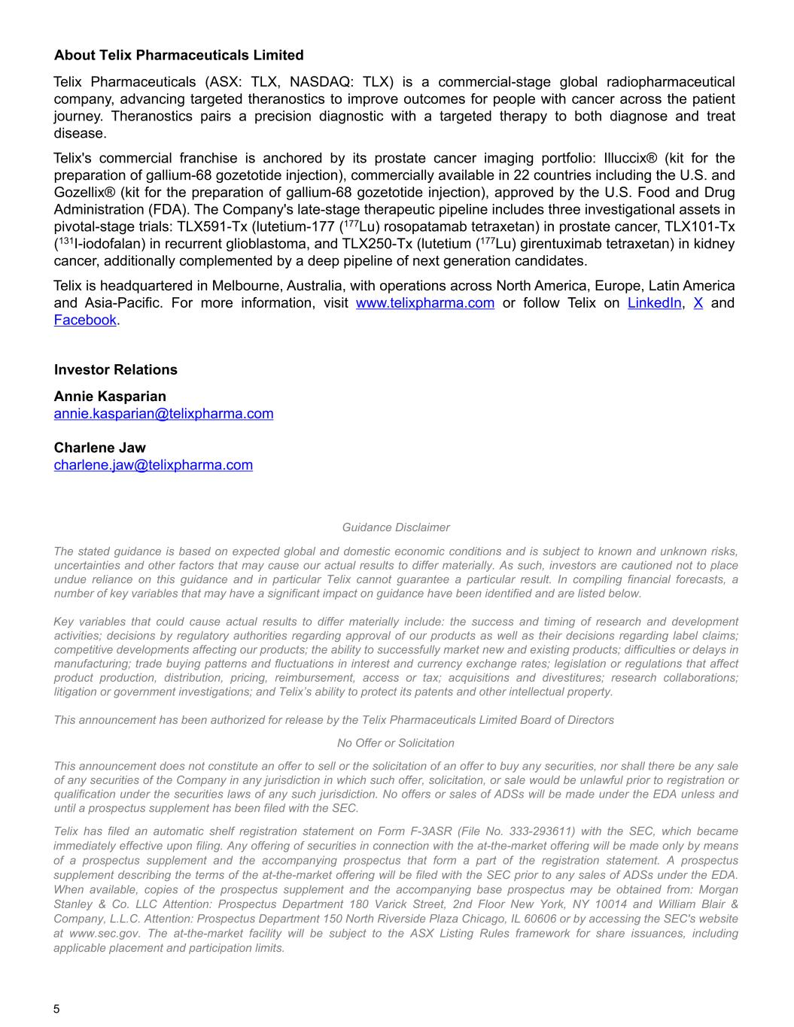
About Telix Pharmaceuticals Limited Telix Pharmaceuticals (ASX: TLX, NASDAQ: TLX) is a commercial-stage global radiopharmaceutical company, advancing targeted theranostics to improve outcomes for people with cancer across the patient journey. Theranostics pairs a precision diagnostic with a targeted therapy to both diagnose and treat disease. Telix's commercial franchise is anchored by its prostate cancer imaging portfolio: Illuccix® (kit for the preparation of gallium-68 gozetotide injection), commercially available in 22 countries including the U.S. and Gozellix® (kit for the preparation of gallium-68 gozetotide injection), approved by the U.S. Food and Drug Administration (FDA). The Company's late-stage therapeutic pipeline includes three investigational assets in pivotal-stage trials: TLX591-Tx (lutetium-177 (177Lu) rosopatamab tetraxetan) in prostate cancer, TLX101-Tx (131I-iodofalan) in recurrent glioblastoma, and TLX250-Tx (lutetium (177Lu) girentuximab tetraxetan) in kidney cancer, additionally complemented by a deep pipeline of next generation candidates. Telix is headquartered in Melbourne, Australia, with operations across North America, Europe, Latin America and Asia-Pacific. For more information, visit www.telixpharma.com or follow Telix on LinkedIn, X and Facebook. Investor Relations Annie Kasparian annie.kasparian@telixpharma.com Charlene Jaw charlene.jaw@telixpharma.com Guidance Disclaimer The stated guidance is based on expected global and domestic economic conditions and is subject to known and unknown risks, uncertainties and other factors that may cause our actual results to differ materially. As such, investors are cautioned not to place undue reliance on this guidance and in particular Telix cannot guarantee a particular result. In compiling financial forecasts, a number of key variables that may have a significant impact on guidance have been identified and are listed below. Key variables that could cause actual results to differ materially include: the success and timing of research and development activities; decisions by regulatory authorities regarding approval of our products as well as their decisions regarding label claims; competitive developments affecting our products; the ability to successfully market new and existing products; difficulties or delays in manufacturing; trade buying patterns and fluctuations in interest and currency exchange rates; legislation or regulations that affect product production, distribution, pricing, reimbursement, access or tax; acquisitions and divestitures; research collaborations; litigation or government investigations; and Telix’s ability to protect its patents and other intellectual property. This announcement has been authorized for release by the Telix Pharmaceuticals Limited Board of Directors No Offer or Solicitation This announcement does not constitute an offer to sell or the solicitation of an offer to buy any securities, nor shall there be any sale of any securities of the Company in any jurisdiction in which such offer, solicitation, or sale would be unlawful prior to registration or qualification under the securities laws of any such jurisdiction. No offers or sales of ADSs will be made under the EDA unless and until a prospectus supplement has been filed with the SEC. Telix has filed an automatic shelf registration statement on Form F-3ASR (File No. 333-293611) with the SEC, which became immediately effective upon filing. Any offering of securities in connection with the at-the-market offering will be made only by means of a prospectus supplement and the accompanying prospectus that form a part of the registration statement. A prospectus supplement describing the terms of the at-the-market offering will be filed with the SEC prior to any sales of ADSs under the EDA. When available, copies of the prospectus supplement and the accompanying base prospectus may be obtained from: Morgan Stanley & Co. LLC Attention: Prospectus Department 180 Varick Street, 2nd Floor New York, NY 10014 and William Blair & Company, L.L.C. Attention: Prospectus Department 150 North Riverside Plaza Chicago, IL 60606 or by accessing the SEC's website at www.sec.gov. The at-the-market facility will be subject to the ASX Listing Rules framework for share issuances, including applicable placement and participation limits. 5

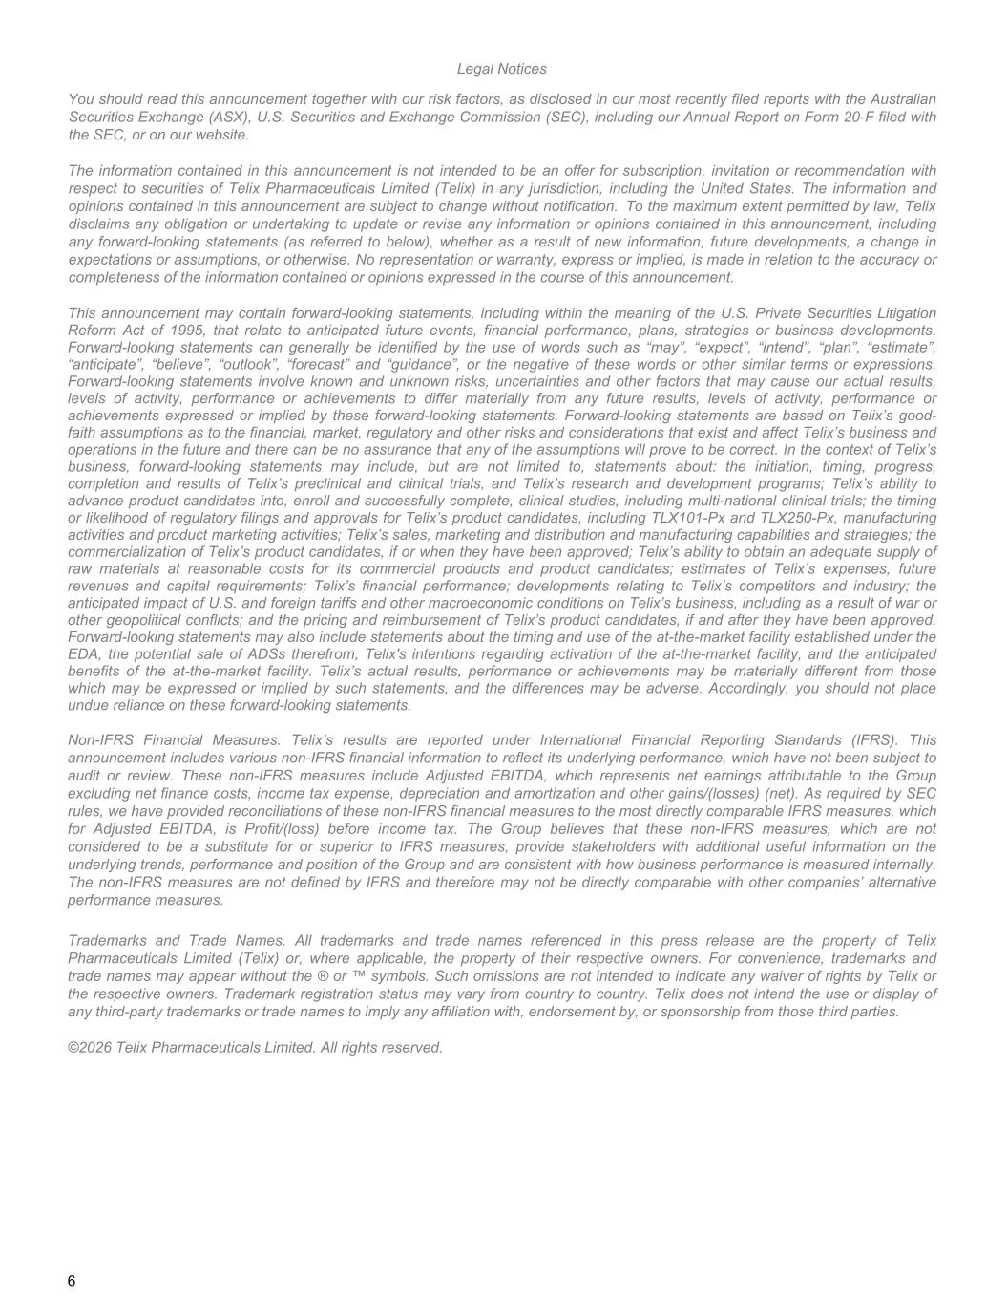
Legal Notices You should read this announcement together with our risk factors, as disclosed in our most recently filed reports with the Australian Securities Exchange (ASX), U.S. Securities and Exchange Commission (SEC), including our Annual Report on Form 20-F filed with the SEC, or on our website. The information contained in this announcement is not intended to be an offer for subscription, invitation or recommendation with respect to securities of Telix Pharmaceuticals Limited (Telix) in any jurisdiction, including the United States. The information and opinions contained in this announcement are subject to change without notification. To the maximum extent permitted by law, Telix disclaims any obligation or undertaking to update or revise any information or opinions contained in this announcement, including any forward-looking statements (as referred to below), whether as a result of new information, future developments, a change in expectations or assumptions, or otherwise. No representation or warranty, express or implied, is made in relation to the accuracy or completeness of the information contained or opinions expressed in the course of this announcement. This announcement may contain forward-looking statements, including within the meaning of the U.S. Private Securities Litigation Reform Act of 1995, that relate to anticipated future events, financial performance, plans, strategies or business developments. Forward-looking statements can generally be identified by the use of words such as “may”, “expect”, “intend”, “plan”, “estimate”, “anticipate”, “believe”, “outlook”, “forecast” and “guidance”, or the negative of these words or other similar terms or expressions. Forward-looking statements involve known and unknown risks, uncertainties and other factors that may cause our actual results, levels of activity, performance or achievements to differ materially from any future results, levels of activity, performance or achievements expressed or implied by these forward-looking statements. Forward-looking statements are based on Telix’s good- faith assumptions as to the financial, market, regulatory and other risks and considerations that exist and affect Telix’s business and operations in the future and there can be no assurance that any of the assumptions will prove to be correct. In the context of Telix’s business, forward-looking statements may include, but are not limited to, statements about: the initiation, timing, progress, completion and results of Telix’s preclinical and clinical trials, and Telix’s research and development programs; Telix’s ability to advance product candidates into, enroll and successfully complete, clinical studies, including multi-national clinical trials; the timing or likelihood of regulatory filings and approvals for Telix’s product candidates, including TLX101-Px and TLX250-Px, manufacturing activities and product marketing activities; Telix’s sales, marketing and distribution and manufacturing capabilities and strategies; the commercialization of Telix’s product candidates, if or when they have been approved; Telix’s ability to obtain an adequate supply of raw materials at reasonable costs for its commercial products and product candidates; estimates of Telix’s expenses, future revenues and capital requirements; Telix’s financial performance; developments relating to Telix’s competitors and industry; the anticipated impact of U.S. and foreign tariffs and other macroeconomic conditions on Telix’s business, including as a result of war or other geopolitical conflicts; and the pricing and reimbursement of Telix’s product candidates, if and after they have been approved. Forward-looking statements may also include statements about the timing and use of the at-the-market facility established under the EDA, the potential sale of ADSs therefrom, Telix's intentions regarding activation of the at-the-market facility, and the anticipated benefits of the at-the-market facility. Telix’s actual results, performance or achievements may be materially different from those which may be expressed or implied by such statements, and the differences may be adverse. Accordingly, you should not place undue reliance on these forward-looking statements. Non-IFRS Financial Measures. Telix’s results are reported under International Financial Reporting Standards (IFRS). This announcement includes various non-IFRS financial information to reflect its underlying performance, which have not been subject to audit or review. These non-IFRS measures include Adjusted EBITDA, which represents net earnings attributable to the Group excluding net finance costs, income tax expense, depreciation and amortization and other gains/(losses) (net). As required by SEC rules, we have provided reconciliations of these non-IFRS financial measures to the most directly comparable IFRS measures, which for Adjusted EBITDA, is Profit/(loss) before income tax. The Group believes that these non-IFRS measures, which are not considered to be a substitute for or superior to IFRS measures, provide stakeholders with additional useful information on the underlying trends, performance and position of the Group and are consistent with how business performance is measured internally. The non-IFRS measures are not defined by IFRS and therefore may not be directly comparable with other companies’ alternative performance measures. Trademarks and Trade Names. All trademarks and trade names referenced in this press release are the property of Telix Pharmaceuticals Limited (Telix) or, where applicable, the property of their respective owners. For convenience, trademarks and trade names may appear without the ® or ™ symbols. Such omissions are not intended to indicate any waiver of rights by Telix or the respective owners. Trademark registration status may vary from country to country. Telix does not intend the use or display of any third-party trademarks or trade names to imply any affiliation with, endorsement by, or sponsorship from those third parties. ©2026 Telix Pharmaceuticals Limited. All rights reserved. 6


1

Financial review

In 2026, Telix continues on a significant growth trajectory, driven by the global commercial success of Illuccix® and
Gozellix®. As the Company advances toward near-term regulatory milestones and progresses a promising pipeline of
therapeutic candidates, these strategic investments in our late-stage candidates are positioning Telix to deliver its next
phase of growth and make a meaningful difference to patients' lives, underpinned by a resilient and diversified business
model with multiple revenue streams.
Our operations have been financed primarily through cash generated by our commercial operations and the issuance of
Ordinary Shares and Convertible Bonds.
Reported profit after tax attributable to Telix Shareholders was $38.3 million for the period ended June 30, 2026,
compared to a loss of $2.3 million for the period ended June 30, 2025. The net profit reflects the impact of income on
entering our strategic collaboration with Regeneron, and continued success in our commercial businesses, allowing us to
increase investment in our Therapeutic pipeline.
Our total comprehensive income was $9.5 million for the period ended June 30, 2026, compared to $3.3 million for the
period ended June 30, 2025. We expect our expenses to increase as we continue our development of, and seek
regulatory approvals for, our product candidates. In addition, if and when we seek and obtain regulatory approval to
commercialize additional product candidates, we will also incur increased expenses in connection with commercialization
and marketing of any such product. Our total comprehensive income or loss may fluctuate significantly from period-to-
period, depending on the timing of our clinical trials and our expenditures on other research and development activities.
The following table sets forth a summary of the Group's Consolidated statement of comprehensive income for the
periods ended June 30, 2026 and June 30, 2025.
2

 | Half-year ended |  | HY 2026 vs. 2025
 | June 30  2026 | June 30  2025 | Change | Change
 | US$'000 | US$'000 | US$'000 | %
 | (in thousands, except percentage and per share data)
Continuing operations
Revenue from contracts with customers | 477,350 | 390,359 | 86,991 | 22
Cost of sales | (217,001) | (181,736) | (35,265) | 19
Gross profit | 260,349 | 208,623 | 51,726 | 25
Other income | 40,000 | - | 40,000 | *
Research and development costs | (123,828) | (81,583) | (42,245) | 52
Selling and marketing expenses | (58,358) | (48,973) | (9,385) | 19
Manufacturing and distribution costs | (28,713) | (18,849) | (9,864) | 52
General and administration costs | (48,663) | (47,723) | (940) | 2
Other gains/(losses)(net) | 5,575 | (1,105) | 6,680 | *
Operating profit | 46,362 | 10,390 | 35,972 | 346
Finance income | 2,274 | 3,616 | (1,342) | (37)
Finance costs | (19,388) | (18,842) | (546) | 3
Profit/(loss) before income tax | 29,248 | (4,836) | 34,084 | *
Income tax benefit | 9,082 | 2,544 | 6,538 | 257
Profit/(loss) for the period | 38,330 | (2,292) | 40,622 | *
Profit/(loss) for the period attributable to:
Owners of Telix Pharmaceuticals Limited | 38,330 | (2,292) | 40,622 | *
Other comprehensive income:
Items that will not be reclassified to profit or loss in
subsequent periods:
Changes in the fair value of investments at fair value  through other comprehensive income | 1,207 | (1,381) | 2,588 | *
Items to be reclassified to profit or loss in subsequent
periods:
Exchange differences on translation of foreign operations | (30,079) | 6,928 | (37,007) | *
Total comprehensive income for the period | 9,458 | 3,255 | 6,203 | 191
*Percentage not meaningful
Revenue from contracts with customers
The Group delivered sustained growth in revenue. Revenue from contracts with customers was $477.3 million for the
period ended June 30, 2026, an increase of $87.0 million, or 22%, compared to $390.4 million for the period ended
June 30, 2025. The Precision Medicine business was the standout driver, generating $388.6 million, while the
Manufacturing Solutions business (TMS) continued to build momentum, generating $88.7 million in sales of third-party
products and services. This increase is also attributable to six months of revenue from RLS in 2026, compared to five
months of revenue in 2025 (acquired on January 28, 2025).
Cost of sales
Cost of sales increased by $35.3 million, or 19%, to $217.0 million for the period ended June 30, 2026, from $181.7 million
for the period ended June 30, 2025. The increase was primarily driven by increased sales volumes from our Precision
Medicine business.

1 Single-photon emission computed tomography.
2 Brand name subject to final regulatory approval.
3
Gross margin improved in 2026 relative to 2025, increasing to 55% for the period ended June 30, 2026 (compared to
53% for the period ended June 30, 2025), reflecting the product mix of high value, Precision Medicine products in Telix's
portfolio and the sales of higher volume and lower margin SPECT1 imaging products at RLS. The Group's gross margin
also reflects the effect of a full half-year of the RLS business. Precision Medicine gross margin improved during the
period ended June 30, 2026 to 65% (64% for the period ended June 30, 2025), supported by increased sales of
Gozellix® in the U.S., disciplined pricing and effective control of cost of sales across the portfolio.
Research and development costs
Revenue growth enabled an increased investment into R&D. R&D costs were $123.8 million for the period ended June 30,
2026, an increase of $42.2 million, or 52%, compared to $81.6 million for the period ended June 30, 2025. In line with our
communicated strategy, the Company is investing a proportion of its revenue into R&D with the goal of creating further
revenue streams. Accordingly, expenditure predominantly focused on advancing clinical trials for late-stage therapeutic
assets and progressing regulatory resubmissions for Precision Medicine assets.
R&D investment reflects:
•the inclusion of a new Tx candidate, TLX597-Tx, a next generation PSMA-targeting prostate cancer radioligand
therapy.
•expansion of the BiPASS™ study, the first study designed to gain marketing authorization for 68Ga-PSMA-PET
imaging in the pre-biopsy setting.
•continued enrollment in Part 2 of the ProstACT Global Phase 3 trial of TLX591-Tx.
•preparing the Zircaix2 (TLX250-Px) BLA and the Pixclara2 (TLX101-Px) NDA resubmissions.
Selling and marketing expenses
Selling and marketing expenses were $58.4 million for the period ended June 30, 2026, an increase of $9.4 million, or
19%, compared to $49.0 million for the period ended June 30, 2025. This increase was primarily driven by increased
investment in promotional activities and sales force operations, deployed to drive higher global sales volumes of Illuccix®
and Gozellix®.
Manufacturing and distribution costs
Manufacturing and distribution costs were $28.7 million for the period ended June 30, 2026, an increase of $9.9 million,
or 52%, compared to $18.8 million for the period ended June 30, 2025. This increase was primarily driven by the impact
of six months of RLS operations on the Group results when compared to approximately five months post-acquisition in
2025, and higher costs associated with increased activity across our TMS sites.
General and administration costs
General and administration costs were $48.7 million for the period ended June 30, 2026, an increase of $1.0 million, or
2%, compared to $47.7 million for the period ended June 30, 2025. This increase was driven by:
•the impact of six months of RLS operations on the Group results.
•increased legal, IT infrastructure and software costs.
Other income
Other income for the period resulted from the $40.0 million initial, non-refundable payment received as part of the
collaboration with Regeneron entered into in April 2026. The Group received the payment in respect of four initial
therapeutic programs, with Regeneron holding options to expand the collaboration to additional programs. Refer to note
4.4 of the Interim financial report for further details.
Other gains/(losses) (net)
Other gains (net) were $5.6 million for the period ended June 30, 2026, a change of $6.7 million, compared to other
losses (net) of $1.1 million for the period ended June 30, 2025. The gain in the current period primarily resulted from
realized and unrealized currency gains and gains on contingent consideration related to the RLS acquisition.
4
Finance income
Finance income was $2.3 million for the period ended June 30, 2026, a decrease of $1.3 million, or 37%, compared to
$3.6 million for the period ended June 30, 2025. Following the acquisition of RLS in January 2025 and associated cash
settlement of the transaction, there was a decrease in cash and cash equivalents placed into short term deposits in the
period ended June 30, 2026 compared to the prior period.
Finance costs
Finance costs were $19.4 million for the period ended June 30, 2026, an increase of $0.6 million, or 3%, compared to
$18.8 million for the period ended June 30, 2025. This increase reflects the impact of the repayment of substantially all
of the Convertible Bonds issued in July 2024 and the issue of new Convertible Bonds in April 2026 at a lower coupon
rate. A gain of $2.9 million on the repurchase of Convertible Bonds is included within finance costs.
Income tax benefit
Income tax benefit was $9.1 million for the period ended June 30, 2026, an increase of $6.6 million compared to $2.5
million for the period ended June 30, 2025. This resulted from the recognition of $21.4 million in deferred tax benefits
attributable to deductible temporary differences. Current tax expense for the period ended June 30, 2026 was $12.3
million, decreased from $21.5 million for the period ended June 30, 2025 as a result of the decrease in taxable profits
generated in the U.S. and Belgium.

Segment results
Our three reportable segments are Precision Medicine, Therapeutics and Manufacturing Solutions.
We evaluate the performance of our segments based on Adjusted EBITDA, calculated as earnings before interest, tax,
depreciation and amortization, adjusted for other gains and losses which may have an impact on the degree to which
earnings reflect the results of core operations, such as remeasurement of contingent consideration, non-recurring
income and expenditure, foreign exchange gains and losses on monetary items, and impairment or impairment reversal
where the impairment is the result of an isolated, non-recurring event.
Our management uses Adjusted EBITDA to assess the core operating performance of segments and to make decisions
about the allocation of resources. We also believe this measure provides useful information to users of our financial
statements by allowing for the assessment of underlying trends in our current operational performance by excluding the
impacts of non-recurring costs.

Precision Medicine
The Precision Medicine segment focuses on the commercial sales of Illuccix®, Gozellix® and other diagnostic products
that may obtain regulatory approvals. This segment includes royalties and sales of goods (which account for the majority
of our revenue from operations), as well as the sales and marketing expenses and costs of sales necessary to support
those revenues and R&D costs associated with development activities of our diagnostic pipeline.
1 Brand name subject to final regulatory approval.
5
The following table sets forth the results of operations for our Precision Medicine segment for the periods ended
June 30, 2026 and June 30, 2025.
 | Half-year ended |  | HY2026 vs. HY2025
 | June 30  2026 | June 30  2025 | Change | Change
 | US$'000 | US$'000 | US$'000 | %
 | (in thousands, except percentage data)
Revenue from contracts with customers | 388,633 | 305,835 | 82,798 | 27
Cost of sales | (134,600) | (108,839) | (25,761) | 24
Gross profit | 254,033 | 196,996 | 57,037 | 29
Research and development costs | (54,482) | (38,116) | (16,366) | 43
Selling and marketing expenses | (49,236) | (40,886) | (8,350) | 20
Manufacturing and distribution costs | (6,625) | (4,105) | (2,520) | 61
General and administration costs | (12,508) | (11,317) | (1,191) | 11
Other gains/(losses) (net) | 1,195 | (1,593) | 2,788 | (175)
Operating profit/(loss) | 132,377 | 100,979 | 31,398 | 31
Other (gains)/losses (net) | (1,195) | 1,593 | (2,788) | (175)
Depreciation and amortization | 707 | 2,074 | (1,367) | (66)
Adjusted EBITDA | 131,889 | 104,646 | 27,243 | 26
For the period ended June 30, 2026, revenue from contracts with customers for our Precision Medicine segment
consisted of $388.2 million (H1 2025: $305.8 million) in sales of goods and $0.4 million (H1 2025: $0.1 million) in royalty
revenue. U.S. sales from Gozellix® and Illuccix® was the primary driver of a 27% increase in revenue, reflecting continued
growth in sales volume, pricing and market share gains. Average daily demand for doses continued to grow throughout
the first half of the year.
Cost of sales increased 24%, driven by higher manufacturing volumes, distribution costs, and radiopharmacy-related
expenses. Gross margin improved to 65% compared to 64% in the prior period, primarily reflecting higher gross margins
achieved on Gozellix® and stable manufacturing and distribution costs.
R&D expenses were $54.5 million in the period ended June 30, 2026, compared to $38.1 million in the period ended
June 30, 2025. The investment was primarily driven by the resubmission of the Pixclara1 NDA, which contained an
expanded clinical evidence package of two major retrospective studies, expanded recruitment for the BiPASS™ study,
which is nearing target enrollment, and preparing the Zircaix1 BLA resubmission. The Illuccix Japan registrational study
has also completed enrollment, and a NDA for TLX591-Px is currently under regulatory review with the Chinese NMPA.
We incurred $4.0 million in the period ended June 30, 2026, compared to $5.2 million in the period ended June 30, 2025
on Zircaix1 commercial inventory to prepare the business for commercial launch.
Selling and marketing expenses were $49.2 million in the period ended June 30, 2026, compared to $40.9 million in the
period ended June 30, 2025. This increase was primarily driven by focused incremental investment in sales force
operations, to drive higher sales volumes of Illuccix® and Gozellix® in the U.S. and accelerate the commercial launch in
Europe, where we saw modest growth throughout the first half of the year.
Manufacturing and distribution costs were $6.6 million in the period ended June 30, 2026, compared to $4.1 million in
the period ended June 30, 2025, reflecting an increase in facility and staff costs to support supply chain and quality
activities to deliver clinical and commercial products.
General and administration costs were $12.5 million in the period ended June 30, 2026, compared to $11.3 million in the
period ended June 30, 2025, reflecting operating leverage and stabilization in corporate activities and related overheads.
Adjusted EBITDA increased by $27.2 million, or 26% to $131.9 million for the period ended June 30, 2026, up from $104.6
million in the period ended June 30, 2025, reflecting the growth in commercial revenues and stabilization in gross
margins, partially offset by higher operating expenditure.
6

Therapeutics
The Therapeutics segment focuses on the development of our core therapeutic pipeline for commercialization. This
segment includes revenue received from license agreements prior to commercialization and research and development
services.
The following table sets forth the results of operations for our Therapeutics segment for the periods ended June 30,
2026 and June 30, 2025.
 | Half-year ended |  | HY2026 vs. HY2025
 | June 30  2026 | June 30  2025 | Change | Change
 | US$'000 | US$'000 | US$'000 | %
 | (in thousands, except percentage data)
Revenue from contracts with customers | - | 3,994 | (3,994) | (100)
Cost of sales | - | (108) | 108 | (100)
Gross profit | - | 3,886 | (3,886) | (100)
Other income | 40,000 | - | 40,000 | *
Research and development costs | (67,968) | (43,868) | (24,100) | 55
Selling and marketing expenses | - | (464) | 464 | (100)
Manufacturing and distribution costs | (2,348) | (1,710) | (638) | 37
General and administration costs | (2,215) | (2,002) | (213) | 11
Other gains (net) | 1,240 | 19 | 1,221 | *
Operating loss | (31,291) | (44,139) | 12,848 | (29)
Other (gains) (net) | (1,240) | (19) | (1,221) | *
Depreciation and amortization | 149 | 117 | 32 | 27
Adjusted EBITDA | (32,382) | (44,041) | 11,659 | (26)
*Percentage not meaningful
For the period ended June 30, 2026, there was no revenue from contracts with customers for our Therapeutics segment
(H1 2025: $4.0 million related to R&D services revenue). The period-over-period change in revenue from contracts with
customers for our Therapeutics segment reflected completion of the revenue recognition associated with the first
upfront payment received from the Grand Pharmaceutical Group Limited (Grand Pharma) contract.
Research and development costs were $68.0 million in the period ended June 30, 2026, compared to $43.9 million in the
period ended June 30, 2025. This increase primarily reflects continued progress in Part 2 of the Phase 3 ProstACT Global
trial, as well as ongoing development of IPAX-2, LUTEON and IPAX BrIGHT. Additional efforts were directed toward
advancing TLX597-Tx and TLX090-Tx. Expenditure during the period included costs associated with manufacturing
activities, site activations, and patient recruitment and dosing activities. Approximately 55% of the Group's R&D
investment was directed toward progressing the Group's therapeutic programs, consistent with expectations and
reflecting the continued prioritization of late-stage and high-value pipeline assets.
Selling and marketing expenses were $nil in the period ended June 30, 2026, compared to $0.5 million in the period
ended June 30, 2025. The decrease was predominantly due to a decrease in employment contractor costs.
Manufacturing and distribution costs were $2.3 million in the period ended June 30, 2026, compared to $1.7 million in the
period ended June 30, 2025, predominantly due to the increase in CMC activities undertaken by our Manufacturing
Solutions business to advance our therapeutics pipeline and logistics costs in delivering clinical doses to patients.
General and administration costs were $2.2 million in the period ended June 30, 2026, compared to $2.0 million in the
period ended June 30, 2025, reflecting a higher allocation of corporate services provided to support the growth in
development activities, including an increase in finance, intellectual property and legal costs.
Other income of $40.0 million was received on entering the Research and Development Collaboration Agreement with
Regeneron in April 2026. Under the collaboration, the parties will co-develop and co-commercialize multiple therapeutic
programs on a 50/50 cost- and profit-sharing basis, combining the Group's radiopharmaceutical development and
manufacturing capabilities with Regeneron's antibody discovery and oncology expertise.
7
Other gains (net) were $1.2 million in the period ended June 30, 2026, compared to $nil in the period ended June 30,
2025.
Adjusted EBITDA for the Therapeutics segment was a loss of $32.4 million in the period ended June 30, 2026, compared
to a loss of $44.0 million in the period ended June 30, 2025, reflecting the $40.0 million received on entering the
Research and Development Collaboration Agreement with Regeneron, offset by the increase in activities as our late-
stage therapeutics products progress through the clinical stages of development.

Manufacturing Solutions
The Manufacturing Solutions segment focuses on the operations of our vertically integrated supply chain and
manufacturing business and includes our production TMS facilities at Seneffe (Brussels South), North Melbourne,
Sacramento and Yokohama, ARTMS, IsoTherapeutics, and RLS Radiopharmacies. This segment comprises distribution
service fee revenue, as well as revenue generated from the sale of PET and SPECT products at RLS. Outside of RLS,
revenue is generated by the provision of contract manufacturing services to our Therapeutics and Precision Medicine
segments, and to companies in the radiopharmaceutical industry. Operating expenses are associated with RLS and our
production facilities in various locations.
The following table sets forth the results of operations for our Manufacturing Solutions segment for the periods ended
June 30, 2026 and June 30, 2025.
 | Half-year ended |  | HY2026 vs. HY2025
 | June 30  2026 | June 30  2025 | Change | Change
 | US$'000 | US$'000 | US$'000 | %
 | (in thousands, except percentage data)
Revenue from contracts with customers | 88,717 | 80,530 | 8,187 | 10
Inter-segment revenue | 57,543 | 33,761 | 23,782 | 70
Cost of sales | (138,435) | (103,485) | (34,950) | 34
Gross profit | 7,825 | 10,806 | (2,981) | (28)
Research and development costs | (2,828) | (2,664) | (164) | 6
Selling and marketing expenses | (9,122) | (7,623) | (1,499) | 20
Manufacturing and distribution costs | (19,740) | (13,034) | (6,706) | 51
General and administration costs | (8,902) | (7,116) | (1,786) | 25
Other (losses)/gains (net) | (176) | 27 | (203) | (765)
Operating loss | (32,943) | (19,604) | (13,339) | 68
Other losses/(gains) (net) | 176 | (27) | 203 | (765)
Depreciation and amortization | 9,811 | 6,969 | 2,842 | 41
Adjusted EBITDA | (22,956) | (12,662) | (10,294) | 81
For the period ended June 30, 2026, revenue from contracts with customers for our Manufacturing Solutions segment
consisted of $88.7 million (2025: $80.5 million) in services revenue, with the period-over-period increase related to a full
six months of operations of the RLS business acquired in late January 2025. Inter-segment revenue was $57.5 million for
the period ended June 30, 2026 versus $33.8 million in 2025. This increase of $23.8 million is attributable to higher dose
volumes of Telix PSMA products at RLS as well as increased activity from our TMS units supporting other parts of the
Telix business.
R&D costs within the Manufacturing Solutions segment remained consistent at $2.8 million in the period ended June 30,
2026, compared to $2.7 million in the period ended June 30, 2025.
Selling and marketing expenses were $9.1 million in the period ended June 30, 2026, compared to $7.6 million in the
period ended June 30, 2025 reflecting the six months of operations from the newly acquired RLS. These costs comprise
predominantly amortization of acquired intangible assets of $2.5 million, employment costs, sales commissions and
travel costs related to sales and marketing personnel.
Manufacturing and distribution costs were $19.7 million and general and administration costs were $8.9 million for our
Manufacturing Solutions segment for the period ended June 30, 2026 (compared to $13.0 million and $7.1 million for the
period ended June 30, 2025, respectively). These increases were predominantly driven by six months of personnel and
occupancy costs from the RLS business, combined with increased activity to prepare the Seneffe (Brussels South)
facility for GMP commercial production.
8
Other losses were $0.2 million in the period ended June 30, 2026, compared to $nil in the period ended June 30, 2025,
comprising the remeasurement of provisions related to contingent consideration liabilities for ARTMS and RLS. The
remeasurements were based on revised probabilities applied to the achievement of certain commercial milestones.
For the period ended June 30, 2026, Adjusted EBITDA for the Manufacturing Solutions business was a loss of $23.0
million, compared to a loss of $12.7 million in the period ended June 30, 2025. The period-over-period change in
Adjusted EBITDA was driven by increased investment in our manufacturing, supply chain and logistics functions and the
continued buildout of our Seneffe, Yokohama and North Melbourne facilities.
RLS contributed $5.5 million toward the operating loss in the period ended June 30, 2026, compared to $4.6 million in
the period ended June 30, 2025. In addition, RLS contributed $2.3 million toward the TMS segment's Adjusted EBITDA
loss in the period ended June 30, 2026, compared to $3.9 million in the period ended June 30, 2025. RLS's operating
loss was relatively stable versus the comparative period, with Adjusted EBITDA reflecting the improvement in the
performance of the business and the strategic investment in our vertically integrated infrastructure.

Cash flows
The following table summarizes our cash flows for the periods presented:
 | Half-year ended
 | June 30  2026 | June 30  2025
 | US$'000 | US$'000
 | (in thousands)
Net cash from operating activities | 23,036 | 17,749
Net cash used in investing activities | (33,717) | (258,854)
Net cash provided by/(used in) financing activities | 118,427 | (2,923)
Net increase/(decrease) in cash held | 107,746 | (244,028)
Operating activities
Net cash from operating activities was $23.0 million during the period ended June 30, 2026. The primary source of cash
from operating activities was $442.9 million in receipts from customers, which predominantly consisted of collections
from sales from the Precision Medicine and Manufacturing Solutions businesses. Receipts of $40.0 million on entering
into the collaboration agreement with Regeneron are also included in operating activities. The improved customer
receipts reflect sales growth from the Precision Medicine business and a full six months of RLS third-party product sales.
The primary uses of cash in operating activities were payments to suppliers and employees of $439.0 million. Other
operating cash outflows included $1.3 million in contingent consideration payments and $14.8 million in income tax
payments.
Net cash from operating activities was $17.7 million during the period ended June 30, 2025. The primary source of cash
from operating activities was $372.0 million in receipts from customers, which predominantly consisted of collections
from sales of Illuccix® from Precision Medicine and five months of receipts from Manufacturing Solutions businesses. The
primary uses of cash in operating activities were payments to suppliers and employees of $348.6 million. Other operating
cash outflows included $3.4 million in income tax payments.
Investing activities
Net cash used in investing activities was $33.7 million during the period ended June 30, 2026, reflecting targeted capital
investment in our pipeline and global manufacturing network. The primary uses of cash in investing activities related to:
•$13.4 million to settle the contingent consideration related to the acquisitions of RLS and deferred consideration
associated with the suite of FAP targeting candidates.
•$14.5 million for the expanded investment at TMS sites across RLS Radiopharmacies, the IsoTherapeutics site in
Angleton, Texas (U.S.), the site in Yokohama (Japan), and our facilities in Seneffe (Brussels South, Belgium) and
North Melbourne (Australia).
Net cash used in investing activities was $258.9 million during the period ended June 30, 2025. The primary uses of cash
in investing activities were the acquisition of businesses. We invested $224.7 million in payments toward our acquisitions
of RLS and assets of ImaginAb and $17.1 million in payments related to the acquisition of intellectual property associated
with FAP targeting candidates, and $6.7 million in property, plant and equipment purchases for the buildout of our
manufacturing facilities.
9
Financing activities
For the period ended June 30, 2026, net cash provided by financing activities totaled $118.4 million. Financing activity
cash flows mainly comprised:
•$587.5 million proceeds from the issuance of New Bonds.
•$466.5 million outflow from the repayment of borrowings, reflecting the settlement of the Existing Bonds issued
in 2024.
•$3.9 million paid toward the principal element of lease liabilities.
•$1.4 million from the issuance of new ordinary shares on the exercise of options previously granted to
employees.
For the period ended June 30, 2025, net cash used in financing activities totaled $2.9 million. Financing activity cash
flows included $0.7 million received from the issuance of new ordinary shares on the exercise of options previously
granted to employees, repayments of principal of $0.5 million toward existing bank loans and $3.1 million paid toward
lease liabilities.

Off-balance sheet arrangements
During the periods presented, we did not, and we do not currently, engage in off-balance sheet financing arrangements
as defined under SEC rules, such as relationships with other entities or financial partnerships, which are often referred to
as structured finance or special purpose entities, established for the purpose of facilitating financing transactions that
are not required to be reflected on our consolidated statement of financial position. In addition, we do not engage in
trading activities involving non-exchange traded contracts.

Liquidity and capital resources
Prior to the fiscal year ended December 31, 2023, we incurred operating losses in each year since our founding. We
anticipate that as we expand through strategic acquisitions, increase our sales and marketing efforts and expand our
investment in R&D, we will need additional capital to fund our operations, which we may raise through a combination of
equity offerings, debt financings, strategic collaborations and other third-party funding arrangements. Our future liquidity
and capital resources will depend on product revenue from the successful continued commercialization of Illuccix® and
Gozellix®, revenue from any future products for which we obtain regulatory approval and the R&D costs and other
expenditure necessary to support these initiatives and future products. Our total comprehensive income was $9.5 million
for the period ended June 30, 2026. Our total comprehensive income was $3.3 million for the period ended June 30,
2025. As of June 30, 2026, we had cash and cash equivalents of $251.9 million and accumulated losses of $110.9 million.
As of June 30, 2026, we held 93.1% of our cash in U.S. dollars, 4.8% in Australian dollars, 1.1% in Euros, 0.4% in Canadian
dollars, 0.2% in British pounds, and 0.2% in Swiss Francs.
Sources and uses of liquidity
Our operations have been financed primarily through cash generated by our commercial operations and the issuance and
sale of new ordinary shares and Convertible Bonds.
We intend to leverage our commercial revenues and the proceeds raised from the issuance of and sale of new ordinary
shares and convertible bonds as a source of funding for the development of additional therapeutic and diagnostic
product candidates in our pipeline, including conducting label-expanding trials across our portfolio of diagnostic imaging
agents and advancing clinical trials for our therapeutic product candidates. In the periods ended June 30, 2026 and
2025, we received $442.9 million and $372.0 million respectively, in receipts from customers, which predominantly
consisted of collections from sales from our Precision Medicine and Manufacturing Solutions businesses.
In the first quarter of 2022, we entered into two loan agreements whereby BNP Paribas agreed to lend us $6.8 million
and IMBC Group agreed to lend us $4.5 million. Each loan is denominated in Euros, in the amounts of €6.1 million and
€4.0 million, respectively, and has been translated to US$ based on the applicable exchange rate as of June 30, 2026.
Each loan has a 10-year term and an interest rate of 1.85% per annum, payable monthly, and each is repayable in 96
monthly installments beginning at the end of a two-year grace period. As of June 30, 2026, the outstanding balance of
these facilities was $9.4 million (translated based on the applicable exchange rate as of June 30, 2026). In connection
with the loan agreement with BNP Paribas, we also entered a roll-over loan agreement whereby BNP Paribas agreed to
lend us an additional $2.3 million (€2.0 million, translated based on the applicable exchange rate as of June 30, 2026).
The loan has a two-year extendable term and a per annum interest rate calculated by adding the eurozone interbank
interest rate as of the determination date to a 1.5% margin, payable based on our choice of interest period ranging from 1
month to 12 months for each advance (with a default interest period of three months if no alternative is chosen), and it is
repayable in full upon its expiration date. We have used the borrowings from these loans in order to fund the renovation
and redevelopment of our Seneffe (Brussels South) production facility.
10
On July 30, 2024 the Group completed the issue of $426,140,000 (A$650,000,000) in convertible bonds maturing in
2029. The bonds were convertible into fully paid ordinary shares in Telix Pharmaceuticals Limited. The initial conversion
price of the convertible bonds was A$24.78 per share, subject to anti-dilution adjustments set out in the final terms and
conditions of the convertible bonds. The net proceeds were $416,324,000, after transaction costs.
The convertible bonds bore interest at a rate of 2.375 per cent per annum. Interest was payable quarterly in arrears on
October 30, January 30, April 30 and July 30 in each year, beginning on October 30, 2024. The convertible bonds would
have matured on or about July 30, 2029.
On December 17, 2024, the Group entered into an agreement with HSBC Bank Australia Limited ("HSBC") to obtain a
working capital facility of up to $34,435,000 (A$50,000,000). To date, the Group has not utilized this facility and has
incurred establishment fee costs of $98,000 (A$150,000) associated with the facility. The working capital facility is
secured by a cash security deposit on an interest-bearing term deposit of $34,435,000 (A$50,000,000) held by HSBC
with a maturity date equivalent to the term of the facility. There are no financial covenants associated with the facility.
On April 15, 2026, the Group announced the successful settlement of the issue of US$600,000,000 1.50 per cent
Convertible Notes due 2031 (New Bonds). The Group concurrently completed the on-market repurchase of
approximately A$637,000,000 in principal of the A$650,000,000 2.375% Convertible Bonds due 2029 issued by Telix in
July 2024 (Existing Bonds). The Existing Bonds repurchased represent approximately 98% of the outstanding Existing
Bonds. In May 2026, we repurchased a further A$5 million of the Existing Bonds. The New Bonds are listed on the
Singapore Exchange Securities Trading Limited (SGX-ST).
The New Bonds bear interest at a rate of 1.50 per cent per annum. Interest is payable quarterly in arrears on January 22,
April 22, July 22 and October 22 in each year, beginning on July 22, 2026. The New Bonds will mature on or about
April 22, 2031, unless redeemed, repurchased, or converted in accordance with their terms.
Funding requirements
We believe that our existing cash resources and cash that we expect to generate from sales from the Precision Medicine
and Manufacturing Solutions businesses will be sufficient to meet our projected operating expenses and capital
expenditure requirements for at least the next 12 months. Our expectations regarding our short-term and long-term
funding requirements are based on assumptions that may prove to be wrong, and we may need additional capital
resources to fund our operating plans and capital expenditure requirements.
We expect our expenses to increase in connection with our ongoing activities, particularly as we continue the
commercialization of products for which we receive regulatory approval and continue clinical development of our
therapeutic product candidates. We expect to finance our operating activities through cash generated from commercial
sales, existing cash and cash equivalents and financing activities, which may include equity offerings, debt financings,
collaborations, strategic alliances and licensing arrangements. To the extent that we raise capital through the sale of
equity or convertible debt securities, the ownership interest of our investors will be diluted, and the terms of these
securities may include liquidation or other preferences that adversely affect the rights of shareholders. Debt financing, if
available, may involve agreements that include covenants limiting or restricting our ability to take specific actions, such
as incurring additional debt, making capital expenditures or declaring dividends. If we raise funds through collaborations,
strategic alliances or licensing arrangements with third parties, we may have to relinquish valuable rights to our
technologies, intellectual property, future revenue streams or product candidates. If we are unable to raise funds through
equity or debt financings when needed, we may be required to delay, limit, reduce or terminate our product development
or future commercialization efforts or grant rights to develop and market product candidates that we would otherwise
prefer to develop and market ourselves.
Our present and future funding requirements will depend on many factors, including, among other things:
•the amount of revenue received from commercial sales of products for which we receive marketing approval.
•the initiation, progress, timing, costs and results of our clinical trials for our product candidates.
•the costs associated with in-licensing or acquiring assets to expand our pipeline, acquiring businesses or assets
to vertically integrate our supply chain and manufacturing and acquiring complementary business.
•the amount of milestones and royalties that we may be required to pay under existing acquisition and licensing
agreements.
•costs associated with expanding our organization.
•the costs involved in filing patent applications and maintaining and enforcing patents or defending against claims
of infringement raised by third parties.
•the time and costs involved in obtaining regulatory approval for our product candidates and any delays we may
encounter as a result of evolving regulatory requirements or adverse results with respect to any of these
product candidates.
11
•the costs of operating as a public listed company in both Australia and the U.S.
For more information as to the risks associated with our future funding needs, see “Item 3. Key Information — D. Risk
Factors” in our previously filed 2025 Annual Report.

Alternative performance measures
In reporting financial information, the Group presents alternative performance measures (APMs) which are not defined or
specified under the requirements of IFRS. The Group believes that these APMs, which are not considered to be a
substitute for or superior to IFRS measures, provide stakeholders with additional useful information on the underlying
trends, performance and position of the Group and are consistent with how business performance is measured internally.
The alternative performance measures are not defined by IFRS and therefore may not be directly comparable with other
companies’ alternative performance measures. The key APMs that the Group uses are outlined below.
APM | Closest  equivalent  IFRS  measure | Reconciling items to IFRS  measure | Definition and purpose
Income statement measures
Adjusted earnings before  interest, tax, depreciation  and amortization (Adjusted  EBITDA) | Profit/(loss)  before  income tax | Finance costs, income tax  expense, depreciation and  amortization,  remeasurement of  provisions, other gains/  (losses). | Used to help assess current operational  performance excluding the impacts of non-  operating expenditure, finance costs and  finance income, depreciation and  amortization and taxation expense. It is a  measure that management uses internally to  assess the performance of the Group’s  segments and make decisions on the  allocation of resources.
Balance sheet measures
Net tangible asset per share | None | Net assets excluding  intangible assets, deferred  tax assets and right-of-use  assets divided by the  Group's weighted average  number of ordinary shares  on issue. | Disclosed in the Group's Appendix 4E as  required by Rule 4.3A of the ASX listing rules.

 | Half-year ended
 | June 30  2026 | June 30  2025
Metric | $’000 | $’000
Profit/(loss) before income tax | 29,248 | (4,836)
Adjusting items:
Finance income | (2,274) | (3,616)
Finance costs | 19,388 | 18,842
Depreciation and amortization | 11,155 | 9,585
Other (gains)/losses net | (5,575) | 1,105
Adjusted EBITDA | 51,942 | 21,080

Foreign private issuer status
We report under the Exchange Act as a “foreign private issuer” under U.S. securities laws. In our capacity as a foreign
private issuer, we are exempt from certain SEC and Nasdaq requirements.
Consequently, we are not subject to all of the disclosure requirements applicable to U.S. domestic public companies. For
example, we are exempt from certain rules under the Exchange Act that impose certain disclosure obligations and
procedural requirements for proxy solicitations under Section 14 of the Exchange Act. In addition, at present, our
executive officers, the members of our board of directors and our principal shareholders are exempt from the reporting
and “short-swing” profit recovery provisions of Section 16 of the Exchange Act and the reporting rules under the
Exchange Act with respect to their purchases and sales of our securities. However, absent an exemption from the SEC,
following recent legislative changes that became effective on March 18, 2026, our officers and directors will be subject
to the insider reporting obligations under Section 16(a) of the Exchange Act, including the requirements to file Forms 3, 4
12
and 5, pursuant to the Holding Foreign Insiders Accountable Act enacted on December 18, 2025. Moreover, we are not
required to file periodic reports and financial statements with the SEC as frequently or as promptly as U.S. companies the
securities of which are registered under the Exchange Act. In addition, we are not required to comply with Regulation FD,
which restricts the selective disclosure of material information.
We may take advantage of these exemptions until such time as we are no longer a foreign private issuer. We will remain
a foreign private issuer until such time that 50% or more of our outstanding voting securities are held by U.S. residents
and any of the following three circumstances applies: (i) the majority of the members of either our board of directors or
our global management team are U.S. citizens or residents; (ii) more than 50% of our assets are located in the U.S.; or (iii)
our business is administered principally in the U.S.
We have taken advantage of certain reduced reporting and other requirements in this Interim Report. Accordingly, the
information contained herein may be different from the information you receive from other public companies.

Changes to share capital
Total number of shares and options on issue
The Company had the below equity instruments on issue:
 | At the date of this  report |  | June 30, 2026 |  | December 31, 2025
 | Number |  | Number |  | Number
Shares on issue | 339,784,294 |  | 339,784,294 |  | 338,777,049
Options, PSARs and share rights on issue | 36,387,067 |  | 36,387,067 |  | 31,744,502
Convertible bonds | 6,250 |  | 6,250 |  | 3,250
Issue of fully paid ordinary shares for acquisitions during the
period
ImaginAb Inc.
On May 8, 2026 the Company issued 264,943 fully paid ordinary Telix shares to settle the deferred consideration
associated with the acquisition of ImaginAb Inc. assets in 2025, on conclusion of a 15-month indemnity period.
Exercise of unlisted share rights, options and performance
share appreciation rights (PSARs) for the issue of fully paid
ordinary shares
Ordinary shares of Telix issued during the half-year ended June 30, 2026 on the exercise of options granted over
unissued shares were as follows:
•a total of 742,000 fully paid ordinary shares were issued upon exercise of 1,525,000 unlisted share options or
PSARs.
Since June 30, 2026 to the date of this Interim Report, no shares were issued from the exercise of options under Telix’s
Equity Incentive Plan.
Lapse of unlisted share options
A total of 1,858,000 share options lapsed unexercised, during the period. These options lapsed in accordance with the
terms of their grant.
Issue of unlisted PSARs and share rights
During the period a total of 8,029,000 unlisted share appreciation rights (SARs), PSARs and deferred share rights (SRs)
were issued to employees and Directors of the Group. This included the following:
13
•339,835 PSARs and 27,121 SRs to the Managing Director and Group Chief Executive Officer, Christian
Behrenbruch following shareholder approval at the Company’s AGM held on May 21, 2026. These PSARs have a
notional exercise price of A$10.86 per PSAR. PSARs have a three-year performance measurement period. The
SRs have a $nil exercise price and a one-year measurement period, with a service condition. The vesting is
subject to achievement of published performance measures, following the completion of the performance
measurement period.
•96,381 SARs to Non-Executive Directors following shareholder approval at the Company’s AGM held on May 21,
2026, as outlined below:
 | Number of SARs | Notional Exercise  Price | Type of share  backing
Marie McDonald | 23,139 | A$13.43 | ASX
David Gill | 30,048 | US$9.47 | ADS
William Jellison | 21,597 | US$9.47 | ADS
Maria Rivas | 21,597 | US$9.47 | ADS
SARs have a three-year measurement period, with a service condition. The SARs have a term that ends on
the fifth anniversary of the date of grant.
As at June 30, 2026, the number of equity incentives on issue under the Equity Incentive Plan and issued under
exception 13 of Listing Rule 7.2 was 7.8% (December 31, 2025: 6.4%).

Issue and concurrent repurchase of convertible bonds
On April 15, 2026, the Group announced the successful settlement of the issue of US$600 million 1.50 per cent
Convertible Notes due 2031 (New Bonds). The Group concurrently completed the on-market repurchase of
approximately A$637 million in principal of the A$650 million 2.375% Convertible Bonds due 2029 issued by Telix in July
2024 (Existing Bonds). The Existing Bonds repurchased represent approximately 98% of the outstanding Existing Bonds.
In May 2026, we repurchased a further A$5 million of the Existing Bonds. The New Bonds are listed on the Singapore
Exchange Securities Trading Limited (SGX-ST).

Rounding
The Company is of a kind referred to in ASIC Legislative Instrument 2026/183, relating to the “rounding off” of amounts in
the Australian Directors’ report and Interim financial report. Amounts in this report are rounded off in accordance with the
instrument to the nearest thousand dollars or, in certain cases, to the nearest dollar.

Events subsequent to the end of the financial year
There were no matters or circumstances from the end of the reporting period to the date of this report, which have
significantly affected, or may significantly affect, the operations of the Group, the results of those operations or the state
of affairs of the Group.

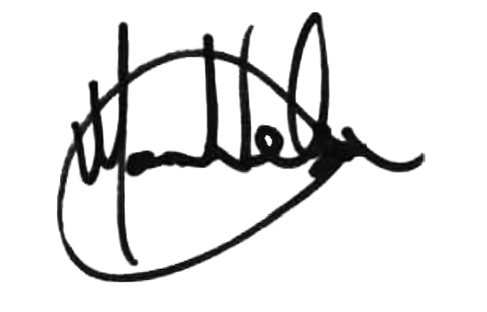
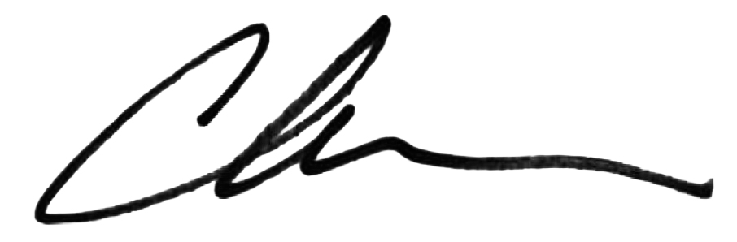

Mark Nelson | Christian Behrenbruch
Interim Chair | Managing Director and Group CEO
August 20, 2026 | August 20, 2026
14

Interim consolidated statement of comprehensive income
for the half-year ended June 30, 2026
 |  | June 30  2026 |  | June 30  2025
 | Note | US$'000 |  | US$'000
Continuing operations
Revenue from contracts with customers | 4.1 | 477,350 |  | 390,359
Cost of sales |  | (217,001) |  | (181,736)
Gross profit |  | 260,349 |  | 208,623
Other income | 4.4 | 40,000 |  | -
Research and development costs |  | (123,828) |  | (81,583)
Selling and marketing expenses |  | (58,358) |  | (48,973)
Manufacturing and distribution costs |  | (28,713) |  | (18,849)
General and administration costs |  | (48,663) |  | (47,723)
Other gains/(losses)(net) |  | 5,575 |  | (1,105)
Operating profit |  | 46,362 |  | 10,390
Finance income |  | 2,274 |  | 3,616
Finance costs | 4.5 | (19,388) |  | (18,842)
Profit/(loss) before income tax |  | 29,248 |  | (4,836)
Income tax benefit |  | 9,082 |  | 2,544
Profit/(loss) for the period |  | 38,330 |  | (2,292)
Profit/(loss) for the period attributable to:
Owners of Telix Pharmaceuticals Limited |  | 38,330 |  | (2,292)
Other comprehensive income:
Items that will not be reclassified to profit or loss in subsequent
periods:
Changes in the fair value of investments at fair value through other  comprehensive income |  | 1,207 |  | (1,381)
Items to be reclassified to profit or loss in subsequent periods:
Exchange differences on translation of foreign operations |  | (30,079) |  | 6,928
Total comprehensive income for the period |  | 9,458 |  | 3,255
Total comprehensive income for the period attributable to:
Owners of Telix Pharmaceuticals Limited |  | 9,458 |  | 3,255
 | June 30  2026 |  | June 30  2025
 | Cents |  | Cents
Basic earnings/(loss) per share from continuing operations after income tax  attributable to the ordinary equity holders of the Company | 11.30 |  | (0.68)
Diluted earnings/(loss) per share from continuing operations after income tax  attributable to the ordinary equity holders of the Company | 10.74 |  | (0.68)
The above interim consolidated statement of comprehensive income should be read in conjunction with the notes to the
Interim consolidated financial statements.
15

Interim consolidated statement of financial position
as at June 30, 2026
 |  |  | June 30  2026 |  | December 31  2025
 | Note |  | US$'000 |  | US$'000
Current assets
Cash and cash equivalents |  |  | 251,910 |  | 141,866
Trade and other receivables |  |  | 163,556 |  | 129,202
Inventories |  |  | 39,029 |  | 37,080
Current tax asset |  |  | 6,832 |  | 6,043
Other current assets |  |  | 26,694 |  | 16,089
Total current assets |  |  | 488,021 |  | 330,280
Non-current assets
Financial assets |  |  | 40,412 |  | 37,094
Deferred tax assets |  |  | 85,295 |  | 59,353
Property, plant and equipment |  |  | 72,238 |  | 58,661
Right-of-use assets |  |  | 57,390 |  | 56,950
Intangible assets | 5 |  | 584,610 |  | 592,823
Other non-current assets |  |  | 33,885 |  | 28,825
Total non-current assets |  |  | 873,830 |  | 833,706
Total assets |  |  | 1,361,851 |  | 1,163,986
Current liabilities
Trade and other payables |  |  | 168,972 |  | 150,349
Borrowings | 6 |  | 11,508 |  | 13,110
Current tax payable |  |  | 33,852 |  | 30,742
Contract liabilities |  |  | 390 |  | 402
Lease liabilities |  |  | 3,916 |  | 5,548
Provisions |  |  | 520 |  | 562
Contingent consideration |  |  | 2,900 |  | 11,540
Employee benefit obligations |  |  | 20,286 |  | 19,371
Total current liabilities |  |  | 242,344 |  | 231,624
Non-current liabilities
Borrowings | 6 |  | 504,877 |  | 391,914
Lease liabilities |  |  | 59,560 |  | 56,534
Deferred tax liabilities |  |  | 43,301 |  | 44,706
Other non-current liabilities |  |  | 3,224 |  | 3,517
Provisions |  |  | 8,562 |  | 9,177
Contingent consideration |  |  | 11,701 |  | 10,694
Employee benefit obligations |  |  | 607 |  | 444
Total non-current liabilities |  |  | 631,832 |  | 516,986
Total liabilities |  |  | 874,176 |  | 748,610
Net assets |  |  | 487,675 |  | 415,376
16
 |  |  | June 30  2026 |  | December 31  2025
 | Note |  | US$'000 |  | US$'000
Equity
Share capital | 8.1 |  | 490,920 |  | 479,962
Share capital reserve |  |  | 28,142 |  | (11,612)
Other reserves | 8.2 |  | 79,509 |  | 101,564
Accumulated losses |  |  | (110,896) |  | (154,538)
Total equity |  |  | 487,675 |  | 415,376
The above interim consolidated statement of financial position should be read in conjunction with the notes to the interim
consolidated financial statements.
17

Interim consolidated statement of changes in equity
for the half-year ended June 30, 2026
 |  | Share  capital |  | Share  capital  reserve |  | Other  reserves |  | Accumulated  losses |  | Total  equity
 | Note | US$'000 |  | US$'000 |  | US$'000 |  | US$'000 |  | US$'000
Balance as at January 1, 2026 |  | 479,962 |  | (11,612) |  | 101,564 |  | (154,538) |  | 415,376
Profit for the period |  | - |  | - |  | - |  | 38,330 |  | 38,330
Other comprehensive loss |  | - |  | - |  | (28,872) |  | - |  | (28,872)
Total comprehensive income |  | - |  | - |  | (28,872) |  | 38,330 |  | 9,458
Issue of shares on acquisitions | 8.1 | 2,790 |  | - |  | - |  | - |  | 2,790
Issue of shares on exercise of  options | 8.1 | 8,168 |  | (6,796) |  | - |  | - |  | 1,372
Repurchase of convertible  bonds | 6.1 | - |  | (43,254) |  | - |  | - |  | (43,254)
Issue of convertible bonds | 6.1 | - |  | 91,709 |  | - |  | - |  | 91,709
Transaction costs arising on  convertible bonds issue |  | - |  | (1,905) |  | - |  | - |  | (1,905)
Share-based payments to  employees | 8.2 | - |  | - |  | 12,129 |  | - |  | 12,129
Transfer on exercise of  options | 8.2 | - |  | - |  | (5,312) |  | 5,312 |  | -
 |  | 10,958 |  | 39,754 |  | 6,817 |  | 5,312 |  | 62,841
Balance as at June 30, 2026 |  | 490,920 |  | 28,142 |  | 79,509 |  | (110,896) |  | 487,675
Balance as at January 1, 2025 |  | 414,012 |  | 15,945 |  | 75,894 |  | (152,914) |  | 352,937
Loss for the period |  | - |  | - |  | - |  | (2,292) |  | (2,292)
Other comprehensive income |  | - |  | - |  | 5,547 |  | - |  | 5,547
Total comprehensive income |  | - |  | - |  | 5,547 |  | (2,292) |  | 3,255
Issue of shares on acquisitions |  | 30,127 |  | - |  | - |  | - |  | 30,127
Issue of shares on exercise of  options |  | 24,513 |  | (23,837) |  | - |  | - |  | 676
Share-based payments to  employees |  | - |  | - |  | 11,786 |  | - |  | 11,786
Share-based payments  associated with acquisitions |  | - |  | - |  | 23,160 |  | - |  | 23,160
Transfer on satisfaction of  acquisition performance rights |  | 4,458 |  | - |  | (4,458) |  | - |  | -
Transfer on exercise of  options |  | - |  | - |  | (4,224) |  | 4,224 |  | -
 |  | 59,098 |  | (23,837) |  | 26,264 |  | 4,224 |  | 65,749
Balance as at June 30, 2025 |  | 473,110 |  | (7,892) |  | 107,705 |  | (150,982) |  | 421,941
The above interim consolidated statement of changes of equity should be read in conjunction with the notes to the
interim consolidated financial statements.
18

Interim consolidated statement of cash flows
for the half-year ended June 30, 2026
 |  | June 30  2026 |  | June 30  2025
 |  | US$'000 |  | US$'000
Cash flows from operating activities
Receipts from customers |  | 442,884 |  | 372,005
Receipts from collaboration agreements |  | 40,000 |  | -
Payments to suppliers and employees |  | (439,037) |  | (348,629)
Payments for contingent consideration |  | (1,250) |  | -
Income taxes paid |  | (14,806) |  | (3,357)
Interest received |  | 2,222 |  | 3,617
Interest paid |  | (6,977) |  | (5,887)
Net cash from operating activities |  | 23,036 |  | 17,749
Cash flows from investing activities
Payments for investments in financial assets |  | (1,000) |  | (826)
Payments for acquisition of subsidiaries, net of cash acquired |  | - |  | (224,659)
Purchases of intangible assets |  | (332) |  | (17,109)
Purchases of other non-current assets |  | (4,509) |  | (4,577)
Purchases of property, plant and equipment |  | (14,456) |  | (6,668)
Payments for contingent consideration |  | (8,808) |  | (5,015)
Payments for deferred consideration |  | (4,612) |  | -
Net cash used in investing activities |  | (33,717) |  | (258,854)
Cash flows from financing activities
Proceeds from borrowings |  | 587,453 |  | -
Repayment of borrowings |  | (466,453) |  | (451)
Principal element of lease payments |  | (3,939) |  | (3,148)
Proceeds from issue of shares and other equity |  | 1,366 |  | 676
Net cash provided by/(used in) financing activities |  | 118,427 |  | (2,923)
Net increase/(decrease) in cash held |  | 107,746 |  | (244,028)
Net foreign exchange differences |  | 2,298 |  | 11,185
Cash and cash equivalents at the beginning of the half-year |  | 141,866 |  | 439,999
Cash and cash equivalents at the end of the half-year |  | 251,910 |  | 207,156
The above interim consolidated statement of cash flows should be read in conjunction with the notes to the interim
consolidated financial statements.
19

Notes to the interim consolidated financial statements

1. Corporate information
Telix Pharmaceuticals Limited ("Telix" or "the Company") is a for-profit company incorporated and domiciled in Australia.
It is limited by shares that are publicly traded on the Australian Securities Exchange (ASX: TLX) and on the Nasdaq Global
Select Market (NASDAQ: TLX). Telix develops and distributes commercial radiopharmaceutical products and continues to
develop a portfolio of clinical-stage products that address significant unmet medical need in oncology and rare diseases.
Telix is the ultimate parent company of the Telix Pharmaceuticals Group (the Group).
This consolidated financial report of Telix Pharmaceuticals Limited for the half-year ended June 30, 2026 was authorized
for issue in accordance with a resolution of the Directors on August 20, 2026.

2. Material accounting policy information
This Interim financial report for the half-year reporting period ended June 30, 2026 has been prepared in accordance
with IAS 34 / AASB 134 Interim Financial Reporting and the Corporations Act 2001 (Cth). This Interim financial report
does not include all the notes of the type normally included in an Annual financial report. Accordingly, this report is to be
read in conjunction with the Annual Report for the year ended December 31, 2025.
The accounting policies adopted are consistent with those of the previous financial year and corresponding interim
reporting period.
A number of new or amended standards became applicable for the current reporting period. The Group did not have to
change its accounting policies or make retrospective adjustments as a result of adopting these standards. The Group has
identified that there is no impact of new standards issued but not yet applied.

2.1. Going concern
These financial statements have been prepared on the basis that the Company is a going concern.
For the half-year ended June 30, 2026, the Group generated a profit after income tax of $38,330,000 (June 30, 2025:
loss after income tax of $2,292,000) and cash generated from operating activities of $23,036,000 (June 30, 2025:
$17,749,000) As at June 30, 2026, the net assets of the Group stood at $487,675,000 (December 31, 2025:
$415,376,000) with cash on hand of $251,910,000 (December 31, 2025: $141,866,000)
Cash on hand and anticipated future cash inflows in relation to commercial activities are considered sufficient to meet
the Group’s forecasted cash outflows in relation to research and development activities currently underway and other
committed business activities for at least 12 months from the date of this report.
On this basis, the Directors are satisfied that the Group continues to be a going concern as at the date of issuance of
these financial statements. Further, the Directors are of the opinion that no asset is likely to be realized for an amount
less than the amount at which it is recorded in the consolidated statement of financial position as at June 30, 2026.
As such, no adjustment has been made to the financial statements relating to the recoverability and classification of the
asset carrying amounts or the classification of liabilities that might be necessary should the Group not continue as a
going concern.

2.2. Other income
Other income includes income recognized in profit or loss that arises from operating activities that does not stem from
relationships with customers. This income arises from certain types of arrangements, as outlined below.
Collaboration agreements
The Group may enter into collaboration agreements to research, develop, manufacture, and commercialize products and/
or product candidates. Each agreement is unique in nature and such arrangements may involve a joint operating activity
where both parties are active participants in the activities of the collaboration and exposed to significant risks and
rewards dependent on the commercial success of the activities. At contract inception, the Group assesses whether
these agreements would be within the scope of IFRS 15 / AASB 15 Revenue from Contracts with Customers or IFRS 11 /
AASB 11 Joint Arrangements.
A counterparty to the contract would not be a customer if, for example, the counterparty has contracted with the Group
to participate in an activity or process in which the parties to the contract share in the risks and benefits that result from
the activity or process (such as developing assets in a collaboration agreement) rather than to obtain the output of the
entity’s ordinary activities.
In such collaboration agreements where research costs are shared, any reimbursement of costs from the collaboration
partner are recognized on a net basis in research expense.
20

3. Segment reporting
The Group has operations in the Americas, Asia-Pacific, and Europe, Middle East and Africa (EMEA) regions, with a
significant presence in the U.S., Australia and Belgium.
Reportable segments
The Group’s operating segments are based on the reports reviewed by the Group Chief Executive Officer who is
considered to be the chief operating decision maker.
Segment performance is evaluated based on Adjusted earnings before interest, tax, depreciation and amortization
("Adjusted EBITDA"). Adjusted EBITDA excludes the effects of the remeasurement of contingent consideration and
government grant liabilities and other gains/(losses) which may have an impact on the quality of earnings such as
impairments where the impairment is the result of an isolated, non-recurring event. Interest income and finance costs are
not allocated to segments as this activity is managed by a central treasury function, which manages the cash position of
the Group.
Segment assets and liabilities are measured in the same way as in the financial statements. The assets and liabilities are
allocated based on the operations of the segment.
Reportable segment | Principal activities
Precision Medicine | Commercial sales of Illuccix, Gozellix and other diagnostic products subsequent to  obtaining regulatory approvals. This segment includes the development activities of  the Group’s diagnostic pipeline. The Group’s International and Medical Technologies  businesses are operating segments that are included within the Precision Medicine  reportable segment due to the similar nature of the diagnostic products being sold or  developed for commercialization.
Therapeutics | Developing the Group’s core therapeutic pipeline for commercialization. This  segment includes revenue received from license agreements prior to  commercialization, income from collaboration agreements and research and  development services. This segment includes the development activities of the  Group’s therapeutic pipeline.
Manufacturing Solutions | This segment comprises revenues and costs associated with the Group's  radiopharmacy network, other manufacturing facilities and assets associated with  the Group’s vertically integrated manufacturing and supply chain. This business  includes facilities at Brussels South, IsoTherapeutics, TMS Sacramento, North  Melbourne, ARTMS and RLS Radiopharmacies.
Reconciling items include head office and centrally managed costs.
21

3.1. Segment performance
For the half-year ended | Precision  Medicine |  | Therapeutics |  | Manufacturing  Solutions |  | Inter-  segment  eliminations |  | Total  segment | 1.
June 30, 2026 | US$'000 |  | US$'000 |  | US$'000 |  | US$'000 |  | US$'000
Revenue from  contracts with  customers | 388,633 |  | - |  | 88,717 |  | - |  | 477,350
Inter-segment revenue | - |  | - |  | 57,543 |  | (57,543) |  | -
Cost of sales | (134,600) |  | - |  | (138,435) |  | 56,034 |  | (217,001)
Gross profit | 254,033 |  | - |  | 7,825 |  | (1,509) |  | 260,349
Other income | - |  | 40,000 |  | - |  | - |  | 40,000
Research and  development costs | (54,482) |  | (67,968) |  | (2,828) |  | 1,450 |  | (123,828)
Selling and marketing  expenses | (49,236) |  | - |  | (9,122) |  | - |  | (58,358)
Manufacturing and  distribution costs | (6,625) |  | (2,348) |  | (19,740) |  | - |  | (28,713)
General and  administration costs | (12,508) |  | (2,215) |  | (8,902) |  | - |  | (23,625)
Other gains/(losses)  (net) | 1,195 |  | 1,240 |  | (176) |  | - |  | 2,259
Operating profit/  (loss) | 132,377 |  | (31,291) |  | (32,943) |  | (59) |  | 68,084
Other (gains)/losses  (net) | (1,195) |  | (1,240) |  | 176 |  | - |  | (2,259)
Depreciation and  amortization | 707 |  | 149 |  | 9,811 |  | - |  | 10,667
Adjusted earnings/  (loss) before interest,  tax, depreciation and  amortization | 131,889 |  | (32,382) |  | (22,956) |  | (59) |  | 76,492
22
For the half-year ended | Precision  Medicine |  | Therapeutics |  | Manufacturing  Solutions |  | Inter-segment  eliminations |  | Total  segment | 1.
June 30, 2025 | US$'000 |  | US$'000 |  | US$'000 |  | US$'000 |  | US$'000
Revenue from contracts  with customers | 305,835 |  | 3,994 |  | 80,530 |  | - |  | 390,359
Inter-segment revenue | - |  | - |  | 33,761 |  | (33,761) |  | -
Cost of sales | (108,839) |  | (108) |  | (103,485) |  | 30,696 |  | (181,736)
Gross profit | 196,996 |  | 3,886 |  | 10,806 |  | (3,065) |  | 208,623
Research and development  costs | (38,116) |  | (43,868) |  | (2,664) |  | 3,065 |  | (81,583)
Selling and marketing  expenses | (40,886) |  | (464) |  | (7,623) |  | - |  | (48,973)
Manufacturing and  distribution costs | (4,105) |  | (1,710) |  | (13,034) |  | - |  | (18,849)
General and administration  costs | (11,317) |  | (2,002) |  | (7,116) |  | - |  | (20,435)
Other (losses)/gains (net) | (1,593) |  | 19 |  | 27 |  | - |  | (1,547)
Operating profit/(loss) | 100,979 |  | (44,139) |  | (19,604) |  | - |  | 37,236
Other losses/(gains) (net) | 1,593 |  | (19) |  | (27) |  | - |  | 1,547
Depreciation and  amortization | 2,074 |  | 117 |  | 6,969 |  | - |  | 9,160
Adjusted earnings/(loss)  before interest, tax,  depreciation and  amortization | 104,646 |  | (44,041) |  | (12,662) |  | - |  | 47,943
Activities between segments are carried out at arm’s length and are eliminated on consolidation. The amounts presented
are measured consistently with the Group’s external reporting. Segment assets are allocated based on the operations of
the segment and the physical location of the asset.

3.2. Reconciliation of total segment adjusted EBITDA to profit/(loss) before income tax
 |  |  | June 30  2026 |  | June 30  2025
 | Note |  | US$'000 |  | US$'000
Total segment adjusted EBITDA |  |  | 76,492 |  | 47,943
Unallocated income, expenses and eliminations:
General and administration costs |  |  | (25,038) |  | (27,288)
Other gains/(losses) (net) |  |  | 5,575 |  | (1,105)
Finance income |  |  | 2,274 |  | 3,616
Finance costs | 4.5 |  | (19,388) |  | (18,842)
Depreciation and amortization | 4.3 |  | (10,667) |  | (9,160)
Profit/(loss) before income tax |  |  | 29,248 |  | (4,836)
General and administration costs include employment costs of $9,800,000 (2025: $17,189,000) and other centrally
managed IT, legal and other corporate costs. The reduction in employment costs within General and administration costs
was due to the allocation of employee share based payments to segments from January 1, 2026.
23

3.3. Operating segment assets and liabilities
 | Precision  Medicine |  | Therapeutics |  | Manufacturing  Solutions |  | Total  segment |  | Reconciling  items |  | Group | 1.
June 30, 2026 | US$'000 |  | US$'000 |  | US$'000 |  | US$'000 |  | US$'000 |  | US$'000
Total assets | 323,308 |  | 232,997 |  | 523,819 |  | 1,080,124 |  | 281,727 |  | 1,361,851
Total liabilities | 157,343 |  | 25,828 |  | 141,994 |  | 325,165 |  | 549,011 |  | 874,176
Additions to non-  current assets | 668 |  | 172 |  | 23,658 |  | 24,498 |  | — |  | 24,498
 | Precision  Medicine |  | Therapeutics |  | Manufacturing  Solutions |  | Total  segment |  | Reconciling  items |  | Group
December 31, 2025 | US$'000 |  | US$'000 |  | US$'000 |  | US$'000 |  | US$'000 |  | US$'000
Total assets | 233,252 |  | 228,110 |  | 515,429 |  | 976,791 |  | 187,195 |  | 1,163,986
Total liabilities | 159,523 |  | 17,099 |  | 156,599 |  | 333,221 |  | 415,389 |  | 748,610
Additions to non-  current assets | 19,503 |  | 67,715 |  | 324,472 |  | 411,690 |  | 7,840 |  | 419,530
Reconciling items primarily comprise cash and cash equivalents held centrally $143,494,000 (2025: $82,833,000),
investments in financial assets $39,412,000 (2025: $37,094,000), property, plant and equipment $8,638,000 (2025:
$6,915,000) and borrowings (convertible bonds) $496,237,000 (2025: $383,023,000) which are managed centrally.

3.4. Geographical information
 | June 30, 2026 |  | June 30, 2025
 | Revenue by location of customer |  | Revenue by location of customer
 | US$'000 |  | US$'000
United States | 468,074 |  | 381,051
Other countries | 9,276 |  | 9,308
Total | 477,350 |  | 390,359
 | June 30, 2026 |  | December 31, 2025
 | Non-current assets by location  of asset |  | Non-current assets by location  of asset
 | US$'000 |  | US$'000
Australia | 110,383 |  | 101,753
Belgium | 58,441 |  | 59,460
Canada | 83,156 |  | 86,643
United Kingdom | 39,146 |  | 37,071
United States | 492,532 |  | 481,181
Other countries | 4,877 |  | 8,245
Total | 788,535 |  | 774,353
The total non-current assets figure above excludes deferred tax assets.
24

4. Profit and loss information

4.1. Revenue from contracts with customers
Disaggregation of revenue from contracts with customers.
The Group derives revenue from the sale and transfer of goods and services over time and at a point in time under the
following major business activities:
 |  |  | June 30  2026 |  | June 30  2025
 | Recognition | Operating segment | US$'000 |  | US$'000
Sale of goods | At a point in time | Precision Medicine | 388,210 |  | 305,765
Sale of goods | At a point in time | Manufacturing Solutions | 83,606 |  | 76,807
Royalty income | At a point in time | Precision Medicine | 423 |  | 55
Provision of services | At a point in time | Manufacturing Solutions | - |  | 15
Provision of services | Over time | Manufacturing Solutions | 5,111 |  | 3,708
Research and development services | Over time | Precision Medicine | - |  | 15
Research and development services | Over time | Therapeutics | - |  | 3,994
Total revenue from continuing  operations |  |  | 477,350 |  | 390,359

4.2. Employment costs
 | June 30  2026 |  | June 30  2025
 | US$'000 |  | US$'000
Salaries and wages | 117,683 |  | 94,813
Sales commissions | 4,914 |  | 3,235
Share-based payment charge | 12,129 |  | 11,585
Non-Executive Directors’ fees | 416 |  | 386
 | 135,142 |  | 110,019
Salaries and wages of $1,098,000 (2025: $916,000) are included within cost of sales in the interim consolidated
statement of comprehensive income.

4.3. Depreciation and amortization
 | June 30  2026 |  | June 30  2025
 | US$'000 |  | US$'000
Amortization of intangible assets | 4,204 |  | 4,620
Depreciation | 6,951 |  | 4,965
 | 11,155 |  | 9,585

4.4. Other income
 | June 30  2026 |  | June 30  2025
 | US$'000 |  | US$'000
Other income from collaboration agreements | (40,000) |  | -
 | (40,000) |  | -
25
Regeneron Pharmaceuticals, Inc.
Overview
In April 2026, Telix entered into a research and development collaboration agreement with Regeneron Pharmaceuticals,
Inc. (“Regeneron”) to jointly develop and commercialize next generation radiopharmaceutical therapeutic candidates and
radio-diagnostics to support patient selection and treatment response assessment. The collaboration leverages
Regeneron’s capabilities in antibody discovery and development and Telix’s radiopharmaceutical platform, development
expertise and manufacturing capabilities.
The parties will conduct research and development activities pursuant to jointly agreed research and development plans
and budgets, overseen through joint governance committees. The collaboration is structured for four initial therapeutic
programs, with Regeneron having the option to expand to include four additional programs. Each party is responsible for
activities aligned to its respective technical expertise.
The parties will share agreed research and development costs equally, with each party responsible for funding the
activities it performs and reimbursing the other party for its share of agreed costs. Telix and Regeneron will also share
equally in the global commercialization costs and potential profits, with Telix retaining the option to co-promote certain
potential products. If Telix elects to opt out of the co-funding model for a particular program, it would be entitled to
receive development and commercial milestones, plus low double-digit royalties on future net sales, for that program.
Treatment of initial consideration
The Group has determined that the arrangement is that of a collaboration whereby Regeneron and Telix are active
participants in the activities of the collaboration and exposed to significant risks and rewards dependent on the
commercial success of the activities. As such, Regeneron is not determined to be a customer to which Telix transferred
control of goods or services. The $40,000,000 initial consideration received from Regeneron has been recognized as
other income to reflect the contribution of Telix’s background intellectual property into the collaboration at inception of
the arrangement.
Treatment of subsequent expenditure through the collaboration
All future spending under the collaboration will be shared equally between Regeneron and Telix. Any reimbursements of
research costs from Regeneron to Telix will be recognized on a net basis in research expense. Further Telix’s obligation
to fund its portion of the collaboration’s expenditure will be recognized within research expense.

4.5. Finance costs
 | June 30  2026 |  | June 30  2025
 | US$'000 |  | US$'000
Unwind of discount | 14,533 |  | 12,410
Interest expense on lease liabilities | 1,783 |  | 1,054
Convertible bond interest expense | 5,334 |  | 4,911
(Gain) on repurchase of convertible bond | (2,935) |  | -
Interest expense | 303 |  | 231
Bank fees | 370 |  | 236
Finance costs | 19,388 |  | 18,842
The Group recognized a gain of $2,935,000 on repurchase of the Existing Bonds being the difference between the
carrying amount of the financial liability that has been extinguished and the consideration paid. Refer to note 6.1 for
further details.
26

5. Intangible assets
 | Goodwill |  | Intellectual  property |  | Customer  relationships  and brands |  | Software |  | Patents |  | Licenses |  | Total | 1.
 | US$'000 |  | US$'000 |  | US$'000 |  | US$'000 |  | US$'000 |  | US$'000 |  | US$'000 | 1.
Balance at January  1, 2026 | 198,988 |  | 231,399 |  | 85,197 |  | 4,324 |  | 372 |  | 72,543 |  | 592,823
Additions | - |  | 172 |  | 167 |  | - |  | - |  | - |  | 339
Reclassifications | - |  | - |  | - |  | - |  | - |  | - |  | -
Amortization  charge | - |  | - |  | (3,000) |  | (196) |  | (3) |  | (1,005) |  | (4,204)
Changes in  provisions | - |  | (539) |  | - |  | - |  | - |  | - |  | (539)
Exchange  differences | (1,475) |  | (2,000) |  | - |  | (96) |  | 1 |  | (239) |  | (3,809)
Balance at June  30, 2026 | 197,513 |  | 229,032 |  | 82,364 |  | 4,032 |  | 370 |  | 71,299 |  | 584,610
Cost | 197,513 |  | 249,036 |  | 91,389 |  | 4,756 |  | 710 |  | 74,816 |  | 618,220
Accumulated  amortization | - |  | (20,004) |  | (9,025) |  | (724) |  | (340) |  | (3,517) |  | (33,610)
Net book amount | 197,513 |  | 229,032 |  | 82,364 |  | 4,032 |  | 370 |  | 71,299 |  | 584,610
Balance as at  January 1, 2025 | 66,586 |  | 176,426 |  | 741 |  | 2,284 |  | 318 |  | 11,503 |  | 257,858
Acquisition of  businesses | 143,660 |  | - |  | 90,200 |  | 806 |  | - |  | 15,400 |  | 250,066
Additions | - |  | 32,410 |  | 127 |  | 1,291 |  | 46 |  | 46,030 |  | 79,904
Measurement  period  adjustments | 4,731 |  | - |  | - |  | - |  | - |  | - |  | 4,731
Reclassifications | (18,759) |  | 18,759 |  | - |  | - |  | - |  | - |  | -
Amortization  charge | - |  | (2,026) |  | (5,871) |  | (460) |  | (17) |  | (1,508) |  | (9,882)
Impairments | - |  | - |  | - |  | - |  | - |  | (566) |  | (566)
Changes in  provisions | 6 |  | (565) |  | - |  | - |  | - |  | - |  | (559)
Exchange  differences | 2,764 |  | 6,395 |  | - |  | 403 |  | 25 |  | 1,684 |  | 11,271
Balance at  December 31,  2025 | 198,988 |  | 231,399 |  | 85,197 |  | 4,324 |  | 372 |  | 72,543 |  | 592,823
Cost | 198,988 |  | 250,952 |  | 91,230 |  | 4,805 |  | 715 |  | 75,095 |  | 621,785
Accumulated  amortization | - |  | (19,553) |  | (6,033) |  | (481) |  | (343) |  | (2,552) |  | (28,962)
Net book amount | 198,988 |  | 231,399 |  | 85,197 |  | 4,324 |  | 372 |  | 72,543 |  | 592,823
The Group has considered reasonably possible changes in the key assumptions and has not identified any instances that
could cause the carrying amounts of the intangible assets at June 30, 2026 to exceed their recoverable amounts.
27

6. Borrowings
 | June 30, 2026 |  |  |  | December 31, 2025
 | Current |  | Non-current |  | Current |  | Non-current | 1.
 | US$'000 |  | US$'000 |  | US$'000 |  | US$'000
Secured
Bank loans | 690 |  | 8,716 |  | 1,418 |  | 8,989
Working capital facility | - |  | (76) |  | - |  | (98)
Total secured borrowings | 690 |  | 8,640 |  | 1,418 |  | 8,891
Unsecured
Convertible bonds | 10,818 |  | 496,237 |  | 11,692 |  | 383,023
Total unsecured borrowings | 10,818 |  | 496,237 |  | 11,692 |  | 383,023
Total borrowings | 11,508 |  | 504,877 |  | 13,110 |  | 391,914

6.1.Convertible bonds
On April 15, 2026, the Group announced the successful settlement of the issue of $600,000,000 1.50 per cent
Convertible Notes due 2031 (New Bonds). The Group concurrently completed the on-market repurchase of
approximately A$637,000,000 in principal of the A$650,000,000 2.375% Convertible Bonds due 2029 issued by Telix in
July 2024 (Existing Bonds). The Existing Bonds repurchased represent approximately 98% of the outstanding Existing
Bonds. In May 2026, the Group repurchased a further A$5,000,000 of the Existing Bonds. The New Bonds are listed on
the Singapore Exchange Securities Trading Limited (SGX-ST).
The New Bonds will bear interest at a rate of 1.50 per cent per annum. Interest is payable quarterly in arrears on January
22, April 22, July 22 and October 22 in each year, beginning on July 22, 2026. The New Bonds will mature on or about
April 22, 2031, unless redeemed, repurchased, or converted in accordance with their terms.
The convertible bonds are presented in the Group’s consolidated statement of financial position as follows:
 | June 30  2026 |  | December 31  2025 | 1.
 | US$'000 |  | US$'000 | 1.
Opening balance | 394,715 |  | 344,218
Unwind of discount | 13,741 |  | 22,502
Interest expense | 5,334 |  | 9,945
Interest paid | (5,101) |  | (9,871)
Repurchase of Existing Bonds | (422,499) |  | -
Face value of New Bonds issued | 600,000 |  | -
Transaction costs | (10,747) |  | -
Other equity securities - value of conversion rights | (91,709) |  | -
Exchange differences | 23,321 |  | 27,921
Closing balance | 507,055 |  | 394,715
Current | 10,818 |  | 11,692
Non-current | 496,237 |  | 383,023
Total convertible bond liability | 507,055 |  | 394,715
Repurchase of existing convertible bonds
The total repurchase consideration is allocated between the liability and equity components using a methodology
consistent with the initial recognition at issuance. The liability component is measured as the fair value of the remaining
contractual cash flows at the repurchase date, discounted using prevailing market rates for comparable debt.
28
The equity component associated with the repurchase was $43,254,000, calculated as the residual after allocating the
fair value to the liability component. A resultant gain of $2,935,000 was recognized in profit or loss only in respect of the
liability component, being the difference between the carrying amount of the liability component immediately prior to
repurchase and the portion of the repurchase consideration allocated to that liability component.
Issue of New Bonds
The initial fair value of the liability portion of the New Bonds was determined using a market interest rate for an
equivalent non-convertible bond at the issue date. This fair value has been reduced by directly attributable transaction
costs associated with the issue of the convertible bonds. The liability is subsequently recognized on an amortized cost
basis until extinguished on conversion or maturity of the bonds, which has been assessed as April 22, 2029. The
remainder of the proceeds is allocated to the conversion option and recognized as part of the share capital reserve, net
of income tax and a proportion of transaction costs, and is not subsequently remeasured.

6.2Fair value
For bank loans, the fair values are not materially different to their carrying amounts, since the interest payable on those
borrowings is either close to current market rates or the borrowings are of a short-term nature.
For the convertible bonds, the fair value of the liability component is outlined below. The fair value is based on
discounted cash flows using a current borrowing rate. They are classified as level 3 fair values in the fair value hierarchy
due to the use of unobservable inputs, including own credit risk.
 | June 30, 2026 |  |  |  | December 31, 2025 |  |  | 1.
 | Carrying  amount |  | Fair value |  | Carrying  amount |  | Fair value | 1.
 | US$'000 |  | US$'000 |  | US$'000 |  | US$'000 | 1.
Bank loans | 9,330 |  | 9,330 |  | 10,309 |  | 10,309
Convertible bonds | 507,055 |  | 506,039 |  | 394,715 |  | 399,348

7. Contractual maturities of financial liabilities
 | 1-6  months |  | 6-12  months |  | 1-5 years |  | Over 5  years |  | Total  contractual  cash flows |  | Carrying  amount of  liabilities
As at June 30, 2026 | US$'000 |  | US$'000 |  | US$'000 |  | US$'000 |  | US$'000 |  | US$'000
Non-derivatives
Trade and other payables | 169,954 |  | 691 |  | 256 |  | - |  | 170,901 |  | 168,972
Other non-current liabilities | - |  | - |  | 4,534 |  | - |  | 4,534 |  | 3,224
Borrowings | 5,114 |  | 5,228 |  | 644,763 |  | 2,117 |  | 657,222 |  | 516,385
Lease liabilities | 7,373 |  | 7,279 |  | 36,108 |  | 40,948 |  | 91,708 |  | 63,476
Government grant liability | 552 |  | 319 |  | 633 |  | - |  | 1,504 |  | 1,448
Contingent consideration | 401 |  | 7,759 |  | 6,219 |  | 1,793 |  | 16,172 |  | 14,601
Total financial liabilities | 183,394 |  | 21,276 |  | 692,513 |  | 44,858 |  | 942,041 |  | 768,106
29
 | 1-6  months |  | 6-12  months |  | 1-5 years |  | Over 5  years |  | Total  contractual  cash flows |  | Carrying  amount of  liabilities
As at December 31, 2025 | US$'000 |  | US$'000 |  | US$'000 |  | US$'000 |  | US$'000 |  | US$'000
Non-derivatives
Trade and other payables | 114,261 |  | 36,088 |  | - |  | - |  | 150,349 |  | 150,349
Other non-current liabilities | - |  | - |  | 3,673 |  | - |  | 3,673 |  | 3,517
Borrowings | 5,860 |  | 5,958 |  | 469,257 |  | 3,024 |  | 484,099 |  | 405,024
Lease liabilities | 3,051 |  | 3,969 |  | 44,409 |  | 34,994 |  | 86,423 |  | 62,082
Government grant liability | 837 |  | 564 |  | 1,236 |  | 169 |  | 2,806 |  | 2,046
Contingent consideration | 8,755 |  | 3,545 |  | 11,737 |  | 665 |  | 24,702 |  | 22,234
Total financial liabilities | 132,764 |  | 50,124 |  | 530,312 |  | 38,852 |  | 752,052 |  | 645,252

8. Equity

8.1. Share capital
 | June 30  2026 |  | December 31  2025 |  | June 30  2026 |  | December 31  2025
 | Number ‘000 |  | Number ‘000 |  | US$'000 |  | US$'000
Opening balance | 338,778 |  | 334,725 |  | 479,962 |  | 414,012
Shares issued through the exercise of  share options and warrants1 | 742 |  | 1,693 |  | 8,168 |  | 29,722
Shares issued for Dedicaid2 | - |  | 38 |  | - |  | 467
Shares issued for Lightpoint3 | - |  | 269 |  | - |  | 4,467
Shares issued for Imaginab4 | 265 |  | 2,053 |  | 2,790 |  | 31,294
Closing balance | 339,785 |  | 338,778 |  | 490,920 |  | 479,962
1.Options exercised during the year through the employee Equity Incentive Plan resulted in 742,000 (2025: 1,693,000)
shares being issued for a total value of $8,168,000 (2025: $29,722,000).
2.On April 27, 2023, the Group completed the acquisition of Dedicaid GmbH. The consideration for the acquisition
comprised 207,000 in Telix shares at a 10-day volume weighted average price of shares on the execution date of
A$8.73 per share. During the prior year, the Group issued 37,575 fully paid ordinary shares upon satisfaction of
certain milestones.
3.On November 1, 2023, the Group completed the acquisition of Lightpoint through the issue of 3,298,000 fully paid
ordinary Telix shares at A$9.37 per share. During the prior year, the Group issued 269,075 fully paid ordinary shares
in satisfaction of Lightpoint milestone rights.
4.On January 30, 2025, the Group completed the acquisition of ImaginAb. The consideration included the issue of
2,053,311 fully paid ordinary Telix shares at A$24.37 per share. On May 8, 2026 the Group issued 264,943 fully paid
ordinary shares at A$14.75 to settle the deferred consideration on conclusion of a 15-month indemnity period.
The weighted average ordinary shares for the period January 1, 2026 to June 30, 2026 is 339,220,212 (2025:
331,226,491). The Company does not have a limited amount of authorized capital under Australian law.
30

8.2. Other reserves
 | Foreign  currency  translation  reserve |  | Share-based  payments  reserve |  | Financial  assets at  FVOCI  reserve |  | Total | 1.
 | US$'000 |  | US$'000 |  | US$'000 |  | US$'000
Balance as at January 1, 2026 | (7,368) |  | 114,073 |  | (5,141) |  | 101,564
Other comprehensive (loss)/income | (30,079) |  | - |  | 1,207 |  | (28,872)
Total comprehensive (loss)/income | (30,079) |  | - |  | 1,207 |  | (28,872)
Share-based payments to employees | - |  | 12,129 |  | - |  | 12,129
Transfer on exercise of options | - |  | (5,312) |  | - |  | (5,312)
 | - |  | 6,817 |  | - |  | 6,817
Balance as at June 30, 2026 | (37,447) |  | 120,890 |  | (3,934) |  | 79,509
 | Foreign  currency  translation  reserve |  | Share-based  payments  reserve |  | Financial  assets at  FVOCI  reserve |  | Total | 1.
 | US$'000 |  | US$'000 |  | US$'000 |  | US$'000
Balance as at January 1, 2025 | (1,611) |  | 81,404 |  | (3,899) |  | 75,894
Other comprehensive | (5,757) |  | - |  | (1,242) |  | (6,999)
Total comprehensive (loss)/income | (5,757) |  | - |  | (1,242) |  | (6,999)
Share-based payments to employees | - |  | 19,350 |  | - |  | 19,350
Share-based payments associated with  acquisitions | - |  | 23,287 |  | - |  | 23,287
Transfer Transfer on satisfaction of  acquisition  performance rights | - |  | (4,467) |  | - |  | (4,467)
Transfer on exercise of options | - |  | (5,501) |  | - |  | (5,501)
 | - |  | 32,669 |  | - |  | 32,669
Balance as at December 31, 2025 | (7,368) |  | 114,073 |  | (5,141) |  | 101,564

9. Fair value
This section explains the judgments and estimates made in determining the fair values of the financial instruments that
are recognized and measured at fair value in the financial statements.
9.1. Financial assets
Financial assets are categorized as either level 1 or level 3 financial assets and remeasured at each reporting date with
movements recognized in other comprehensive income. The inputs used in the level 1 fair value calculations are with
reference to published price quotations for the associated equity instruments in an active market. The sensitivity analysis
below reflects exposure to financial assets measured by reference to published price quotations, which excludes the
Group's restricted cash balance.
Level 3 financial assets are subject to key assumptions and unobservable inputs which include risk adjusted post-tax
discount rates and forecasted discounted cashflows. These inputs significantly impact the underlying value of these
assets.
Sensitivity of level 1 financial assets
An increase/(decrease) of 10% in the share price of each financial asset while holding all other variables constant will
increase/(decrease) other comprehensive income by $224,000 (December 31, 2025: $102,000).
31
Sensitivity of level 3 financial assets
An increase/(decrease) of 10% in the discounted cashflows of each financial asset while holding all other variables
constant will increase/(decrease) other comprehensive income by $274,000 (December 31, 2025: $266,000).
9.2. Financial liabilities
Contingent consideration liabilities are categorized as level 3 financial liabilities and remeasured at each reporting date
with movements recognized in profit or loss, except in instances where changes are permitted to be added to/reduce an
associated asset. The inputs used in fair value calculations are determined by Management.
The carrying amount of financial liabilities measured at fair value is principally calculated based on inputs other than
quoted prices that are observable for these financial liabilities, either directly (i.e. as unquoted prices) or indirectly (i.e.
derived from prices). Where no price information is available from a quoted market source, alternative market
mechanisms or recent comparable transactions, fair value is estimated based on Management’s views on relevant future
prices, net of valuation allowances to accommodate liquidity, modelling and other risks implicit in such estimates.
Sensitivity of level 3 financial liabilities
The potential effect of using reasonably possible alternative assumptions in valuation models, based on a change in the
most significant input, such as sales volumes, by an increase/(decrease) of 10% while holding all other variables constant
will increase/(decrease) profit before tax by $239,000 (December 31, 2025: $275,000).
Valuation processes
The finance team of the Group performs the valuation of contingent consideration liabilities required for financial
reporting purposes, including level 3 fair values. This team reports directly to the Chief Financial Officer (CFO).
Discussions of valuation processes and results are held between the CFO and Board at least once every six months, in
line with the Group’s half-yearly reporting periods.
The main level 3 inputs used by the Group in measuring the fair value of contingent consideration liabilities are derived
and evaluated as follows:
•discount rates are determined by an independent third-party using a weighted average cost of capital model to
calculate a post-tax rate that reflects current market assessments of the time value of money and the risk specific
to the asset.
•regulatory/marketing authorization approval dates and approval for marketing authorization probability risk factors
are derived in consultation with the Group’s regulatory team.
•expected sales volumes and net sales price per unit are estimated based on market information on annual incidence
rates and information for similar products and expected market penetration.
•contingent consideration cash flows are estimated based on the terms of the sale contract. Changes in fair values
are analyzed at the end of each reporting period during the half-yearly valuation discussion between the CFO and
Board. As part of this discussion the CFO presents a report that explains the reason for the fair value movement.

10. Contingent liabilities
The Group has received a subpoena from the U.S. Securities and Exchange Commission (SEC) seeking various
documents and information primarily relating to the Group’s disclosures regarding the development of the Group’s
prostate cancer therapeutic candidates. This matter remains a fact-finding request. Telix is cooperating with the
subpoena including responding to the SEC’s requests. The SEC has not asserted any charges against the Group or any of
its personnel, and no conclusions have been reached. At this stage, the Group cannot predict the duration, scope or
outcome of this matter. The Group will continue to monitor the inquiry and update its disclosures as appropriate.
On November 10, 2025, a putative securities class action complaint was filed in the United States District Court for the
Southern District of Indiana seeking, among other relief, class certification, designation of a lead plaintiff, damages and a
jury trial. On January 20, 2026, the Group was formally served the complaint on behalf of a purported U.S. shareholder.
The Group has filed a motion to dismiss this matter. This case is still in its earliest stages, and the Group plans to
rigorously defend itself in this matter. No class has been certified and the court has not ruled on any dispositive motions.
At this stage, the Group cannot predict the duration, scope or outcome of this matter.
Legal fees and other costs associated with contingent matters, including litigation, regulatory inquiries and
investigations, are expensed as incurred.
32

10.1. Commitments
The Group has commitments against existing development activities and capital commitments relating to property plant
and equipment and the purchase of isotope raw materials . R&D commitments are estimated based on the contractual
obligations included within agreements entered into by the Group, to the extent that a work order has been executed
with the vendor.
The Group's supply agreements contain minimum purchase commitments in certain situations, the amount and timing of
which are not known. Additionally, the Group enters into contracts in the normal course of business with clinical trial sites
and clinical supply manufacturers and with vendors for preclinical studies and clinical trials, research supplies and other
services and drugs for operating purposes. These contracts generally provide for termination after a notice period, and,
therefore, are cancellable contracts.
The Group has entered into in-licensing arrangements with various companies. Such agreements may require the Group
to make payments on achievement of stages of development, launch or revenue milestones and may include variable
payments that are based on unit sales or profit (e.g., royalty and profit share payments). The amount of variable
payments under these agreements are inherently uncertain and difficult to predict, given the direct link to future sales,
profit levels and the range of outcomes. These payments are not included in this table of contractual obligations.
To the extent a commitment is determined to be onerous, these are provided for within provisions in the Consolidated
statement of financial position.
At June 30, 2026 and at the date of these financial statements, the Group had capital commitments relating to the
construction of the Seneffe (Brussels South) manufacturing facility and the purchase of isotope raw materials from a
vendor over a three-year period.
 | Due < 1 year |  | Due > 1 year | 1.
 | US$'000 |  | US$'000 | 1.
As at June 30, 2026
Capital commitments | 42,665 |  | 6,410
R&D commitments | 53,234 |  | 13,309
 | 95,899 |  | 19,719
As at December 31, 2025
Capital commitments | 35,822 |  | 11,367
R&D commitments | 30,402 |  | 7,601
 | 66,224 |  | 18,968

11. Events occurring after the reporting period

There were no subsequent events that required adjustment to or disclosure in the financial statements of the Group for
the half-year ended June 30, 2026.
33

Directors’ declaration
In the opinion of the Directors:
a.the financial statements and notes of the Group are in accordance with the Australian Corporations Act 2001
(Cth), including:
i.giving a true and fair view of the Group's financial position as at June 30, 2026 and of its performance for
the half-year ended on that date.
ii.complying with applicable Accounting Standards, the Corporations Regulation 2001 and other mandatory
professional reporting requirements.
b.there are reasonable grounds to believe that the Company will be able to pay its debts as and when they become
due and payable.
This declaration is made in accordance with a resolution of the Directors and has been made after receiving the
declarations by the Chief Executive Officer and Chief Financial Officer for the half-year ended June 30, 2026.

Mark Nelson | Christian Behrenbruch
Interim Chair | Managing Director and Group CEO
August 20, 2026 | August 20, 2026

