UNITED STATES
SECURITIES AND EXCHANGE COMMISSION
Washington, D.C. 20549

FORM 6-K

REPORT OF FOREIGN PRIVATE ISSUER
PURSUANT TO RULE 13a-16 OR 15d-16 OF
THE SECURITIES EXCHANGE ACT OF 1934

For the month of September, 2026

Commission File Number: 001-42128

Telix Pharmaceuticals Limited
(Translation of registrant’s name into English)

55 Flemington Road
North Melbourne, Victoria 3051, Australia
(Address of principal executive offices)

Indicate by check mark whether the registrant files or will file annual reports under cover of Form 20-F or Form 40-
F.

Form 20-F ☒ Form 40-F ☐

INFORMATION CONTAINED IN THIS FORM 6-K REPORT

On September 30, 2026 (Melbourne, Australia), Telix Pharmaceuticals Limited ("Telix") filed the following
announcements with the Australian Securities Exchange titled “FDA Fast Track for BiPass Pre Biopsy Prostate
Imaging," a copy of which is attached to this Form 6-K as Exhibit 99.1.
The information contained in this Form 6-K, except for (i) the commentary in Exhibit 99.1 appearing in the sixth
paragraph of the announcement and (ii) information accessible by hyperlinks included therein, is incorporated by
reference into our Registration Statement on Form F-3ASR (File No. 333-293611) and Registration Statement on
Form S-8 (File No. 333-283917).

99.1
Press release – September 30, 2026
SIGNATURES

Pursuant to the requirements of the Securities Exchange Act of 1934, the registrant has duly caused this report to be
signed on its behalf by the undersigned, thereunto duly authorized.

Date:

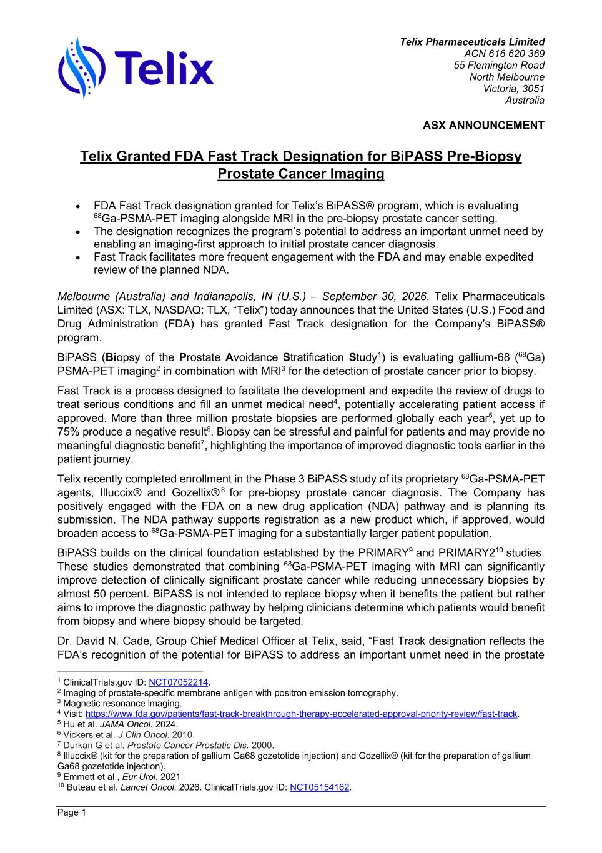
Telix Pharmaceuticals Limited ACN 616 620 369 55 Flemington Road North Melbourne Victoria, 3051 Australia ASX ANNOUNCEMENT Page 1 Telix Granted FDA Fast Track Designation for BiPASS Pre-Biopsy Prostate Cancer Imaging • FDA Fast Track designation granted for Telix’s BiPASS® program, which is evaluating 68Ga-PSMA-PET imaging alongside MRI in the pre-biopsy prostate cancer setting. • The designation recognizes the program’s potential to address an important unmet need by enabling an imaging-first approach to initial prostate cancer diagnosis. • Fast Track facilitates more frequent engagement with the FDA and may enable expedited review of the planned NDA. Melbourne (Australia) and Indianapolis, IN (U.S.) – September 30, 2026. Telix Pharmaceuticals Limited (ASX: TLX, NASDAQ: TLX, “Telix”) today announces that the United States (U.S.) Food and Drug Administration (FDA) has granted Fast Track designation for the Company’s BiPASS® program. BiPASS (Biopsy of the Prostate Avoidance Stratification Study1) is evaluating gallium-68 (68Ga) PSMA-PET imaging2 in combination with MRI3 for the detection of prostate cancer prior to biopsy. Fast Track is a process designed to facilitate the development and expedite the review of drugs to treat serious conditions and fill an unmet medical need4, potentially accelerating patient access if approved. More than three million prostate biopsies are performed globally each year5, yet up to 75% produce a negative result6. Biopsy can be stressful and painful for patients and may provide no meaningful diagnostic benefit7, highlighting the importance of improved diagnostic tools earlier in the patient journey. Telix recently completed enrollment in the Phase 3 BiPASS study of its proprietary 68Ga-PSMA-PET agents, Illuccix® and Gozellix® 8 for pre-biopsy prostate cancer diagnosis. The Company has positively engaged with the FDA on a new drug application (NDA) pathway and is planning its submission. The NDA pathway supports registration as a new product which, if approved, would broaden access to 68Ga-PSMA-PET imaging for a substantially larger patient population. BiPASS builds on the clinical foundation established by the PRIMARY9 and PRIMARY210 studies. These studies demonstrated that combining 68Ga-PSMA-PET imaging with MRI can significantly improve detection of clinically significant prostate cancer while reducing unnecessary biopsies by almost 50 percent. BiPASS is not intended to replace biopsy when it benefits the patient but rather aims to improve the diagnostic pathway by helping clinicians determine which patients would benefit from biopsy and where biopsy should be targeted. Dr. David N. Cade, Group Chief Medical Officer at Telix, said, “Fast Track designation reflects the FDA’s recognition of the potential for BiPASS to address an important unmet need in the prostate 1 ClinicalTrials.gov ID: NCT07052214. 2 Imaging of prostate-specific membrane antigen with positron emission tomography. 3 Magnetic resonance imaging. 4 Visit: https://www.fda.gov/patients/fast-track-breakthrough-therapy-accelerated-approval-priority-review/fast-track. 5 Hu et al. JAMA Oncol. 2024. 6 Vickers et al. J Clin Oncol. 2010. 7 Durkan G et al. Prostate Cancer Prostatic Dis. 2000. 8 Illuccix® (kit for the preparation of gallium Ga68 gozetotide injection) and Gozellix® (kit for the preparation of gallium Ga68 gozetotide injection). 9 Emmett et al., Eur Urol. 2021. 10 Buteau et al. Lancet Oncol. 2026. ClinicalTrials.gov ID: NCT05154162.

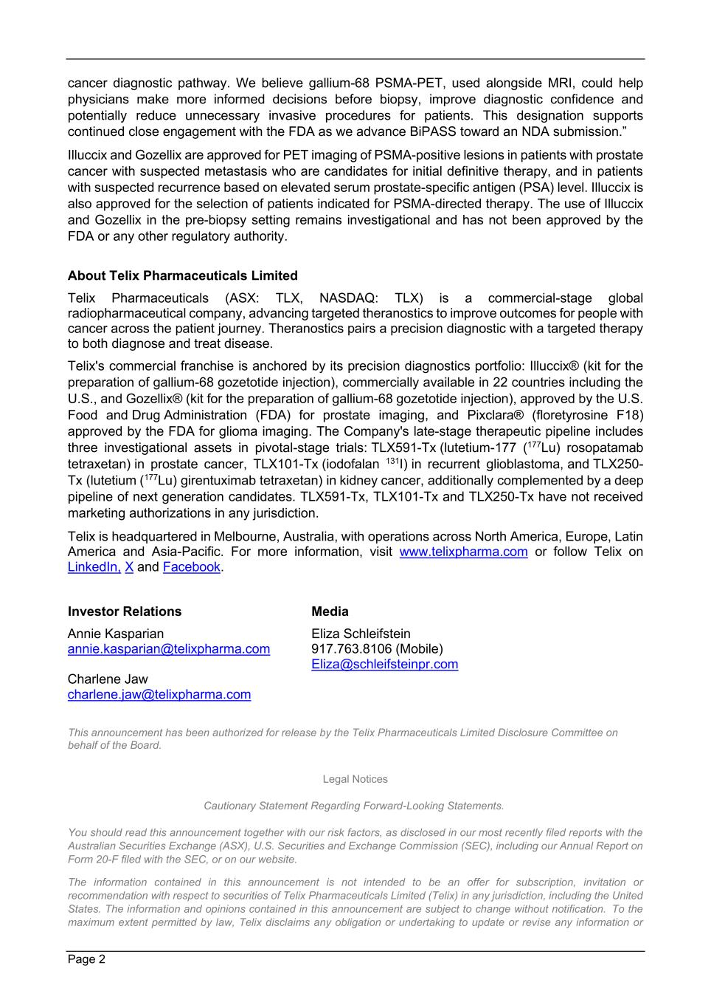
Page 2 cancer diagnostic pathway. We believe gallium-68 PSMA-PET, used alongside MRI, could help physicians make more informed decisions before biopsy, improve diagnostic confidence and potentially reduce unnecessary invasive procedures for patients. This designation supports continued close engagement with the FDA as we advance BiPASS toward an NDA submission.” Illuccix and Gozellix are approved for PET imaging of PSMA-positive lesions in patients with prostate cancer with suspected metastasis who are candidates for initial definitive therapy, and in patients with suspected recurrence based on elevated serum prostate-specific antigen (PSA) level. Illuccix is also approved for the selection of patients indicated for PSMA-directed therapy. The use of Illuccix and Gozellix in the pre-biopsy setting remains investigational and has not been approved by the FDA or any other regulatory authority. About Telix Pharmaceuticals Limited Telix Pharmaceuticals (ASX: TLX, NASDAQ: TLX) is a commercial-stage global radiopharmaceutical company, advancing targeted theranostics to improve outcomes for people with cancer across the patient journey. Theranostics pairs a precision diagnostic with a targeted therapy to both diagnose and treat disease. Telix's commercial franchise is anchored by its precision diagnostics portfolio: Illuccix® (kit for the preparation of gallium-68 gozetotide injection), commercially available in 22 countries including the U.S., and Gozellix® (kit for the preparation of gallium-68 gozetotide injection), approved by the U.S. Food and Drug Administration (FDA) for prostate imaging, and Pixclara® (floretyrosine F18) approved by the FDA for glioma imaging. The Company's late-stage therapeutic pipeline includes three investigational assets in pivotal-stage trials: TLX591-Tx (lutetium-177 (177Lu) rosopatamab tetraxetan) in prostate cancer, TLX101-Tx (iodofalan 131I) in recurrent glioblastoma, and TLX250- Tx (lutetium (177Lu) girentuximab tetraxetan) in kidney cancer, additionally complemented by a deep pipeline of next generation candidates. TLX591-Tx, TLX101-Tx and TLX250-Tx have not received marketing authorizations in any jurisdiction. Telix is headquartered in Melbourne, Australia, with operations across North America, Europe, Latin America and Asia-Pacific. For more information, visit www.telixpharma.com or follow Telix on LinkedIn, X and Facebook. Investor Relations Annie Kasparian annie.kasparian@telixpharma.com Charlene Jaw charlene.jaw@telixpharma.com Media Eliza Schleifstein 917.763.8106 (Mobile) Eliza@schleifsteinpr.com This announcement has been authorized for release by the Telix Pharmaceuticals Limited Disclosure Committee on behalf of the Board. Legal Notices Cautionary Statement Regarding Forward-Looking Statements. You should read this announcement together with our risk factors, as disclosed in our most recently filed reports with the Australian Securities Exchange (ASX), U.S. Securities and Exchange Commission (SEC), including our Annual Report on Form 20-F filed with the SEC, or on our website. The information contained in this announcement is not intended to be an offer for subscription, invitation or recommendation with respect to securities of Telix Pharmaceuticals Limited (Telix) in any jurisdiction, including the United States. The information and opinions contained in this announcement are subject to change without notification. To the maximum extent permitted by law, Telix disclaims any obligation or undertaking to update or revise any information or

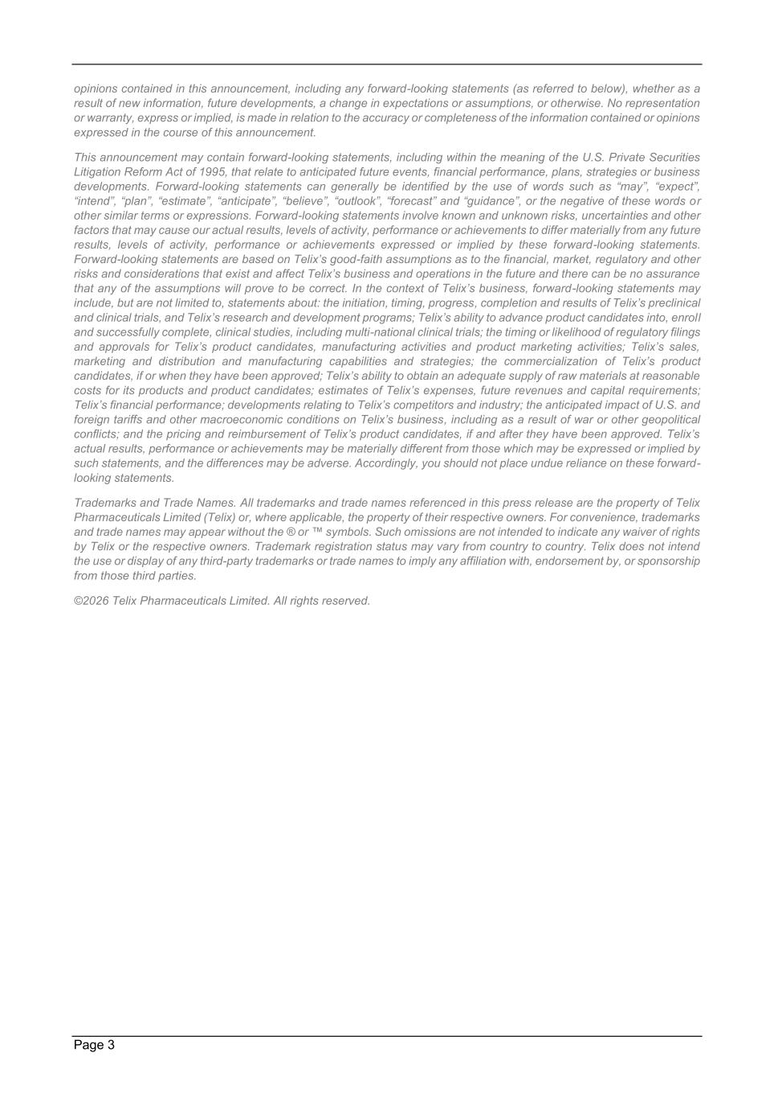
Page 3 opinions contained in this announcement, including any forward-looking statements (as referred to below), whether as a result of new information, future developments, a change in expectations or assumptions, or otherwise. No representation or warranty, express or implied, is made in relation to the accuracy or completeness of the information contained or opinions expressed in the course of this announcement. This announcement may contain forward-looking statements, including within the meaning of the U.S. Private Securities Litigation Reform Act of 1995, that relate to anticipated future events, financial performance, plans, strategies or business developments. Forward-looking statements can generally be identified by the use of words such as “may”, “expect”, “intend”, “plan”, “estimate”, “anticipate”, “believe”, “outlook”, “forecast” and “guidance”, or the negative of these words or other similar terms or expressions. Forward-looking statements involve known and unknown risks, uncertainties and other factors that may cause our actual results, levels of activity, performance or achievements to differ materially from any future results, levels of activity, performance or achievements expressed or implied by these forward-looking statements. Forward-looking statements are based on Telix’s good-faith assumptions as to the financial, market, regulatory and other risks and considerations that exist and affect Telix’s business and operations in the future and there can be no assurance that any of the assumptions will prove to be correct. In the context of Telix’s business, forward-looking statements may include, but are not limited to, statements about: the initiation, timing, progress, completion and results of Telix’s preclinical and clinical trials, and Telix’s research and development programs; Telix’s ability to advance product candidates into, enroll and successfully complete, clinical studies, including multi-national clinical trials; the timing or likelihood of regulatory filings and approvals for Telix’s product candidates, manufacturing activities and product marketing activities; Telix’s sales, marketing and distribution and manufacturing capabilities and strategies; the commercialization of Telix’s product candidates, if or when they have been approved; Telix’s ability to obtain an adequate supply of raw materials at reasonable costs for its products and product candidates; estimates of Telix’s expenses, future revenues and capital requirements; Telix’s financial performance; developments relating to Telix’s competitors and industry; the anticipated impact of U.S. and foreign tariffs and other macroeconomic conditions on Telix’s business, including as a result of war or other geopolitical conflicts; and the pricing and reimbursement of Telix’s product candidates, if and after they have been approved. Telix’s actual results, performance or achievements may be materially different from those which may be expressed or implied by such statements, and the differences may be adverse. Accordingly, you should not place undue reliance on these forward- looking statements. Trademarks and Trade Names. All trademarks and trade names referenced in this press release are the property of Telix Pharmaceuticals Limited (Telix) or, where applicable, the property of their respective owners. For convenience, trademarks and trade names may appear without the ® or ™ symbols. Such omissions are not intended to indicate any waiver of rights by Telix or the respective owners. Trademark registration status may vary from country to country. Telix does not intend the use or display of any third-party trademarks or trade names to imply any affiliation with, endorsement by, or sponsorship from those third parties. ©2026 Telix Pharmaceuticals Limited. All rights reserved.

