UNITED STATES
SECURITIES AND EXCHANGE COMMISSION
Washington, D.C. 20549

FORM 6-K

REPORT OF FOREIGN PRIVATE ISSUER
PURSUANT TO RULE 13a-16 OR 15d-16 OF
THE SECURITIES EXCHANGE ACT OF 1934

For the month of July, 2026

Commission File Number: 001-42128

Telix Pharmaceuticals Limited
(Translation of registrant’s name into English)

55 Flemington Road
North Melbourne, Victoria 3051, Australia
(Address of principal executive offices)

Indicate by check mark whether the registrant files or will file annual reports under cover of Form 20-F or Form 40-
F.

Form 20-F ☒ Form 40-F ☐

INFORMATION CONTAINED IN THIS FORM 6-K REPORT

On July 2, 2026 (Melbourne, Australia), Telix Pharmaceuticals Limited filed an announcement with the Australian
Securities Exchange titled “FDA Alignment to Advance ProstACT Global Phase 3 Trial,” a copy of which is
attached to this Form 6-K as Exhibit 99.1.
The information contained in this Form 6-K, except for (i) the commentary in Exhibit 99.1 appearing in the third and
fourth paragraphs on page 1 and (ii) information accessible by hyperlinks included therein, is incorporated by
reference into our Registration Statement on Form F-3ASR (File No. 333-293611) and Registration Statement on
Form S-8 (File No. 333-283917).

99.1
Press release – July 2, 2026
SIGNATURES

Pursuant to the requirements of the Securities Exchange Act of 1934, the registrant has duly caused this report to be
signed on its behalf by the undersigned, thereunto duly authorized.

Date:

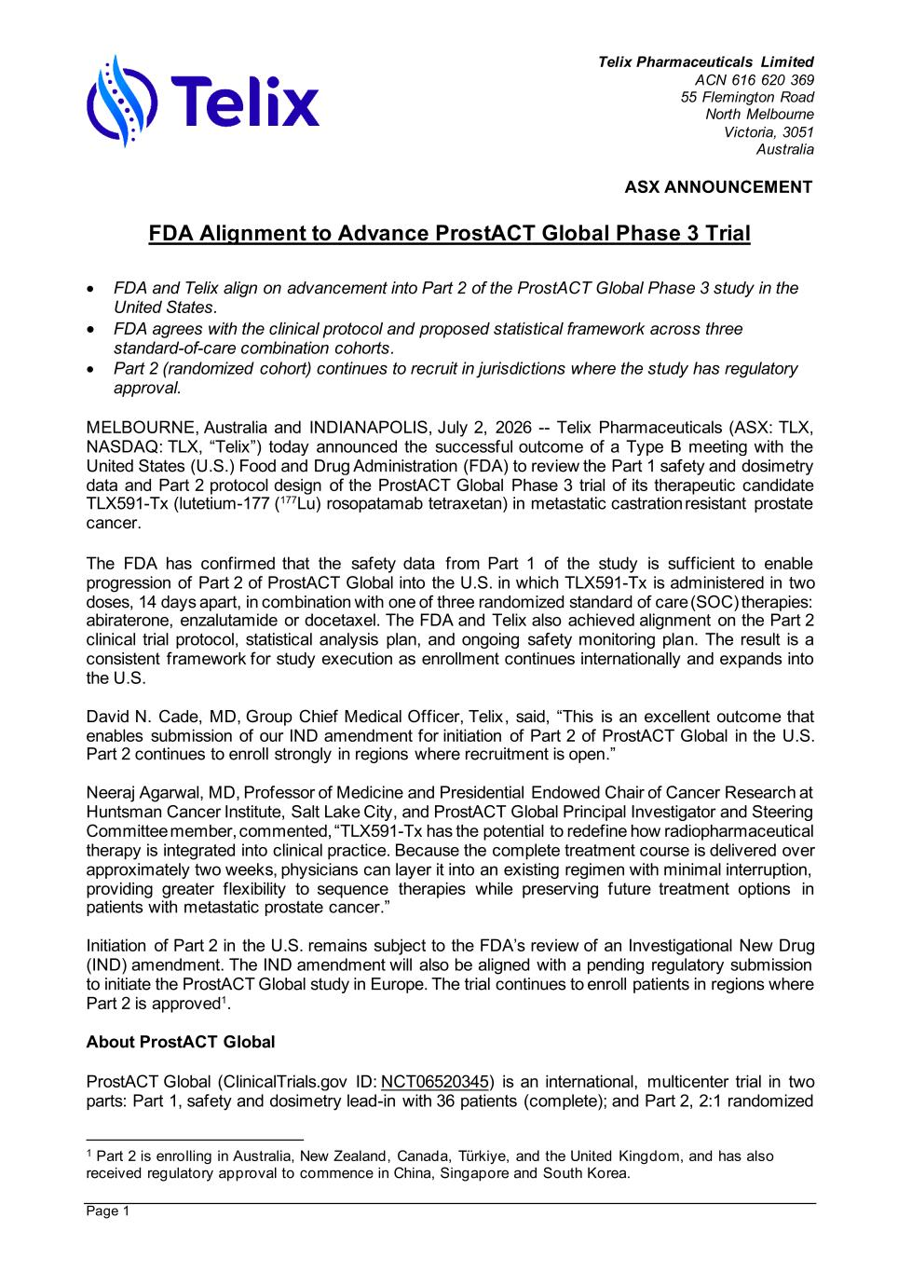
Telix Pharmaceuticals Limited ACN 616 620 369 55 Flemington Road North Melbourne Victoria, 3051 Australia ASX ANNOUNCEMENT Page 1 FDA Alignment to Advance ProstACT Global Phase 3 Trial • FDA and Telix align on advancement into Part 2 of the ProstACT Global Phase 3 study in the United States. • FDA agrees with the clinical protocol and proposed statistical framework across three standard-of-care combination cohorts. • Part 2 (randomized cohort) continues to recruit in jurisdictions where the study has regulatory approval. MELBOURNE, Australia and INDIANAPOLIS, July 2, 2026 -- Telix Pharmaceuticals (ASX: TLX, NASDAQ: TLX, “Telix”) today announced the successful outcome of a Type B meeting with the United States (U.S.) Food and Drug Administration (FDA) to review the Part 1 safety and dosimetry data and Part 2 protocol design of the ProstACT Global Phase 3 trial of its therapeutic candidate TLX591-Tx (lutetium-177 (177Lu) rosopatamab tetraxetan) in metastatic castration resistant prostate cancer. The FDA has confirmed that the safety data from Part 1 of the study is sufficient to enable progression of Part 2 of ProstACT Global into the U.S. in which TLX591-Tx is administered in two doses, 14 days apart, in combination with one of three randomized standard of care (SOC) therapies: abiraterone, enzalutamide or docetaxel. The FDA and Telix also achieved alignment on the Part 2 clinical trial protocol, statistical analysis plan, and ongoing safety monitoring plan. The result is a consistent framework for study execution as enrollment continues internationally and expands into the U.S. David N. Cade, MD, Group Chief Medical Officer, Telix, said, “This is an excellent outcome that enables submission of our IND amendment for initiation of Part 2 of ProstACT Global in the U.S. Part 2 continues to enroll strongly in regions where recruitment is open.” Neeraj Agarwal, MD, Professor of Medicine and Presidential Endowed Chair of Cancer Research at Huntsman Cancer Institute, Salt Lake City, and ProstACT Global Principal Investigator and Steering Committee member, commented, “TLX591-Tx has the potential to redefine how radiopharmaceutical therapy is integrated into clinical practice. Because the complete treatment course is delivered over approximately two weeks, physicians can layer it into an existing regimen with minimal interruption, providing greater flexibility to sequence therapies while preserving future treatment options in patients with metastatic prostate cancer.” Initiation of Part 2 in the U.S. remains subject to the FDA’s review of an Investigational New Drug (IND) amendment. The IND amendment will also be aligned with a pending regulatory submission to initiate the ProstACT Global study in Europe. The trial continues to enroll patients in regions where Part 2 is approved1. About ProstACT Global ProstACT Global (ClinicalTrials.gov ID: NCT06520345) is an international, multicenter trial in two parts: Part 1, safety and dosimetry lead-in with 36 patients (complete); and Part 2, 2:1 randomized 1 Part 2 is enrolling in Australia, New Zealand, Canada, Türkiye, and the United Kingdom, and has also received regulatory approval to commence in China, Singapore and South Korea.

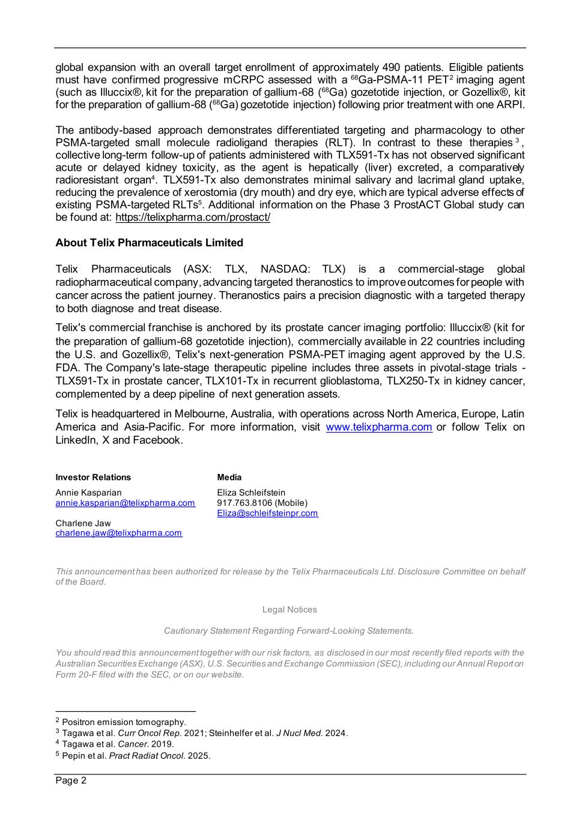
Page 2 global expansion with an overall target enrollment of approximately 490 patients. Eligible patients must have confirmed progressive mCRPC assessed with a 68Ga-PSMA-11 PET2 imaging agent (such as Illuccix®, kit for the preparation of gallium-68 (68Ga) gozetotide injection, or Gozellix®, kit for the preparation of gallium-68 (68Ga) gozetotide injection) following prior treatment with one ARPI. The antibody-based approach demonstrates differentiated targeting and pharmacology to other PSMA-targeted small molecule radioligand therapies (RLT). In contrast to these therapies 3 , collective long-term follow-up of patients administered with TLX591-Tx has not observed significant acute or delayed kidney toxicity, as the agent is hepatically (liver) excreted, a comparatively radioresistant organ4. TLX591-Tx also demonstrates minimal salivary and lacrimal gland uptake, reducing the prevalence of xerostomia (dry mouth) and dry eye, which are typical adverse effects of existing PSMA-targeted RLTs5. Additional information on the Phase 3 ProstACT Global study can be found at: https://telixpharma.com/prostact/ About Telix Pharmaceuticals Limited Telix Pharmaceuticals (ASX: TLX, NASDAQ: TLX) is a commercial-stage global radiopharmaceutical company, advancing targeted theranostics to improve outcomes for people with cancer across the patient journey. Theranostics pairs a precision diagnostic with a targeted therapy to both diagnose and treat disease. Telix's commercial franchise is anchored by its prostate cancer imaging portfolio: Illuccix® (kit for the preparation of gallium-68 gozetotide injection), commercially available in 22 countries including the U.S. and Gozellix®, Telix's next-generation PSMA-PET imaging agent approved by the U.S. FDA. The Company's late-stage therapeutic pipeline includes three assets in pivotal-stage trials - TLX591-Tx in prostate cancer, TLX101-Tx in recurrent glioblastoma, TLX250-Tx in kidney cancer, complemented by a deep pipeline of next generation assets. Telix is headquartered in Melbourne, Australia, with operations across North America, Europe, Latin America and Asia-Pacific. For more information, visit www.telixpharma.com or follow Telix on LinkedIn, X and Facebook. Investor Relations Annie Kasparian annie.kasparian@telixpharma.com Charlene Jaw charlene.jaw@telixpharma.com Media Eliza Schleifstein 917.763.8106 (Mobile) Eliza@schleifsteinpr.com This announcement has been authorized for release by the Telix Pharmaceuticals Ltd. Disclosure Committee on behalf of the Board. Legal Notices Cautionary Statement Regarding Forward-Looking Statements. You should read this announcement together with our risk factors, as disclosed in our most recently filed reports with the Australian Securities Exchange (ASX), U.S. Securities and Exchange Commission (SEC), including our Annual Report on Form 20-F filed with the SEC, or on our website. 2 Positron emission tomography. 3 Tagawa et al. Curr Oncol Rep. 2021; Steinhelfer et al. J Nucl Med. 2024. 4 Tagawa et al. Cancer. 2019. 5 Pepin et al. Pract Radiat Oncol. 2025.

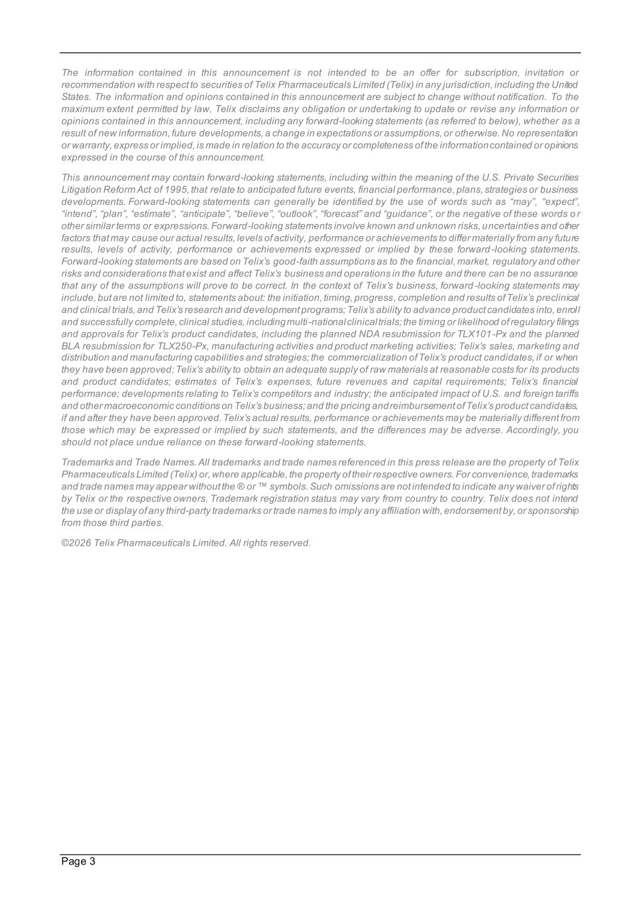
Page 3 The information contained in this announcement is not intended to be an offer for subscription, invitation or recommendation with respect to securities of Telix Pharmaceuticals Limited (Telix) in any jurisdiction, including the United States. The information and opinions contained in this announcement are subject to change without notification. To the maximum extent permitted by law, Telix disclaims any obligation or undertaking to update or revise any information or opinions contained in this announcement, including any forward-looking statements (as referred to below), whether as a result of new information, future developments, a change in expectations or assumptions, or otherwise. No representation or warranty, express or implied, is made in relation to the accuracy or completeness of the information contained or opinions expressed in the course of this announcement. This announcement may contain forward-looking statements, including within the meaning of the U.S. Private Securities Litigation Reform Act of 1995, that relate to anticipated future events, financial performance, plans, strategies or business developments. Forward-looking statements can generally be identified by the use of words such as “may”, “expect”, “intend”, “plan”, “estimate”, “anticipate”, “believe”, “outlook”, “forecast” and “guidance”, or the negative of these words o r other similar terms or expressions. Forward-looking statements involve known and unknown risks, uncertainties and other factors that may cause our actual results, levels of activity, performance or achievements to differ materially from any future results, levels of activity, performance or achievements expressed or implied by these forward -looking statements. Forward-looking statements are based on Telix’s good-faith assumptions as to the financial, market, regulatory and other risks and considerations that exist and affect Telix’s business and operations in the future and there can be no assurance that any of the assumptions will prove to be correct. In the context of Telix’s business, forward -looking statements may include, but are not limited to, statements about: the initiation, timing, progress, completion and results of Telix’s preclinical and clinical trials, and Telix’s research and development programs; Telix’s ability to advance product candidates into, enrol l and successfully complete, clinical studies, including multi -national clinical trials; the timing or likelihood of regulatory filings and approvals for Telix’s product candidates, including the planned NDA resubmission for TLX101-Px and the planned BLA resubmission for TLX250-Px, manufacturing activities and product marketing activities; Telix’s sales, marketing and distribution and manufacturing capabilities and strategies; the commercialization of Telix’s product candidates, if or when they have been approved; Telix’s ability to obtain an adequate supply of raw materials at reasonable costs for its products and product candidates; estimates of Telix’s expenses, future revenues and capital requirements; Telix’s financial performance; developments relating to Telix’s competitors and industry; the anticipated impact of U.S. and foreign tariffs and other macroeconomic conditions on Telix’s business; and the pricing and reimbursement of Telix’s product candidates, if and after they have been approved. Telix’s actual results, performance or achievements may be materially different from those which may be expressed or implied by such statements, and the differences may be adverse. Accordingly, you should not place undue reliance on these forward-looking statements. Trademarks and Trade Names. All trademarks and trade names referenced in this press release are the property of Telix Pharmaceuticals Limited (Telix) or, where applicable, the property of their respective owners. For convenience, trademarks and trade names may appear without the ® or ™ symbols. Such omissions are not intended to indicate any waiver of rights by Telix or the respective owners. Trademark registration status may vary from country to country. Telix does not intend the use or display of any third-party trademarks or trade names to imply any affiliation with, endorsement by, or sponsorship from those third parties. ©2026 Telix Pharmaceuticals Limited. All rights reserved.

