UNITED STATES
SECURITIES AND EXCHANGE COMMISSION
Washington, D.C. 20549

FORM 6-K

REPORT OF FOREIGN PRIVATE ISSUER
PURSUANT TO RULE 13a-16 OR 15d-16 OF
THE SECURITIES EXCHANGE ACT OF 1934

For the month of September, 2026

Commission File Number: 001-42128

Telix Pharmaceuticals Limited
(Translation of registrant’s name into English)

55 Flemington Road
North Melbourne, Victoria 3051, Australia
(Address of principal executive offices)

Indicate by check mark whether the registrant files or will file annual reports under cover of Form 20-F or Form 40-
F.

Form 20-F ☒ Form 40-F ☐

INFORMATION CONTAINED IN THIS FORM 6-K REPORT

On September 21, 2026 (Melbourne, Australia), Telix Pharmaceuticals Limited ("Telix") filed the following
announcements with the Australian Securities Exchange titled: (i) “Telix and ITM Join Forces to Create a
Radiopharmaceutical Powerhouse” and (ii) "Telix + ITM A radiopharmaceutical powerhouse with enhanced
capabilities across the value chain" copies of which are attached to this Form 6-K as Exhibit 99.1 and Exhibit 99.2,
respectively.
The information contained in this Form 6-K, except for information accessible by hyperlinks included therein, are
incorporated by reference into Telix’s Registration Statement on Form S-8 (File No. 333-283917).
99.2

99.1
Press release – September 21, 2026
SIGNATURES

Pursuant to the requirements of the Securities Exchange Act of 1934, the registrant has duly caused this report to be
signed on its behalf by the undersigned, thereunto duly authorized.

Date:

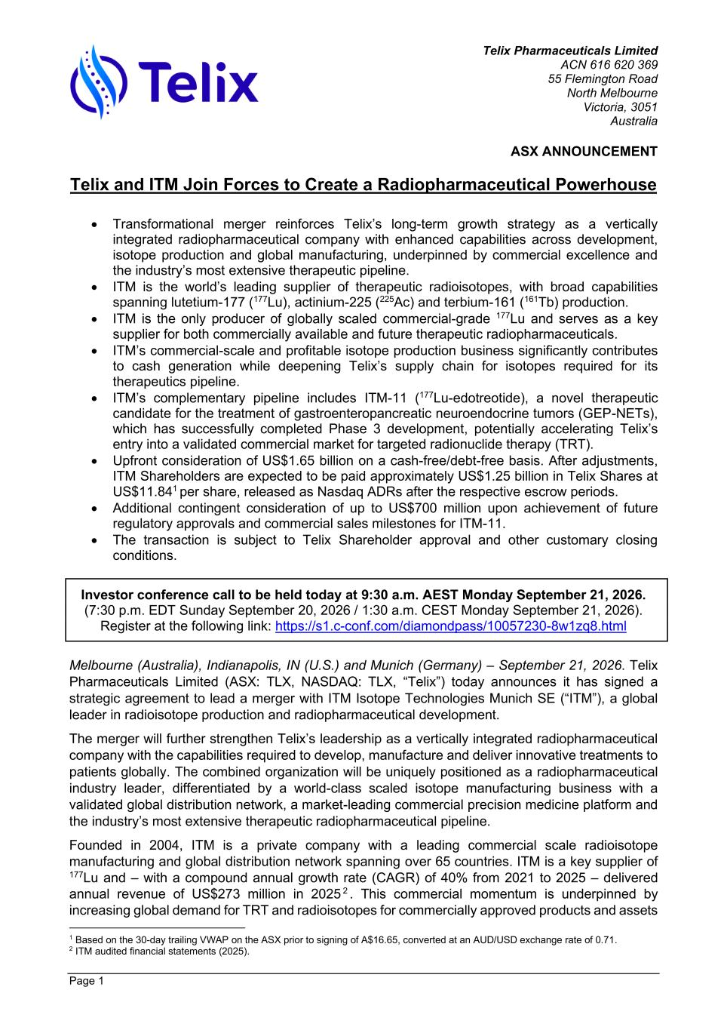
Telix Pharmaceuticals Limited ACN 616 620 369 55 Flemington Road North Melbourne Victoria, 3051 Australia ASX ANNOUNCEMENT Page 1 Telix and ITM Join Forces to Create a Radiopharmaceutical Powerhouse • Transformational merger reinforces Telix’s long-term growth strategy as a vertically integrated radiopharmaceutical company with enhanced capabilities across development, isotope production and global manufacturing, underpinned by commercial excellence and the industry’s most extensive therapeutic pipeline. • ITM is the world’s leading supplier of therapeutic radioisotopes, with broad capabilities spanning lutetium-177 (177Lu), actinium-225 (225Ac) and terbium-161 (161Tb) production. • ITM is the only producer of globally scaled commercial-grade 177Lu and serves as a key supplier for both commercially available and future therapeutic radiopharmaceuticals. • ITM’s commercial-scale and profitable isotope production business significantly contributes to cash generation while deepening Telix’s supply chain for isotopes required for its therapeutics pipeline. • ITM’s complementary pipeline includes ITM-11 (177Lu-edotreotide), a novel therapeutic candidate for the treatment of gastroenteropancreatic neuroendocrine tumors (GEP-NETs), which has successfully completed Phase 3 development, potentially accelerating Telix’s entry into a validated commercial market for targeted radionuclide therapy (TRT). • Upfront consideration of US$1.65 billion on a cash-free/debt-free basis. After adjustments, ITM Shareholders are expected to be paid approximately US$1.25 billion in Telix Shares at US$11.841 per share, released as Nasdaq ADRs after the respective escrow periods. • Additional contingent consideration of up to US$700 million upon achievement of future regulatory approvals and commercial sales milestones for ITM-11. • The transaction is subject to Telix Shareholder approval and other customary closing conditions. Investor conference call to be held today at 9:30 a.m. AEST Monday September 21, 2026. (7:30 p.m. EDT Sunday September 20, 2026 / 1:30 a.m. CEST Monday September 21, 2026). Register at the following link: https://s1.c-conf.com/diamondpass/10057230-8w1zq8.html Melbourne (Australia), Indianapolis, IN (U.S.) and Munich (Germany) – September 21, 2026. Telix Pharmaceuticals Limited (ASX: TLX, NASDAQ: TLX, “Telix”) today announces it has signed a strategic agreement to lead a merger with ITM Isotope Technologies Munich SE (“ITM”), a global leader in radioisotope production and radiopharmaceutical development. The merger will further strengthen Telix’s leadership as a vertically integrated radiopharmaceutical company with the capabilities required to develop, manufacture and deliver innovative treatments to patients globally. The combined organization will be uniquely positioned as a radiopharmaceutical industry leader, differentiated by a world-class scaled isotope manufacturing business with a validated global distribution network, a market-leading commercial precision medicine platform and the industry’s most extensive therapeutic radiopharmaceutical pipeline. Founded in 2004, ITM is a private company with a leading commercial scale radioisotope manufacturing and global distribution network spanning over 65 countries. ITM is a key supplier of 177Lu and – with a compound annual growth rate (CAGR) of 40% from 2021 to 2025 – delivered annual revenue of US$273 million in 2025 2 . This commercial momentum is underpinned by increasing global demand for TRT and radioisotopes for commercially approved products and assets 1 Based on the 30-day trailing VWAP on the ASX prior to signing of A$16.65, converted at an AUD/USD exchange rate of 0.71. 2 ITM audited financial statements (2025).

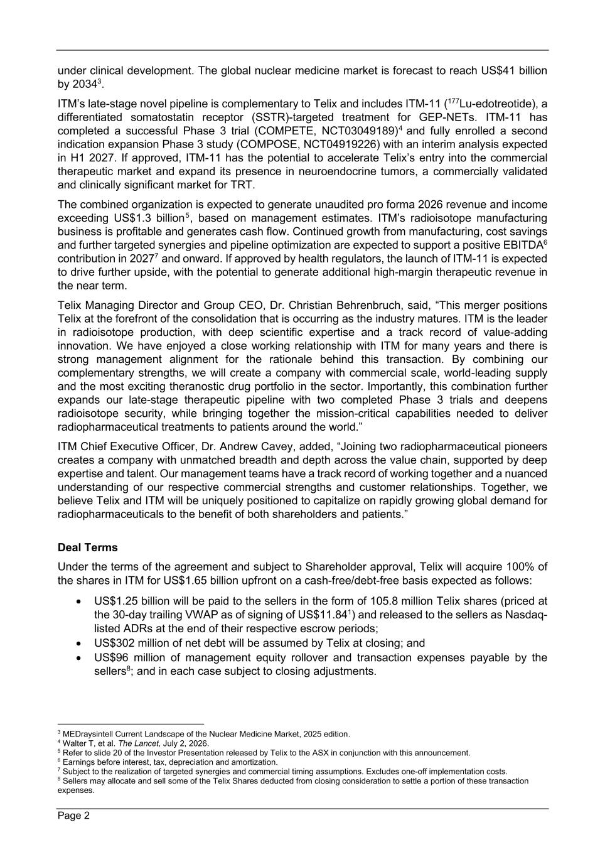
Page 2 under clinical development. The global nuclear medicine market is forecast to reach US$41 billion by 20343. ITM’s late-stage novel pipeline is complementary to Telix and includes ITM-11 (177Lu-edotreotide), a differentiated somatostatin receptor (SSTR)-targeted treatment for GEP-NETs. ITM-11 has completed a successful Phase 3 trial (COMPETE, NCT03049189)4 and fully enrolled a second indication expansion Phase 3 study (COMPOSE, NCT04919226) with an interim analysis expected in H1 2027. If approved, ITM-11 has the potential to accelerate Telix’s entry into the commercial therapeutic market and expand its presence in neuroendocrine tumors, a commercially validated and clinically significant market for TRT. The combined organization is expected to generate unaudited pro forma 2026 revenue and income exceeding US$1.3 billion5, based on management estimates. ITM’s radioisotope manufacturing business is profitable and generates cash flow. Continued growth from manufacturing, cost savings and further targeted synergies and pipeline optimization are expected to support a positive EBITDA6 contribution in 20277 and onward. If approved by health regulators, the launch of ITM-11 is expected to drive further upside, with the potential to generate additional high-margin therapeutic revenue in the near term. Telix Managing Director and Group CEO, Dr. Christian Behrenbruch, said, “This merger positions Telix at the forefront of the consolidation that is occurring as the industry matures. ITM is the leader in radioisotope production, with deep scientific expertise and a track record of value-adding innovation. We have enjoyed a close working relationship with ITM for many years and there is strong management alignment for the rationale behind this transaction. By combining our complementary strengths, we will create a company with commercial scale, world-leading supply and the most exciting theranostic drug portfolio in the sector. Importantly, this combination further expands our late-stage therapeutic pipeline with two completed Phase 3 trials and deepens radioisotope security, while bringing together the mission-critical capabilities needed to deliver radiopharmaceutical treatments to patients around the world.” ITM Chief Executive Officer, Dr. Andrew Cavey, added, “Joining two radiopharmaceutical pioneers creates a company with unmatched breadth and depth across the value chain, supported by deep expertise and talent. Our management teams have a track record of working together and a nuanced understanding of our respective commercial strengths and customer relationships. Together, we believe Telix and ITM will be uniquely positioned to capitalize on rapidly growing global demand for radiopharmaceuticals to the benefit of both shareholders and patients.” Deal Terms Under the terms of the agreement and subject to Shareholder approval, Telix will acquire 100% of the shares in ITM for US$1.65 billion upfront on a cash-free/debt-free basis expected as follows: • US$1.25 billion will be paid to the sellers in the form of 105.8 million Telix shares (priced at the 30-day trailing VWAP as of signing of US$11.841) and released to the sellers as Nasdaq- listed ADRs at the end of their respective escrow periods; • US$302 million of net debt will be assumed by Telix at closing; and • US$96 million of management equity rollover and transaction expenses payable by the sellers8; and in each case subject to closing adjustments. 3 MEDraysintell Current Landscape of the Nuclear Medicine Market, 2025 edition. 4 Walter T, et al. The Lancet, July 2, 2026. 5 Refer to slide 20 of the Investor Presentation released by Telix to the ASX in conjunction with this announcement. 6 Earnings before interest, tax, depreciation and amortization. 7 Subject to the realization of targeted synergies and commercial timing assumptions. Excludes one-off implementation costs. 8 Sellers may allocate and sell some of the Telix Shares deducted from closing consideration to settle a portion of these transaction expenses.

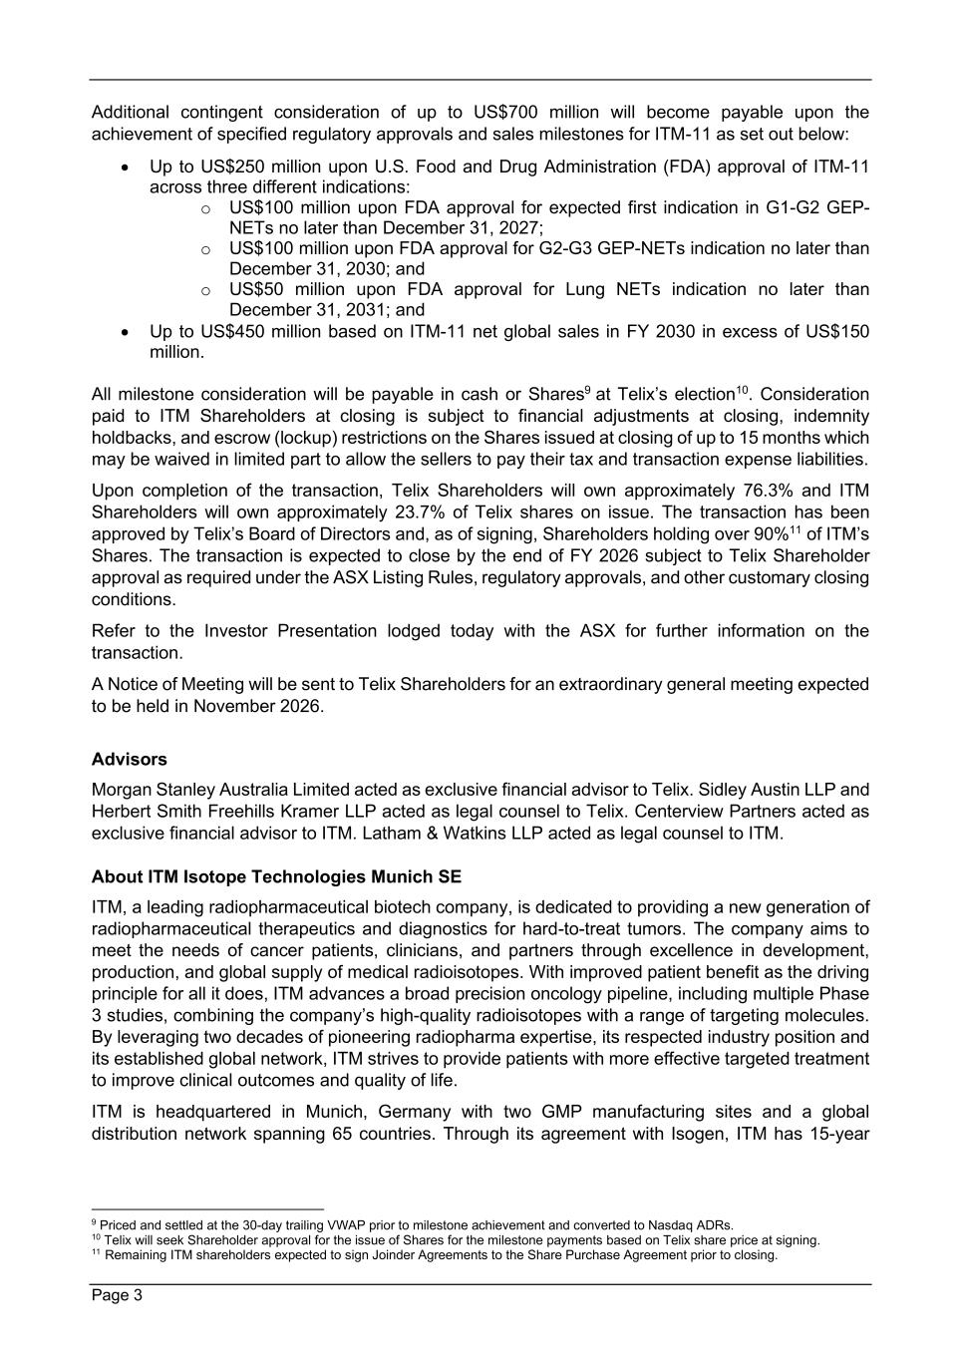
Page 3 Additional contingent consideration of up to US$700 million will become payable upon the achievement of specified regulatory approvals and sales milestones for ITM-11 as set out below: • Up to US$250 million upon U.S. Food and Drug Administration (FDA) approval of ITM-11 across three different indications: o US$100 million upon FDA approval for expected first indication in G1-G2 GEP- NETs no later than December 31, 2027; o US$100 million upon FDA approval for G2-G3 GEP-NETs indication no later than December 31, 2030; and o US$50 million upon FDA approval for Lung NETs indication no later than December 31, 2031; and • Up to US$450 million based on ITM-11 net global sales in FY 2030 in excess of US$150 million. All milestone consideration will be payable in cash or Shares9 at Telix’s election10. Consideration paid to ITM Shareholders at closing is subject to financial adjustments at closing, indemnity holdbacks, and escrow (lockup) restrictions on the Shares issued at closing of up to 15 months which may be waived in limited part to allow the sellers to pay their tax and transaction expense liabilities. Upon completion of the transaction, Telix Shareholders will own approximately 76.3% and ITM Shareholders will own approximately 23.7% of Telix shares on issue. The transaction has been approved by Telix’s Board of Directors and, as of signing, Shareholders holding over 90%11 of ITM’s Shares. The transaction is expected to close by the end of FY 2026 subject to Telix Shareholder approval as required under the ASX Listing Rules, regulatory approvals, and other customary closing conditions. Refer to the Investor Presentation lodged today with the ASX for further information on the transaction. A Notice of Meeting will be sent to Telix Shareholders for an extraordinary general meeting expected to be held in November 2026. Advisors Morgan Stanley Australia Limited acted as exclusive financial advisor to Telix. Sidley Austin LLP and Herbert Smith Freehills Kramer LLP acted as legal counsel to Telix. Centerview Partners acted as exclusive financial advisor to ITM. Latham & Watkins LLP acted as legal counsel to ITM. About ITM Isotope Technologies Munich SE ITM, a leading radiopharmaceutical biotech company, is dedicated to providing a new generation of radiopharmaceutical therapeutics and diagnostics for hard-to-treat tumors. The company aims to meet the needs of cancer patients, clinicians, and partners through excellence in development, production, and global supply of medical radioisotopes. With improved patient benefit as the driving principle for all it does, ITM advances a broad precision oncology pipeline, including multiple Phase 3 studies, combining the company’s high-quality radioisotopes with a range of targeting molecules. By leveraging two decades of pioneering radiopharma expertise, its respected industry position and its established global network, ITM strives to provide patients with more effective targeted treatment to improve clinical outcomes and quality of life. ITM is headquartered in Munich, Germany with two GMP manufacturing sites and a global distribution network spanning 65 countries. Through its agreement with Isogen, ITM has 15-year 9 Priced and settled at the 30-day trailing VWAP prior to milestone achievement and converted to Nasdaq ADRs. 10 Telix will seek Shareholder approval for the issue of Shares for the milestone payments based on Telix share price at signing. 11 Remaining ITM shareholders expected to sign Joinder Agreements to the Share Purchase Agreement prior to closing.

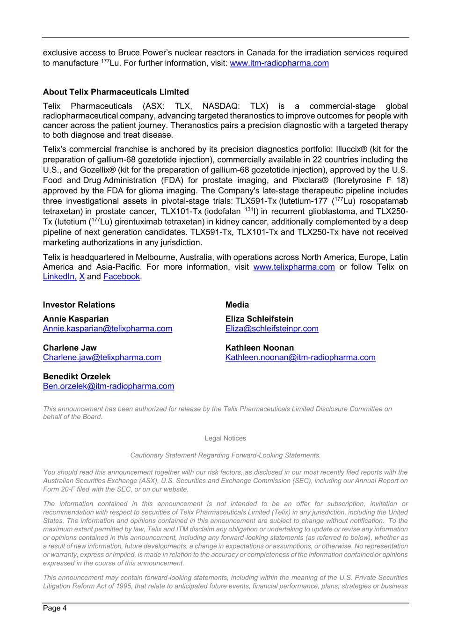
Page 4 exclusive access to Bruce Power’s nuclear reactors in Canada for the irradiation services required to manufacture 177Lu. For further information, visit: www.itm-radiopharma.com About Telix Pharmaceuticals Limited Telix Pharmaceuticals (ASX: TLX, NASDAQ: TLX) is a commercial-stage global radiopharmaceutical company, advancing targeted theranostics to improve outcomes for people with cancer across the patient journey. Theranostics pairs a precision diagnostic with a targeted therapy to both diagnose and treat disease. Telix's commercial franchise is anchored by its precision diagnostics portfolio: Illuccix® (kit for the preparation of gallium-68 gozetotide injection), commercially available in 22 countries including the U.S., and Gozellix® (kit for the preparation of gallium-68 gozetotide injection), approved by the U.S. Food and Drug Administration (FDA) for prostate imaging, and Pixclara® (floretyrosine F 18) approved by the FDA for glioma imaging. The Company's late-stage therapeutic pipeline includes three investigational assets in pivotal-stage trials: TLX591-Tx (lutetium-177 (177Lu) rosopatamab tetraxetan) in prostate cancer, TLX101-Tx (iodofalan 131I) in recurrent glioblastoma, and TLX250- Tx (lutetium (177Lu) girentuximab tetraxetan) in kidney cancer, additionally complemented by a deep pipeline of next generation candidates. TLX591-Tx, TLX101-Tx and TLX250-Tx have not received marketing authorizations in any jurisdiction. Telix is headquartered in Melbourne, Australia, with operations across North America, Europe, Latin America and Asia-Pacific. For more information, visit www.telixpharma.com or follow Telix on LinkedIn, X and Facebook. Investor Relations Annie Kasparian Annie.kasparian@telixpharma.com Charlene Jaw Charlene.jaw@telixpharma.com Benedikt Orzelek Ben.orzelek@itm-radiopharma.com Media Eliza Schleifstein Eliza@schleifsteinpr.com Kathleen Noonan Kathleen.noonan@itm-radiopharma.com This announcement has been authorized for release by the Telix Pharmaceuticals Limited Disclosure Committee on behalf of the Board. Legal Notices Cautionary Statement Regarding Forward-Looking Statements. You should read this announcement together with our risk factors, as disclosed in our most recently filed reports with the Australian Securities Exchange (ASX), U.S. Securities and Exchange Commission (SEC), including our Annual Report on Form 20-F filed with the SEC, or on our website. The information contained in this announcement is not intended to be an offer for subscription, invitation or recommendation with respect to securities of Telix Pharmaceuticals Limited (Telix) in any jurisdiction, including the United States. The information and opinions contained in this announcement are subject to change without notification. To the maximum extent permitted by law, Telix and ITM disclaim any obligation or undertaking to update or revise any information or opinions contained in this announcement, including any forward-looking statements (as referred to below), whether as a result of new information, future developments, a change in expectations or assumptions, or otherwise. No representation or warranty, express or implied, is made in relation to the accuracy or completeness of the information contained or opinions expressed in the course of this announcement. This announcement may contain forward-looking statements, including within the meaning of the U.S. Private Securities Litigation Reform Act of 1995, that relate to anticipated future events, financial performance, plans, strategies or business

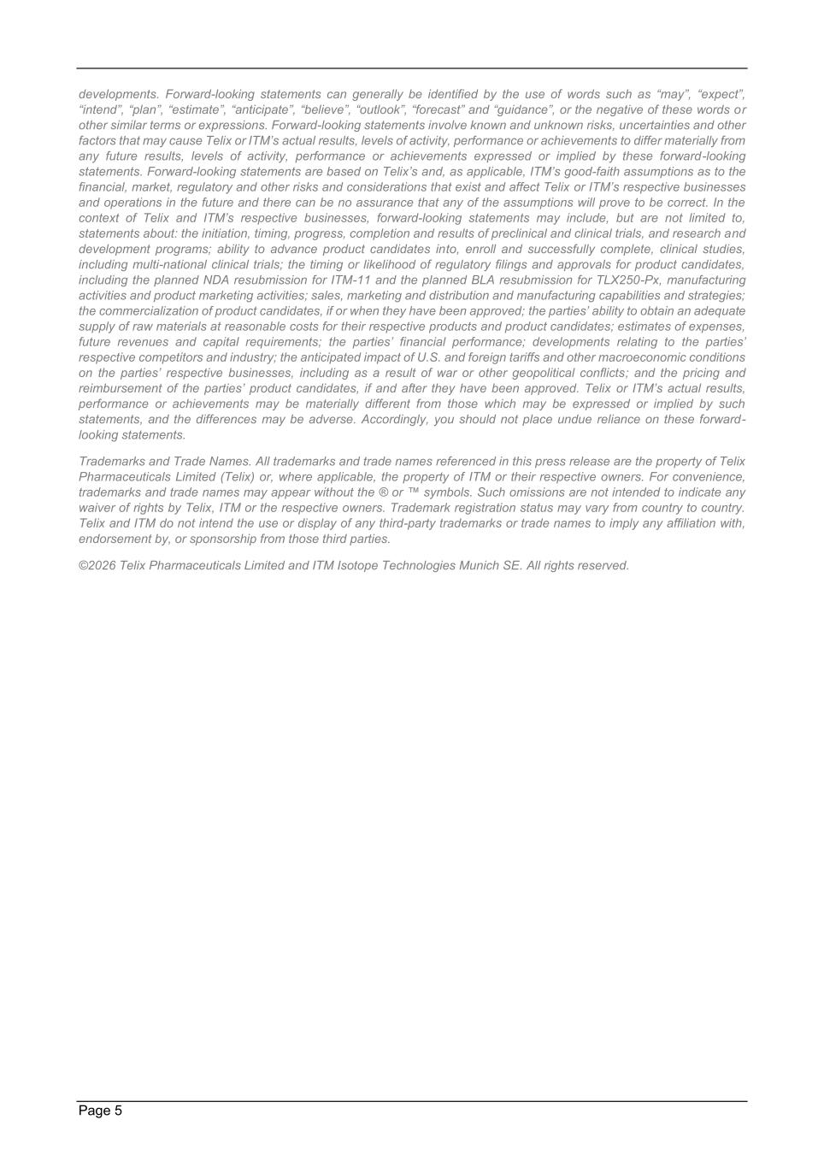
Page 5 developments. Forward-looking statements can generally be identified by the use of words such as “may”, “expect”, “intend”, “plan”, “estimate”, “anticipate”, “believe”, “outlook”, “forecast” and “guidance”, or the negative of these words or other similar terms or expressions. Forward-looking statements involve known and unknown risks, uncertainties and other factors that may cause Telix or ITM’s actual results, levels of activity, performance or achievements to differ materially from any future results, levels of activity, performance or achievements expressed or implied by these forward-looking statements. Forward-looking statements are based on Telix’s and, as applicable, ITM’s good-faith assumptions as to the financial, market, regulatory and other risks and considerations that exist and affect Telix or ITM’s respective businesses and operations in the future and there can be no assurance that any of the assumptions will prove to be correct. In the context of Telix and ITM’s respective businesses, forward-looking statements may include, but are not limited to, statements about: the initiation, timing, progress, completion and results of preclinical and clinical trials, and research and development programs; ability to advance product candidates into, enroll and successfully complete, clinical studies, including multi-national clinical trials; the timing or likelihood of regulatory filings and approvals for product candidates, including the planned NDA resubmission for ITM-11 and the planned BLA resubmission for TLX250-Px, manufacturing activities and product marketing activities; sales, marketing and distribution and manufacturing capabilities and strategies; the commercialization of product candidates, if or when they have been approved; the parties’ ability to obtain an adequate supply of raw materials at reasonable costs for their respective products and product candidates; estimates of expenses, future revenues and capital requirements; the parties’ financial performance; developments relating to the parties’ respective competitors and industry; the anticipated impact of U.S. and foreign tariffs and other macroeconomic conditions on the parties’ respective businesses, including as a result of war or other geopolitical conflicts; and the pricing and reimbursement of the parties’ product candidates, if and after they have been approved. Telix or ITM’s actual results, performance or achievements may be materially different from those which may be expressed or implied by such statements, and the differences may be adverse. Accordingly, you should not place undue reliance on these forward- looking statements. Trademarks and Trade Names. All trademarks and trade names referenced in this press release are the property of Telix Pharmaceuticals Limited (Telix) or, where applicable, the property of ITM or their respective owners. For convenience, trademarks and trade names may appear without the ® or ™ symbols. Such omissions are not intended to indicate any waiver of rights by Telix, ITM or the respective owners. Trademark registration status may vary from country to country. Telix and ITM do not intend the use or display of any third-party trademarks or trade names to imply any affiliation with, endorsement by, or sponsorship from those third parties. ©2026 Telix Pharmaceuticals Limited and ITM Isotope Technologies Munich SE. All rights reserved.

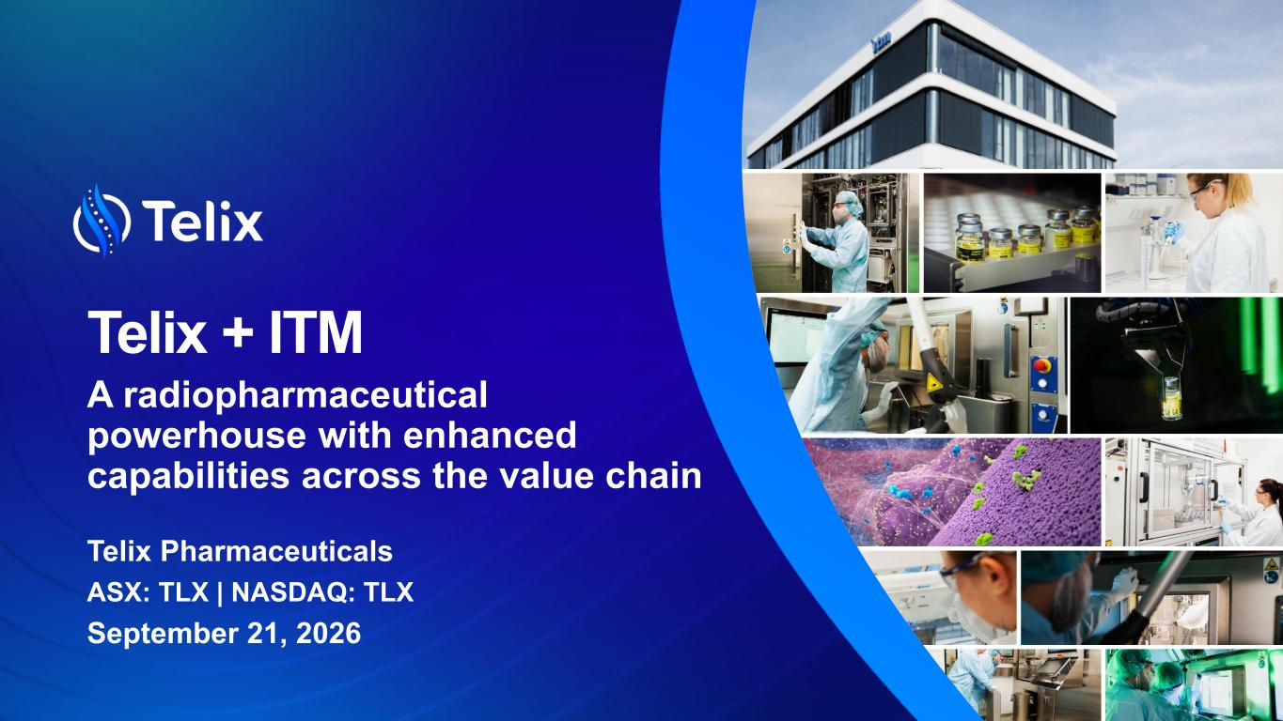
A radiopharmaceutical powerhouse with enhanced capabilities across the value chain Telix + ITM Telix Pharmaceuticals ASX: TLX | NASDAQ: TLX September 21, 2026

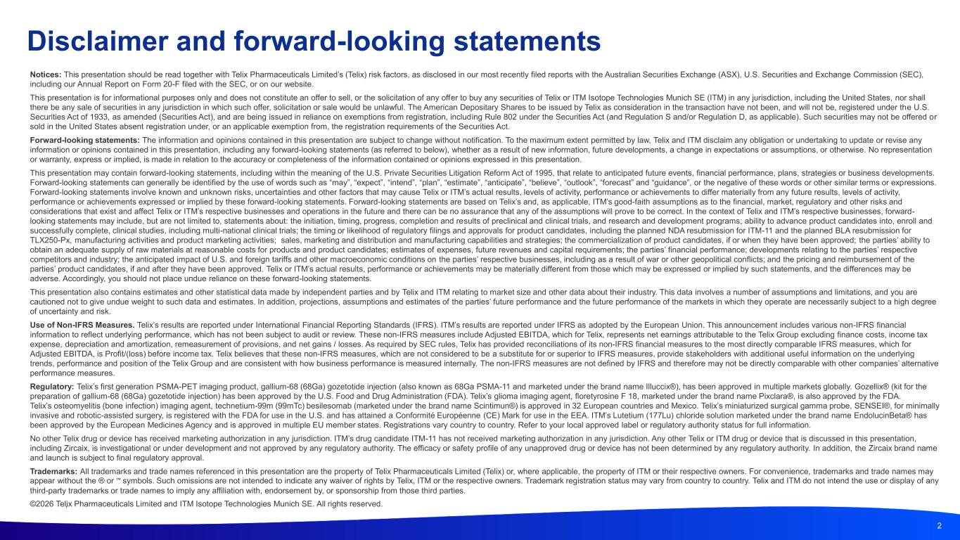
2 Disclaimer and forward-looking statements Notices: This presentation should be read together with Telix Pharmaceuticals Limited’s (Telix) risk factors, as disclosed in our most recently filed reports with the Australian Securities Exchange (ASX), U.S. Securities and Exchange Commission (SEC), including our Annual Report on Form 20-F filed with the SEC, or on our website. This presentation is for informational purposes only and does not constitute an offer to sell, or the solicitation of any offer to buy any securities of Telix or ITM Isotope Technologies Munich SE (ITM) in any jurisdiction, including the United States, nor shall there be any sale of securities in any jurisdiction in which such offer, solicitation or sale would be unlawful. The American Depositary Shares to be issued by Telix as consideration in the transaction have not been, and will not be, registered under the U.S. Securities Act of 1933, as amended (Securities Act), and are being issued in reliance on exemptions from registration, including Rule 802 under the Securities Act (and Regulation S and/or Regulation D, as applicable). Such securities may not be offered or sold in the United States absent registration under, or an applicable exemption from, the registration requirements of the Securities Act. Forward-looking statements: The information and opinions contained in this presentation are subject to change without notification. To the maximum extent permitted by law, Telix and ITM disclaim any obligation or undertaking to update or revise any information or opinions contained in this presentation, including any forward-looking statements (as referred to below), whether as a result of new information, future developments, a change in expectations or assumptions, or otherwise. No representation or warranty, express or implied, is made in relation to the accuracy or completeness of the information contained or opinions expressed in this presentation.​ This presentation may contain forward-looking statements, including within the meaning of the U.S. Private Securities Litigation Reform Act of 1995, that relate to anticipated future events, financial performance, plans, strategies or business developments. Forward-looking statements can generally be identified by the use of words such as “may”, “expect”, “intend”, “plan”, “estimate”, “anticipate”, “believe”, “outlook”, “forecast” and “guidance”, or the negative of these words or other similar terms or expressions. Forward-looking statements involve known and unknown risks, uncertainties and other factors that may cause Telix or ITM’s actual results, levels of activity, performance or achievements to differ materially from any future results, levels of activity, performance or achievements expressed or implied by these forward-looking statements. Forward-looking statements are based on Telix’s and, as applicable, ITM’s good-faith assumptions as to the financial, market, regulatory and other risks and considerations that exist and affect Telix or ITM’s respective businesses and operations in the future and there can be no assurance that any of the assumptions will prove to be correct. In the context of Telix and ITM’s respective businesses, forward- looking statements may include, but are not limited to, statements about: the initiation, timing, progress, completion and results of preclinical and clinical trials, and research and development programs; ability to advance product candidates into, enroll and successfully complete, clinical studies, including multi-national clinical trials; the timing or likelihood of regulatory filings and approvals for product candidates, including the planned NDA resubmission for ITM-11 and the planned BLA resubmission for TLX250-Px, manufacturing activities and product marketing activities; sales, marketing and distribution and manufacturing capabilities and strategies; the commercialization of product candidates, if or when they have been approved; the parties’ ability to obtain an adequate supply of raw materials at reasonable costs for products and product candidates; estimates of expenses, future revenues and capital requirements; the parties’ financial performance; developments relating to the parties’ respective competitors and industry; the anticipated impact of U.S. and foreign tariffs and other macroeconomic conditions on the parties’ respective businesses, including as a result of war or other geopolitical conflicts; and the pricing and reimbursement of the parties’ product candidates, if and after they have been approved. Telix or ITM’s actual results, performance or achievements may be materially different from those which may be expressed or implied by such statements, and the differences may be adverse. Accordingly, you should not place undue reliance on these forward-looking statements. This presentation also contains estimates and other statistical data made by independent parties and by Telix and ITM relating to market size and other data about their industry. This data involves a number of assumptions and limitations, and you are cautioned not to give undue weight to such data and estimates. In addition, projections, assumptions and estimates of the parties’ future performance and the future performance of the markets in which they operate are necessarily subject to a high degree of uncertainty and risk. Use of Non-IFRS Measures. Telix’s results are reported under International Financial Reporting Standards (IFRS). ITM’s results are reported under IFRS as adopted by the European Union. This announcement includes various non-IFRS financial information to reflect underlying performance, which has not been subject to audit or review. These non-IFRS measures include Adjusted EBITDA, which for Telix, represents net earnings attributable to the Telix Group excluding finance costs, income tax expense, depreciation and amortization, remeasurement of provisions, and net gains / losses. As required by SEC rules, Telix has provided reconciliations of its non-IFRS financial measures to the most directly comparable IFRS measures, which for Adjusted EBITDA, is Profit/(loss) before income tax. Telix believes that these non-IFRS measures, which are not considered to be a substitute for or superior to IFRS measures, provide stakeholders with additional useful information on the underlying trends, performance and position of the Telix Group and are consistent with how business performance is measured internally. The non-IFRS measures are not defined by IFRS and therefore may not be directly comparable with other companies’ alternative performance measures. Regulatory: Telix’s first generation PSMA-PET imaging product, gallium-68 (68Ga) gozetotide injection (also known as 68Ga PSMA-11 and marketed under the brand name Illuccix®), has been approved in multiple markets globally. Gozellix® (kit for the preparation of gallium-68 (68Ga) gozetotide injection) has been approved by the U.S. Food and Drug Administration (FDA). Telix’s glioma imaging agent, floretyrosine F 18, marketed under the brand name Pixclara®, is also approved by the FDA. Telix’s osteomyelitis (bone infection) imaging agent, technetium-99m (99mTc) besilesomab (marketed under the brand name Scintimun®) is approved in 32 European countries and Mexico. Telix’s miniaturized surgical gamma probe, SENSEI®, for minimally invasive and robotic-assisted surgery, is registered with the FDA for use in the U.S. and has attained a Conformité Européenne (CE) Mark for use in the EEA. ITM’s Lutetium (177Lu) chloride solution marketed under the brand name EndolucinBeta® has been approved by the European Medicines Agency and is approved in multiple EU member states. Registrations vary country to country. Refer to your local approved label or regulatory authority status for full information. No other Telix drug or device has received marketing authorization in any jurisdiction. ITM’s drug candidate ITM-11 has not received marketing authorization in any jurisdiction. Any other Telix or ITM drug or device that is discussed in this presentation, including Zircaix, is investigational or under development and not approved by any regulatory authority. The efficacy or safety profile of any unapproved drug or device has not been determined by any regulatory authority. In addition, the Zircaix brand name and launch is subject to final regulatory approval. Trademarks: All trademarks and trade names referenced in this presentation are the property of Telix Pharmaceuticals Limited (Telix) or, where applicable, the property of ITM or their respective owners. For convenience, trademarks and trade names may appear without the ® or symbols. Such omissions are not intended to indicate any waiver of rights by Telix, ITM or the respective owners. Trademark registration status may vary from country to country. Telix and ITM do not intend the use or display of any third-party trademarks or trade names to imply any affiliation with, endorsement by, or sponsorship from those third parties. ©2026 Telix Pharmaceuticals Limited and ITM Isotope Technologies Munich SE. All rights reserved.

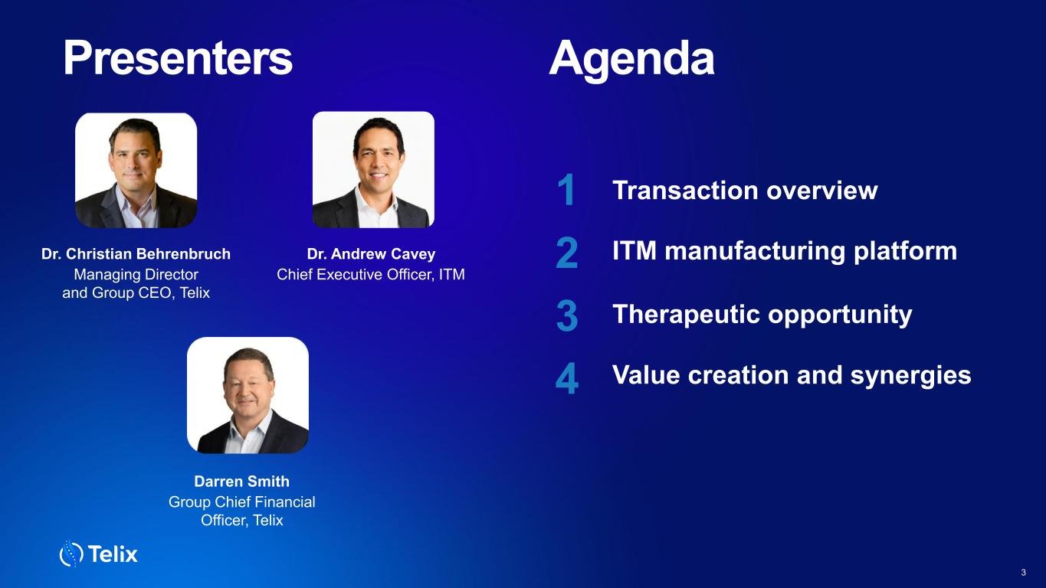
Presenters Dr. Christian Behrenbruch Managing Director and Group CEO, Telix Darren Smith Group Chief Financial Officer, Telix Agenda 1 2 3 4 3 Dr. Andrew Cavey Chief Executive Officer, ITM Transaction overview Value creation and synergies ITM manufacturing platform Therapeutic opportunity

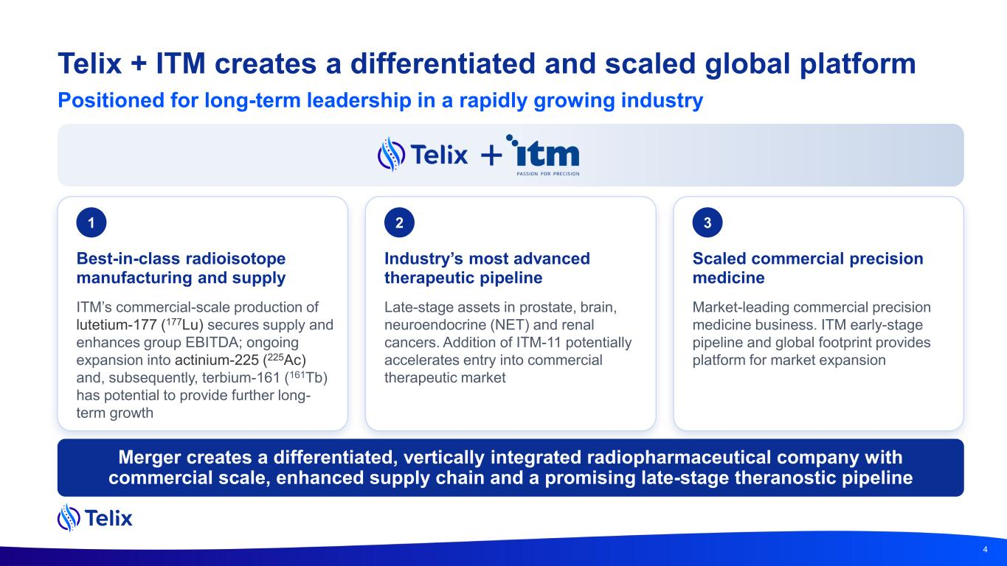
Telix + ITM creates a differentiated and scaled global platform 4 1 Best-in-class radioisotope manufacturing and supply ITM’s commercial-scale production of lutetium-177 (177Lu) secures supply and enhances group EBITDA; ongoing expansion into actinium-225 (225Ac) and, subsequently, terbium-161 (161Tb) has potential to provide further long- term growth 2 Industry’s most advanced therapeutic pipeline Late-stage assets in prostate, brain, neuroendocrine (NET) and renal cancers. Addition of ITM-11 potentially accelerates entry into commercial therapeutic market 3 Scaled commercial precision medicine Market-leading commercial precision medicine business. ITM early-stage pipeline and global footprint provides platform for market expansion Merger creates a differentiated, vertically integrated radiopharmaceutical company with commercial scale, enhanced supply chain and a promising late-stage theranostic pipeline Positioned for long-term leadership in a rapidly growing industry

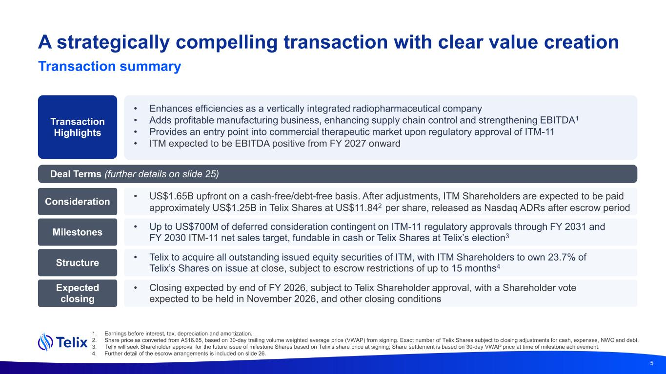
A strategically compelling transaction with clear value creation 1. Earnings before interest, tax, depreciation and amortization. 2. Share price as converted from A$16.65, based on 30-day trailing volume weighted average price (VWAP) from signing. Exact number of Telix Shares subject to closing adjustments for cash, expenses, NWC and debt. 3. Telix will seek Shareholder approval for the future issue of milestone Shares based on Telix’s share price at signing; Share settlement is based on 30-day VWAP price at time of milestone achievement. 4. Further detail of the escrow arrangements is included on slide 26. Transaction Highlights • Enhances efficiencies as a vertically integrated radiopharmaceutical company • Adds profitable manufacturing business, enhancing supply chain control and strengthening EBITDA1 • Provides an entry point into commercial therapeutic market upon regulatory approval of ITM-11 • ITM expected to be EBITDA positive from FY 2027 onward Consideration • US$1.65B upfront on a cash-free/debt-free basis. After adjustments, ITM Shareholders are expected to be paid approximately US$1.25B in Telix Shares at US$11.842 per share, released as Nasdaq ADRs after escrow period Milestones • Up to US$700M of deferred consideration contingent on ITM-11 regulatory approvals through FY 2031 and FY 2030 ITM-11 net sales target, fundable in cash or Telix Shares at Telix’s election3 Structure • Telix to acquire all outstanding issued equity securities of ITM, with ITM Shareholders to own 23.7% of Telix’s Shares on issue at close, subject to escrow restrictions of up to 15 months4 Expected closing • Closing expected by end of FY 2026, subject to Telix Shareholder approval, with a Shareholder vote expected to be held in November 2026, and other closing conditions Deal Terms (further details on slide 25) 5 Transaction summary

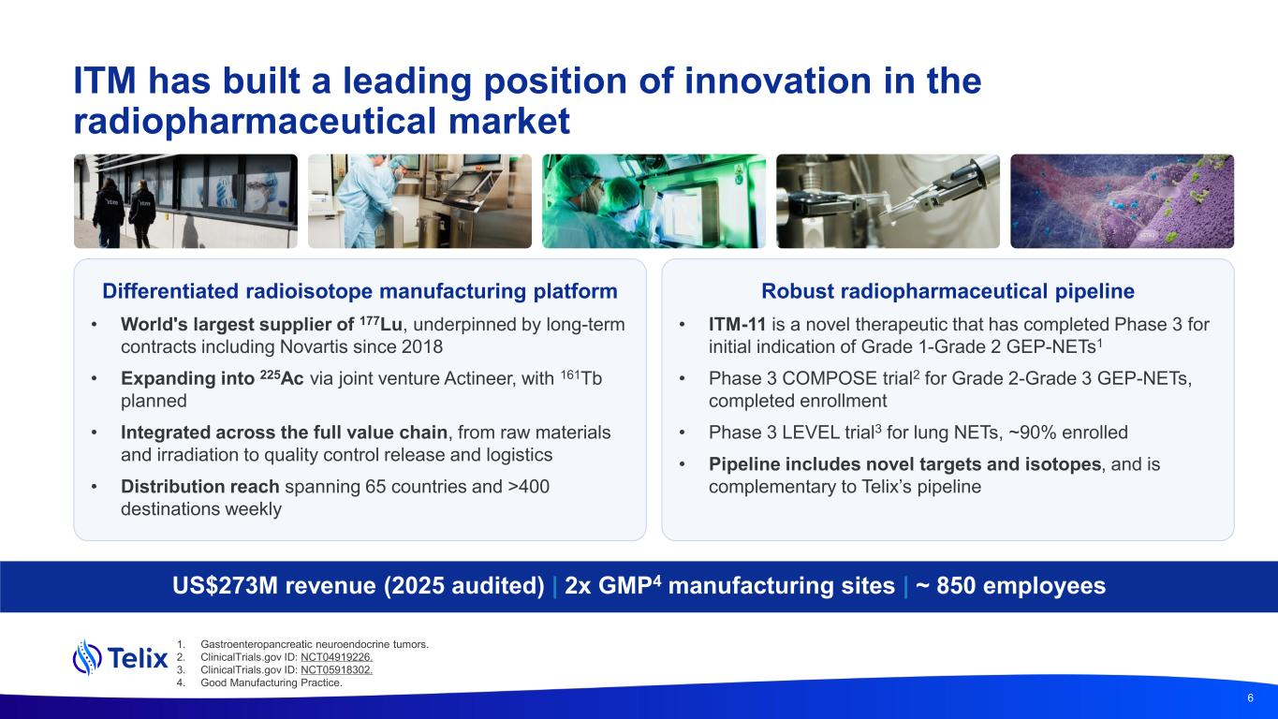
ITM has built a leading position of innovation in the radiopharmaceutical market Differentiated radioisotope manufacturing platform • World's largest supplier of 177Lu, underpinned by long-term contracts including Novartis since 2018 • Expanding into 225Ac via joint venture Actineer, with 161Tb planned • Integrated across the full value chain, from raw materials and irradiation to quality control release and logistics • Distribution reach spanning 65 countries and >400 destinations weekly US$273M revenue (2025 audited) | 2x GMP4 manufacturing sites | ~ 850 employees 6 Robust radiopharmaceutical pipeline • ITM-11 is a novel therapeutic that has completed Phase 3 for initial indication of Grade 1-Grade 2 GEP-NETs1 • Phase 3 COMPOSE trial2 for Grade 2-Grade 3 GEP-NETs, completed enrollment • Phase 3 LEVEL trial3 for lung NETs, ~90% enrolled • Pipeline includes novel targets and isotopes, and is complementary to Telix’s pipeline 1. Gastroenteropancreatic neuroendocrine tumors. 2. ClinicalTrials.gov ID: NCT04919226. 3. ClinicalTrials.gov ID: NCT05918302. 4. Good Manufacturing Practice.

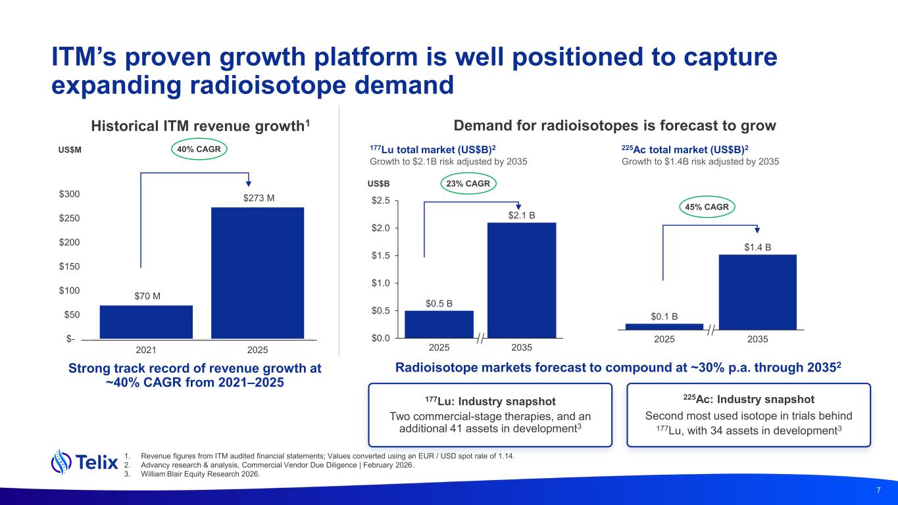
ITM’s proven growth platform is well positioned to capture expanding radioisotope demand Historical ITM revenue growth1 Demand for radioisotopes is forecast to grow $70 M $273 M $- $50 $100 $150 $200 $250 $300 2021 2025 177Lu total market (US$B)2 Growth to $2.1B risk adjusted by 2035 Strong track record of revenue growth at ~40% CAGR from 2021–2025 Radioisotope markets forecast to compound at ~30% p.a. through 20352 225Ac total market (US$B)2 Growth to $1.4B risk adjusted by 2035 7 US$M 177Lu: Industry snapshot Two commercial-stage therapies, and an additional 41 assets in development3 225Ac: Industry snapshot Second most used isotope in trials behind 177Lu, with 34 assets in development3 1. Revenue figures from ITM audited financial statements; Values converted using an EUR / USD spot rate of 1.14. 2. Advancy research & analysis, Commercial Vendor Due Diligence | February 2026. 3. William Blair Equity Research 2026. $0.5 B $2.1 B $0.0 $0.5 $1.0 $1.5 $2.0 $2.5 2025 2035 $0.1 B $1.4 B 2025 2035 45% CAGR 23% CAGR 40% CAGR US$B

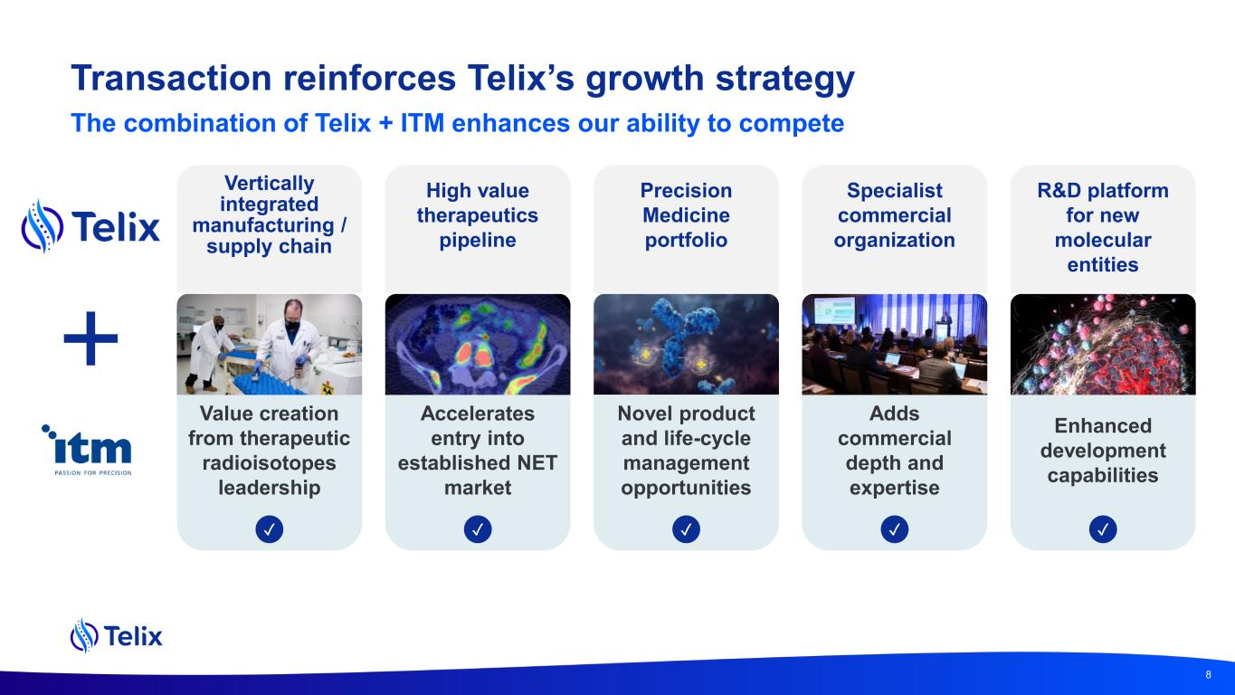
Transaction reinforces Telix’s growth strategy High value therapeutics pipeline Vertically integrated manufacturing / supply chain Specialist commercial organization R&D platform for new molecular entities Precision Medicine portfolio Accelerates entry into established NET market Enhanced development capabilities Novel product and life-cycle management opportunities Adds commercial depth and expertise Value creation from therapeutic radioisotopes leadership ✓ ✓✓ ✓✓ The combination of Telix + ITM enhances our ability to compete 8

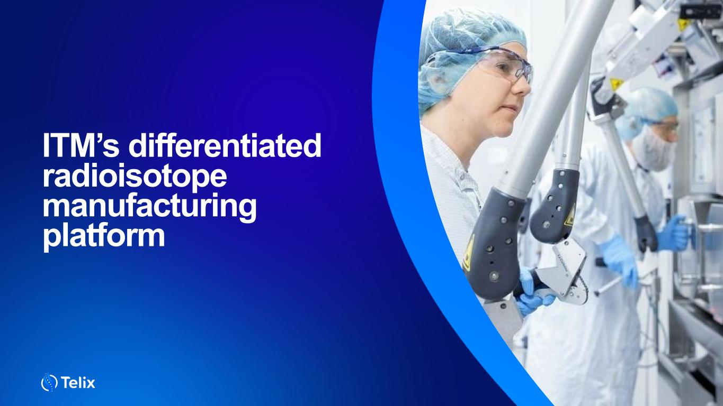
9 ITM’s differentiated radioisotope manufacturing platform

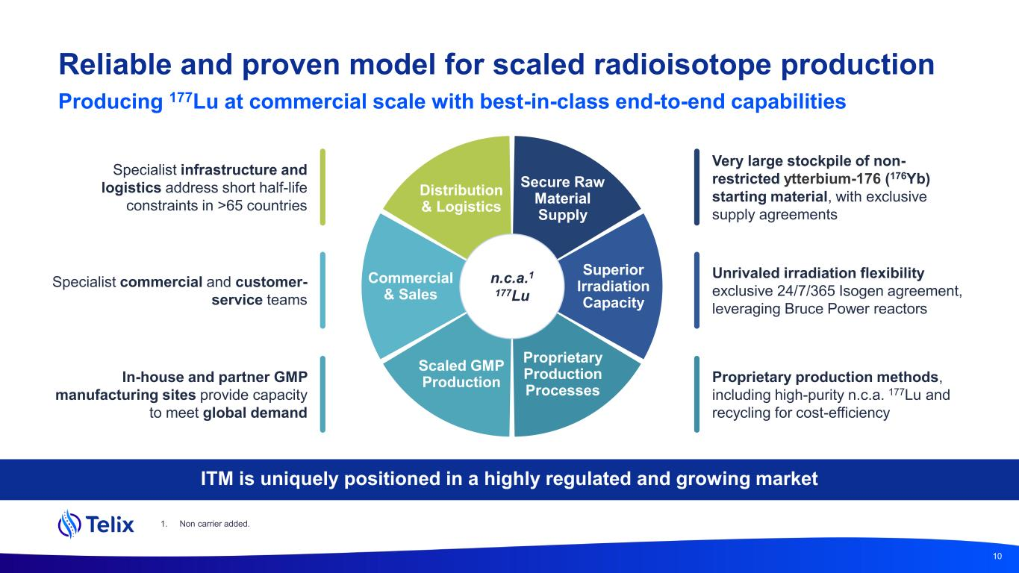
Reliable and proven model for scaled radioisotope production n.c.a.1 177Lu Proprietary Production Processes Scaled GMP Production Commercial & Sales Distribution & Logistics Secure Raw Material Supply Superior Irradiation Capacity 10 Producing 177Lu at commercial scale with best-in-class end-to-end capabilities Very large stockpile of non- restricted ytterbium-176 (176Yb) starting material, with exclusive supply agreements Specialist infrastructure and logistics address short half-life constraints in >65 countries Specialist commercial and customer- service teams Unrivaled irradiation flexibility exclusive 24/7/365 Isogen agreement, leveraging Bruce Power reactors Proprietary production methods, including high-purity n.c.a. 177Lu and recycling for cost-efficiency In-house and partner GMP manufacturing sites provide capacity to meet global demand 1. Non carrier added. ITM is uniquely positioned in a highly regulated and growing market

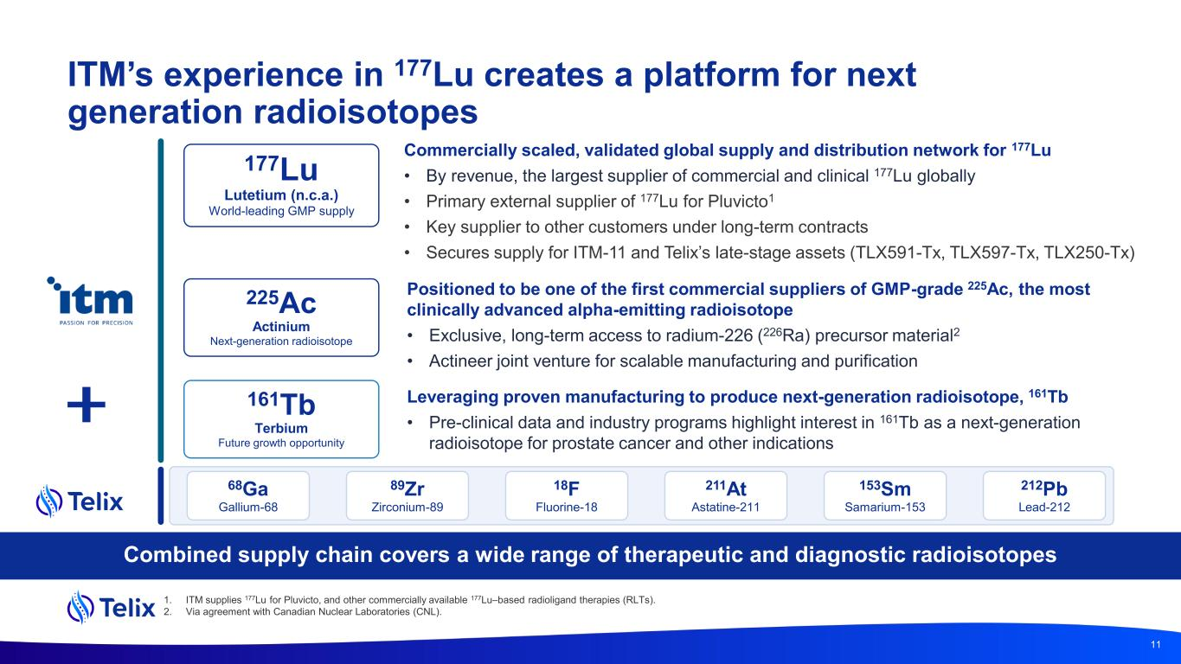
ITM’s experience in 177Lu creates a platform for next generation radioisotopes Combined supply chain covers a wide range of therapeutic and diagnostic radioisotopes 177Lu Lutetium (n.c.a.) World-leading GMP supply Commercially scaled, validated global supply and distribution network for 177Lu • By revenue, the largest supplier of commercial and clinical 177Lu globally • Primary external supplier of 177Lu for Pluvicto1 • Key supplier to other customers under long-term contracts • Secures supply for ITM-11 and Telix’s late-stage assets (TLX591-Tx, TLX597-Tx, TLX250-Tx) 225Ac Actinium Next-generation radioisotope Positioned to be one of the first commercial suppliers of GMP-grade 225Ac, the most clinically advanced alpha-emitting radioisotope • Exclusive, long-term access to radium-226 (226Ra) precursor material2 • Actineer joint venture for scalable manufacturing and purification 161Tb Terbium Future growth opportunity Leveraging proven manufacturing to produce next-generation radioisotope, 161Tb • Pre-clinical data and industry programs highlight interest in 161Tb as a next-generation radioisotope for prostate cancer and other indications 11 1. ITM supplies 177Lu for Pluvicto, and other commercially available 177Lu–based radioligand therapies (RLTs). 2. Via agreement with Canadian Nuclear Laboratories (CNL). 68Ga Gallium-68 89Zr Zirconium-89 211At Astatine-211 153Sm Samarium-153 212Pb Lead-212 18F Fluorine-18

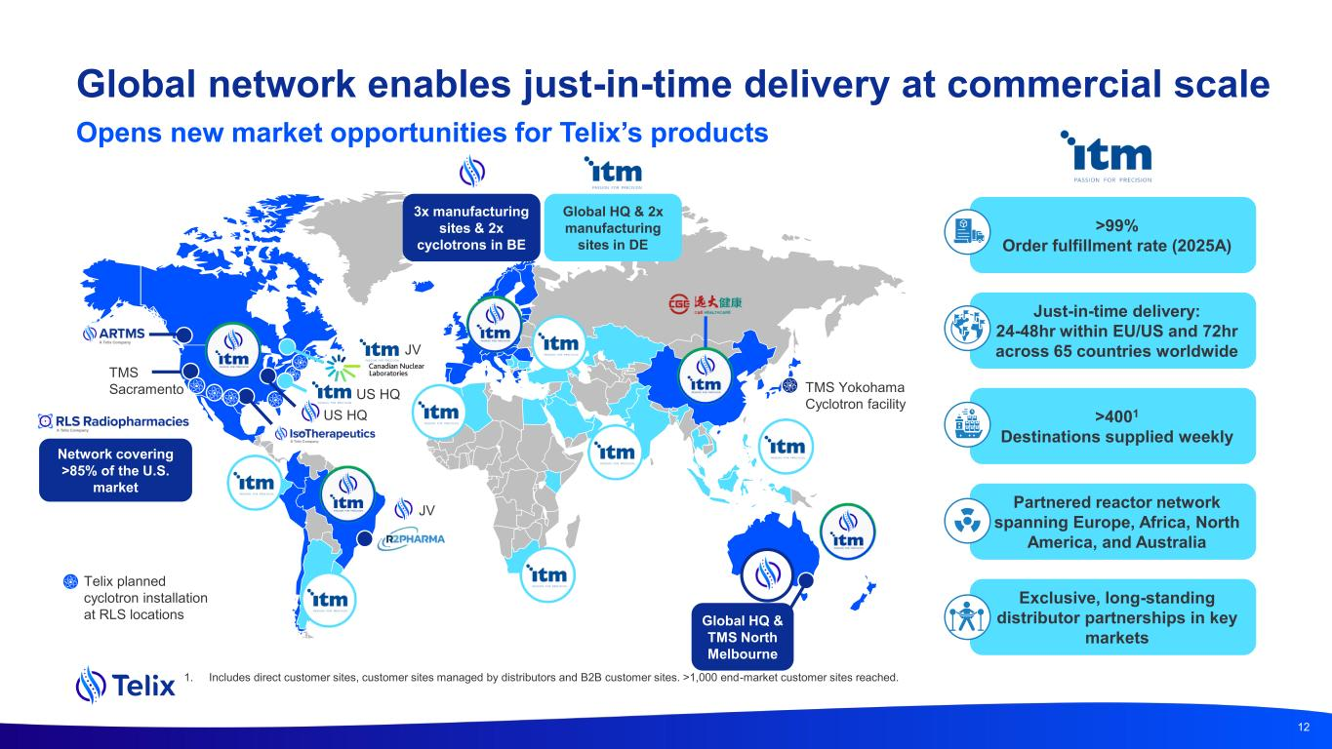
Global network enables just-in-time delivery at commercial scale Opens new market opportunities for Telix’s products 12 JV TMS Sacramento Telix planned cyclotron installation at RLS locations 3x manufacturing sites & 2x cyclotrons in BE Global HQ & 2x manufacturing sites in DE TMS Yokohama Cyclotron facility Just-in-time delivery: 24-48hr within EU/US and 72hr across 65 countries worldwide Exclusive, long-standing distributor partnerships in key markets >99% Order fulfillment rate (2025A) >4001 Destinations supplied weekly JV US HQ US HQ Global HQ & TMS North Melbourne Partnered reactor network spanning Europe, Africa, North America, and Australia Network covering >85% of the U.S. market 1. Includes direct customer sites, customer sites managed by distributors and B2B customer sites. >1,000 end-market customer sites reached.

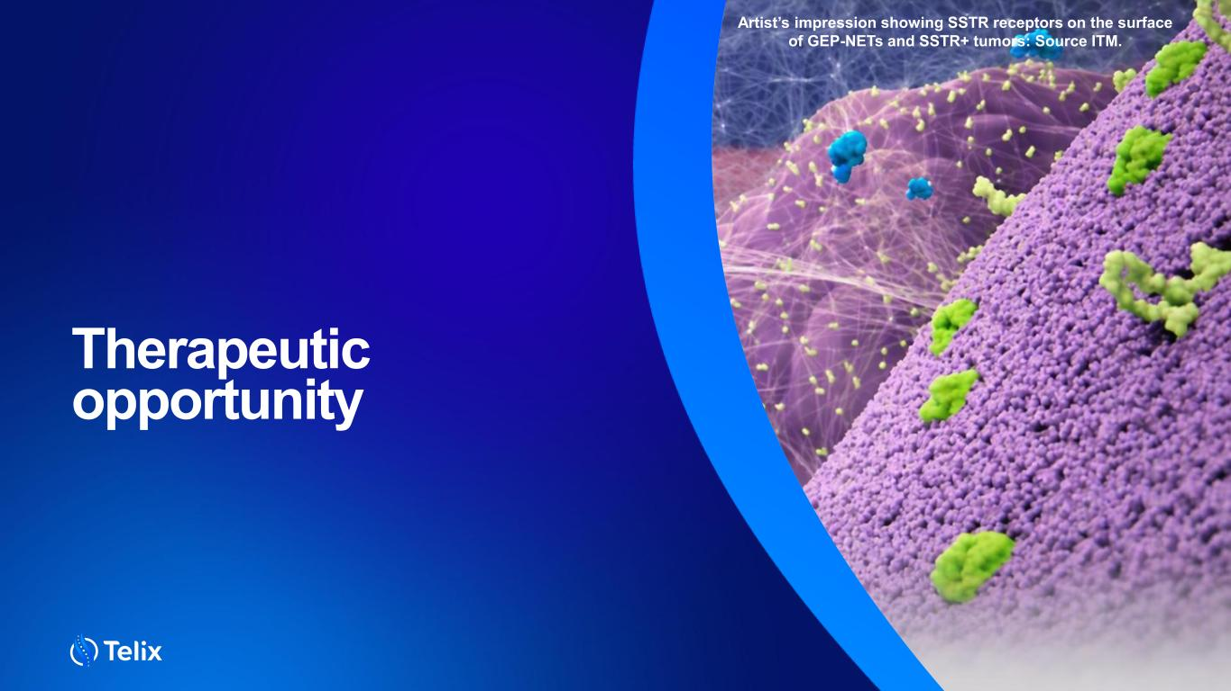
Therapeutic opportunity Artist’s impression showing SSTR receptors on the surface of GEP-NETs and SSTR+ tumors: Source ITM.

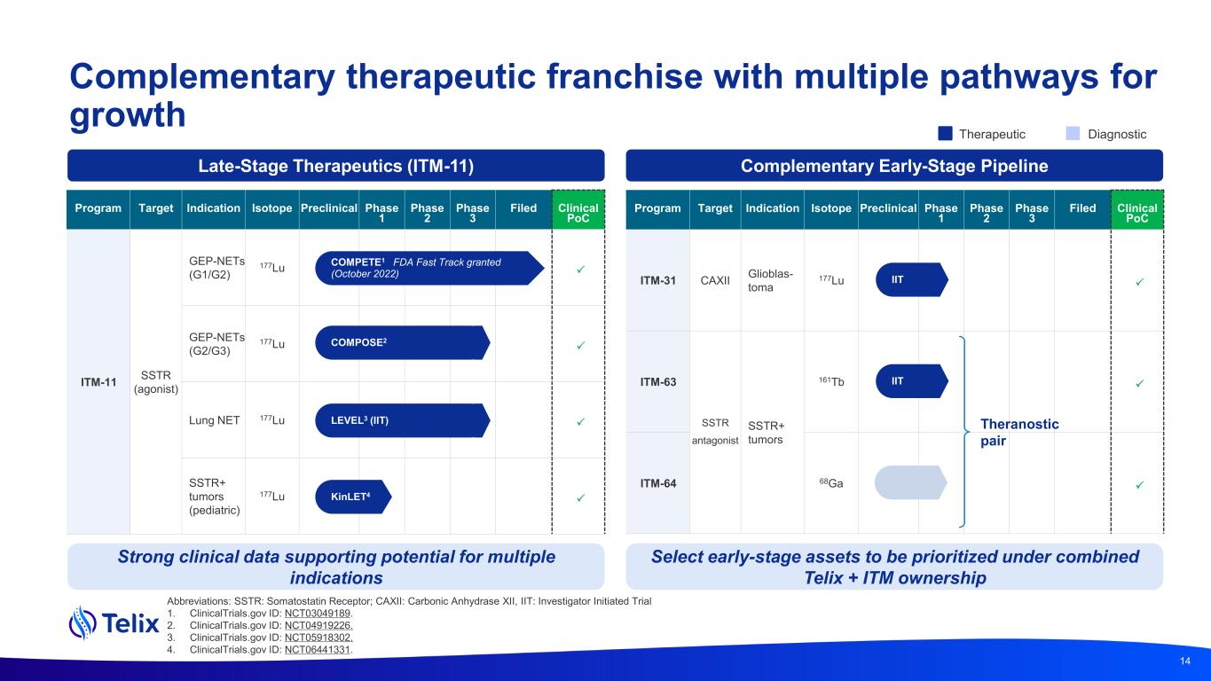
Abbreviations: SSTR: Somatostatin Receptor; CAXII: Carbonic Anhydrase XII, IIT: Investigator Initiated Trial 1. ClinicalTrials.gov ID: NCT03049189. 2. ClinicalTrials.gov ID: NCT04919226. 3. ClinicalTrials.gov ID: NCT05918302. 4. ClinicalTrials.gov ID: NCT06441331. Complementary therapeutic franchise with multiple pathways for growth Program Target Indication Isotope Preclinical Phase 1 Phase 2 Phase 3 Filed Clinical PoC ITM-31 CAXII Glioblas- toma 177Lu  ITM-63 SSTR antagonist SSTR+ tumors 161Tb  ITM-64 68Ga  Therapeutic Diagnostic Late-Stage Therapeutics (ITM-11) Complementary Early-Stage Pipeline COMPOSE LEVEL (ISS) COMPETE FDA Fast Track granted (October 2022) Program Target Indication Isotope Preclinical Phase 1 Phase 2 Phase 3 Filed Clinical PoC ITM-11 SSTR (agonist) GEP-NETs (G1/G2) 177Lu  GEP-NETs (G2/G3) 177Lu  Lung NET 177Lu  SSTR+ tumors (pediatric) 177Lu  COMPOSE2 LEVEL3 (IIT) COMPETE1 FDA Fast Track granted (October 2022) 14 IIT Theranostic pair IIT Strong clinical data supporting potential for multiple indications Select early-stage assets to be prioritized under combined Telix + ITM ownership KinLET4

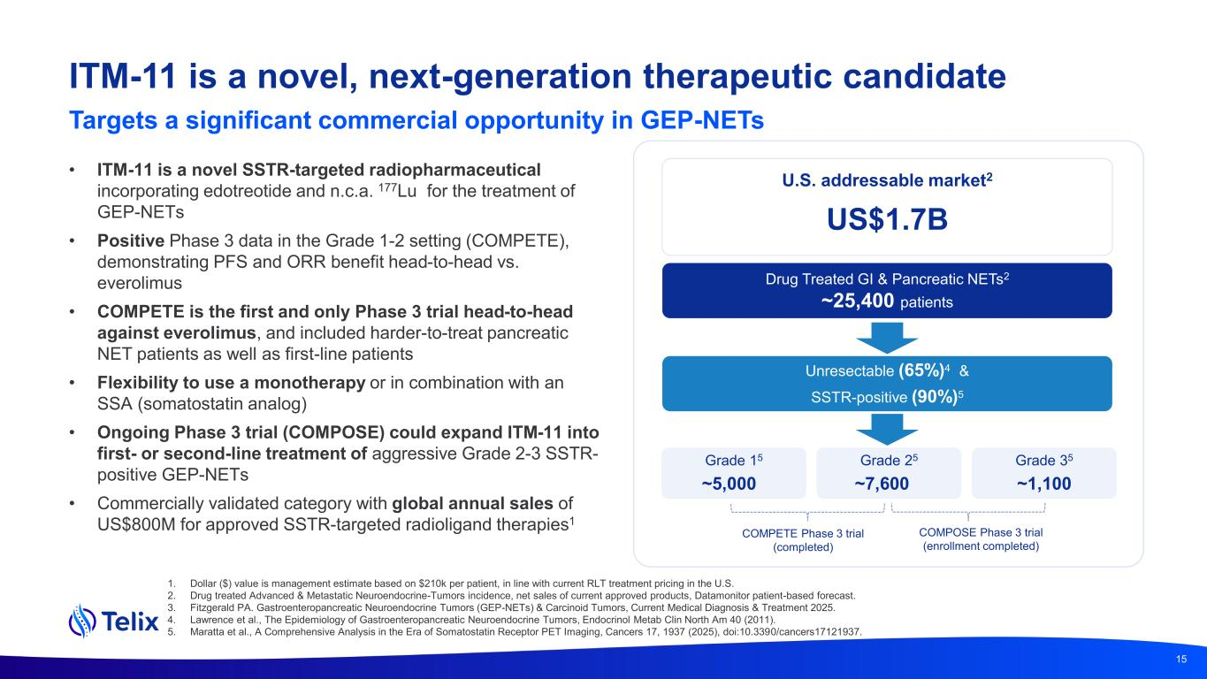
ITM-11 is a novel, next-generation therapeutic candidate Targets a significant commercial opportunity in GEP-NETs U.S. addressable market2 US$1.7B Grade 15 ~5,000 Grade 35 ~1,100 • ITM-11 is a novel SSTR-targeted radiopharmaceutical incorporating edotreotide and n.c.a. 177Lu for the treatment of GEP-NETs • Positive Phase 3 data in the Grade 1-2 setting (COMPETE), demonstrating PFS and ORR benefit head-to-head vs. everolimus • COMPETE is the first and only Phase 3 trial head-to-head against everolimus, and included harder-to-treat pancreatic NET patients as well as first-line patients • Flexibility to use a monotherapy or in combination with an SSA (somatostatin analog) • Ongoing Phase 3 trial (COMPOSE) could expand ITM-11 into first- or second-line treatment of aggressive Grade 2-3 SSTR- positive GEP-NETs • Commercially validated category with global annual sales of US$800M for approved SSTR-targeted radioligand therapies1 15 1. Dollar ($) value is management estimate based on $210k per patient, in line with current RLT treatment pricing in the U.S. 2. Drug treated Advanced & Metastatic Neuroendocrine-Tumors incidence, net sales of current approved products, Datamonitor patient-based forecast. 3. Fitzgerald PA. Gastroenteropancreatic Neuroendocrine Tumors (GEP-NETs) & Carcinoid Tumors, Current Medical Diagnosis & Treatment 2025. 4. Lawrence et al., The Epidemiology of Gastroenteropancreatic Neuroendocrine Tumors, Endocrinol Metab Clin North Am 40 (2011). 5. Maratta et al., A Comprehensive Analysis in the Era of Somatostatin Receptor PET Imaging, Cancers 17, 1937 (2025), doi:10.3390/cancers17121937. Unresectable (65%)4 & SSTR-positive (90%)5 COMPETE Phase 3 trial (completed) COMPOSE Phase 3 trial (enrollment completed) Drug Treated GI & Pancreatic NETs2 ~25,400 patients Grade 25 ~7,600

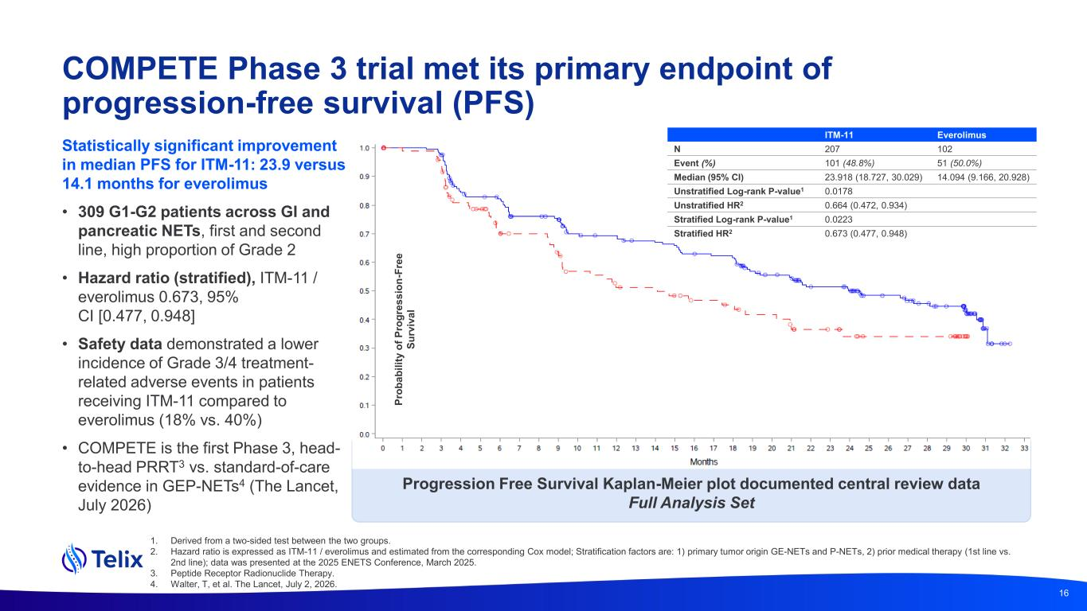
1. Derived from a two-sided test between the two groups. 2. Hazard ratio is expressed as ITM-11 / everolimus and estimated from the corresponding Cox model; Stratification factors are: 1) primary tumor origin GE-NETs and P-NETs, 2) prior medical therapy (1st line vs. 2nd line); data was presented at the 2025 ENETS Conference, March 2025. 3. Peptide Receptor Radionuclide Therapy. 4. Walter, T, et al. The Lancet, July 2, 2026. COMPETE Phase 3 trial met its primary endpoint of progression-free survival (PFS) Statistically significant improvement in median PFS for ITM-11: 23.9 versus 14.1 months for everolimus • 309 G1-G2 patients across GI and pancreatic NETs, first and second line, high proportion of Grade 2 • Hazard ratio (stratified), ITM-11 / everolimus 0.673, 95% CI [0.477, 0.948] • Safety data demonstrated a lower incidence of Grade 3/4 treatment- related adverse events in patients receiving ITM-11 compared to everolimus (18% vs. 40%) • COMPETE is the first Phase 3, head- to-head PRRT3 vs. standard-of-care evidence in GEP-NETs4 (The Lancet, July 2026) Progression Free Survival Kaplan-Meier plot documented central review data Full Analysis Set P ro b a b il it y o f P ro g re s s io n -F re e S u rv iv a l 16 ITM-11 Everolimus N 207 102 Event (%) 101 (48.8%) 51 (50.0%) Median (95% CI) 23.918 (18.727, 30.029) 14.094 (9.166, 20.928) Unstratified Log-rank P-value1 0.0178 Unstratified HR2 0.664 (0.472, 0.934) Stratified Log-rank P-value1 0.0223 Stratified HR2 0.673 (0.477, 0.948)

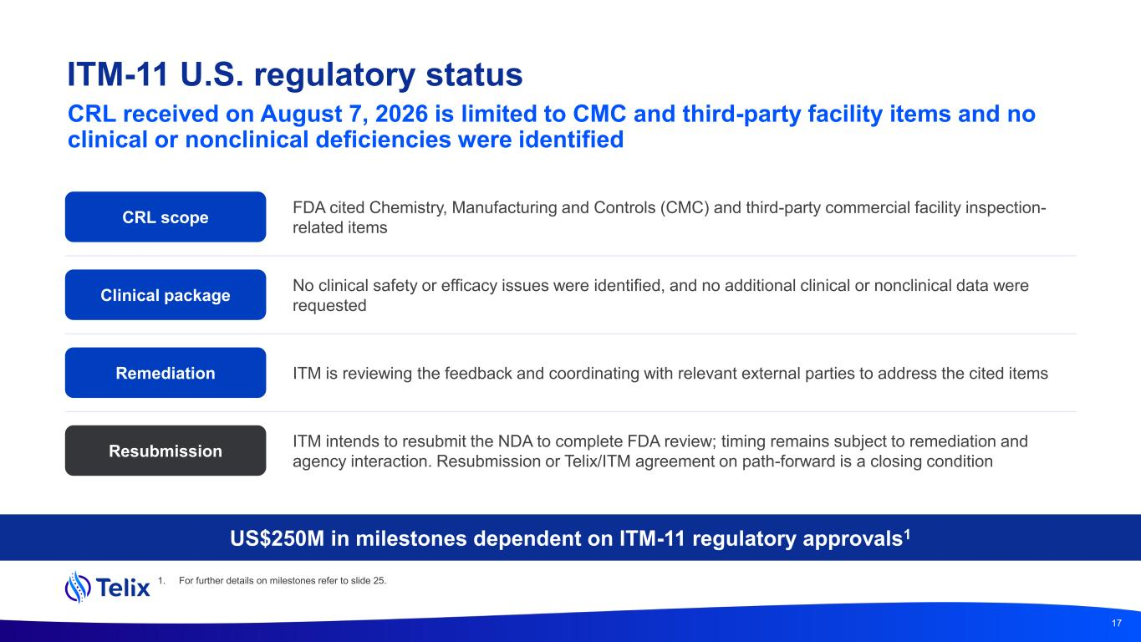
ITM-11 U.S. regulatory status CRL received on August 7, 2026 is limited to CMC and third-party facility items and no clinical or nonclinical deficiencies were identified CRL scope FDA cited Chemistry, Manufacturing and Controls (CMC) and third-party commercial facility inspection- related items Clinical package No clinical safety or efficacy issues were identified, and no additional clinical or nonclinical data were requested Remediation ITM is reviewing the feedback and coordinating with relevant external parties to address the cited items Resubmission ITM intends to resubmit the NDA to complete FDA review; timing remains subject to remediation and agency interaction. Resubmission or Telix/ITM agreement on path-forward is a closing condition US$250M in milestones dependent on ITM-11 regulatory approvals1 17 1. For further details on milestones refer to slide 25.

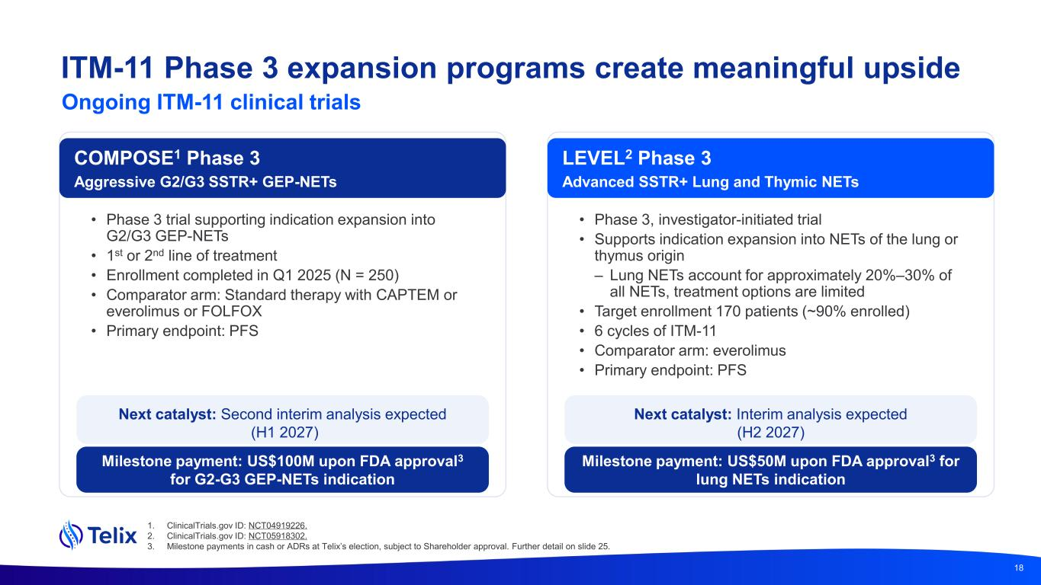
18 • Phase 3 trial supporting indication expansion into G2/G3 GEP-NETs • 1st or 2nd line of treatment • Enrollment completed in Q1 2025 (N = 250) • Comparator arm: Standard therapy with CAPTEM or everolimus or FOLFOX • Primary endpoint: PFS • Phase 3, investigator-initiated trial • Supports indication expansion into NETs of the lung or thymus origin – Lung NETs account for approximately 20%–30% of all NETs, treatment options are limited • Target enrollment 170 patients (~90% enrolled) • 6 cycles of ITM-11 • Comparator arm: everolimus • Primary endpoint: PFS COMPOSE1 Phase 3 Aggressive G2/G3 SSTR+ GEP-NETs LEVEL2 Phase 3 Advanced SSTR+ Lung and Thymic NETs Next catalyst: Second interim analysis expected (H1 2027) Next catalyst: Interim analysis expected (H2 2027) Milestone payment: US$100M upon FDA approval3 for G2-G3 GEP-NETs indication Milestone payment: US$50M upon FDA approval3 for lung NETs indication ITM-11 Phase 3 expansion programs create meaningful upside Ongoing ITM-11 clinical trials 1. ClinicalTrials.gov ID: NCT04919226. 2. ClinicalTrials.gov ID: NCT05918302. 3. Milestone payments in cash or ADRs at Telix’s election, subject to Shareholder approval. Further detail on slide 25.

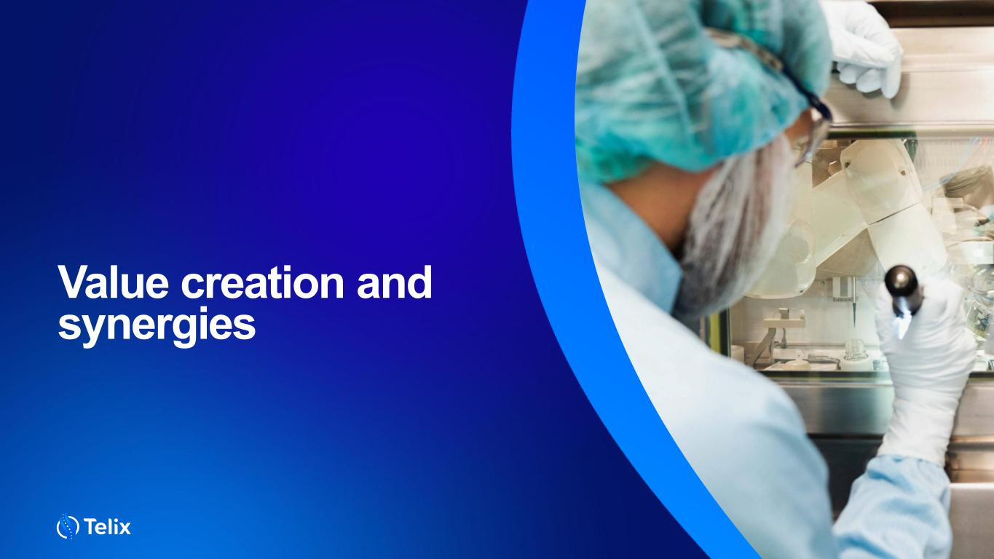
19 Value creation and synergies

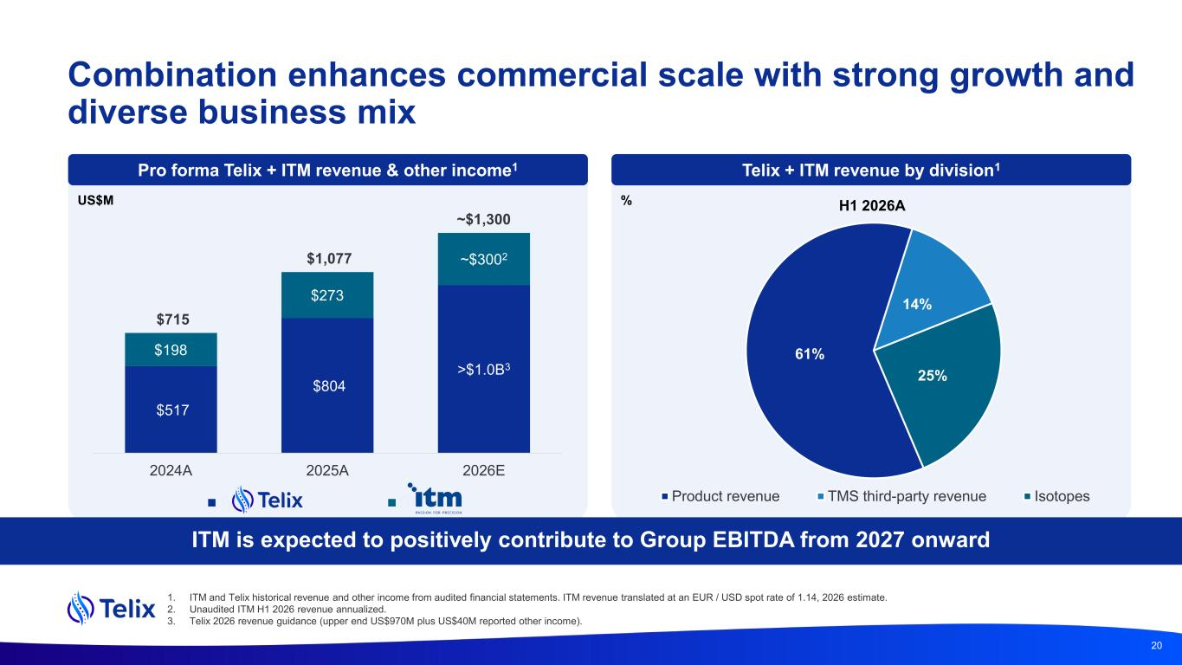
$517 $804 >$1.0B3 $198 $273 ~$3002 $715 $1,077 ~$1,300 2024A 2025A 2026E Telix ITM Combination enhances commercial scale with strong growth and diverse business mix 20 61% 14% 25% Product revenue TMS third-party revenue Isotopes Telix + ITM revenue by division1 (1) US$M ITM is expected to positively contribute to Group EBITDA from 2027 onward Pro forma Telix + ITM revenue & other income1 % H1 2026A 1. ITM and Telix historical revenue and other income from audited financial statements. ITM revenue translated at an EUR / USD spot rate of 1.14, 2026 estimate. 2. Unaudited ITM H1 2026 revenue annualized. 3. Telix 2026 revenue guidance (upper end US$970M plus US$40M reported other income).

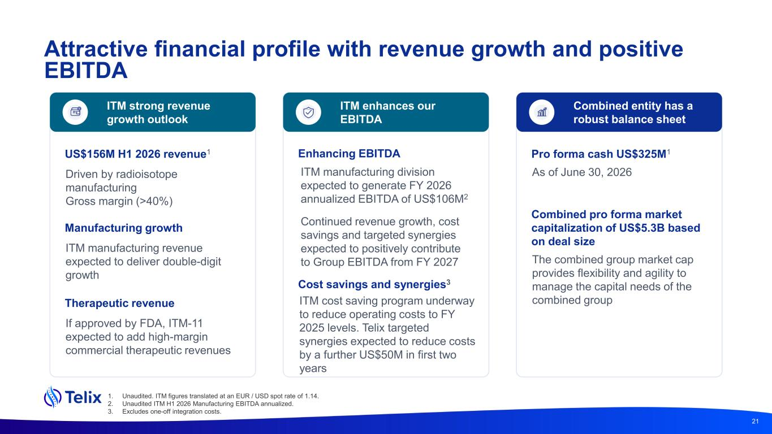
21 ITM strong revenue growth outlook US$156M H1 2026 revenue1 Driven by radioisotope manufacturing Gross margin (>40%) ITM enhances our EBITDA ITM manufacturing division expected to generate FY 2026 annualized EBITDA of US$106M2 Continued revenue growth, cost savings and targeted synergies expected to positively contribute to Group EBITDA from FY 2027 Manufacturing growth ITM manufacturing revenue expected to deliver double-digit growth Combined entity has a robust balance sheet Pro forma cash US$325M1 As of June 30, 2026 Combined pro forma market capitalization of US$5.3B based on deal size Therapeutic revenue If approved by FDA, ITM-11 expected to add high-margin commercial therapeutic revenues Enhancing EBITDA The combined group market cap provides flexibility and agility to manage the capital needs of the combined group 1. Unaudited. ITM figures translated at an EUR / USD spot rate of 1.14. 2. Unaudited ITM H1 2026 Manufacturing EBITDA annualized. 3. Excludes one-off integration costs. Cost savings and synergies3 ITM cost saving program underway to reduce operating costs to FY 2025 levels. Telix targeted synergies expected to reduce costs by a further US$50M in first two years Attractive financial profile with revenue growth and positive EBITDA

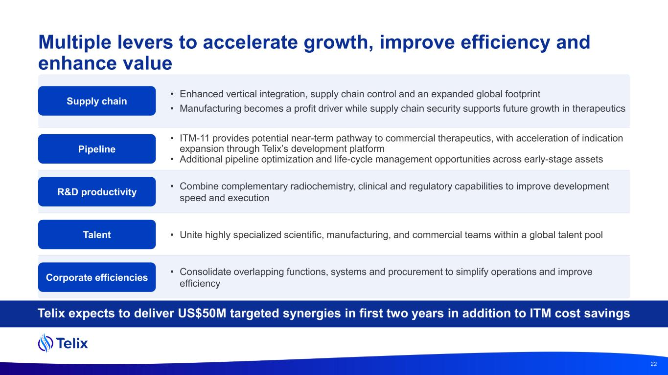
Multiple levers to accelerate growth, improve efficiency and enhance value Telix expects to deliver US$50M targeted synergies in first two years in addition to ITM cost savings 22 • Enhanced vertical integration, supply chain control and an expanded global footprint • Manufacturing becomes a profit driver while supply chain security supports future growth in therapeutics • ITM-11 provides potential near-term pathway to commercial therapeutics, with acceleration of indication expansion through Telix’s development platform • Additional pipeline optimization and life-cycle management opportunities across early-stage assets • Combine complementary radiochemistry, clinical and regulatory capabilities to improve development speed and execution • Unite highly specialized scientific, manufacturing, and commercial teams within a global talent pool • Consolidate overlapping functions, systems and procurement to simplify operations and improve efficiency Supply chain Pipeline R&D productivity Talent Corporate efficiencies

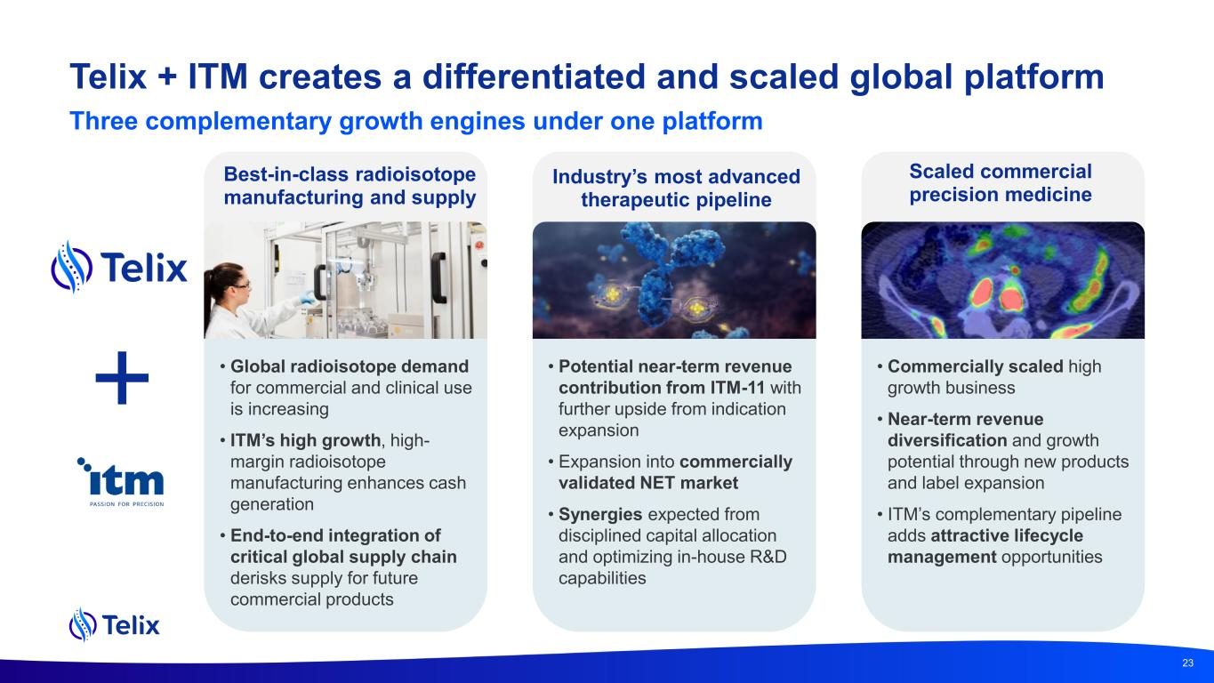
Telix + ITM creates a differentiated and scaled global platform Scaled commercial precision medicine Industry’s most advanced therapeutic pipeline Best-in-class radioisotope manufacturing and supply • Potential near-term revenue contribution from ITM-11 with further upside from indication expansion • Expansion into commercially validated NET market • Synergies expected from disciplined capital allocation and optimizing in-house R&D capabilities • Commercially scaled high growth business • Near-term revenue diversification and growth potential through new products and label expansion • ITM’s complementary pipeline adds attractive lifecycle management opportunities • Global radioisotope demand for commercial and clinical use is increasing • ITM’s high growth, high- margin radioisotope manufacturing enhances cash generation • End-to-end integration of critical global supply chain derisks supply for future commercial products 23 Three complementary growth engines under one platform


Key terms and financial statements

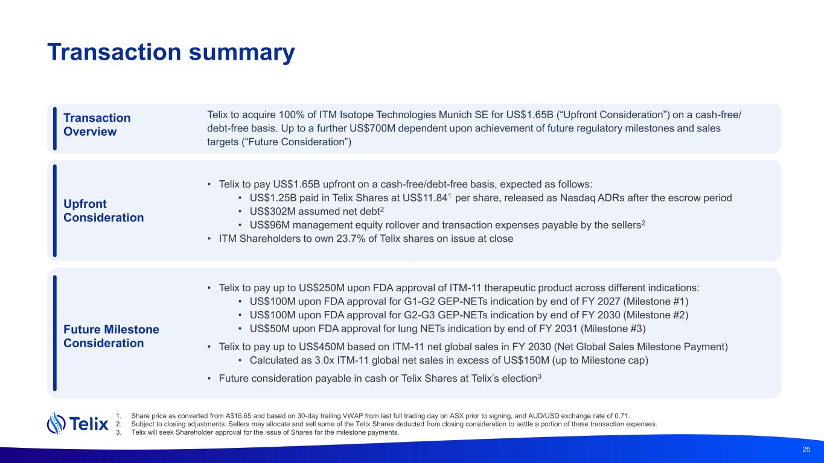
Transaction summary 1. Share price as converted from A$16.65 and based on 30-day trailing VWAP from last full trading day on ASX prior to signing, and AUD/USD exchange rate of 0.71. 2. Subject to closing adjustments. Sellers may allocate and sell some of the Telix Shares deducted from closing consideration to settle a portion of these transaction expenses. 3. Telix will seek Shareholder approval for the issue of Shares for the milestone payments. 25 Transaction Overview Telix to acquire 100% of ITM Isotope Technologies Munich SE for US$1.65B (“Upfront Consideration”) on a cash-free/ debt-free basis. Up to a further US$700M dependent upon achievement of future regulatory milestones and sales targets (“Future Consideration”) Future Milestone Consideration • Telix to pay up to US$250M upon FDA approval of ITM-11 therapeutic product across different indications: • US$100M upon FDA approval for G1-G2 GEP-NETs indication by end of FY 2027 (Milestone #1) • US$100M upon FDA approval for G2-G3 GEP-NETs indication by end of FY 2030 (Milestone #2) • US$50M upon FDA approval for lung NETs indication by end of FY 2031 (Milestone #3) • Telix to pay up to US$450M based on ITM-11 net global sales in FY 2030 (Net Global Sales Milestone Payment) • Calculated as 3.0x ITM-11 global net sales in excess of US$150M (up to Milestone cap) • Future consideration payable in cash or Telix Shares at Telix’s election3 Upfront Consideration • Telix to pay US$1.65B upfront on a cash-free/debt-free basis, expected as follows: • US$1.25B paid in Telix Shares at US$11.841 per share, released as Nasdaq ADRs after the escrow period • US$302M assumed net debt2 • US$96M management equity rollover and transaction expenses payable by the sellers2 • ITM Shareholders to own 23.7% of Telix shares on issue at close

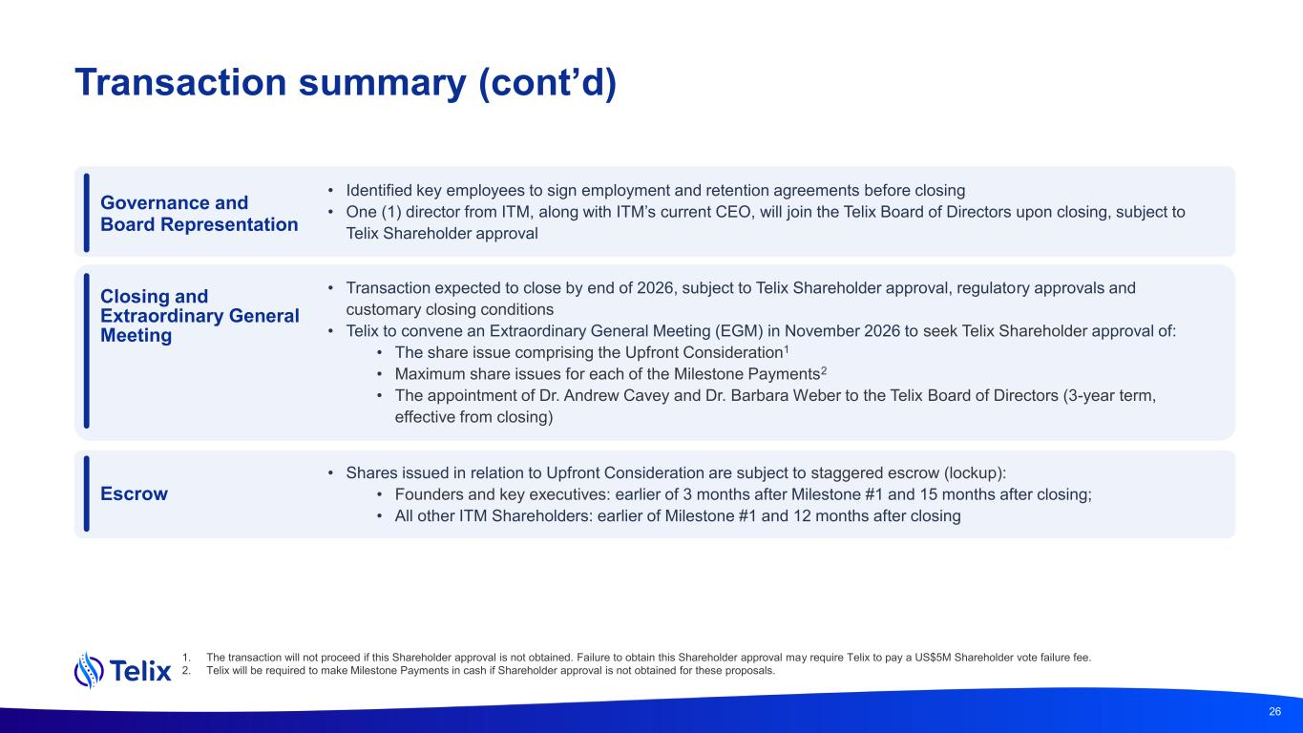
Transaction summary (cont’d) 1. The transaction will not proceed if this Shareholder approval is not obtained. Failure to obtain this Shareholder approval may require Telix to pay a US$5M Shareholder vote failure fee. 2. Telix will be required to make Milestone Payments in cash if Shareholder approval is not obtained for these proposals. 26 Closing and Extraordinary General Meeting • Transaction expected to close by end of 2026, subject to Telix Shareholder approval, regulatory approvals and customary closing conditions • Telix to convene an Extraordinary General Meeting (EGM) in November 2026 to seek Telix Shareholder approval of: • The share issue comprising the Upfront Consideration1 • Maximum share issues for each of the Milestone Payments2 • The appointment of Dr. Andrew Cavey and Dr. Barbara Weber to the Telix Board of Directors (3-year term, effective from closing) Escrow • Shares issued in relation to Upfront Consideration are subject to staggered escrow (lockup): • Founders and key executives: earlier of 3 months after Milestone #1 and 15 months after closing; • All other ITM Shareholders: earlier of Milestone #1 and 12 months after closing Governance and Board Representation • Identified key employees to sign employment and retention agreements before closing • One (1) director from ITM, along with ITM’s current CEO, will join the Telix Board of Directors upon closing, subject to Telix Shareholder approval

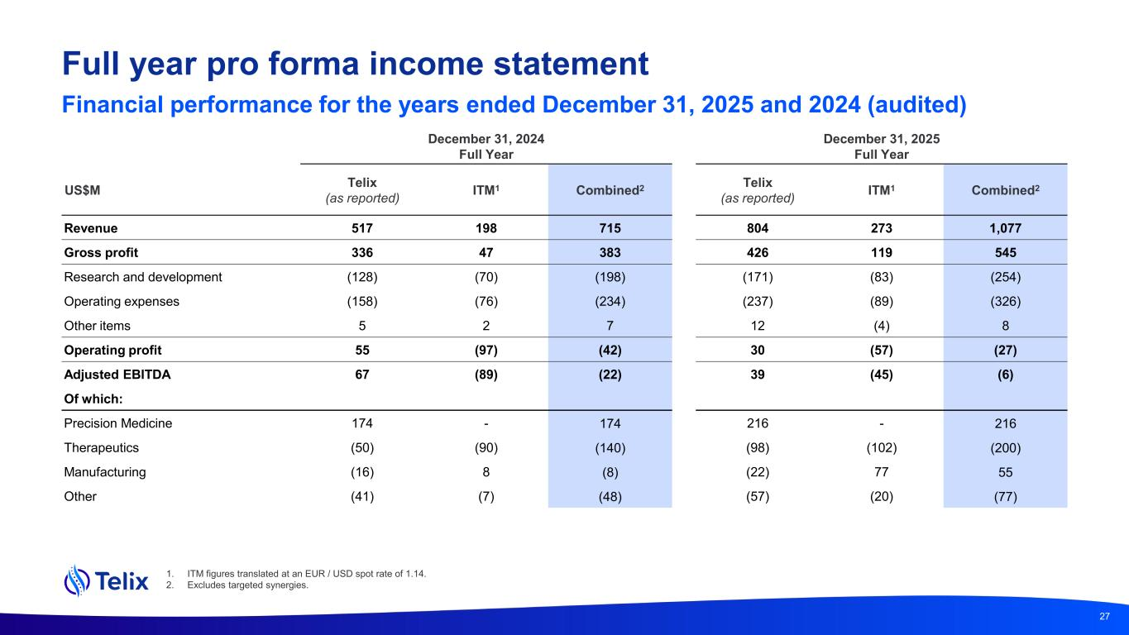
Full year pro forma income statement Financial performance for the years ended December 31, 2025 and 2024 (audited) December 31, 2024 Full Year December 31, 2025 Full Year US$M Telix (as reported) ITM1 Combined2 Telix (as reported) ITM1 Combined2 Revenue 517 198 715 804 273 1,077 Gross profit 336 47 383 426 119 545 Research and development (128) (70) (198) (171) (83) (254) Operating expenses (158) (76) (234) (237) (89) (326) Other items 5 2 7 12 (4) 8 Operating profit 55 (97) (42) 30 (57) (27) Adjusted EBITDA 67 (89) (22) 39 (45) (6) Of which: Precision Medicine 174 - 174 216 - 216 Therapeutics (50) (90) (140) (98) (102) (200) Manufacturing (16) 8 (8) (22) 77 55 Other (41) (7) (48) (57) (20) (77) 27 1. ITM figures translated at an EUR / USD spot rate of 1.14. 2. Excludes targeted synergies. 27

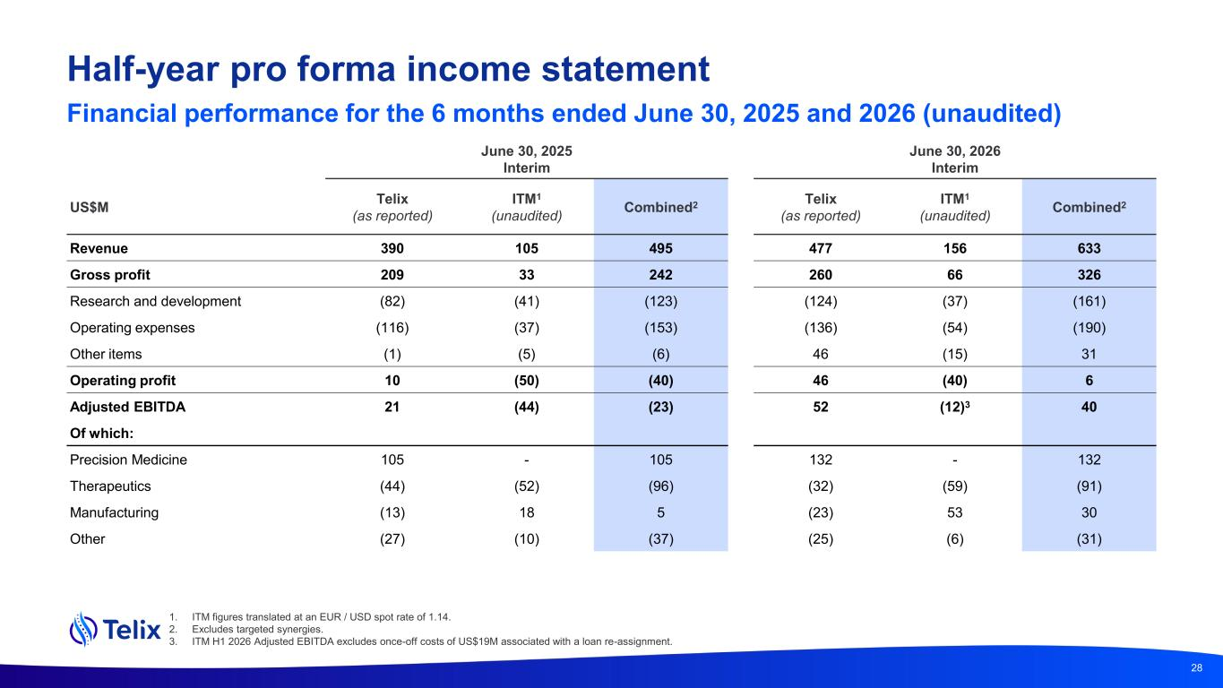
Half-year pro forma income statement Financial performance for the 6 months ended June 30, 2025 and 2026 (unaudited) June 30, 2025 Interim June 30, 2026 Interim US$M Telix (as reported) ITM1 (unaudited) Combined2 Telix (as reported) ITM1 (unaudited) Combined2 Revenue 390 105 495 477 156 633 Gross profit 209 33 242 260 66 326 Research and development (82) (41) (123) (124) (37) (161) Operating expenses (116) (37) (153) (136) (54) (190) Other items (1) (5) (6) 46 (15) 31 Operating profit 10 (50) (40) 46 (40) 6 Adjusted EBITDA 21 (44) (23) 52 (12)3 40 Of which: Precision Medicine 105 - 105 132 - 132 Therapeutics (44) (52) (96) (32) (59) (91) Manufacturing (13) 18 5 (23) 53 30 Other (27) (10) (37) (25) (6) (31) 28 1. ITM figures translated at an EUR / USD spot rate of 1.14. 2. Excludes targeted synergies. 3. ITM H1 2026 Adjusted EBITDA excludes once-off costs of US$19M associated with a loan re-assignment.

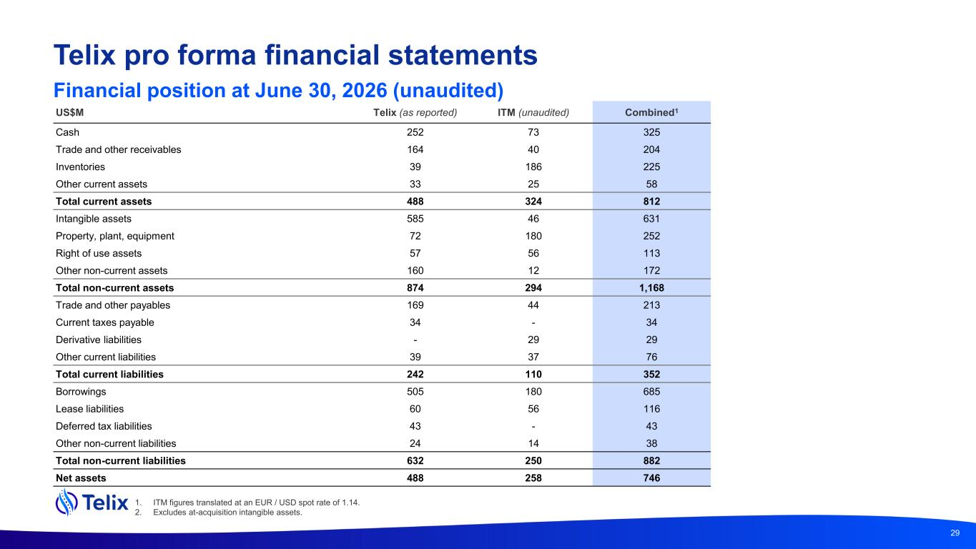
US$M Telix (as reported) ITM (unaudited) Combined1 Cash 252 73 325 Trade and other receivables 164 40 204 Inventories 39 186 225 Other current assets 33 25 58 Total current assets 488 324 812 Intangible assets 585 46 631 Property, plant, equipment 72 180 252 Right of use assets 57 56 113 Other non-current assets 160 12 172 Total non-current assets 874 294 1,168 Trade and other payables 169 44 213 Current taxes payable 34 - 34 Derivative liabilities - 29 29 Other current liabilities 39 37 76 Total current liabilities 242 110 352 Borrowings 505 180 685 Lease liabilities 60 56 116 Deferred tax liabilities 43 - 43 Other non-current liabilities 24 14 38 Total non-current liabilities 632 250 882 Net assets 488 258 746 29 1. ITM figures translated at an EUR / USD spot rate of 1.14. 2. Excludes at-acquisition intangible assets. Telix pro forma financial statements Financial position at June 30, 2026 (unaudited)

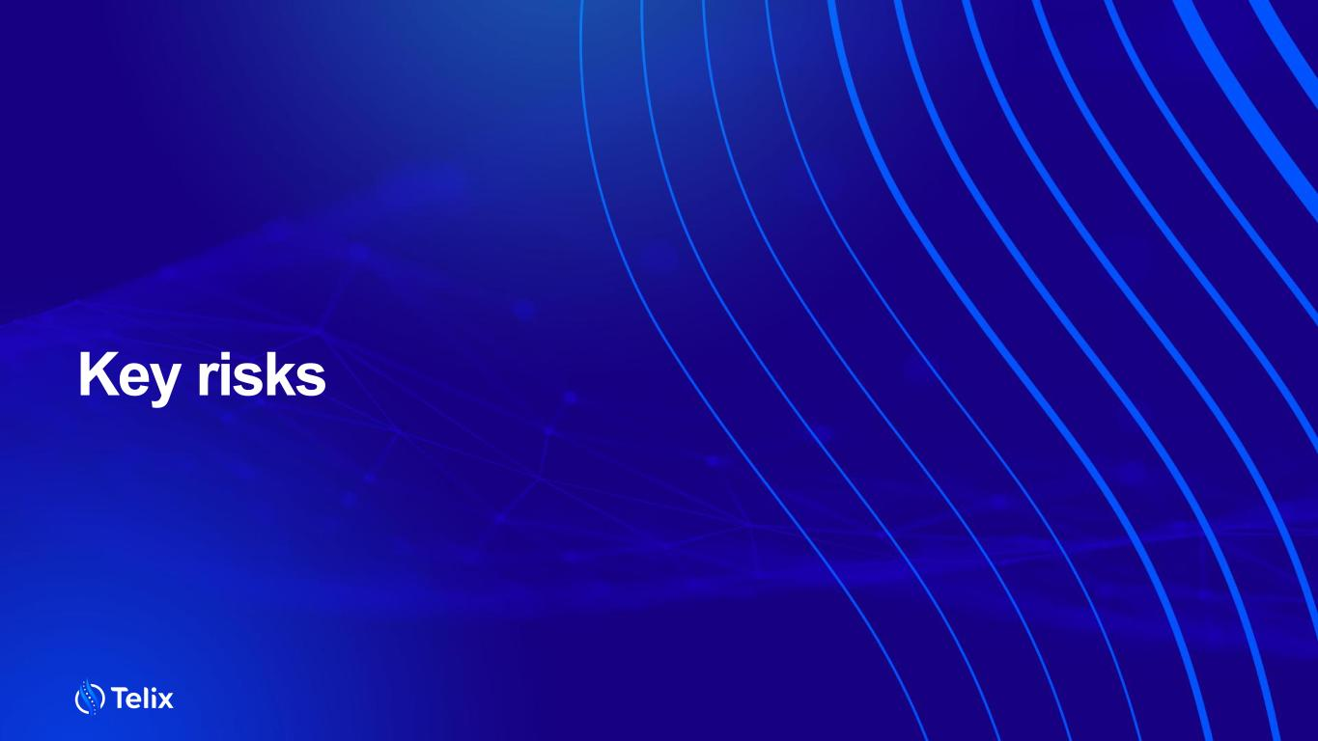
Key risks

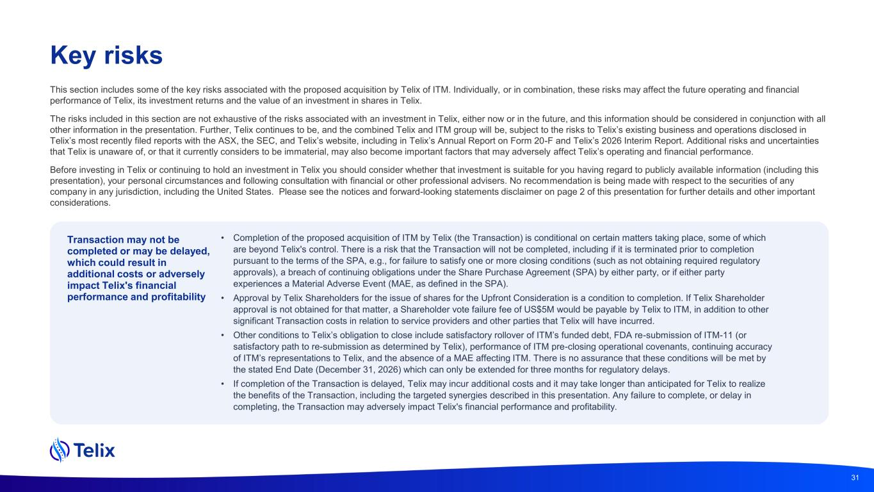
Key risks Transaction may not be completed or may be delayed, which could result in additional costs or adversely impact Telix's financial performance and profitability • Completion of the proposed acquisition of ITM by Telix (the Transaction) is conditional on certain matters taking place, some of which are beyond Telix's control. There is a risk that the Transaction will not be completed, including if it is terminated prior to completion pursuant to the terms of the SPA, e.g., for failure to satisfy one or more closing conditions (such as not obtaining required regulatory approvals), a breach of continuing obligations under the Share Purchase Agreement (SPA) by either party, or if either party experiences a Material Adverse Event (MAE, as defined in the SPA). • Approval by Telix Shareholders for the issue of shares for the Upfront Consideration is a condition to completion. If Telix Shareholder approval is not obtained for that matter, a Shareholder vote failure fee of US$5M would be payable by Telix to ITM, in addition to other significant Transaction costs in relation to service providers and other parties that Telix will have incurred. • Other conditions to Telix’s obligation to close include satisfactory rollover of ITM’s funded debt, FDA re-submission of ITM-11 (or satisfactory path to re-submission as determined by Telix), performance of ITM pre-closing operational covenants, continuing accuracy of ITM’s representations to Telix, and the absence of a MAE affecting ITM. There is no assurance that these conditions will be met by the stated End Date (December 31, 2026) which can only be extended for three months for regulatory delays. • If completion of the Transaction is delayed, Telix may incur additional costs and it may take longer than anticipated for Telix to realize the benefits of the Transaction, including the targeted synergies described in this presentation. Any failure to complete, or delay in completing, the Transaction may adversely impact Telix's financial performance and profitability. 31 This section includes some of the key risks associated with the proposed acquisition by Telix of ITM. Individually, or in combination, these risks may affect the future operating and financial performance of Telix, its investment returns and the value of an investment in shares in Telix. The risks included in this section are not exhaustive of the risks associated with an investment in Telix, either now or in the future, and this information should be considered in conjunction with all other information in the presentation. Further, Telix continues to be, and the combined Telix and ITM group will be, subject to the risks to Telix’s existing business and operations disclosed in Telix’s most recently filed reports with the ASX, the SEC, and Telix’s website, including in Telix’s Annual Report on Form 20-F and Telix’s 2026 Interim Report. Additional risks and uncertainties that Telix is unaware of, or that it currently considers to be immaterial, may also become important factors that may adversely affect Telix’s operating and financial performance. Before investing in Telix or continuing to hold an investment in Telix you should consider whether that investment is suitable for you having regard to publicly available information (including this presentation), your personal circumstances and following consultation with financial or other professional advisers. No recommendation is being made with respect to the securities of any company in any jurisdiction, including the United States. Please see the notices and forward-looking statements disclaimer on page 2 of this presentation for further details and other important considerations.

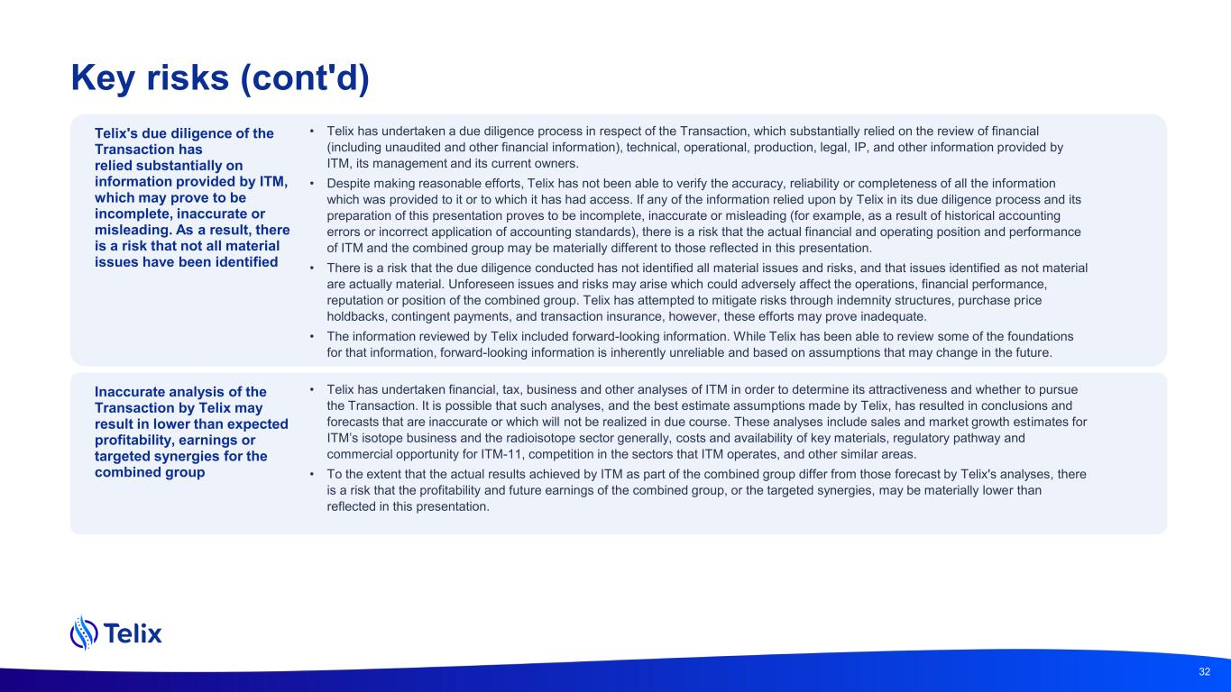
Key risks (cont'd) Telix's due diligence of the Transaction has relied substantially on information provided by ITM, which may prove to be incomplete, inaccurate or misleading. As a result, there is a risk that not all material issues have been identified • Telix has undertaken a due diligence process in respect of the Transaction, which substantially relied on the review of financial (including unaudited and other financial information), technical, operational, production, legal, IP, and other information provided by ITM, its management and its current owners. • Despite making reasonable efforts, Telix has not been able to verify the accuracy, reliability or completeness of all the information which was provided to it or to which it has had access. If any of the information relied upon by Telix in its due diligence process and its preparation of this presentation proves to be incomplete, inaccurate or misleading (for example, as a result of historical accounting errors or incorrect application of accounting standards), there is a risk that the actual financial and operating position and performance of ITM and the combined group may be materially different to those reflected in this presentation. • There is a risk that the due diligence conducted has not identified all material issues and risks, and that issues identified as not material are actually material. Unforeseen issues and risks may arise which could adversely affect the operations, financial performance, reputation or position of the combined group. Telix has attempted to mitigate risks through indemnity structures, purchase price holdbacks, contingent payments, and transaction insurance, however, these efforts may prove inadequate. • The information reviewed by Telix included forward-looking information. While Telix has been able to review some of the foundations for that information, forward-looking information is inherently unreliable and based on assumptions that may change in the future. 32 Inaccurate analysis of the Transaction by Telix may result in lower than expected profitability, earnings or targeted synergies for the combined group • Telix has undertaken financial, tax, business and other analyses of ITM in order to determine its attractiveness and whether to pursue the Transaction. It is possible that such analyses, and the best estimate assumptions made by Telix, has resulted in conclusions and forecasts that are inaccurate or which will not be realized in due course. These analyses include sales and market growth estimates for ITM’s isotope business and the radioisotope sector generally, costs and availability of key materials, regulatory pathway and commercial opportunity for ITM-11, competition in the sectors that ITM operates, and other similar areas. • To the extent that the actual results achieved by ITM as part of the combined group differ from those forecast by Telix's analyses, there is a risk that the profitability and future earnings of the combined group, or the targeted synergies, may be materially lower than reflected in this presentation.

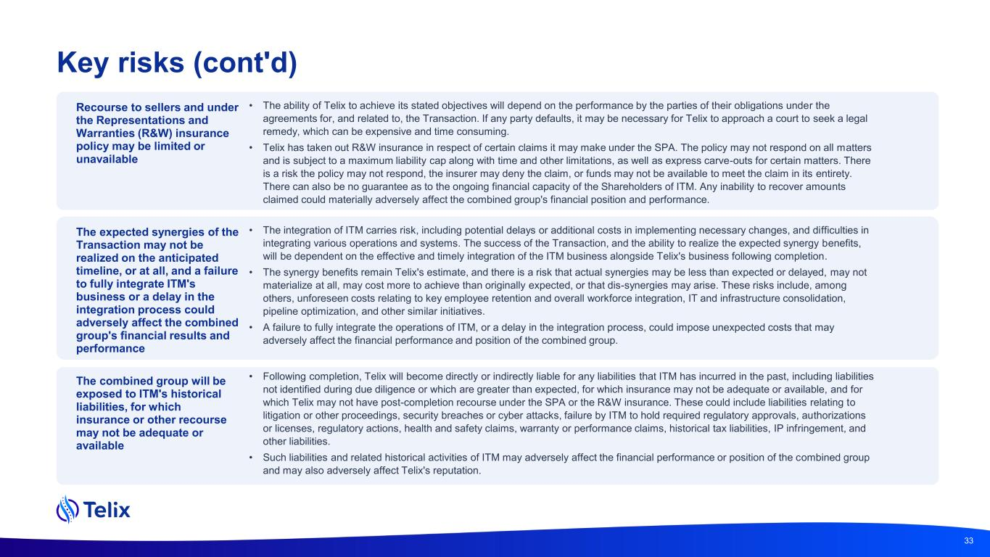
Key risks (cont'd) Recourse to sellers and under the Representations and Warranties (R&W) insurance policy may be limited or unavailable • The ability of Telix to achieve its stated objectives will depend on the performance by the parties of their obligations under the agreements for, and related to, the Transaction. If any party defaults, it may be necessary for Telix to approach a court to seek a legal remedy, which can be expensive and time consuming. • Telix has taken out R&W insurance in respect of certain claims it may make under the SPA. The policy may not respond on all matters and is subject to a maximum liability cap along with time and other limitations, as well as express carve-outs for certain matters. There is a risk the policy may not respond, the insurer may deny the claim, or funds may not be available to meet the claim in its entirety. There can also be no guarantee as to the ongoing financial capacity of the Shareholders of ITM. Any inability to recover amounts claimed could materially adversely affect the combined group's financial position and performance. The expected synergies of the Transaction may not be realized on the anticipated timeline, or at all, and a failure to fully integrate ITM's business or a delay in the integration process could adversely affect the combined group's financial results and performance • The integration of ITM carries risk, including potential delays or additional costs in implementing necessary changes, and difficulties in integrating various operations and systems. The success of the Transaction, and the ability to realize the expected synergy benefits, will be dependent on the effective and timely integration of the ITM business alongside Telix's business following completion. • The synergy benefits remain Telix's estimate, and there is a risk that actual synergies may be less than expected or delayed, may not materialize at all, may cost more to achieve than originally expected, or that dis-synergies may arise. These risks include, among others, unforeseen costs relating to key employee retention and overall workforce integration, IT and infrastructure consolidation, pipeline optimization, and other similar initiatives. • A failure to fully integrate the operations of ITM, or a delay in the integration process, could impose unexpected costs that may adversely affect the financial performance and position of the combined group. 33 The combined group will be exposed to ITM's historical liabilities, for which insurance or other recourse may not be adequate or available • Following completion, Telix will become directly or indirectly liable for any liabilities that ITM has incurred in the past, including liabilities not identified during due diligence or which are greater than expected, for which insurance may not be adequate or available, and for which Telix may not have post-completion recourse under the SPA or the R&W insurance. These could include liabilities relating to litigation or other proceedings, security breaches or cyber attacks, failure by ITM to hold required regulatory approvals, authorizations or licenses, regulatory actions, health and safety claims, warranty or performance claims, historical tax liabilities, IP infringement, and other liabilities. • Such liabilities and related historical activities of ITM may adversely affect the financial performance or position of the combined group and may also adversely affect Telix's reputation.

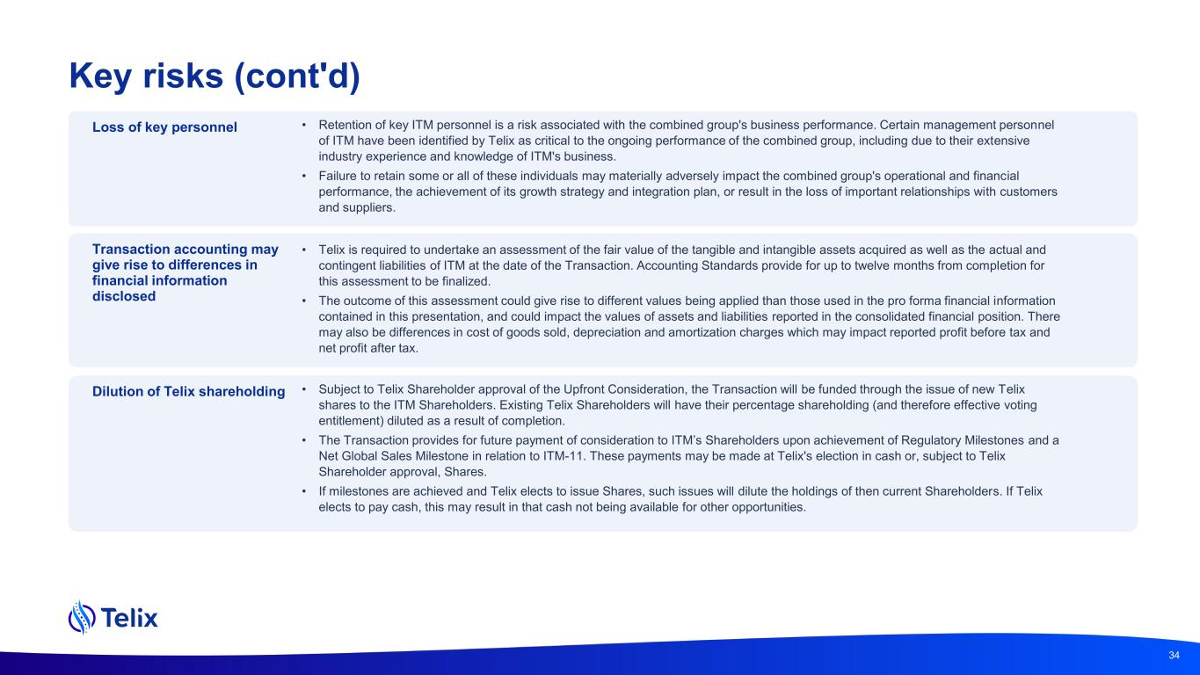
Key risks (cont'd) Loss of key personnel • Retention of key ITM personnel is a risk associated with the combined group's business performance. Certain management personnel of ITM have been identified by Telix as critical to the ongoing performance of the combined group, including due to their extensive industry experience and knowledge of ITM's business. • Failure to retain some or all of these individuals may materially adversely impact the combined group's operational and financial performance, the achievement of its growth strategy and integration plan, or result in the loss of important relationships with customers and suppliers. Transaction accounting may give rise to differences in financial information disclosed • Telix is required to undertake an assessment of the fair value of the tangible and intangible assets acquired as well as the actual and contingent liabilities of ITM at the date of the Transaction. Accounting Standards provide for up to twelve months from completion for this assessment to be finalized. • The outcome of this assessment could give rise to different values being applied than those used in the pro forma financial information contained in this presentation, and could impact the values of assets and liabilities reported in the consolidated financial position. There may also be differences in cost of goods sold, depreciation and amortization charges which may impact reported profit before tax and net profit after tax. Dilution of Telix shareholding • Subject to Telix Shareholder approval of the Upfront Consideration, the Transaction will be funded through the issue of new Telix shares to the ITM Shareholders. Existing Telix Shareholders will have their percentage shareholding (and therefore effective voting entitlement) diluted as a result of completion. • The Transaction provides for future payment of consideration to ITM’s Shareholders upon achievement of Regulatory Milestones and a Net Global Sales Milestone in relation to ITM-11. These payments may be made at Telix's election in cash or, subject to Telix Shareholder approval, Shares. • If milestones are achieved and Telix elects to issue Shares, such issues will dilute the holdings of then current Shareholders. If Telix elects to pay cash, this may result in that cash not being available for other opportunities. 34

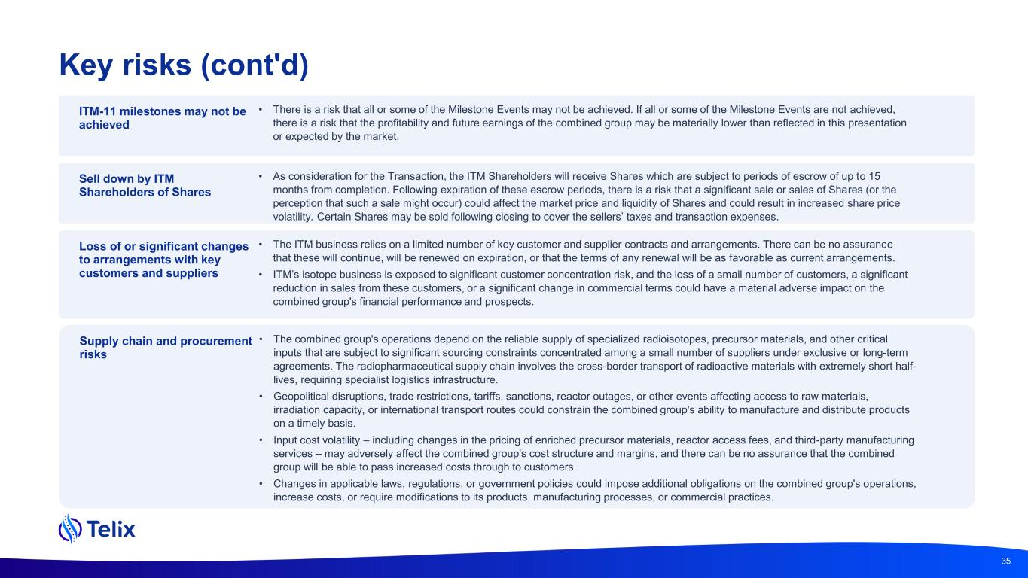
Key risks (cont'd) ITM-11 milestones may not be achieved • There is a risk that all or some of the Milestone Events may not be achieved. If all or some of the Milestone Events are not achieved, there is a risk that the profitability and future earnings of the combined group may be materially lower than reflected in this presentation or expected by the market. Sell down by ITM Shareholders of Shares • As consideration for the Transaction, the ITM Shareholders will receive Shares which are subject to periods of escrow of up to 15 months from completion. Following expiration of these escrow periods, there is a risk that a significant sale or sales of Shares (or the perception that such a sale might occur) could affect the market price and liquidity of Shares and could result in increased share price volatility. Certain Shares may be sold following closing to cover the sellers’ taxes and transaction expenses. Loss of or significant changes to arrangements with key customers and suppliers • The ITM business relies on a limited number of key customer and supplier contracts and arrangements. There can be no assurance that these will continue, will be renewed on expiration, or that the terms of any renewal will be as favorable as current arrangements. • ITM’s isotope business is exposed to significant customer concentration risk, and the loss of a small number of customers, a significant reduction in sales from these customers, or a significant change in commercial terms could have a material adverse impact on the combined group's financial performance and prospects. 35 Supply chain and procurement risks • The combined group's operations depend on the reliable supply of specialized radioisotopes, precursor materials, and other critical inputs that are subject to significant sourcing constraints concentrated among a small number of suppliers under exclusive or long-term agreements. The radiopharmaceutical supply chain involves the cross-border transport of radioactive materials with extremely short half- lives, requiring specialist logistics infrastructure. • Geopolitical disruptions, trade restrictions, tariffs, sanctions, reactor outages, or other events affecting access to raw materials, irradiation capacity, or international transport routes could constrain the combined group's ability to manufacture and distribute products on a timely basis. • Input cost volatility – including changes in the pricing of enriched precursor materials, reactor access fees, and third-party manufacturing services – may adversely affect the combined group's cost structure and margins, and there can be no assurance that the combined group will be able to pass increased costs through to customers. • Changes in applicable laws, regulations, or government policies could impose additional obligations on the combined group's operations, increase costs, or require modifications to its products, manufacturing processes, or commercial practices.

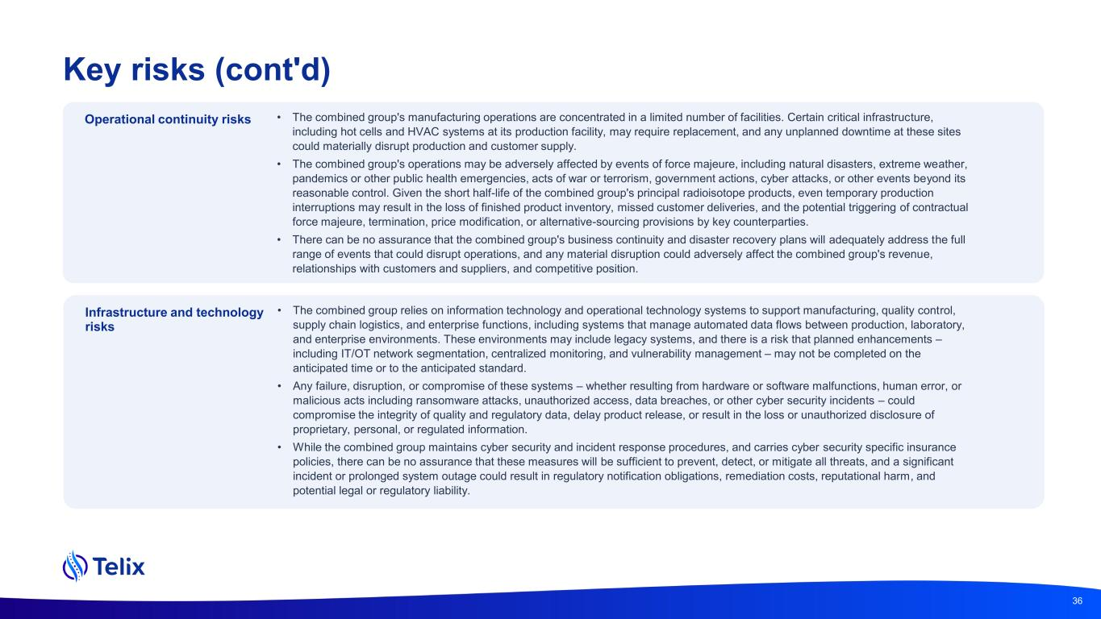
Key risks (cont'd) Operational continuity risks • The combined group's manufacturing operations are concentrated in a limited number of facilities. Certain critical infrastructure, including hot cells and HVAC systems at its production facility, may require replacement, and any unplanned downtime at these sites could materially disrupt production and customer supply. • The combined group's operations may be adversely affected by events of force majeure, including natural disasters, extreme weather, pandemics or other public health emergencies, acts of war or terrorism, government actions, cyber attacks, or other events beyond its reasonable control. Given the short half-life of the combined group's principal radioisotope products, even temporary production interruptions may result in the loss of finished product inventory, missed customer deliveries, and the potential triggering of contractual force majeure, termination, price modification, or alternative-sourcing provisions by key counterparties. • There can be no assurance that the combined group's business continuity and disaster recovery plans will adequately address the full range of events that could disrupt operations, and any material disruption could adversely affect the combined group's revenue, relationships with customers and suppliers, and competitive position. 36 Infrastructure and technology risks • The combined group relies on information technology and operational technology systems to support manufacturing, quality control, supply chain logistics, and enterprise functions, including systems that manage automated data flows between production, laboratory, and enterprise environments. These environments may include legacy systems, and there is a risk that planned enhancements – including IT/OT network segmentation, centralized monitoring, and vulnerability management – may not be completed on the anticipated time or to the anticipated standard. • Any failure, disruption, or compromise of these systems – whether resulting from hardware or software malfunctions, human error, or malicious acts including ransomware attacks, unauthorized access, data breaches, or other cyber security incidents – could compromise the integrity of quality and regulatory data, delay product release, or result in the loss or unauthorized disclosure of proprietary, personal, or regulated information. • While the combined group maintains cyber security and incident response procedures, and carries cyber security specific insurance policies, there can be no assurance that these measures will be sufficient to prevent, detect, or mitigate all threats, and a significant incident or prolonged system outage could result in regulatory notification obligations, remediation costs, reputational harm, and potential legal or regulatory liability.

