UNITED STATES
SECURITIES AND EXCHANGE COMMISSION
Washington, D.C. 20549

FORM 6-K

REPORT OF FOREIGN PRIVATE ISSUER
PURSUANT TO RULE 13a-16 OR 15d-16 OF
THE SECURITIES EXCHANGE ACT OF 1934

For the month of September, 2026

Commission File Number: 001-42128

Telix Pharmaceuticals Limited
(Translation of registrant’s name into English)

55 Flemington Road
North Melbourne, Victoria 3051, Australia
(Address of principal executive offices)

Indicate by check mark whether the registrant files or will file annual reports under cover of Form 20-F or
Form 40-F.

Form 20-F ☒ Form 40-F ☐

INFORMATION CONTAINED IN THIS FORM 6-K REPORT

On September 14, 2026 (Melbourne, Australia), Telix Pharmaceuticals Limited filed an announcement
with the Australian Securities Exchange titled “FDA Approves Telix’s Brain Cancer Imaging Drug Pixclara,”
a copy of which is attached to this Form 6-K as Exhibit 99.1.

99.1
Press release – September 14, 2026
SIGNATURES

Pursuant to the requirements of the Securities Exchange Act of 1934, the registrant has duly caused this
report to be signed on its behalf by the undersigned, thereunto duly authorized.

Date
:

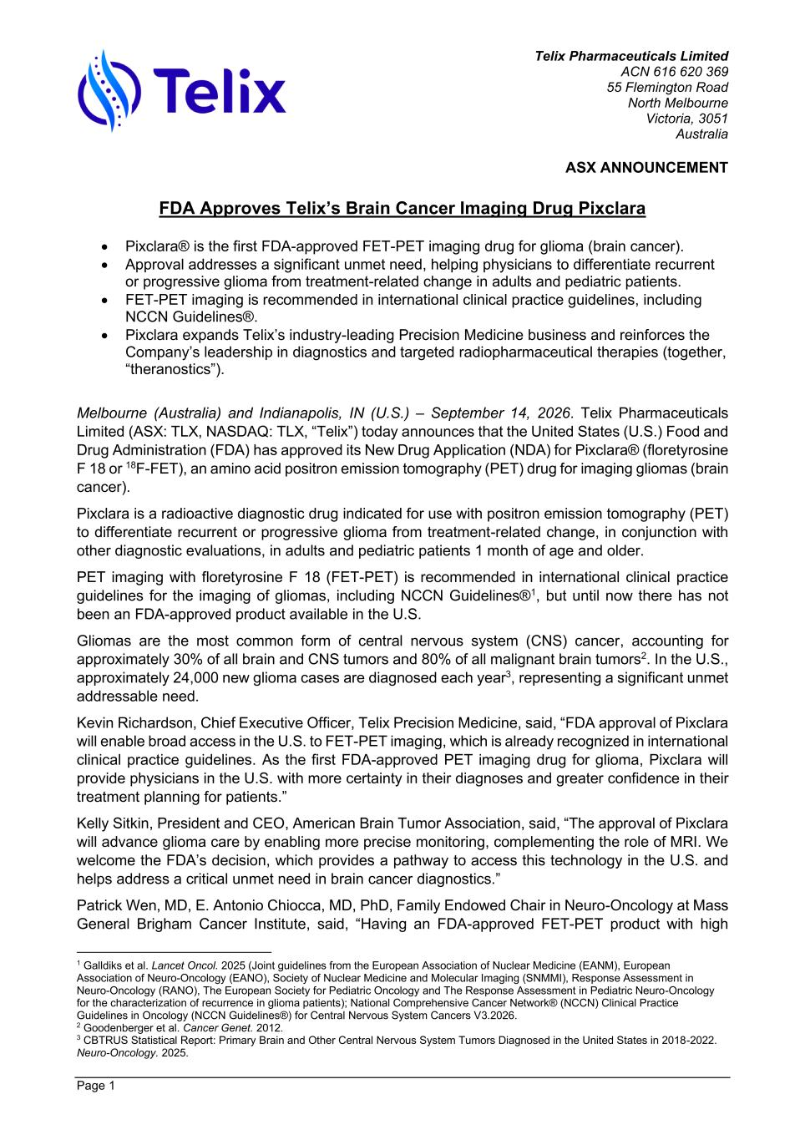
Telix Pharmaceuticals Limited ACN 616 620 369 55 Flemington Road North Melbourne Victoria, 3051 Australia ASX ANNOUNCEMENT Page 1 FDA Approves Telix’s Brain Cancer Imaging Drug Pixclara • Pixclara® is the first FDA-approved FET-PET imaging drug for glioma (brain cancer). • Approval addresses a significant unmet need, helping physicians to differentiate recurrent or progressive glioma from treatment-related change in adults and pediatric patients. • FET-PET imaging is recommended in international clinical practice guidelines, including NCCN Guidelines®. • Pixclara expands Telix’s industry-leading Precision Medicine business and reinforces the Company’s leadership in diagnostics and targeted radiopharmaceutical therapies (together, “theranostics”). Melbourne (Australia) and Indianapolis, IN (U.S.) – September 14, 2026. Telix Pharmaceuticals Limited (ASX: TLX, NASDAQ: TLX, “Telix”) today announces that the United States (U.S.) Food and Drug Administration (FDA) has approved its New Drug Application (NDA) for Pixclara® (floretyrosine F 18 or 18F-FET), an amino acid positron emission tomography (PET) drug for imaging gliomas (brain cancer). Pixclara is a radioactive diagnostic drug indicated for use with positron emission tomography (PET) to differentiate recurrent or progressive glioma from treatment-related change, in conjunction with other diagnostic evaluations, in adults and pediatric patients 1 month of age and older. PET imaging with floretyrosine F 18 (FET-PET) is recommended in international clinical practice guidelines for the imaging of gliomas, including NCCN Guidelines®1, but until now there has not been an FDA-approved product available in the U.S. Gliomas are the most common form of central nervous system (CNS) cancer, accounting for approximately 30% of all brain and CNS tumors and 80% of all malignant brain tumors2. In the U.S., approximately 24,000 new glioma cases are diagnosed each year3, representing a significant unmet addressable need. Kevin Richardson, Chief Executive Officer, Telix Precision Medicine, said, “FDA approval of Pixclara will enable broad access in the U.S. to FET-PET imaging, which is already recognized in international clinical practice guidelines. As the first FDA-approved PET imaging drug for glioma, Pixclara will provide physicians in the U.S. with more certainty in their diagnoses and greater confidence in their treatment planning for patients.” Kelly Sitkin, President and CEO, American Brain Tumor Association, said, “The approval of Pixclara will advance glioma care by enabling more precise monitoring, complementing the role of MRI. We welcome the FDA’s decision, which provides a pathway to access this technology in the U.S. and helps address a critical unmet need in brain cancer diagnostics.” Patrick Wen, MD, E. Antonio Chiocca, MD, PhD, Family Endowed Chair in Neuro-Oncology at Mass General Brigham Cancer Institute, said, “Having an FDA-approved FET-PET product with high 1 Galldiks et al. Lancet Oncol. 2025 (Joint guidelines from the European Association of Nuclear Medicine (EANM), European Association of Neuro-Oncology (EANO), Society of Nuclear Medicine and Molecular Imaging (SNMMI), Response Assessment in Neuro-Oncology (RANO), The European Society for Pediatric Oncology and The Response Assessment in Pediatric Neuro-Oncology for the characterization of recurrence in glioma patients); National Comprehensive Cancer Network® (NCCN) Clinical Practice Guidelines in Oncology (NCCN Guidelines®) for Central Nervous System Cancers V3.2026. 2 Goodenberger et al. Cancer Genet. 2012. 3 CBTRUS Statistical Report: Primary Brain and Other Central Nervous System Tumors Diagnosed in the United States in 2018-2022. Neuro-Oncology. 2025.

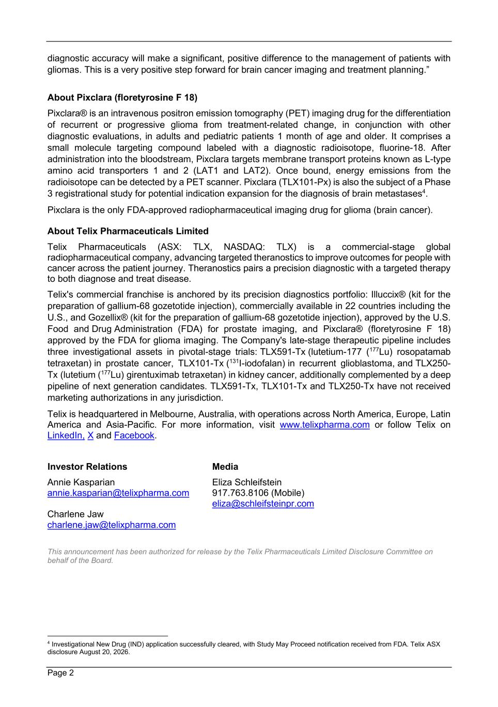
Page 2 diagnostic accuracy will make a significant, positive difference to the management of patients with gliomas. This is a very positive step forward for brain cancer imaging and treatment planning.” About Pixclara (floretyrosine F 18) Pixclara® is an intravenous positron emission tomography (PET) imaging drug for the differentiation of recurrent or progressive glioma from treatment-related change, in conjunction with other diagnostic evaluations, in adults and pediatric patients 1 month of age and older. It comprises a small molecule targeting compound labeled with a diagnostic radioisotope, fluorine-18. After administration into the bloodstream, Pixclara targets membrane transport proteins known as L-type amino acid transporters 1 and 2 (LAT1 and LAT2). Once bound, energy emissions from the radioisotope can be detected by a PET scanner. Pixclara (TLX101-Px) is also the subject of a Phase 3 registrational study for potential indication expansion for the diagnosis of brain metastases4. Pixclara is the only FDA-approved radiopharmaceutical imaging drug for glioma (brain cancer). About Telix Pharmaceuticals Limited Telix Pharmaceuticals (ASX: TLX, NASDAQ: TLX) is a commercial-stage global radiopharmaceutical company, advancing targeted theranostics to improve outcomes for people with cancer across the patient journey. Theranostics pairs a precision diagnostic with a targeted therapy to both diagnose and treat disease. Telix's commercial franchise is anchored by its precision diagnostics portfolio: Illuccix® (kit for the preparation of gallium-68 gozetotide injection), commercially available in 22 countries including the U.S., and Gozellix® (kit for the preparation of gallium-68 gozetotide injection), approved by the U.S. Food and Drug Administration (FDA) for prostate imaging, and Pixclara® (floretyrosine F 18) approved by the FDA for glioma imaging. The Company's late-stage therapeutic pipeline includes three investigational assets in pivotal-stage trials: TLX591-Tx (lutetium-177 (177Lu) rosopatamab tetraxetan) in prostate cancer, TLX101-Tx (131I-iodofalan) in recurrent glioblastoma, and TLX250- Tx (lutetium (177Lu) girentuximab tetraxetan) in kidney cancer, additionally complemented by a deep pipeline of next generation candidates. TLX591-Tx, TLX101-Tx and TLX250-Tx have not received marketing authorizations in any jurisdiction. Telix is headquartered in Melbourne, Australia, with operations across North America, Europe, Latin America and Asia-Pacific. For more information, visit www.telixpharma.com or follow Telix on LinkedIn, X and Facebook. Investor Relations Annie Kasparian annie.kasparian@telixpharma.com Charlene Jaw charlene.jaw@telixpharma.com Media Eliza Schleifstein 917.763.8106 (Mobile) eliza@schleifsteinpr.com This announcement has been authorized for release by the Telix Pharmaceuticals Limited Disclosure Committee on behalf of the Board. 4 Investigational New Drug (IND) application successfully cleared, with Study May Proceed notification received from FDA. Telix ASX disclosure August 20, 2026.

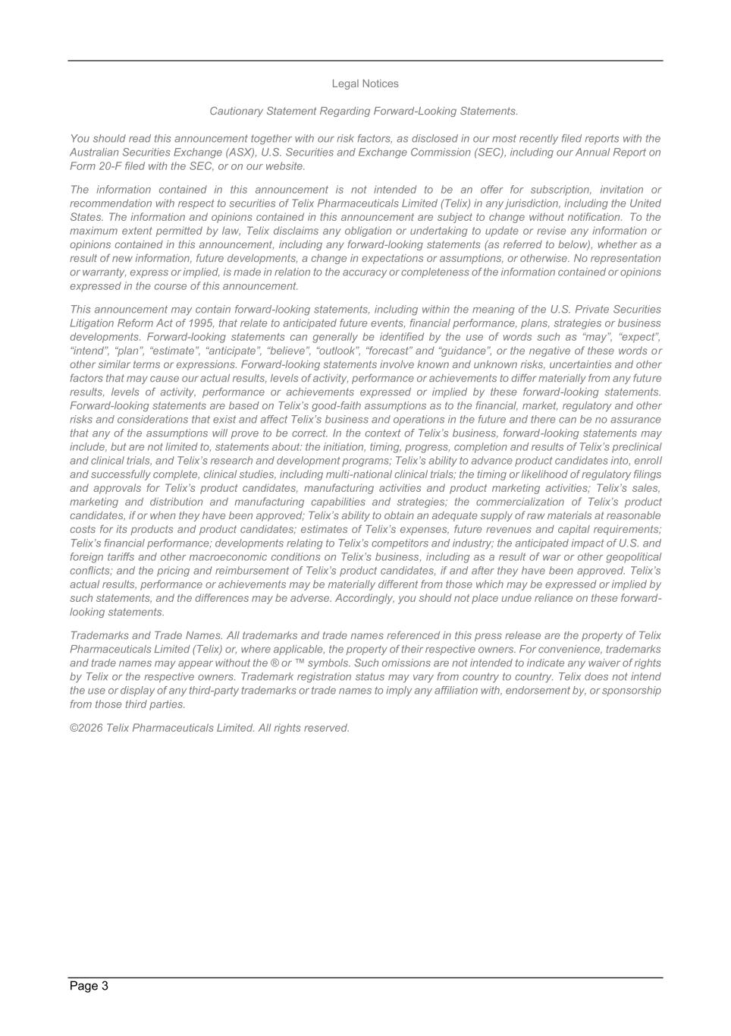
Page 3 Legal Notices Cautionary Statement Regarding Forward-Looking Statements. You should read this announcement together with our risk factors, as disclosed in our most recently filed reports with the Australian Securities Exchange (ASX), U.S. Securities and Exchange Commission (SEC), including our Annual Report on Form 20-F filed with the SEC, or on our website. The information contained in this announcement is not intended to be an offer for subscription, invitation or recommendation with respect to securities of Telix Pharmaceuticals Limited (Telix) in any jurisdiction, including the United States. The information and opinions contained in this announcement are subject to change without notification. To the maximum extent permitted by law, Telix disclaims any obligation or undertaking to update or revise any information or opinions contained in this announcement, including any forward-looking statements (as referred to below), whether as a result of new information, future developments, a change in expectations or assumptions, or otherwise. No representation or warranty, express or implied, is made in relation to the accuracy or completeness of the information contained or opinions expressed in the course of this announcement. This announcement may contain forward-looking statements, including within the meaning of the U.S. Private Securities Litigation Reform Act of 1995, that relate to anticipated future events, financial performance, plans, strategies or business developments. Forward-looking statements can generally be identified by the use of words such as “may”, “expect”, “intend”, “plan”, “estimate”, “anticipate”, “believe”, “outlook”, “forecast” and “guidance”, or the negative of these words or other similar terms or expressions. Forward-looking statements involve known and unknown risks, uncertainties and other factors that may cause our actual results, levels of activity, performance or achievements to differ materially from any future results, levels of activity, performance or achievements expressed or implied by these forward-looking statements. Forward-looking statements are based on Telix’s good-faith assumptions as to the financial, market, regulatory and other risks and considerations that exist and affect Telix’s business and operations in the future and there can be no assurance that any of the assumptions will prove to be correct. In the context of Telix’s business, forward-looking statements may include, but are not limited to, statements about: the initiation, timing, progress, completion and results of Telix’s preclinical and clinical trials, and Telix’s research and development programs; Telix’s ability to advance product candidates into, enroll and successfully complete, clinical studies, including multi-national clinical trials; the timing or likelihood of regulatory filings and approvals for Telix’s product candidates, manufacturing activities and product marketing activities; Telix’s sales, marketing and distribution and manufacturing capabilities and strategies; the commercialization of Telix’s product candidates, if or when they have been approved; Telix’s ability to obtain an adequate supply of raw materials at reasonable costs for its products and product candidates; estimates of Telix’s expenses, future revenues and capital requirements; Telix’s financial performance; developments relating to Telix’s competitors and industry; the anticipated impact of U.S. and foreign tariffs and other macroeconomic conditions on Telix’s business, including as a result of war or other geopolitical conflicts; and the pricing and reimbursement of Telix’s product candidates, if and after they have been approved. Telix’s actual results, performance or achievements may be materially different from those which may be expressed or implied by such statements, and the differences may be adverse. Accordingly, you should not place undue reliance on these forward- looking statements. Trademarks and Trade Names. All trademarks and trade names referenced in this press release are the property of Telix Pharmaceuticals Limited (Telix) or, where applicable, the property of their respective owners. For convenience, trademarks and trade names may appear without the ® or ™ symbols. Such omissions are not intended to indicate any waiver of rights by Telix or the respective owners. Trademark registration status may vary from country to country. Telix does not intend the use or display of any third-party trademarks or trade names to imply any affiliation with, endorsement by, or sponsorship from those third parties. ©2026 Telix Pharmaceuticals Limited. All rights reserved.

