UNITED STATES
SECURITIES AND EXCHANGE COMMISSION
Washington, D.C. 20549

FORM 6-K

REPORT OF FOREIGN PRIVATE ISSUER
PURSUANT TO RULE 13a-16 OR 15d-16 OF
THE SECURITIES EXCHANGE ACT OF 1934

For the month of July, 2026

Commission File Number: 001-42128

Telix Pharmaceuticals Limited
(Translation of registrant’s name into English)

55 Flemington Road
North Melbourne, Victoria 3051, Australia
(Address of principal executive offices)

Indicate by check mark whether the registrant files or will file annual reports under cover of Form 20-F or Form 40-
F.

Form 20-F ☒ Form 40-F ☐

INFORMATION CONTAINED IN THIS FORM 6-K REPORT

On July 21, 2026 (Melbourne, Australia), Telix Pharmaceuticals Limited filed an announcement with the Australian
Securities Exchange titled “Q2 2026 Revenue US$247M Strong Momentum Pipeline Progress” a copy of which is
attached to this Form 6-K as Exhibit 99.1.

99.1
Press release – July 21, 2026
SIGNATURES

Pursuant to the requirements of the Securities Exchange Act of 1934, the registrant has duly caused this report to be
signed on its behalf by the undersigned, thereunto duly authorized.

Date:

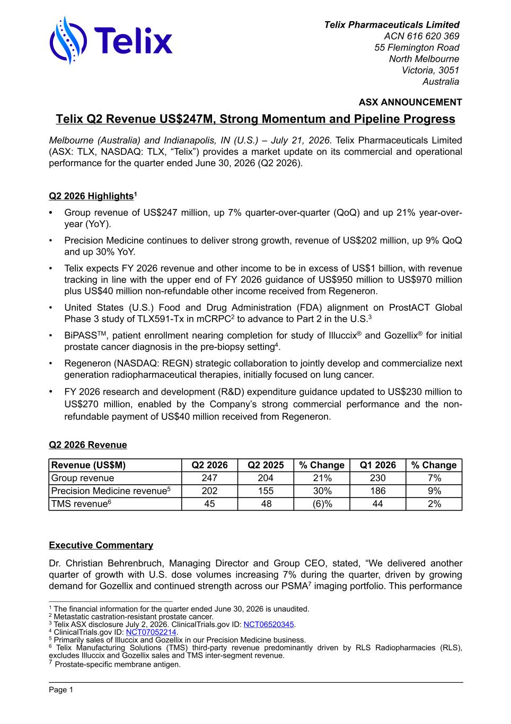
Telix Q2 Revenue US$247M, Strong Momentum and Pipeline Progress Melbourne (Australia) and Indianapolis, IN (U.S.) – July 21, 2026. Telix Pharmaceuticals Limited (ASX: TLX, NASDAQ: TLX, “Telix”) provides a market update on its commercial and operational performance for the quarter ended June 30, 2026 (Q2 2026). Q2 2026 Highlights1 • Group revenue of US$247 million, up 7% quarter-over-quarter (QoQ) and up 21% year-over- year (YoY). • Precision Medicine continues to deliver strong growth, revenue of US$202 million, up 9% QoQ and up 30% YoY. • Telix expects FY 2026 revenue and other income to be in excess of US$1 billion, with revenue tracking in line with the upper end of FY 2026 guidance of US$950 million to US$970 million plus US$40 million non-refundable other income received from Regeneron. • United States (U.S.) Food and Drug Administration (FDA) alignment on ProstACT Global Phase 3 study of TLX591-Tx in mCRPC2 to advance to Part 2 in the U.S.3 • BiPASSTM, patient enrollment nearing completion for study of Illuccix® and Gozellix® for initial prostate cancer diagnosis in the pre-biopsy setting4. • Regeneron (NASDAQ: REGN) strategic collaboration to jointly develop and commercialize next generation radiopharmaceutical therapies, initially focused on lung cancer. • FY 2026 research and development (R&D) expenditure guidance updated to US$230 million to US$270 million, enabled by the Company’s strong commercial performance and the non- refundable payment of US$40 million received from Regeneron. Q2 2026 Revenue Revenue (US$M) Q2 2026 Q2 2025 % Change Q1 2026 % Change Group revenue 247 204 21% 230 7% Precision Medicine revenue5 202 155 30% 186 9% TMS revenue6 45 48 (6)% 44 2% Executive Commentary Dr. Christian Behrenbruch, Managing Director and Group CEO, stated, “We delivered another quarter of growth with U.S. dose volumes increasing 7% during the quarter, driven by growing demand for Gozellix and continued strength across our PSMA7 imaging portfolio. This performance ASX ANNOUNCEMENT Page 1 1 The financial information for the quarter ended June 30, 2026 is unaudited. 2 Metastatic castration-resistant prostate cancer. 3 Telix ASX disclosure July 2, 2026. ClinicalTrials.gov ID: NCT06520345. 4 ClinicalTrials.gov ID: NCT07052214. 5 Primarily sales of Illuccix and Gozellix in our Precision Medicine business. 6 Telix Manufacturing Solutions (TMS) third-party revenue predominantly driven by RLS Radiopharmacies (RLS), excludes Illuccix and Gozellix sales and TMS inter-segment revenue. 7 Prostate-specific membrane antigen. Telix Pharmaceuticals Limited ACN 616 620 369 55 Flemington Road North Melbourne Victoria, 3051 Australia

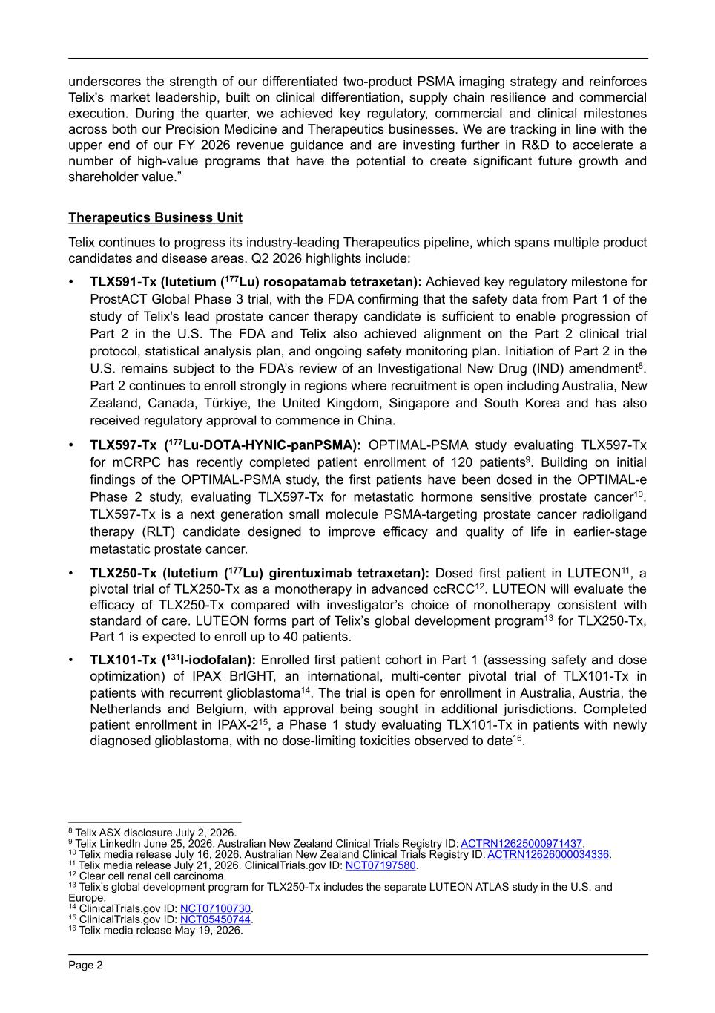
underscores the strength of our differentiated two-product PSMA imaging strategy and reinforces Telix's market leadership, built on clinical differentiation, supply chain resilience and commercial execution. During the quarter, we achieved key regulatory, commercial and clinical milestones across both our Precision Medicine and Therapeutics businesses. We are tracking in line with the upper end of our FY 2026 revenue guidance and are investing further in R&D to accelerate a number of high-value programs that have the potential to create significant future growth and shareholder value.” Therapeutics Business Unit Telix continues to progress its industry-leading Therapeutics pipeline, which spans multiple product candidates and disease areas. Q2 2026 highlights include: • TLX591-Tx (lutetium (177Lu) rosopatamab tetraxetan): Achieved key regulatory milestone for ProstACT Global Phase 3 trial, with the FDA confirming that the safety data from Part 1 of the study of Telix's lead prostate cancer therapy candidate is sufficient to enable progression of Part 2 in the U.S. The FDA and Telix also achieved alignment on the Part 2 clinical trial protocol, statistical analysis plan, and ongoing safety monitoring plan. Initiation of Part 2 in the U.S. remains subject to the FDA’s review of an Investigational New Drug (IND) amendment8. Part 2 continues to enroll strongly in regions where recruitment is open including Australia, New Zealand, Canada, Türkiye, the United Kingdom, Singapore and South Korea and has also received regulatory approval to commence in China. • TLX597-Tx (177Lu-DOTA-HYNIC-panPSMA): OPTIMAL-PSMA study evaluating TLX597-Tx for mCRPC has recently completed patient enrollment of 120 patients9. Building on initial findings of the OPTIMAL-PSMA study, the first patients have been dosed in the OPTIMAL-e Phase 2 study, evaluating TLX597-Tx for metastatic hormone sensitive prostate cancer10. TLX597-Tx is a next generation small molecule PSMA-targeting prostate cancer radioligand therapy (RLT) candidate designed to improve efficacy and quality of life in earlier-stage metastatic prostate cancer. • TLX250-Tx (lutetium (177Lu) girentuximab tetraxetan): Dosed first patient in LUTEON11, a pivotal trial of TLX250-Tx as a monotherapy in advanced ccRCC12. LUTEON will evaluate the efficacy of TLX250-Tx compared with investigator’s choice of monotherapy consistent with standard of care. LUTEON forms part of Telix’s global development program13 for TLX250-Tx, Part 1 is expected to enroll up to 40 patients. • TLX101-Tx (131I-iodofalan): Enrolled first patient cohort in Part 1 (assessing safety and dose optimization) of IPAX BrIGHT, an international, multi-center pivotal trial of TLX101-Tx in patients with recurrent glioblastoma14. The trial is open for enrollment in Australia, Austria, the Netherlands and Belgium, with approval being sought in additional jurisdictions. Completed patient enrollment in IPAX-215, a Phase 1 study evaluating TLX101-Tx in patients with newly diagnosed glioblastoma, with no dose-limiting toxicities observed to date16. Page 2 8 Telix ASX disclosure July 2, 2026. 9 Telix LinkedIn June 25, 2026. Australian New Zealand Clinical Trials Registry ID: ACTRN12625000971437. 10 Telix media release July 16, 2026. Australian New Zealand Clinical Trials Registry ID: ACTRN12626000034336. 11 Telix media release July 21, 2026. ClinicalTrials.gov ID: NCT07197580. 12 Clear cell renal cell carcinoma. 13 Telix’s global development program for TLX250-Tx includes the separate LUTEON ATLAS study in the U.S. and Europe. 14 ClinicalTrials.gov ID: NCT07100730. 15 ClinicalTrials.gov ID: NCT05450744. 16 Telix media release May 19, 2026.

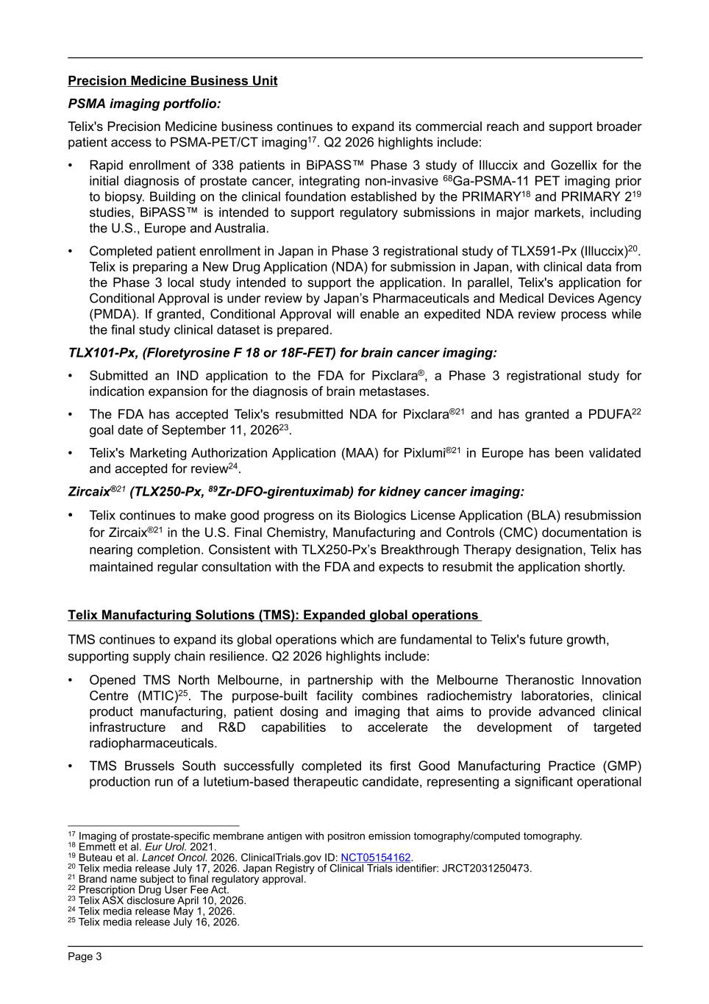
Precision Medicine Business Unit PSMA imaging portfolio: Telix's Precision Medicine business continues to expand its commercial reach and support broader patient access to PSMA-PET/CT imaging17. Q2 2026 highlights include: • Rapid enrollment of 338 patients in BiPASS™ Phase 3 study of Illuccix and Gozellix for the initial diagnosis of prostate cancer, integrating non-invasive 68Ga-PSMA-11 PET imaging prior to biopsy. Building on the clinical foundation established by the PRIMARY18 and PRIMARY 219 studies, BiPASS™ is intended to support regulatory submissions in major markets, including the U.S., Europe and Australia. • Completed patient enrollment in Japan in Phase 3 registrational study of TLX591-Px (Illuccix)20. Telix is preparing a New Drug Application (NDA) for submission in Japan, with clinical data from the Phase 3 local study intended to support the application. In parallel, Telix's application for Conditional Approval is under review by Japan’s Pharmaceuticals and Medical Devices Agency (PMDA). If granted, Conditional Approval will enable an expedited NDA review process while the final study clinical dataset is prepared. TLX101-Px, (Floretyrosine F 18 or 18F-FET) for brain cancer imaging: • Submitted an IND application to the FDA for Pixclara®, a Phase 3 registrational study for indication expansion for the diagnosis of brain metastases. • The FDA has accepted Telix's resubmitted NDA for Pixclara®21 and has granted a PDUFA22 goal date of September 11, 202623. • Telix's Marketing Authorization Application (MAA) for Pixlumi®21 in Europe has been validated and accepted for review24. Zircaix®21 (TLX250-Px, 89Zr-DFO-girentuximab) for kidney cancer imaging: • Telix continues to make good progress on its Biologics License Application (BLA) resubmission for Zircaix®21 in the U.S. Final Chemistry, Manufacturing and Controls (CMC) documentation is nearing completion. Consistent with TLX250-Px’s Breakthrough Therapy designation, Telix has maintained regular consultation with the FDA and expects to resubmit the application shortly. Telix Manufacturing Solutions (TMS): Expanded global operations TMS continues to expand its global operations which are fundamental to Telix's future growth, supporting supply chain resilience. Q2 2026 highlights include: • Opened TMS North Melbourne, in partnership with the Melbourne Theranostic Innovation Centre (MTIC)25. The purpose-built facility combines radiochemistry laboratories, clinical product manufacturing, patient dosing and imaging that aims to provide advanced clinical infrastructure and R&D capabilities to accelerate the development of targeted radiopharmaceuticals. • TMS Brussels South successfully completed its first Good Manufacturing Practice (GMP) production run of a lutetium-based therapeutic candidate, representing a significant operational Page 3 17 Imaging of prostate-specific membrane antigen with positron emission tomography/computed tomography. 18 Emmett et al. Eur Urol. 2021. 19 Buteau et al. Lancet Oncol. 2026. ClinicalTrials.gov ID: NCT05154162. 20 Telix media release July 17, 2026. Japan Registry of Clinical Trials identifier: JRCT2031250473. 21 Brand name subject to final regulatory approval. 22 Prescription Drug User Fee Act. 23 Telix ASX disclosure April 10, 2026. 24 Telix media release May 1, 2026. 25 Telix media release July 16, 2026.

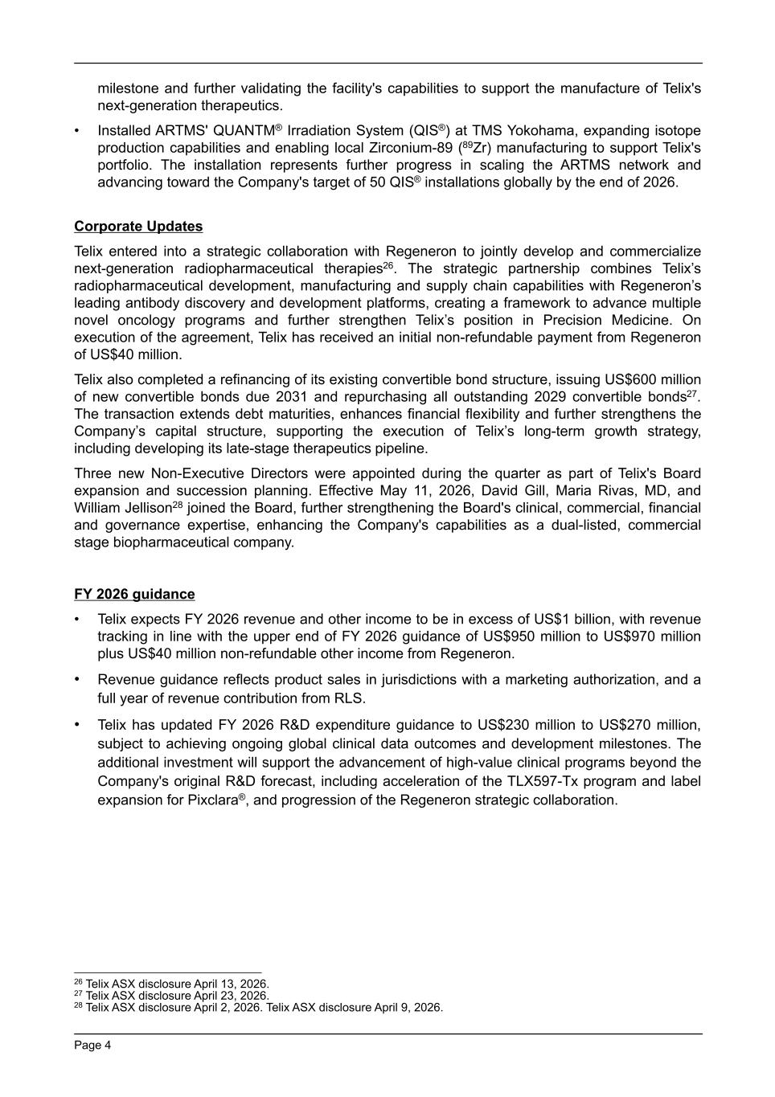
milestone and further validating the facility's capabilities to support the manufacture of Telix's next-generation therapeutics. • Installed ARTMS' QUANTM® Irradiation System (QIS®) at TMS Yokohama, expanding isotope production capabilities and enabling local Zirconium-89 (89Zr) manufacturing to support Telix's portfolio. The installation represents further progress in scaling the ARTMS network and advancing toward the Company's target of 50 QIS® installations globally by the end of 2026. Corporate Updates Telix entered into a strategic collaboration with Regeneron to jointly develop and commercialize next-generation radiopharmaceutical therapies26. The strategic partnership combines Telix’s radiopharmaceutical development, manufacturing and supply chain capabilities with Regeneron’s leading antibody discovery and development platforms, creating a framework to advance multiple novel oncology programs and further strengthen Telix’s position in Precision Medicine. On execution of the agreement, Telix has received an initial non-refundable payment from Regeneron of US$40 million. Telix also completed a refinancing of its existing convertible bond structure, issuing US$600 million of new convertible bonds due 2031 and repurchasing all outstanding 2029 convertible bonds27. The transaction extends debt maturities, enhances financial flexibility and further strengthens the Company’s capital structure, supporting the execution of Telix’s long-term growth strategy, including developing its late-stage therapeutics pipeline. Three new Non-Executive Directors were appointed during the quarter as part of Telix's Board expansion and succession planning. Effective May 11, 2026, David Gill, Maria Rivas, MD, and William Jellison28 joined the Board, further strengthening the Board's clinical, commercial, financial and governance expertise, enhancing the Company's capabilities as a dual-listed, commercial stage biopharmaceutical company. FY 2026 guidance • Telix expects FY 2026 revenue and other income to be in excess of US$1 billion, with revenue tracking in line with the upper end of FY 2026 guidance of US$950 million to US$970 million plus US$40 million non-refundable other income from Regeneron. • Revenue guidance reflects product sales in jurisdictions with a marketing authorization, and a full year of revenue contribution from RLS. • Telix has updated FY 2026 R&D expenditure guidance to US$230 million to US$270 million, subject to achieving ongoing global clinical data outcomes and development milestones. The additional investment will support the advancement of high-value clinical programs beyond the Company's original R&D forecast, including acceleration of the TLX597-Tx program and label expansion for Pixclara®, and progression of the Regeneron strategic collaboration. Page 4 26 Telix ASX disclosure April 13, 2026. 27 Telix ASX disclosure April 23, 2026. 28 Telix ASX disclosure April 2, 2026. Telix ASX disclosure April 9, 2026.

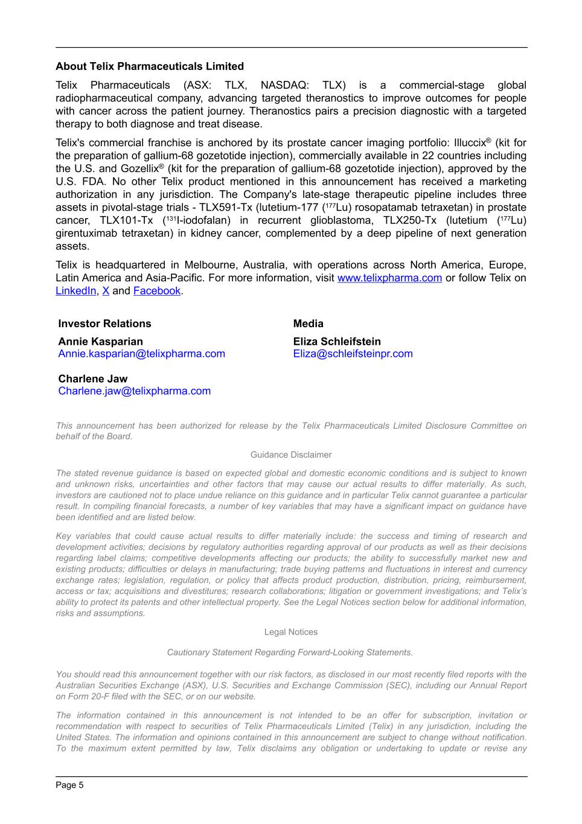
About Telix Pharmaceuticals Limited Telix Pharmaceuticals (ASX: TLX, NASDAQ: TLX) is a commercial-stage global radiopharmaceutical company, advancing targeted theranostics to improve outcomes for people with cancer across the patient journey. Theranostics pairs a precision diagnostic with a targeted therapy to both diagnose and treat disease. Telix's commercial franchise is anchored by its prostate cancer imaging portfolio: Illuccix® (kit for the preparation of gallium-68 gozetotide injection), commercially available in 22 countries including the U.S. and Gozellix® (kit for the preparation of gallium-68 gozetotide injection), approved by the U.S. FDA. No other Telix product mentioned in this announcement has received a marketing authorization in any jurisdiction. The Company's late-stage therapeutic pipeline includes three assets in pivotal-stage trials - TLX591-Tx (lutetium-177 (177Lu) rosopatamab tetraxetan) in prostate cancer, TLX101-Tx (131I-iodofalan) in recurrent glioblastoma, TLX250-Tx (lutetium (177Lu) girentuximab tetraxetan) in kidney cancer, complemented by a deep pipeline of next generation assets. Telix is headquartered in Melbourne, Australia, with operations across North America, Europe, Latin America and Asia-Pacific. For more information, visit www.telixpharma.com or follow Telix on LinkedIn, X and Facebook. Investor Relations Annie Kasparian Annie.kasparian@telixpharma.com Charlene Jaw Charlene.jaw@telixpharma.com Media Eliza Schleifstein Eliza@schleifsteinpr.com This announcement has been authorized for release by the Telix Pharmaceuticals Limited Disclosure Committee on behalf of the Board. Guidance Disclaimer The stated revenue guidance is based on expected global and domestic economic conditions and is subject to known and unknown risks, uncertainties and other factors that may cause our actual results to differ materially. As such, investors are cautioned not to place undue reliance on this guidance and in particular Telix cannot guarantee a particular result. In compiling financial forecasts, a number of key variables that may have a significant impact on guidance have been identified and are listed below. Key variables that could cause actual results to differ materially include: the success and timing of research and development activities; decisions by regulatory authorities regarding approval of our products as well as their decisions regarding label claims; competitive developments affecting our products; the ability to successfully market new and existing products; difficulties or delays in manufacturing; trade buying patterns and fluctuations in interest and currency exchange rates; legislation, regulation, or policy that affects product production, distribution, pricing, reimbursement, access or tax; acquisitions and divestitures; research collaborations; litigation or government investigations; and Telix’s ability to protect its patents and other intellectual property. See the Legal Notices section below for additional information, risks and assumptions. Legal Notices Cautionary Statement Regarding Forward-Looking Statements. You should read this announcement together with our risk factors, as disclosed in our most recently filed reports with the Australian Securities Exchange (ASX), U.S. Securities and Exchange Commission (SEC), including our Annual Report on Form 20-F filed with the SEC, or on our website. The information contained in this announcement is not intended to be an offer for subscription, invitation or recommendation with respect to securities of Telix Pharmaceuticals Limited (Telix) in any jurisdiction, including the United States. The information and opinions contained in this announcement are subject to change without notification. To the maximum extent permitted by law, Telix disclaims any obligation or undertaking to update or revise any Page 5

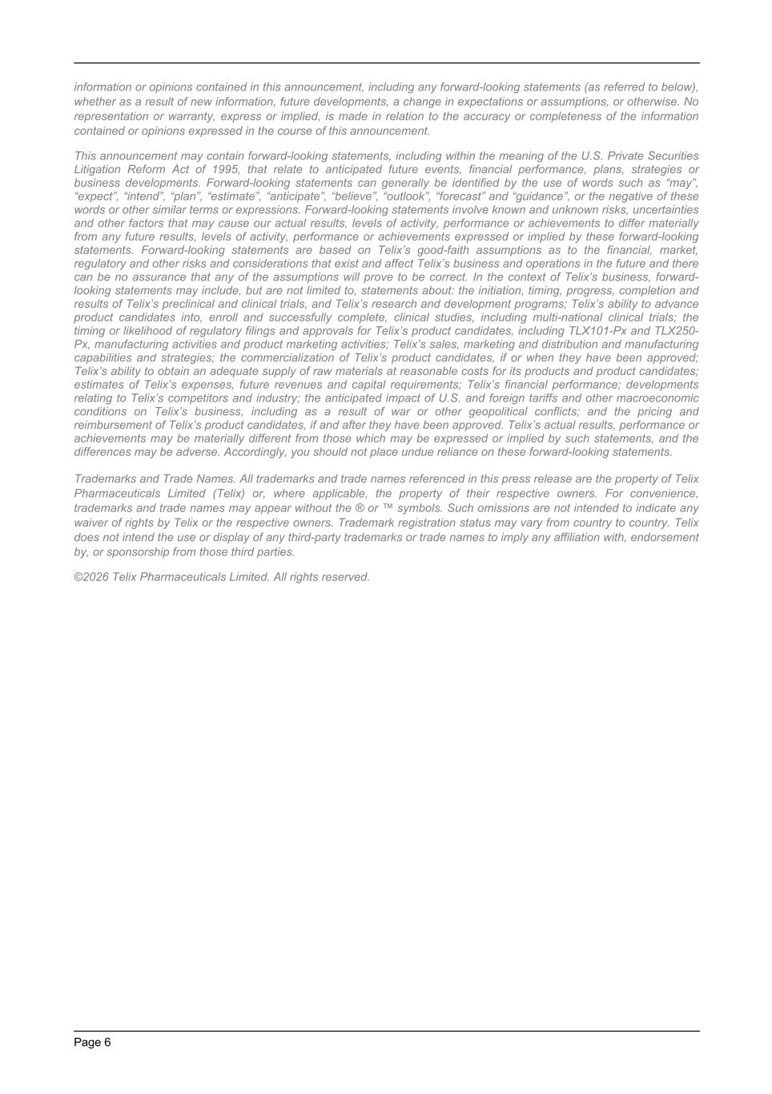
information or opinions contained in this announcement, including any forward-looking statements (as referred to below), whether as a result of new information, future developments, a change in expectations or assumptions, or otherwise. No representation or warranty, express or implied, is made in relation to the accuracy or completeness of the information contained or opinions expressed in the course of this announcement. This announcement may contain forward-looking statements, including within the meaning of the U.S. Private Securities Litigation Reform Act of 1995, that relate to anticipated future events, financial performance, plans, strategies or business developments. Forward-looking statements can generally be identified by the use of words such as “may”, “expect”, “intend”, “plan”, “estimate”, “anticipate”, “believe”, “outlook”, “forecast” and “guidance”, or the negative of these words or other similar terms or expressions. Forward-looking statements involve known and unknown risks, uncertainties and other factors that may cause our actual results, levels of activity, performance or achievements to differ materially from any future results, levels of activity, performance or achievements expressed or implied by these forward-looking statements. Forward-looking statements are based on Telix’s good-faith assumptions as to the financial, market, regulatory and other risks and considerations that exist and affect Telix’s business and operations in the future and there can be no assurance that any of the assumptions will prove to be correct. In the context of Telix’s business, forward- looking statements may include, but are not limited to, statements about: the initiation, timing, progress, completion and results of Telix’s preclinical and clinical trials, and Telix’s research and development programs; Telix’s ability to advance product candidates into, enroll and successfully complete, clinical studies, including multi-national clinical trials; the timing or likelihood of regulatory filings and approvals for Telix’s product candidates, including TLX101-Px and TLX250- Px, manufacturing activities and product marketing activities; Telix’s sales, marketing and distribution and manufacturing capabilities and strategies; the commercialization of Telix’s product candidates, if or when they have been approved; Telix’s ability to obtain an adequate supply of raw materials at reasonable costs for its products and product candidates; estimates of Telix’s expenses, future revenues and capital requirements; Telix’s financial performance; developments relating to Telix’s competitors and industry; the anticipated impact of U.S. and foreign tariffs and other macroeconomic conditions on Telix’s business, including as a result of war or other geopolitical conflicts; and the pricing and reimbursement of Telix’s product candidates, if and after they have been approved. Telix’s actual results, performance or achievements may be materially different from those which may be expressed or implied by such statements, and the differences may be adverse. Accordingly, you should not place undue reliance on these forward-looking statements. Trademarks and Trade Names. All trademarks and trade names referenced in this press release are the property of Telix Pharmaceuticals Limited (Telix) or, where applicable, the property of their respective owners. For convenience, trademarks and trade names may appear without the ® or ™ symbols. Such omissions are not intended to indicate any waiver of rights by Telix or the respective owners. Trademark registration status may vary from country to country. Telix does not intend the use or display of any third-party trademarks or trade names to imply any affiliation with, endorsement by, or sponsorship from those third parties. ©2026 Telix Pharmaceuticals Limited. All rights reserved. Page 6

